______________ VILOYATI _________ TUMANI MAKTABGACHA VA MAKTAB TA’LIMI BO’LIMIGA QARASHLI
___-SONLI O’RTA TA’LIM MAKTABI
INGLIZ TILI FANI O’QITUVCHISI
_______________________________NING
9-sinflar uchun Unit 1. Lesson 1
Overview and about you
mavzusida 1 soatlik
Dars ishlanmasi

_______________-2023

Date_____ Form_____ Subject: English
Theme: Overview and about you
Aims:
Educational: - to learn about activities and personal interests
Developing: - to develop listening, reading, writing, and speaking skills
Socio-cultural: - to raise awareness of different cultures
Up bringing: - to enrich pupils’ knowledge of our tradition and nation
Learning outcomes: At the end of the lesson, pupils will be able to use learnt language in practice, ask and answer questions
Competence: SC1, FLCC, and PC
Type of the lesson: Mixed, group work, pair-work, individual work
Method of the lesson: nontraditional, mixed
Equipment of the lesson: Prepare 9 SB, Workbook, the DVD of the book, flashcards

TECHNOLOGICAL MAP OF THE LESSON:

№ | Part of the lesson | Tasks | Time
1 | Organizational  Moment | -to greet pupils.  - to check up the register | 5 min
2 | Repeating last lesson | - to give pupils some questions about last lesson. – to ask words from previous lesson | 5 min
3 | Explaining new theme | - to explain to pupils new vocabulary and theme | 20 min
4 | Consolidating new theme. | - to consolidate new theme and new words of the theme. | 10 min
5 | Marking. | - To mark pupils | 5 min
6 | Homework. | - Giving homework.

Procedure of the lesson:
I. Organizing moment: Motivation, Greeting, checking attendance, season, weather, checking the preparation for the lesson.
- Check for homework given on past lesson.
- Ask pupils all new words learnt on previous lesson.

II. Pre-activity:
If students did Level 2 together, this activity gets them using simple English again after the break; if they didn’t, it helps them get to know each other.
Write the words food, sport, city, animal and colour on the board. Give students one minute to write down their favourite thing in each category. Start by giving them an example for each, e.g. ice cream, basketball, Milan, elephant and green.
In pairs, students then compare and discuss their answers. Demonstrate with a stronger student:
‘What’s your favourite food, Mario?’
I love sushi. There’s a great sushi place near my house. What about you?
As a variation, all students should walk around the class asking and comparing answers to see which items in each category are the most popular.

III. Main part
Pre-teach award (a prize you give to someone for something good they did), then ask students for examples of awards or prizes it is possible for young people to win, for example in sports competitions, youth movements or school exams. Put students into groups to discuss the questions.

Encourage students to brainstorm other awards and prizes in their country. (If you have students from different countries, the discussion is more interesting if you put different nationalities together.) Then exchange ideas as a class. As an extension activity, put students into pairs to think of funny awards for their class for this year: for example, for the student who smiles the most, the student who asks the most questions.

Activity 1 Read the poster and look at the photos. Then answer the questions in pairs.

Ask students to look at the poster and the heading. Ask, ‘Who is the Duke of Edinburgh?’ (Prince Philip, husband of the queen of England, Elizabeth II).
Pre-teach volunteering (offering to do something without expecting payment), expedition (an organised journey, especially a long one for a particular purpose) and hiking (the activity of going for a long walk for pleasure outdoors). Point out the pronunciation of Edinburgh (/ˈed.ɪn.bər.ə/). If necessary, read out the background information to help students. Ask, ‘Who is MrJones?’ (the school’s Duke of Edinburgh’s Award leader). Put students into pairs to read and answer the questions;then check the answers as a class.
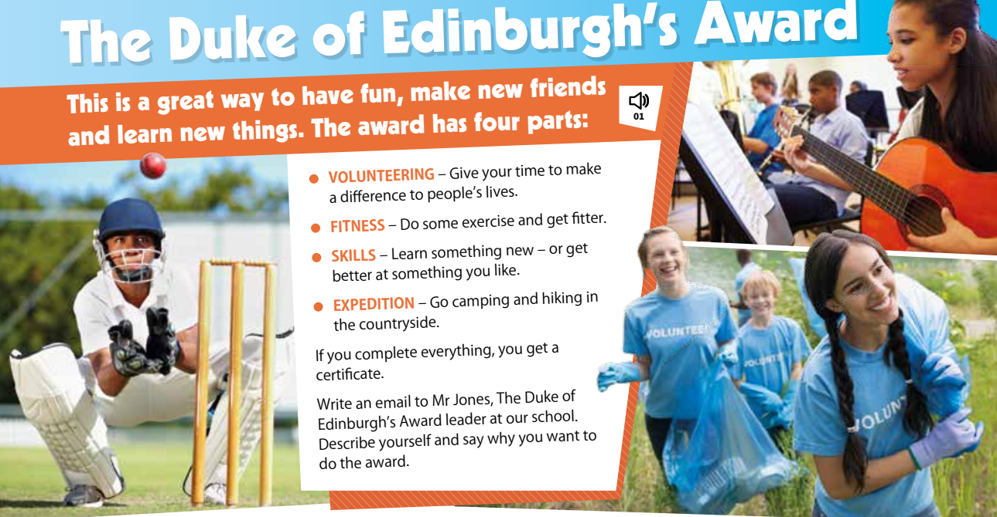
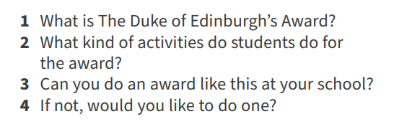

Answers
1 It’s an achievement award.
2 They volunteer, do fitness activities or exercise, learn something new and go on an expedition.
3 and 4 Students’ own answers

Activity 2 Read the students’ emails on page 11 and answer the questions with Daniel or Grace.

Ask students to look at the emails. Ask, ‘Who tells a lot of jokes?’ (Daniel). Tell students to answer the questions.
Check the answers then ask students, ‘Who sounds more interesting, Daniel or Grace?’

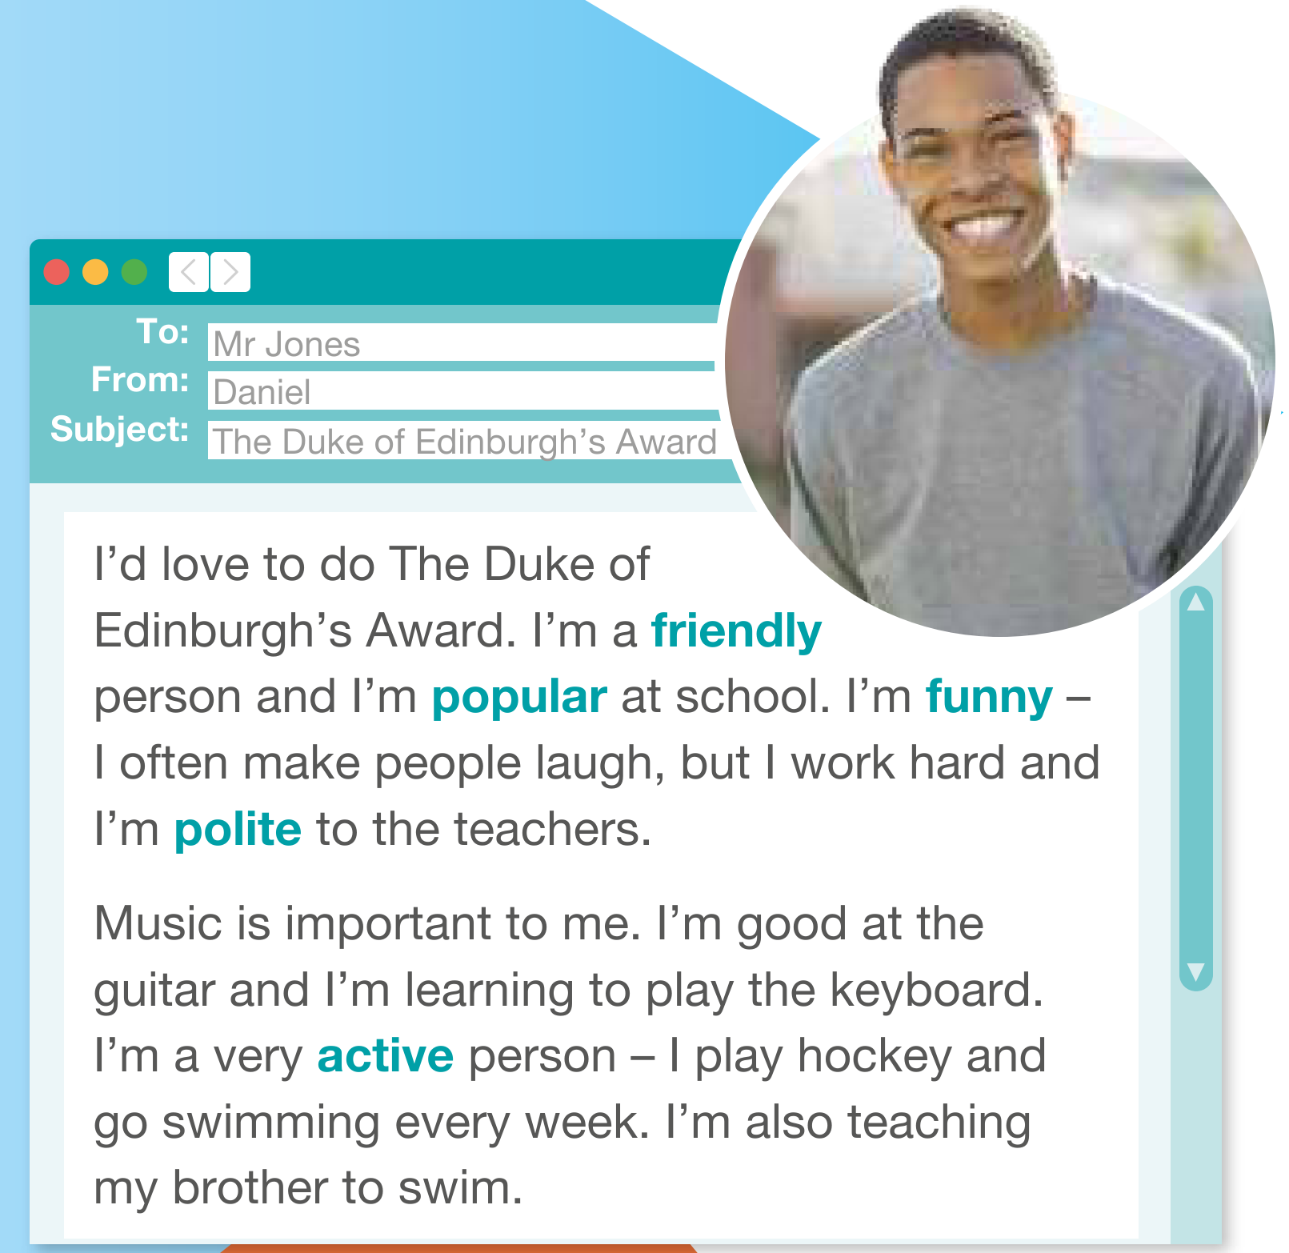

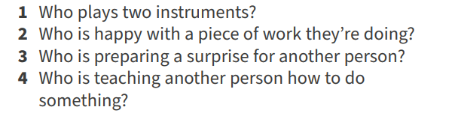

Answers
1 Daniel 2 Grace 3 Grace 4 Daniel

The Reading text is recorded for students to listen, read and check their answers.

Activity 3 Check the meaning of the words in the emails on page 11. Then use them to complete the sentences.

Ask concept-checking questions about the words. For example, ‘Are friendly people nice or not nice?’ (nice).
Let weaker students translate the words. Drill all the words. Then tell students to complete the sentences. Put students into pairs to compare their answers.
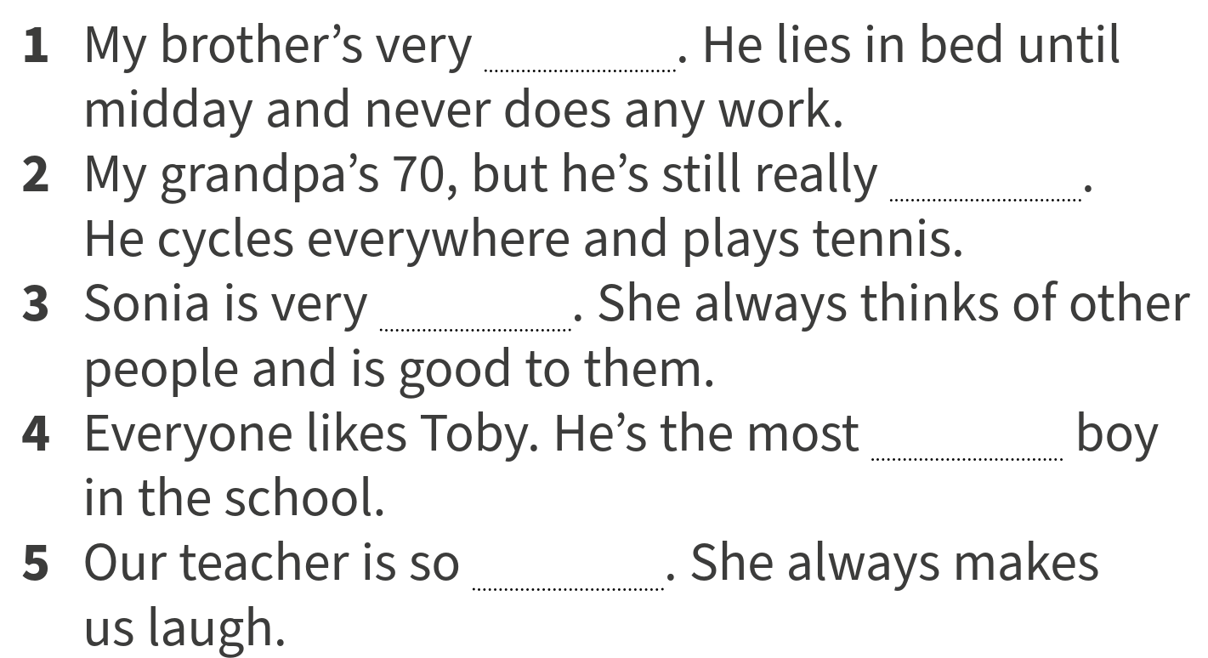
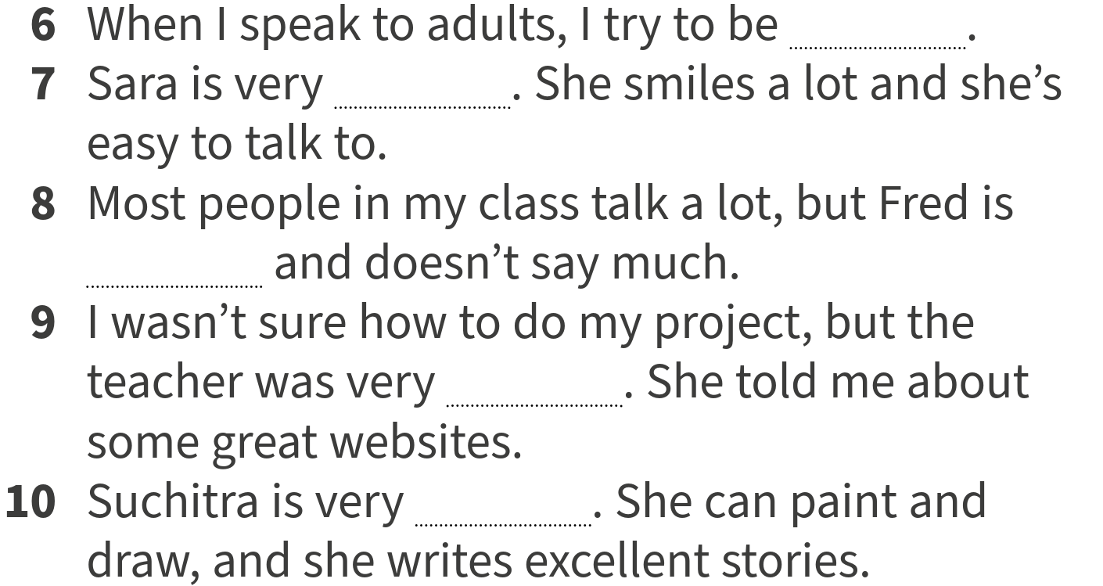

Answers
The answers are recorded for students to check and then repeat.
1 lazy 2 active 3 kind 4 popular 5 funny 6 polite 7 friendly 8 quiet 9 helpful 10 creative

Activity 4 Write sentences about your partner using the adjectives in Exercise 3. Give the sentences to your teacher to read out for the class to try and guess who they are about.

Put students into pairs and have them write four sentences about their partner using adjectives.
Tell them not to name their partner but to use they instead, for example, They don’t talk very much. Collect the sentences then read them out for the class to guess the student. Write the sentences which have mistakes on the board and tell students to correct or improve them.

IV. Post-activity
WB Activity 1 Put the letters in the correct order to make adjectives. The first letter is given.
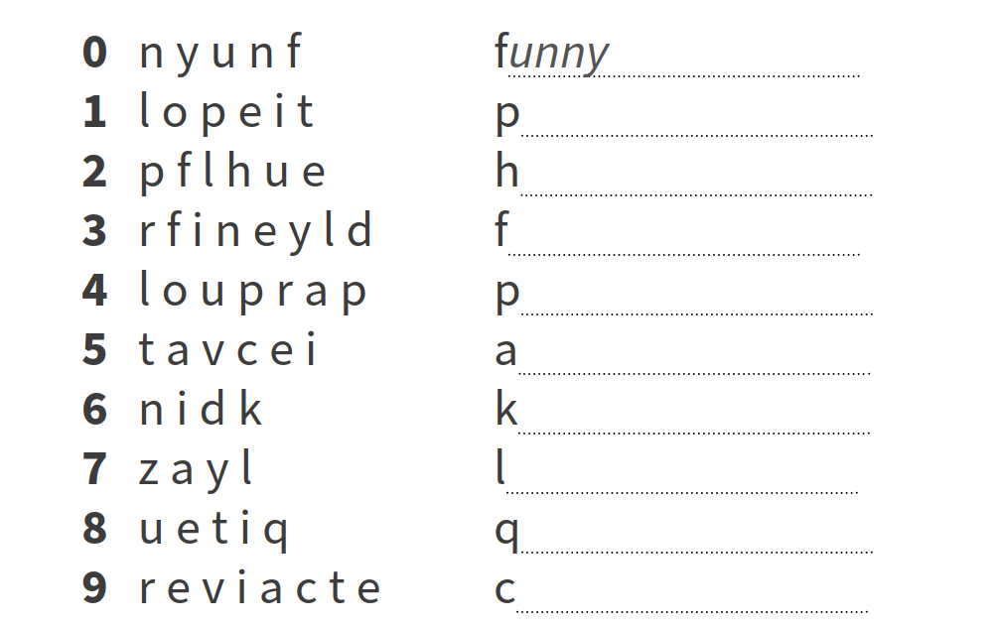

V. Homework
WB Activity 2 Complete the sentences with words in Exercise 1.
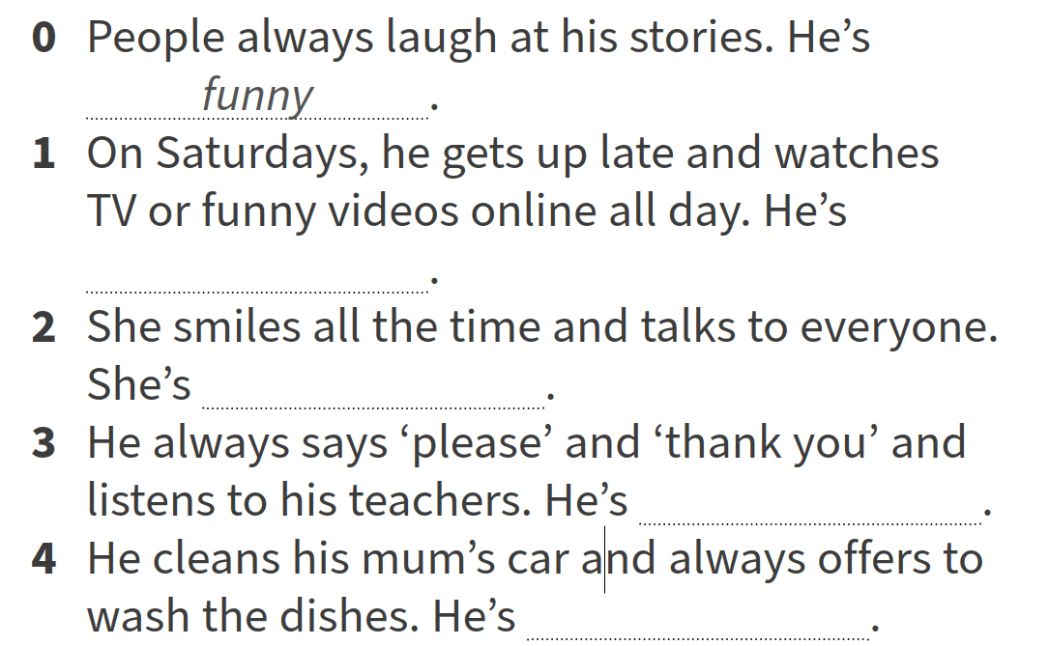
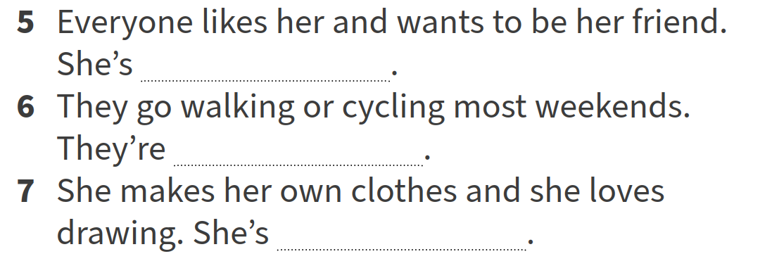
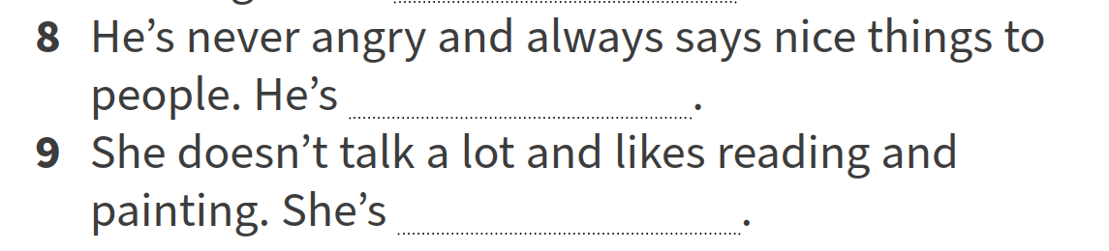

VI. Evaluation
Giving marks according to pupils’ participation to the lesson

Deputy director on educational affairs: _________ Signature: __________

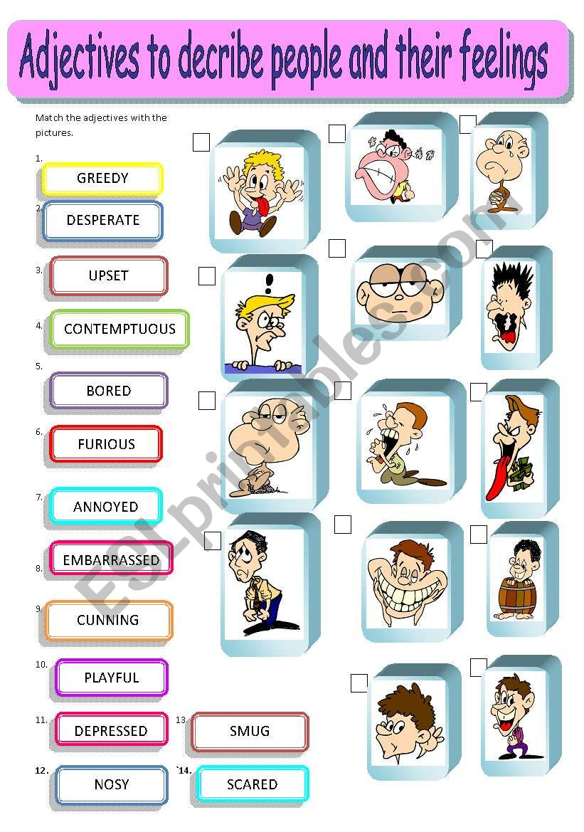
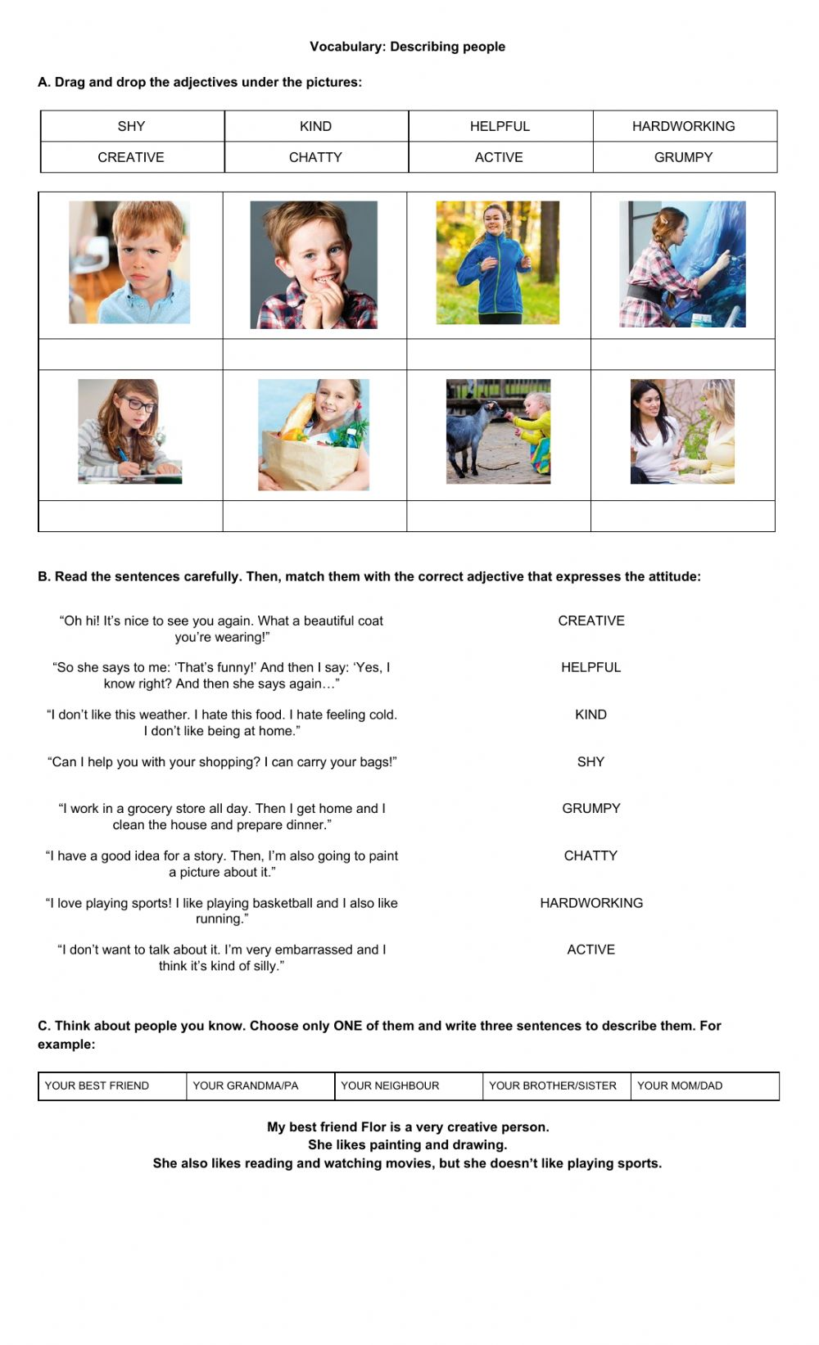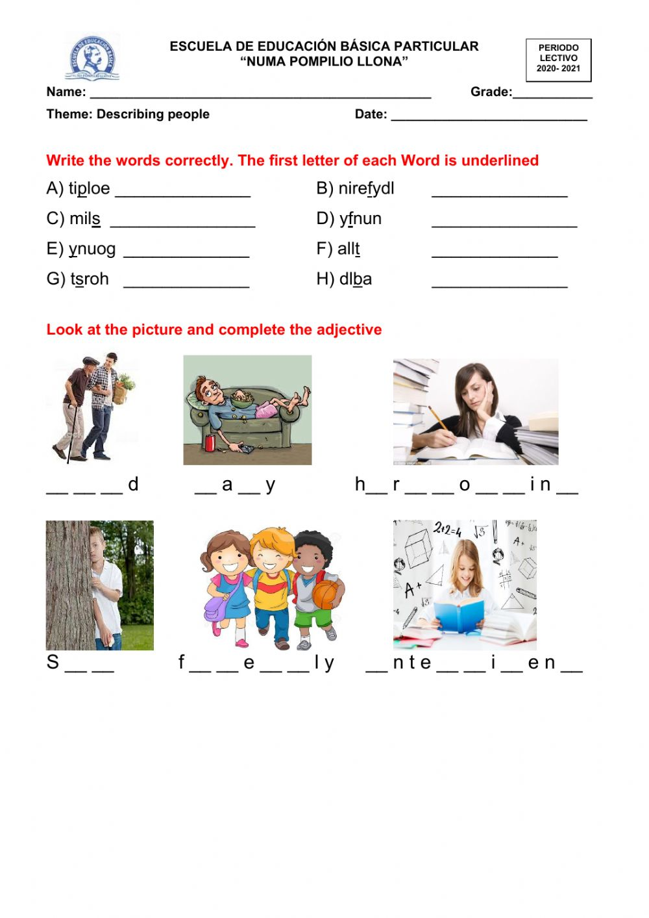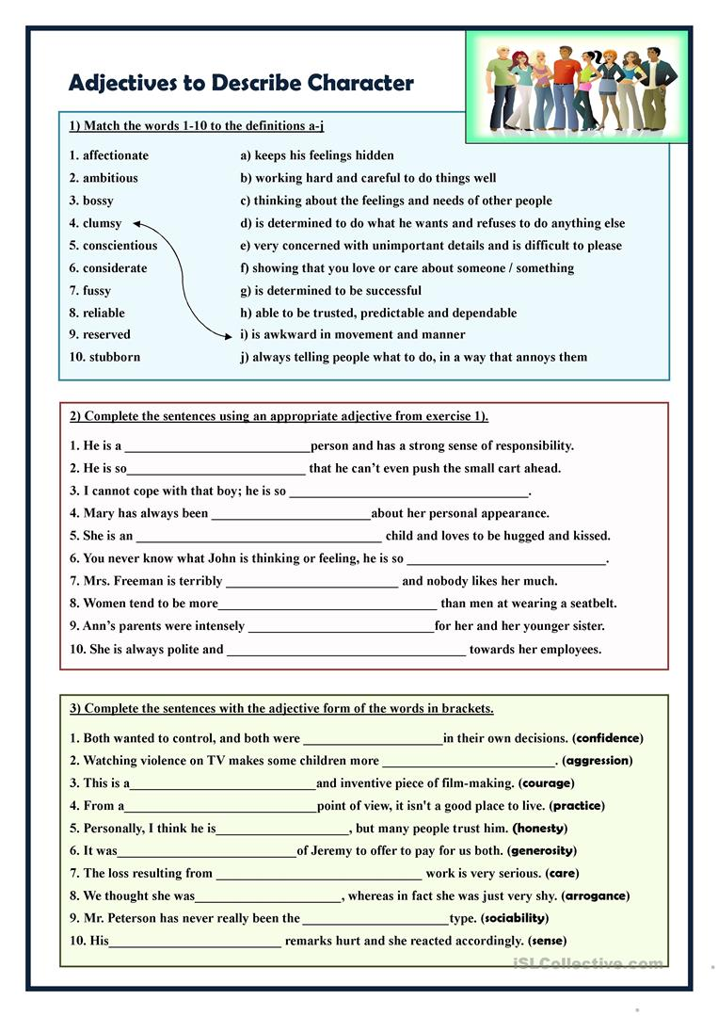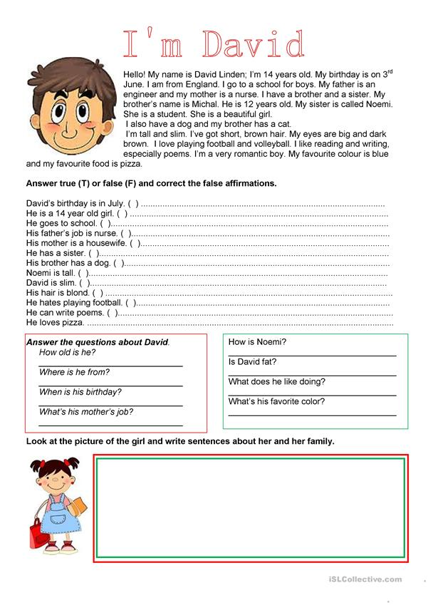

Huddi shunday namunada Guess What va Prepare darsliklaridan istalgan mavzu bo’yicha namunaviy dars ishlanmalar olishingiz mumkin. Biz bilan bog’lanish uchun Telegramdan @uzteachers_admin manzili yoki +998911800985 telegram raqami ga xabar yuboring. Narxi 1ta mavzu
20 ming so’m
To’lov payme yoki click orqali
BOG’LANISH FAQAT TELEGRAM ORQALI. Telefon qilinganda yoki sms yozilganda javob berilmaydi!

