______________ VILOYATI _________ TUMANI XALQ TA’LIMI BO’LIMIGA QARASHLI
___-SONLI O’RTA TA”LIM MAKTABI
INGLIZ TILI FANI O’QITUVCHISI
_______________________________NING
9-sinflar uchun Unit 5. Lesson 5
Westminster and Washington
mavzusida 1 soatlik

Dars ishlanmasi
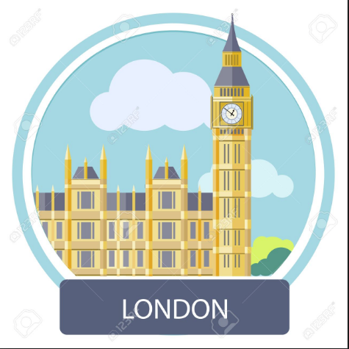

_______________-2019
Date_____ Form_____ Subject: English
Theme: Westminster and Washington
Aims:
Educational: - to introduce and practise new topic vocabulary
Developing: - to practise reading for detailed information and to take notes
- to practise using the Wordlist
- to practise doing a research task (homework)
Socio-cultural: - to raise awareness of different cultures
Up bringing: - to enrich pupils’ knowledge of our tradition and nation
Learning outcomes: At the end of the lesson pupils will be able to talk about UK Parlament ; government of the USA
Competence: SC1, FLCC, and PC
Type of the lesson: Mixed, group work, pair-work, individual work
Method of the lesson: nontraditional, mixed
Equipment of the lesson: Textbook “Fly High 8”, pictures, internet, computers, projector

TECHNOLOGICAL MAP OF THE LESSON:

№ | Part of the lesson | Tasks | Time
1 | Organizational  Moment | -to greet pupils.  - to check up the register | 5 min
2 | Repeating last lesson | - to give pupils some questions about last lesson. – to ask words from previous lesson | 5 min
3 | Explaining new theme | - to explain to pupils new vocabulary and theme | 20 min
4 | Consolidating new theme. | - to consolidate new theme and new words of the theme. | 10 min
5 | Marking. | - To mark pupils | 5 min
6 | Homework. | - Giving homework.

Procedure of the lesson:
I. Organizing moment: Motivation, Greeting, checking attendance, season, weather, checking the preparation for the lesson.

II. Asking homework:
- Check for homework given on past lesson.
- Ask pupils all new words learnt on previous lesson.

III. Pre-activity:

Stop the Bus

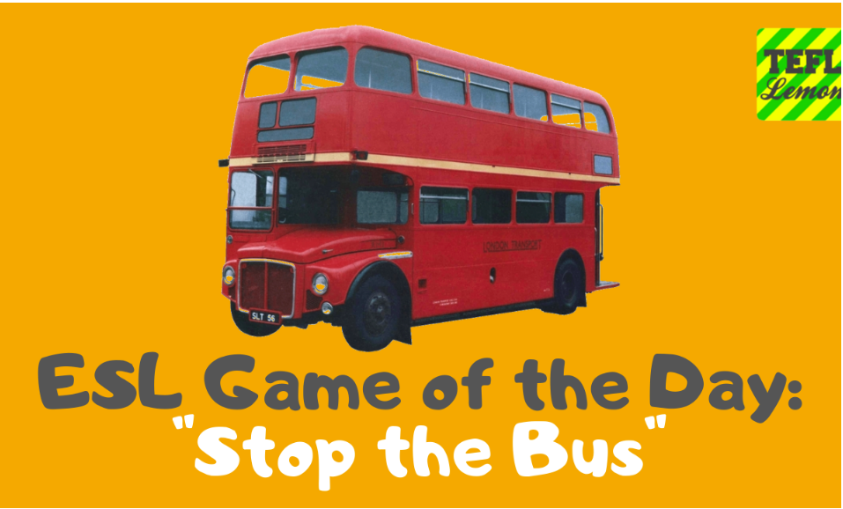
Put your ESL students into small teams of 3-4 students, or even pairs if you have a smaller ESL teens or adults class. Have your English students sat around separate tables or in small circles on the floor. Each team need a piece of paper and some pens or pencils.
When you're ready, write a BIG letter on the board, for example, 'T' and shout 'Go!'
The teams now must write as many words as they can beginning with the letter 'T', or whatever letter you wrote on the whiteboard.
At any given point, ANY student can shout out 'STOP THE BUS!' and everyone in the classroom must immediately put down their pens and stop writing. Go around and check how many words each team has written and discount any words which are repeated. The team with the most words spelled correctly is the winner!
Students usually call out 'Stop the Bus' when they think their team has got a lot of words and feel that they can't be caught, but sometimes it backfires and another team has more! A quality TEFL warmer for teens and adults, or older children!

IV. Main part
Activity 1 Find the words in the Wordlist. Write the words and translations.
Objectives: to practise working with the Wordlist; to practise pronouncing the words correctly
Ask PP to find the words in the Wordlist and write them and their translation in their exercise books. Then you read the words. Let your PP repeat after you in chorus, then in rows and/or individually.

convention make up statute law common law
legislature appoint cabinet make a decision delegate
retain license provide maintain Capitol

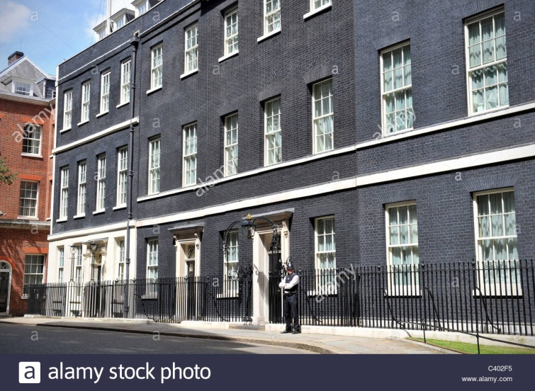
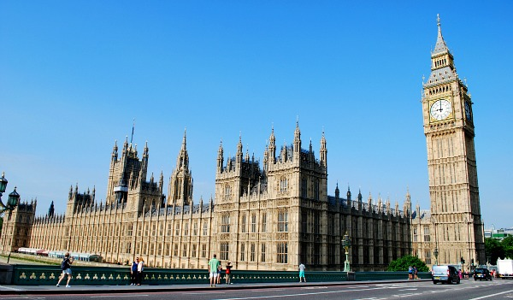

The houses of Parliament at Westminster in London 10 Downing Street in london

Activity 2a Read and answer the questions.
Objective: to practise reading for detailed information
Ask PP to read the text carefully and then find the answers to the questions.

1 how many parts does the UK Parliament consist of?
2 Who elects the Prime Minister of the UK?
3 What is another name for the houses of Parliament?

Good morning. My name is James Mclenan. i work here at Westminster. And i’m going
to be your guide to the house of Commons. Britain is a parliamentary democracy with a
constitutional monarch – Queen Elizabeth ii – as head of State. The British Constitution,
unlike those of most other countries, is not written in one document. instead it is made up of statute law, common law and conventions from the last 1,000 years. Parliament is the legislature and the supreme authority. it consists of three elements – the Monarchy, the house of lords and the house of Commons. These meet together only for special ceremonies.
The house of lords and the house of Commons meet in the houses of Parliament, which are known as Westminster. The government is formed by the political party with the most MPs (members of parliament). The Queen then appoints its leader as Prime Minister.
The Prime Minister’s official residence is at 10 Downing Street in central London. As head of the government, the Prime Minister appoints about 100 ministers, 20 of them are in the Cabinet – the senior group which takes major policy decisions.

Activity 2b Copy and complete the table for the UK.
Objective: to read for detailed information and to take notes from reading
Ask PP to copy the table, re-read the text in 2a and complete the table. It is similar to the table they completed for Uzbekistan and the USA in Lesson 3. If they like, PP could simply add to that table.

Country and  capital city | State Structure | Head of State | Head of the  government | Name of government  Building

Activity 3a Read the interview and answer the questions.
Objective: to read for the main information
PP read the text and answer the questions.

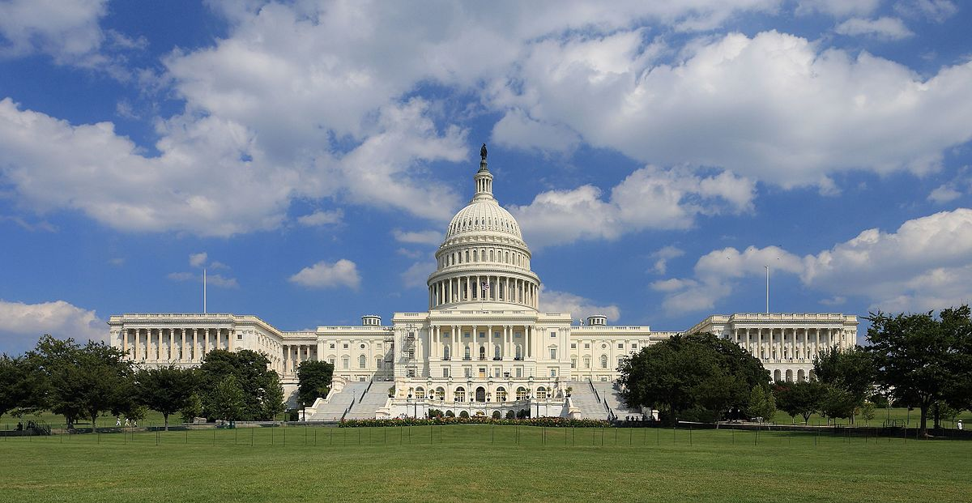

1 What is the capital of the USA?
2 What is the name of the government of the USA?
3 What is the name of the place where the government buildings are?

Hello I’m John Tolbertson. I’m a representative of the Senate and I’m going to tell you about Washington, which is the nation’s capital. The city of Washington is in the District of Columbia on the Potomac River. Its population is more than 3.4 million. The US Congress meets in the Capitol, where government officers discuss new laws and make decisions. Under the constitution the states delegate much of their sovereignty to this central government in Washington. But they keep many important powers for themselves. Each of the 50 states, for example, retains the right to run its own public school system, to license its doctors and other professionals, to provide police protection for its citizens and to maintain its roads.

Key: 1 Washington 2 Congress 3 Capitol

V. Post-activity
Activity 3b Copy and complete the table for the US.
Objective: to read for detailed information and to take notes from reading
Ask PP to copy the table, re-read the text in 2a and complete the table.
You could ask PP to look at the four tables and talk about and compare the
systems in the four countries, using the example in Lesson 3 Activity 2b.

Country and  capital city | State Structure | Head of State | Head of the  government | Name of government  Building

VI. Homework 5 min
Discuss with PP which countries they could try to find out about. You could
suggest Canada, Australia and New Zealand. Explain that they can find the
information in their mother tongue if it is not available in English. Discuss with
them where they might find the information e.g. in an encyclopedia, in an
atlas, and, if your school has access to the Internet, on the Internet. (They
can use a search engine, key in the name of the country, then government,
and then see what they can find.)
Remind PP not to write the name of their country on their work. PP bring their
work for others to read and guess the country.
NOTE: Remind PP to bring to class for the next lesson the things they prepared
for homework in Lessons 1 and 2.

VII. Evaluation. Giving marks

Deputy director on educational affairs: ____________________ Signature _________
Additional Information and materials
Palace of Westminster
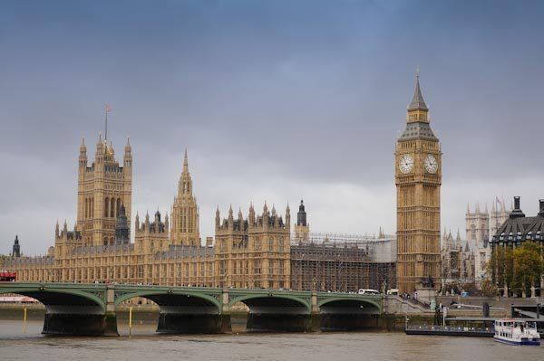
The palace of Westminster, usually called the House of Parliament, is situated alongside the River Thames in Westminster, London. Britain’s Members of Parliament meet here.
The building was designed by architect Charles Barry and built in the 1840s, replacing an earlier building destroyed in fire. The complex of buildings covers 8 acres and has over 1.000 rooms.
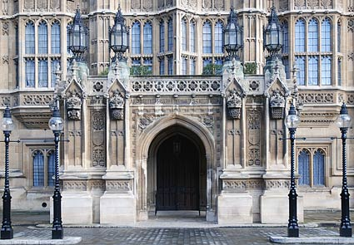
Big Ben is the name of the huge bell in the Elizabeth Clock Tower. The clock’s mechanism is regulated by adding pennies for weight, and the 4 clock faces are each 23 feet across.
No animals are allowed into the Palace of Westminster, other than seeing eye dogs. However, the huge building is said to be overrun with mice.
The Hall of Westminster is the oldest surviving part of the original building and has the largest medieval roof in England. At one time, Britain’s king and queens lived here.
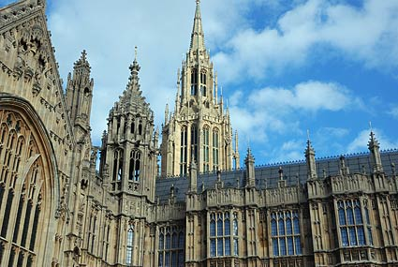
The building contains over 100 staircases and 3 miles of corridor. It has its own gymnasium, shooting range and hair salon.
The Palace of Westminster is known for its centuries old traditions. In the lifts are hooks designed for hanging swords on and some floor marking are designed to be 2 sword lengths apart.
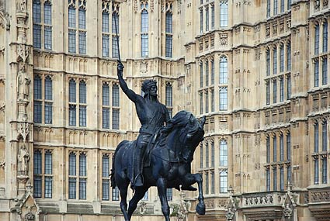
The Royal Gallery is one of the largest rooms. It is used for important dinners, receptions and ceremonies. In the past, it was used for trials.
The Lord’s Chamber where the House of Lords meets is the palace’s most lavishly decorated room. However, the Lord Speaker sits on a large sack of wool, representing Britain’s wool trade.
The Commons Chamber, where members of Parliament meet, is decorated in green, according to an old tradition. It also contains furnishings from Commonwealth countries including Canada and Australia.
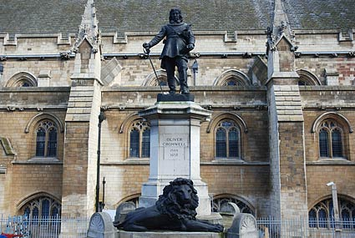

The Houses of Parliament
Choose the correct headline to each paragraph. One is odd.
- The funny tradition.
- Important things.
- The Queen’s speech.
- The British Government.
- Two lines.
- The famous Woolsack.
- The oldest part of the Palace of Westminster.
- The Palace of Westminster consists of three parts: the Royal Apartments where the colour is gold, the House of Lords where the seats are red and the House of Commons where the seats are green. The Chamber of the House of Lords is also called the Parliament Chamber, because every year when the Queen comes to open Parliament, all three parts of Parliament come together here for the Queen's Speech. In fact, it's not really the Queen's Speech, because she doesn't write it. The Government writes it for her. In the speech the Queen tells Parliament about the Government's plans for the next year.
- Oh, and that cushion is, actually, the famous Woolsack. And yes, there is wool inside it. It's a part of a very old tradition which started in the 14th century. It was put in Parliament to symbolise the importance of wool to the British economy at that time. The person who usually sits on the Woolsack is the Lord Chancellor. He presides over the House of Lords.
- The House of Commons is where MPs make decisions on new laws. There are two statues, one on each side of the arch. Both of these two men were Prime Ministers. One is David Lloyd George, and the other - Sir Winston Churchill. They represent the two main British political parties - the Labour Party and the Conservative Party. They have a tradition: if you're a Conservative, touch Churchill's shoe, and if you're Labour, touch Lloyd George's shoe.
- These are two long narrow corridors which are very important for the whole country because MPs come here to vote on bills for new laws. On the left there is the "aye", or yes, lobby. MPs who agree with a bill go there. On the right there is the "no" lobby for MPs who want to vote against the bill. Then the officials count the "ayes" and the "noes" to get the results. So in the British Parliament MPs don't vote by pushing a button; they vote with their feet.
- E. Now look at the floor. Can you see two red lines in front of the benches on each side of the chamber?That's part of a tradition too. The distance between these two lines is two swords' lengths. In the old days when MPs used to carry swords, it was dangerous if they got angry with each other. So these two lines are here to remind MPs that they shouldn't start a fight, and they can't go over this line when they are speaking in a debate.
- Westminster Hall is the oldest part of the Palace of Westminster, and it's more than a thousand years old. The son of William the Conqueror... Do you remember the Norman leader who won the Battle of Hastings? Well, it was his son who started the building of the hall. This building has seen a lot of famous events. In 1605 Guy Fawkes tried to blow up the Houses of Parliament, and in World War II bombs fell on it.

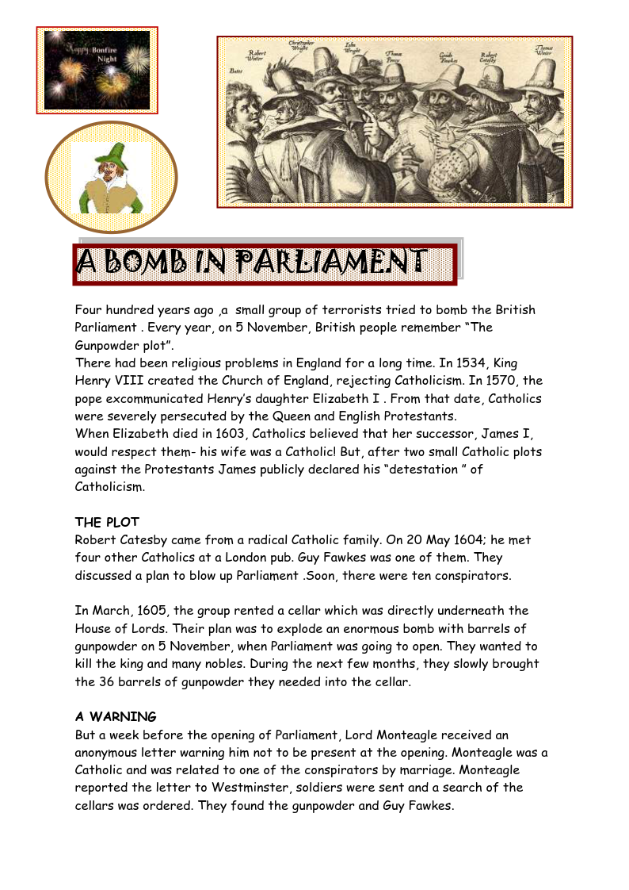
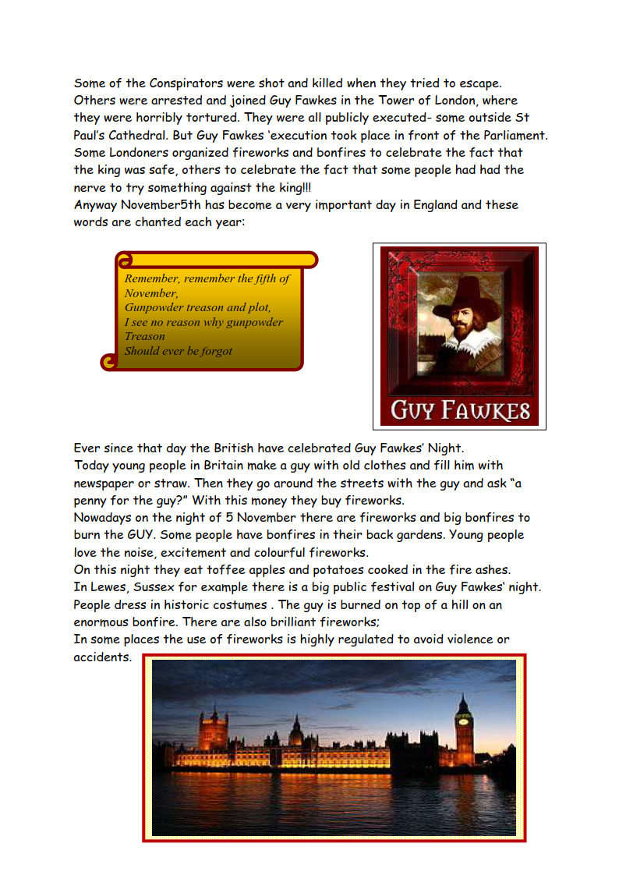

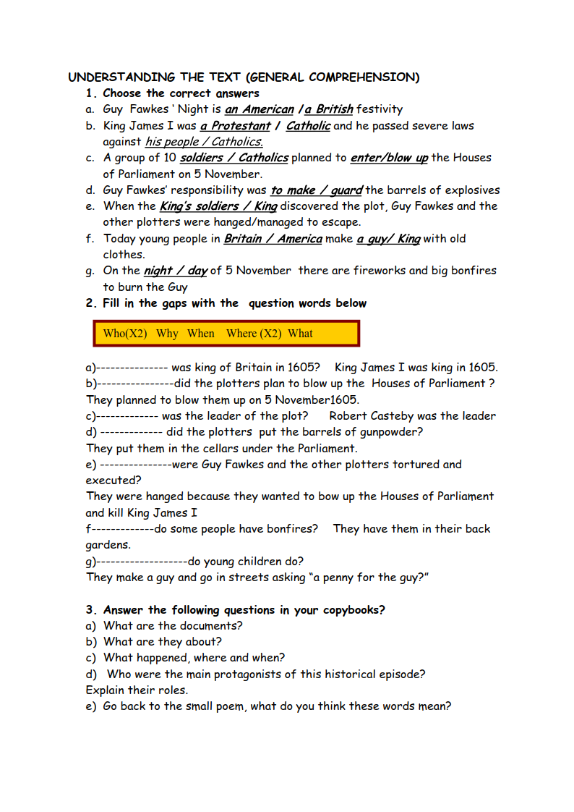

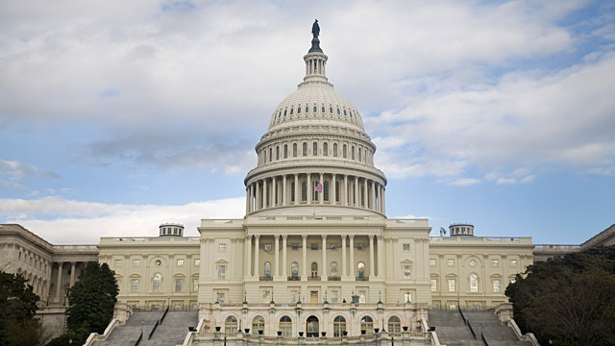
The Capitol

Often mistaken to be the White House by first-time visitors to Washington, the United States Capitol, or simply Capitol, is home of the United States Congress and its two legislative bodies, the US House of Representatives and the US Senate. Standing tall atop the Capitol Hill at the eastern end of the National Mall, this architecturally impressive and magnificent building is situated in Washington DC, United States. Ever since the construction of the Capitol began in 1793, it has been built, burnt, rebuilt, extended and restored several times only to present spectators with the most important federal building in America in today’s times.

Interesting & Fun Facts About The United States Capitol
- This Washington State’s Legislative Building serves as a working governmental center as well as a symbol of Washington’s free and democratic government.
- Rising at a height of 287 feet, this legislative building is the fourth tallest masonry dome in the world. As many as 173 million pounds of stone, brick, concrete and steel have been used in the construction of the building.
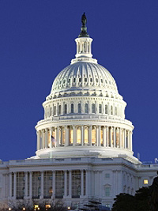
- The Capitol building has been divided into two wings: the north wing is the Senate chamber, while the south wing is the House of Representatives chamber.
- The structure of this symbolically significant building was an outcome of a design competition held by Thomas Jefferson in 1792, which was won by amateur architect, William Thornton. Initially, French architect Stephen Hallet’s design was selected, but it was later rejected on the context of being too fancy and costly. However, Hallet was appointed as the superintendent of construction.
- The design went under several modifications, the first being by Hallet due to the various problems. Later modifications came from Benjamin Henry Latrobe and Charles Bulfinch.
- While the Senate wing was complete by 1800, the House wing could only be completed in 1811.
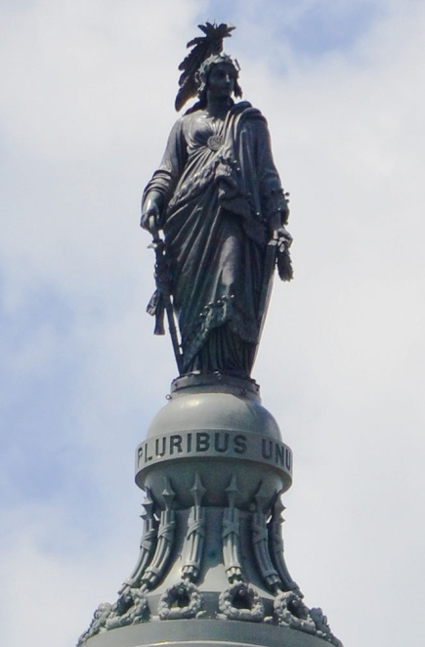
- The building went under expansion during the 1850s. The East Front of the Capitol building was designed by architects Carrère and Hastings, who designed the Senate and House office buildings as well.
- The National Statuary Hall Collection housed in the building showcases two statues of notable personalities donated by each of the 50 US states.
- Amongst all, the most remarkable statue is a bronze statue of King Kamehameha that was donated by Hawaii.

- The statue that rests on top of the dome is known as ‘Miss Freedom’ that weighs 2,000 pounds and is 15 feet tall.
- The Capitol rests in an area of 274 acres surrounded by lawns, walkways, streets, drives and planting areas.
- The National Park Service declared the Capitol as a National Historic Landmark on December 19, 1960. The building ranks in the sixth position in American Institute of Architects’ list of ‘America’s Favorite Architecture’.
- The newest addition to the Capitol is the Capitol Visitor Center that was built in 2008. Spread across 580,000 square feet, this underground 3-level screens all the visitors through a magnetometer, before they enter the building.

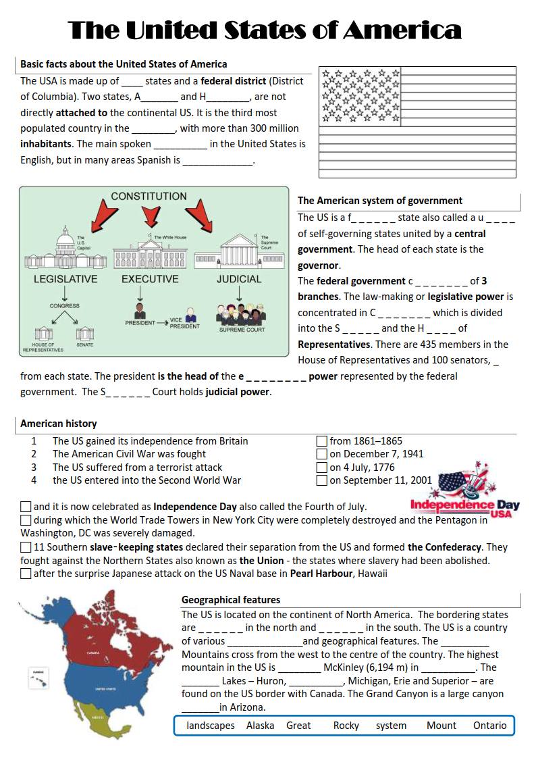
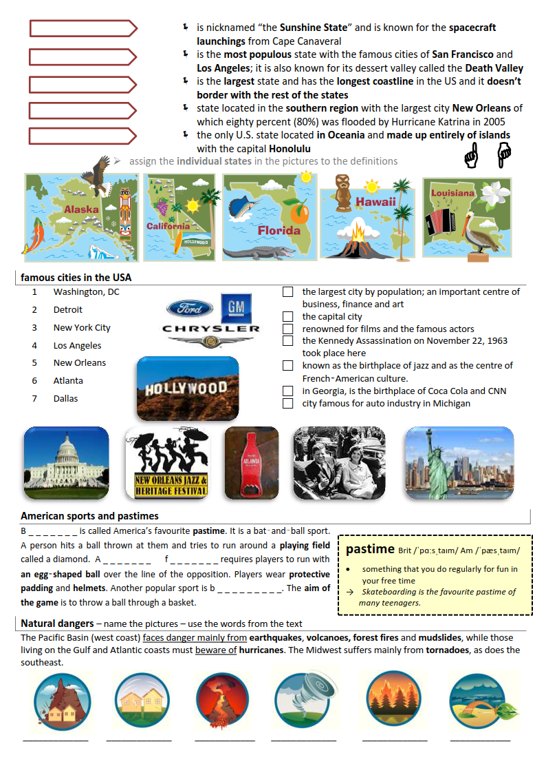

Basic facts about the United States of America
50
Alaska
Hawaii
world
language
spoken

The American system of government
federal
union
consists
Congress
Senate
House
2
executive
Supreme

American history
on the right hand-side – 2,4,1,3
below 1,3,2,4

Geographical features
! Canada (not given in the list of words)
! Mexico (not given in the list of words)
landscapes
Rocky
Mount
Alaska
Great
Ontario
system

Individual states
Florida
California
Alaska
Louisiana
Hawaii

Famous cities in the USA
3,1,4,7,5,6,2

American sports and pastimes
Baseball
American football
basketball

Natural dangers
mudslide
earthquake
volcano (volcanic eruption)
tornado
forest fire
hurricane

Siz istagan darslik asosidagi mavzu bo’yicha namunaviy dars ishlanmaga buyurtma berishingiz mumkin. Biz bilan bog’lanish +998911800985 telegram raqami, @uzteachers_admin ga xabar yuboring.
Narxi 20 ming so’m (1-9-sinflar uchun)
To’lov payme yoki click orqali
Bog’lanish faqat telegram orqali. Telefon qilinganda yoki sms yozilganda javob bermasligim ehtimoli yuqori

