______________ VILOYATI _________ TUMANI XALQ TA’LIMI BO’LIMIGA QARASHLI
___-SONLI O’RTA TA”LIM MAKTABI
INGLIZ TILI FANI O’QITUVCHISI
_______________________________NING
8-sinflar uchun Unit 6. Lesson 2
Music of Uzbekistan
mavzusida 1 soatlik

Dars ishlanmasi
_______________-2019

Date_____ Form_____ Subject: English
Theme: Music of Uzbekistan
Aims:
Educational: - to talk about music and musicians in Uzbekistan
Developing: - to practise reading and listening for main ideas
- to practise translating (homework)
Socio-cultural: - to raise awareness of different cultures
Up bringing: - to enrich pupils’ knowledge of our tradition and nation
Learning outcomes: At the end of the lesson pupils will be able to talk about music and musicians in Uzbekistan; talk about their favourite musicians and music
Competence: SC1, FLCC, and PC
Type of the lesson: Mixed, group work, pair-work, individual work
Method of the lesson: nontraditional, mixed
Equipment of the lesson: Textbook “Fly High 8”, pictures, internet, computers, projector

TECHNOLOGICAL MAP OF THE LESSON:

№ | Part of the lesson | Tasks | Time
1 | Organizational  Moment | -to greet pupils.  - to check up the register | 5 min
2 | Repeating last lesson | - to give pupils some questions about last lesson. – to ask words from previous lesson | 5 min
3 | Explaining new theme | - to explain to pupils new vocabulary and theme | 20 min
4 | Consolidating new theme. | - to consolidate new theme and new words of the theme. | 10 min
5 | Marking. | - To mark pupils | 5 min
6 | Homework. | - Giving homework.

Procedure of the lesson:
I. Organizing moment: Motivation, Greeting, checking attendance, season, weather, checking the preparation for the lesson.
II. Asking homework:
- Check for homework given on past lesson.
- Ask pupils all new words learnt on previous lesson.

III. Pre-activity:
Warm up
Hang the pictures on the wall and ask your pupils did they recognize them
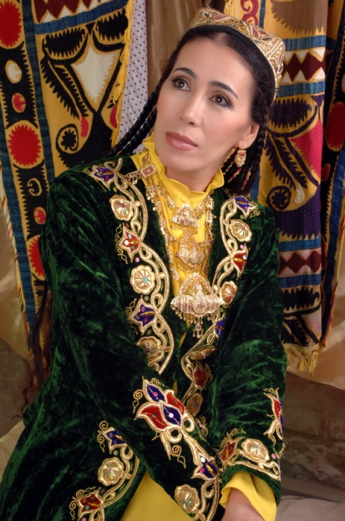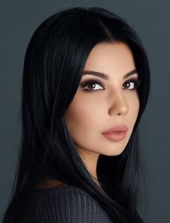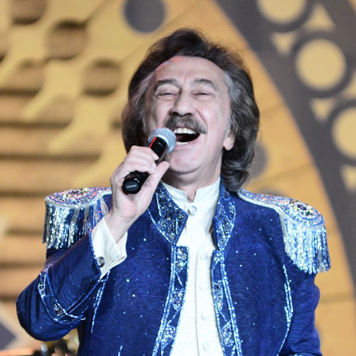

IV. Main part
Activity 1 Listen to the song
Objective: to listen for pleasure
PP listen to the song and say wh o sings the song.

CD script
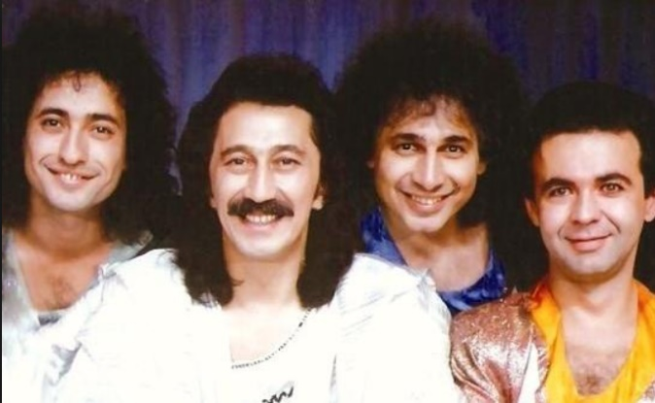
Горячее солнце. Горячий песок
Горячие губы - воды бы глоток
В горячей пустыне не видно следа
Скажи, караванщик: Когда же вода?
Учкудук три колодца
Защити, защити нас от солнца
Ты в пустыне - спасательный круг
Учкудук
Вдруг дерево жизни - таинственный страж
А может быть, это лишь только мираж
А может быть, это усталости бред
И нет Учкудука, спасения нет
Учкудук три колодца
Защити, защити нас от солнца
Ты в пустыне - спасательный круг
Учкудук
Любой в Учкудуке расскажет старик
Как город-красавец в пустыне возник
Как в синее небо взметнулись дома
И как удивилась природа сама
Учкудук три колодца
Защити, защити нас от солнца
Ты в пустыне - спасательный круг
Учкудук

Activity 2a Find the words in the Wordlist and translate.
Objectives: to prepare for the next activity: to practise using the Wordlist
When PP have found out the meaning of the words, say the words and ask PP to repeat after you.

soloist ensemble composer conservatoire film
score inheritance roots flute

Activity 2b Listen to the radio programme about Great Musicians of Uzbekistan and say: who it is about, where he came from and what he is famous for.
Objective: to listen for main ideas
PP listen and answer the question. You could check that PP realise that the music at the beginning and end of the programme is by Burxonov.

CD script
(a couple of bars of a the National Anthem of Uzbekistan) ...Welcome to our programme Great Musicians of Uzbekistan. Today we are going to hear about Mutal (Mutavakkil) Burxonov, one of the great musicians of Uzbekistan. He was born in 1916 in Bukhara. In 1949 he graduated from the Moscow Conservatoire. He composed many, many pieces of music in a number of different styles, including the National Anthem of
the Republic of Uzbekistan and the opera ‘Alisher Navoi’. His other compositions include the film score for many films and many songs. His works form a large part of the musical inheritance of modern Uzbekistan, (a few bars of a film score by Burxonov)

Key:
It is about Mutal Burxonov. He came from Bukhara and he is famous for composing the National Anthem of Uzbekistan, the opera ;Alisher Navoi’, music for films and many songs.

Activity 3a Read the text and give it a title.
Objectives: to read for main ideas; to inform PP of the existence of music festivals in Uzbekistan; to encourage them to participate in the festivals
PP read the text silently. When they finish, ask them for their suggestions for a title. Ask them to explain why they suggest the title. Accept all reasonable answers.

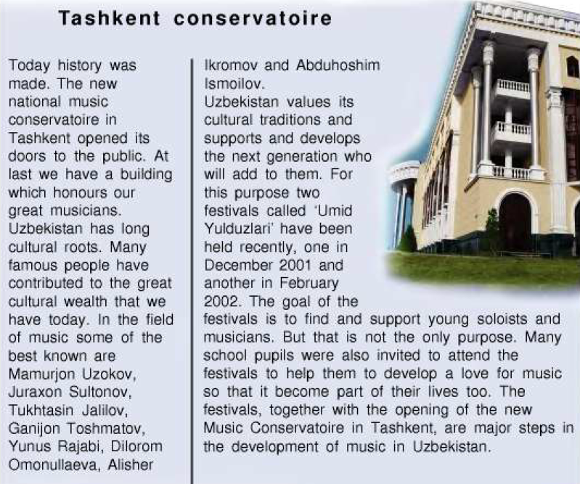

Activity 3b Work in pairs. Answer the questions.
Objectives: to practise expressing opinions and giving reasons; to encourage PP to consider the purpose of such festivals and how it might be helpful for their development
Give PP a minute to think about their answers. You could let PP discuss in pairs first before answering.

1 Have you ever been to 'Umid Yulduzlari ?
2 Would you like to go to 'Umid Yulduzlari’9 Why/why not?
3 Would you like to take part or to listen? How do you think you would feel?

V. Post-activity
Play the board game
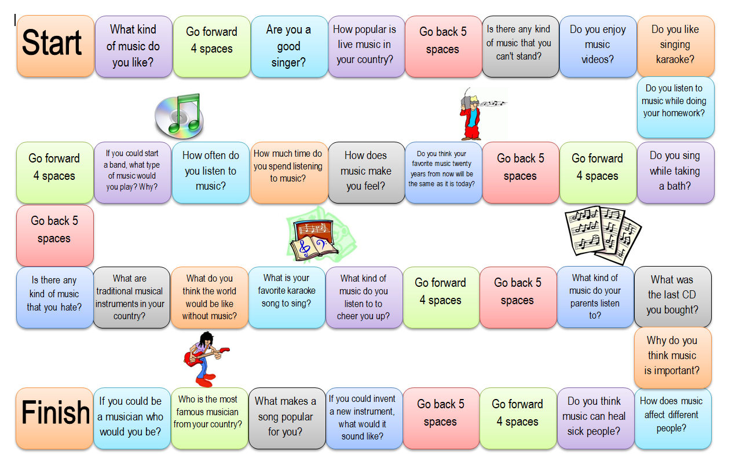

VI. Homework 5 min
Read the new words and their meaning. Translate the words in bold.
A band is a group of people who play modern music together. There are jazz bands, rock bands. The word ‘group’ is also used e.g. a folk group, a pop group.
A concert is music which is played for a lot of people, a performance given by musicians or singers.
To rehearse' means to practise something such as a play or concert before giving a
public performance.

VII. Evaluation. Giving marks

Deputy director on educational affairs: ____________________ Signature _________

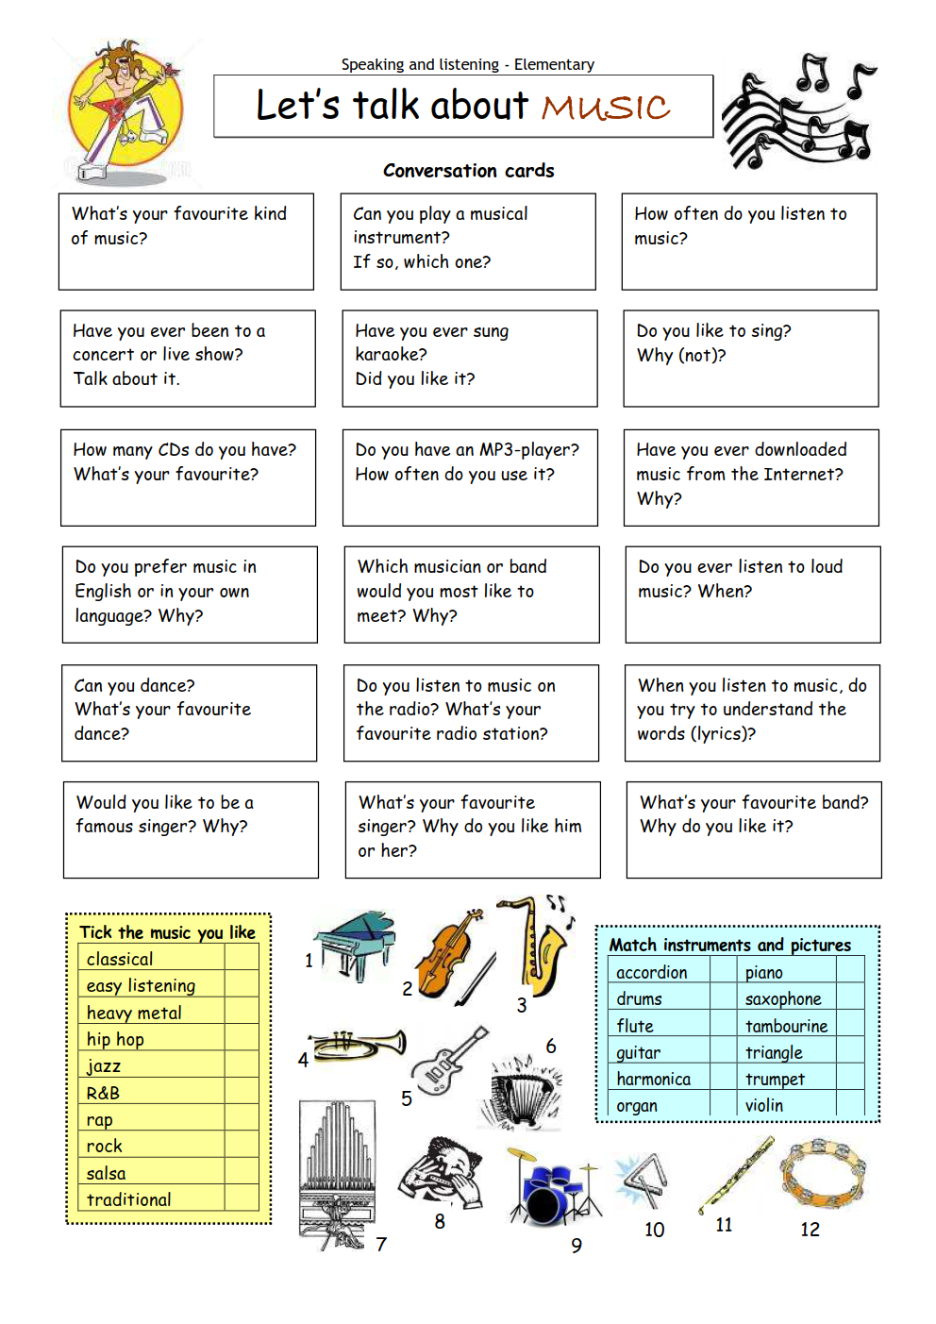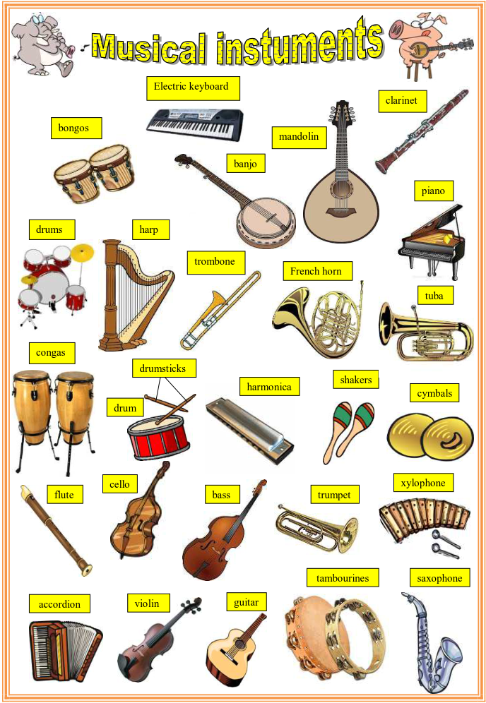
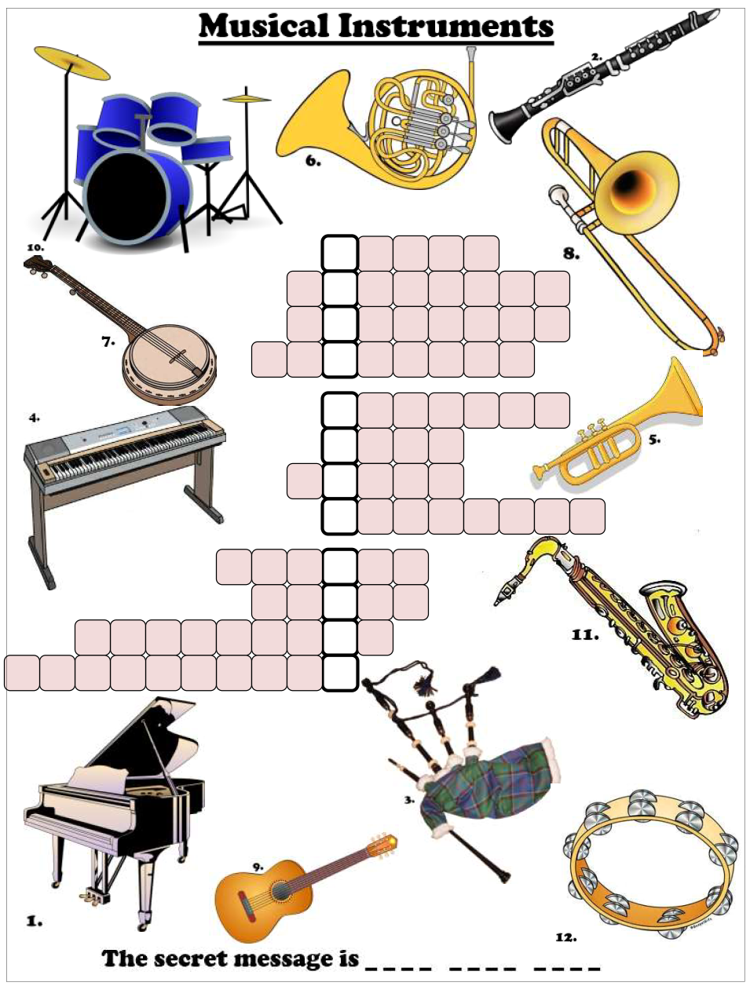

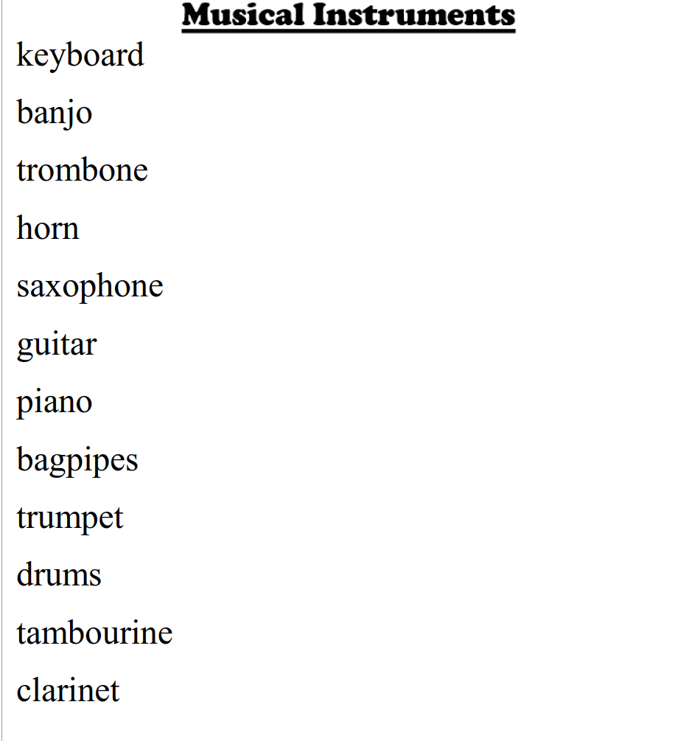

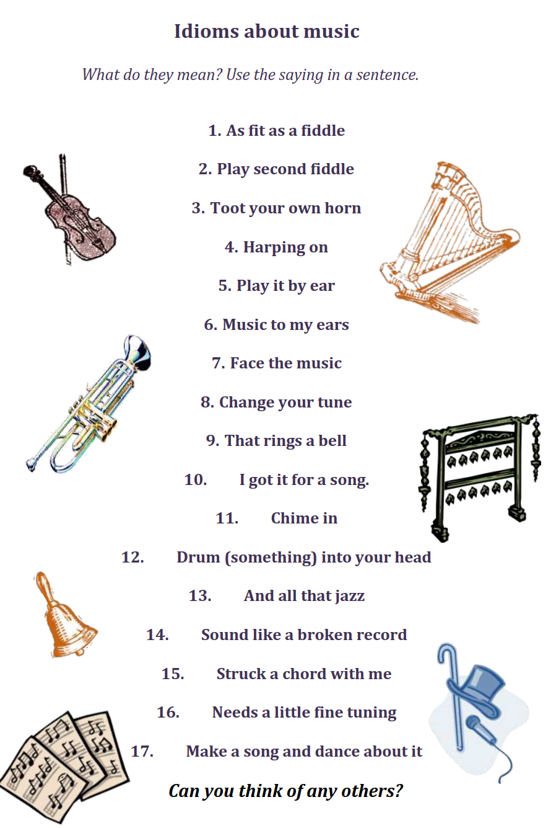

Siz istagan darslik asosidagi mavzu bo’yicha namunaviy dars ishlanmaga buyurtma berishingiz mumkin. Biz bilan bog’lanish +998911800985 telegram raqami, @uzteachers_admin ga xabar yuboring.
Narxi 20 ming so’m (1-9-sinflar uchun)
To’lov payme yoki click orqali
Bog’lanish faqat telegram orqali. Telefon qilinganda yoki sms yozilganda javob bermasligim ehtimoli yuqori

