______________ VILOYATI _________ TUMANI MAKTABGACHA VA MAKTAB TA’LIMI BO’LIMIGA QARASHLI
___-SONLI O’RTA TA’LIM MAKTABI
INGLIZ TILI FANI O’QITUVCHISI
_______________________________NING
7-sinflar uchun Unit 0. Lesson 4
What can people do?
mavzusida 1 soatlik
Dars ishlanmasi
_______________-2023

Date_____ Form_____ Subject: English
Theme: What can people do?
Aims:
Educational: - to learn common and unusual sports and games
Developing: - to learn adverbs of frequency
Learning outcomes: At the end of the lesson pupils will be able to talk about adverbs of frequency
Competence: SC1, FLCC, and PC
Type of the lesson: Mixed, group work, pair-work, individual work
Method of the lesson: nontraditional, mixed
Equipment of the lesson: “Prepare 7” SB, WB, pictures, internet, computers, projector

TECHNOLOGICAL MAP OF THE LESSON:

№ | Part of the lesson | Tasks | Time
1 | Organizational  Moment | -to greet pupils.  - to check up the register | 5 min
2 | Repeating last lesson | - to give pupils some questions about last lesson. – to ask words from previous lesson | 5 min
3 | Explaining new theme | - to explain to pupils new vocabulary and theme | 20 min
4 | Consolidating new theme. | - to consolidate new theme and new words of the theme. | 10 min
5 | Marking. | - To mark pupils | 5 min
6 | Homework. | - Giving homework.

Procedure of the lesson:
I. Organizing moment: Motivation, Greeting, checking attendance, season, weather, checking the preparation for the lesson.
- Check for homework given on past lesson.
- Ask pupils all new words learnt on previous lesson.

II. Pre-activity:

Activity 1 Match the photos A–H to the words in the box.
Encourage the students to look at the photos first and try to say what the people are doing in each one before they read the words and match them to the photos.
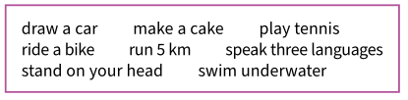
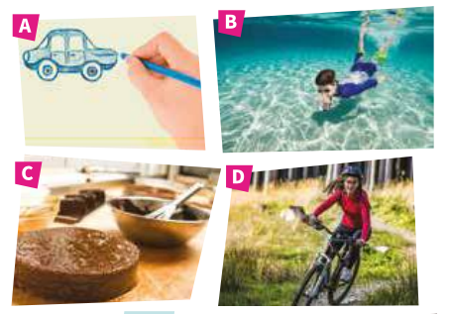
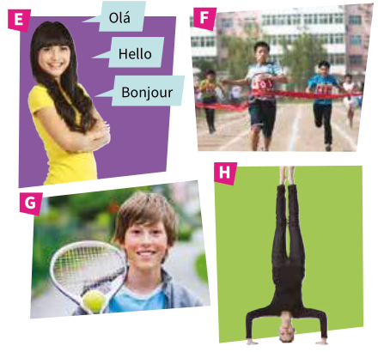
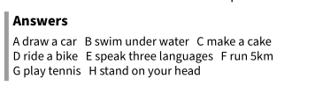
III. Main part

Activity 2. In pairs, ask and answer about the activities in Exercise 1.
Encourage the students to make a question with each of the words in Exercise 1 first. With a weaker class, you might want to do this together on the board. Allow them
time to ask and answer the questions in pairs. Then, if appropriate, ask them to stand up and ask at least four other students the questions. If not, they can do this in groups of six. Point out that they should take notes as they will need to report back to the class. They might find this easier if they complete a chart in their notebooks like the one below.
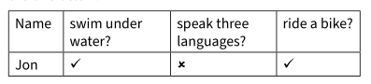
When they have finished, ask ‘How many students can swim under water?’ and encourage them to answer with either a number or with names, e.g. Five students can
swim under water / Ana and David can swim under water.

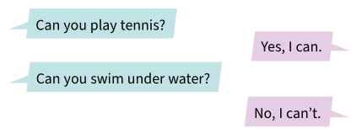
Now ask around the class. How many people
can …
• swim under water?
• speak three languages?
• ride a bike?
• play tennis?
• draw a car?

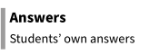
Activity 3 Read about the students and answer the questions. Use complete sentences.
Ask the students to read what the people say about themselves and answer the questions. Point out that they should use complete sentences. In Unit 1, the students will look at the present simple with adverbs of frequency.
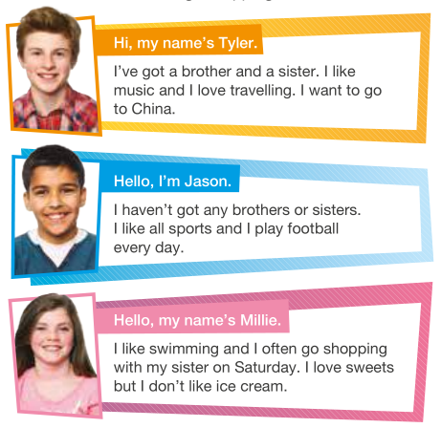
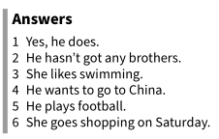

1 Does Tyler like music?
2 How many brothers has Jason got?
3 What sport does Millie like?
4 Where does Tyler want to go?
5 What does Jason do every day?
6 When does Millie go shopping?

Activity 4. Work with a partner. Ask and answer the questions.
Write the question prompts on the board and encourage the class to make complete questions. Demonstrate by getting volunteers to ask you the questions and give full
answers. For example:
Student: What kind of music do you like? Teacher: I like pop and rock. I don’t like classical music. Then, the students take turns to ask and answer the
questions. Point out that they will need to take notes so
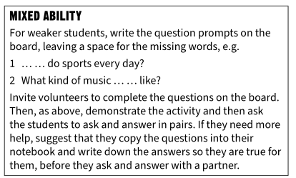
that they can tell the class about their partner.
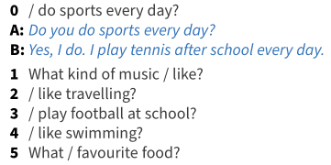

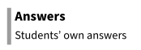

Activity 1. Write questions to find out about your partner’s …
Brainstorm the questions as a class first. Then, invite two stronger students to demonstrate the activity orally, giving complete answers. The students then write the questions individually before asking and answering in pairs. Point out that they need to listen to their partner carefully as they will need to write some sentences about them. Remind them that when they do this, they need to use the third person he or she.
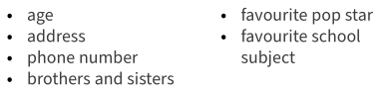
In pairs, ask and answer the questions. Then write sentences about your partner.
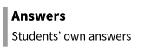

IV. Post-activity

Workbook activity 1 Match the verbs to the words and phrases.
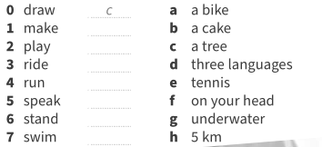

V. Homework
Workbook activity 2 Write questions with the phrases in Exercise 1.
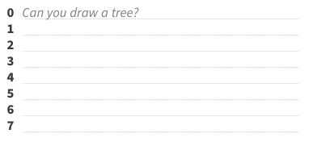
Workbook activity 3. Answer the questions in Exercise 2 for you.
Workbook activity 4 Complete the sentences with the phrases in Exercise 1 or use your own ideas.
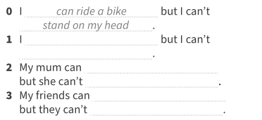

Workbook activity 5 Complete the text with the present simple form of
the verbs in brackets.
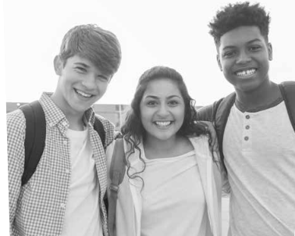
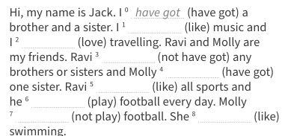

Workbook activity 6. Put the words in the correct order to make questions.
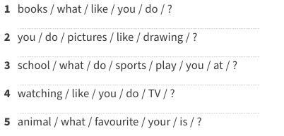
Workbook activity 7. Answer the questions in Exercise 6 for you.
Workbook activity 8. Complete the sentences for you.

Workbook activity 1 Match the questions to the answers.
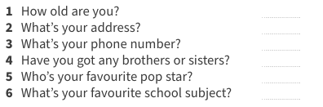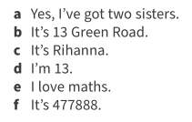
Workbook activity 2.
Write about your best friend. Use the questions in Exercise 1 to help you and write about 50 words.

VI. Evaluation

Deputy director on educational affairs: _________ Signature: _________

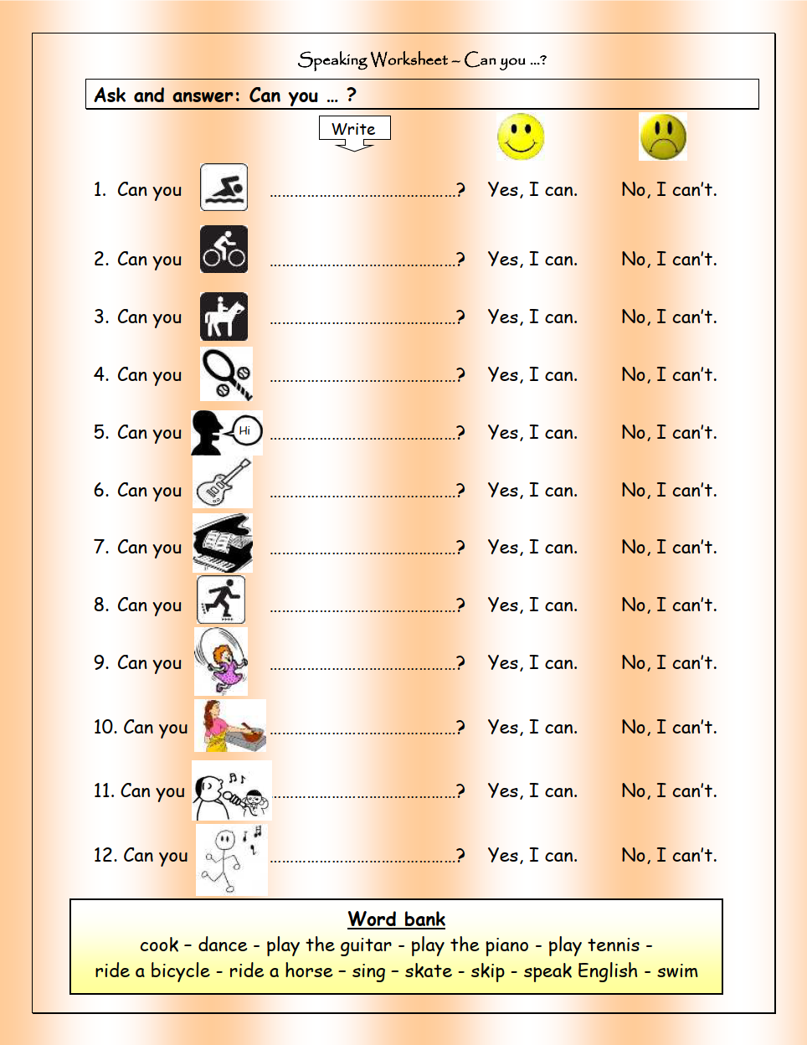

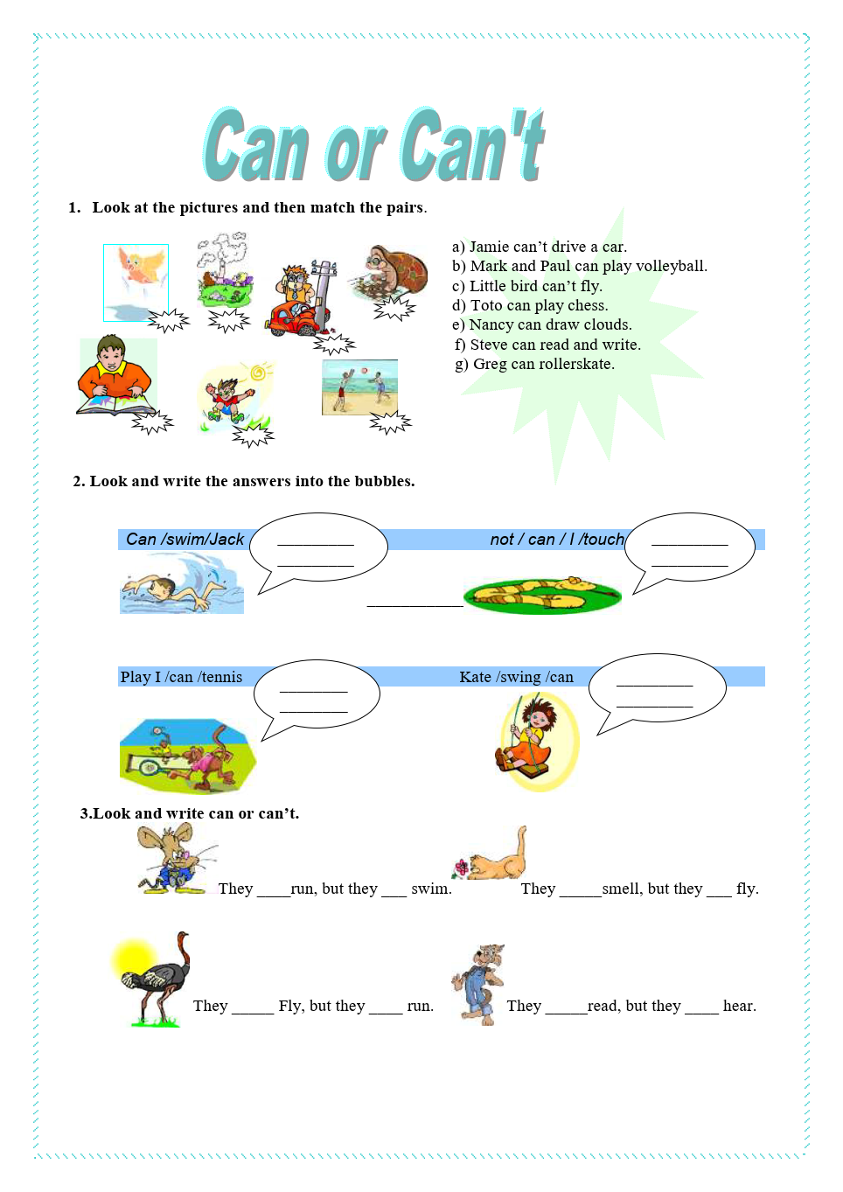

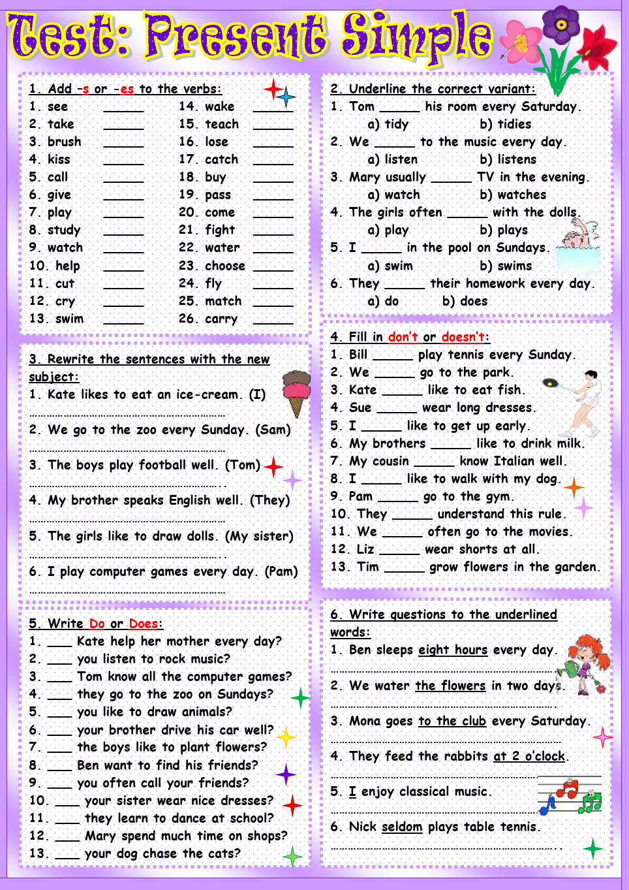
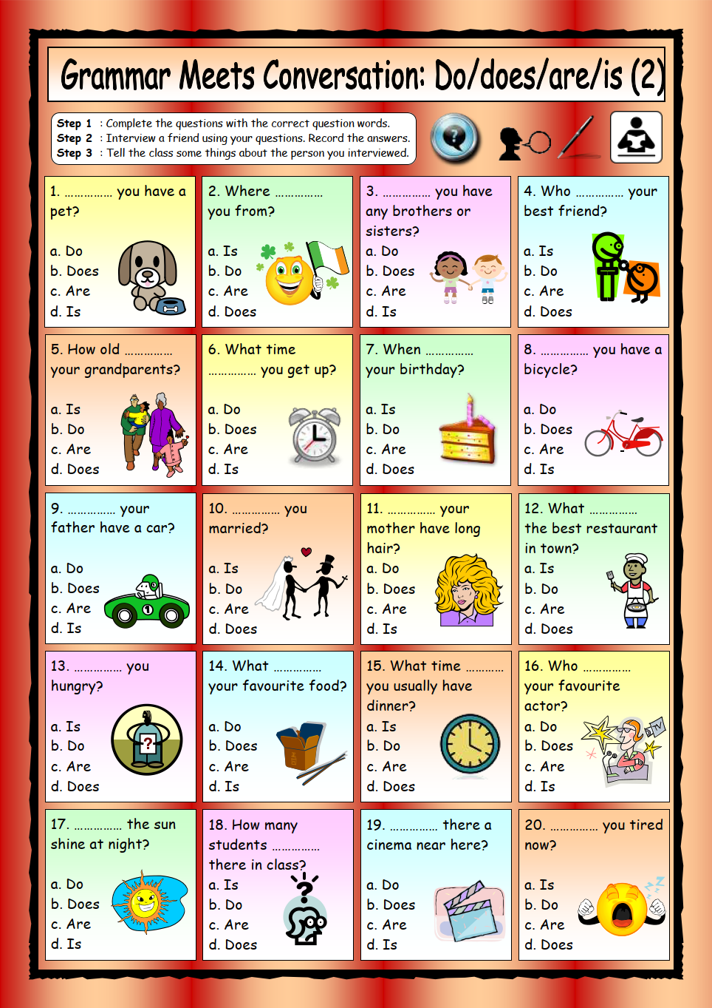
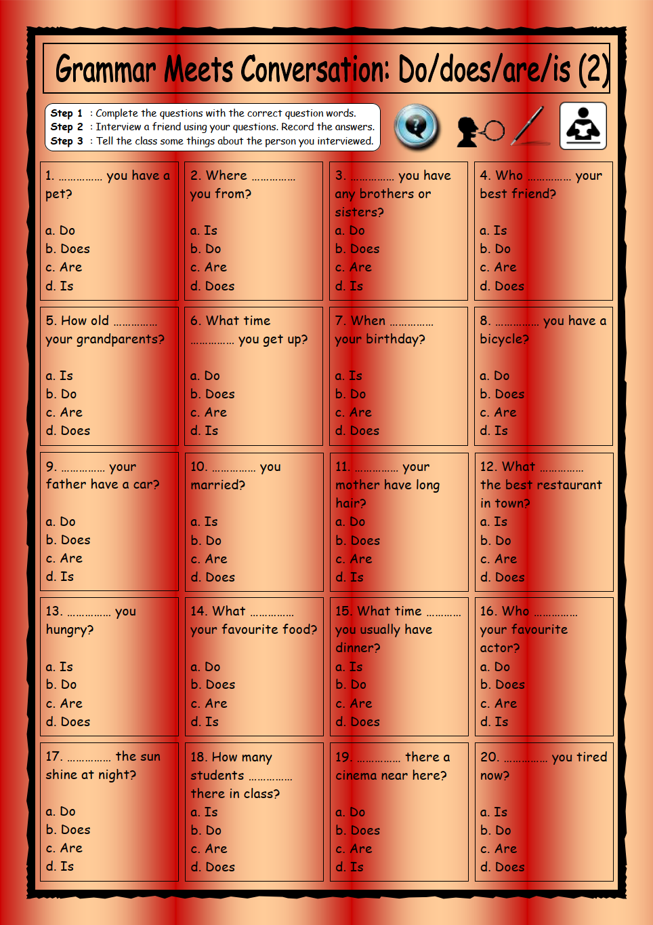
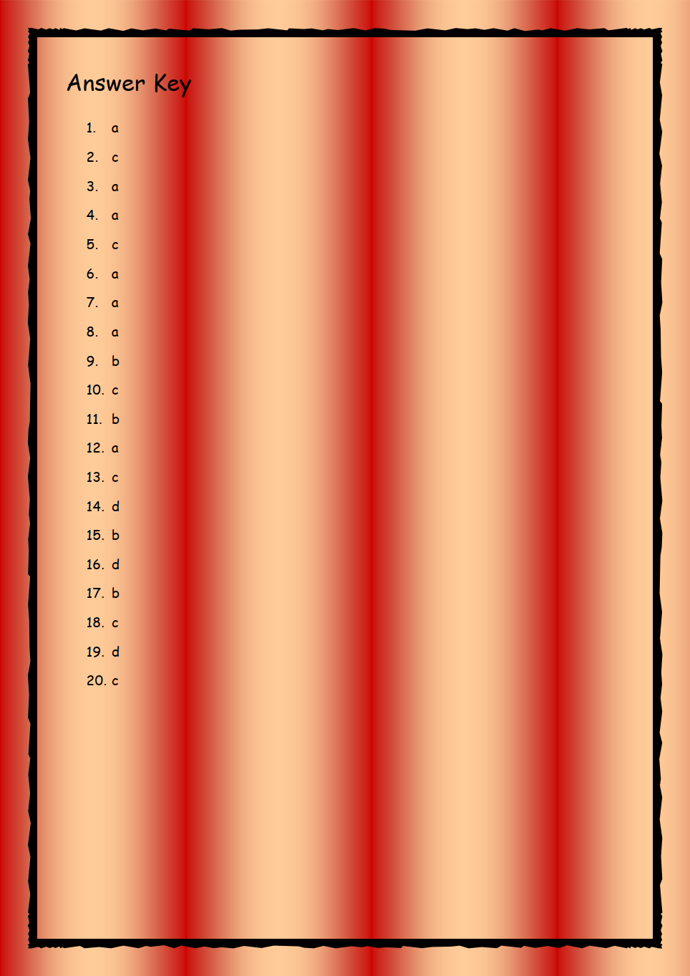

Huddi shunday namunada Guess What va Prepare darsliklaridan istalgan mavzu bo’yicha namunaviy dars ishlanmalar olishingiz mumkin. Biz bilan bog’lanish uchun Telegramdan @uzteachers_admin manzili yoki +998911800985 telegram raqami ga xabar yuboring. Narxi 1ta mavzu
20 ming so’m
To’lov payme yoki click orqali
BOG’LANISH FAQAT TELEGRAM ORQALI. Telefon qilinganda yoki sms yozilganda javob berilmaydi!

