______________ VILOYATI _________ TUMANI XALQ TA’LIMI BO’LIMIGA QARASHLI
___-SONLI O’RTA TA’LIM MAKTABI
INGLIZ TILI FANI O’QITUVCHISI
_______________________________NING
7-sinflar uchun Unit 5. Lesson 3
School uniform
mavzusida 1 soatlik
Dars ishlanmasi
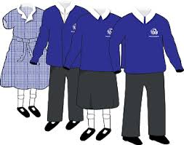

_______________-2018
Date_____ Form_____ Subject: English
Theme: School uniform
Aims:
Educational: - to introduce and practise tag questions for confirmation
Developing: - to listen for specific and detailed information
Socio-cultural: - to talk about uniforms
Up bringing: - to teach the pupils to respect for other people

Learning outcomes: At the end of the lesson pupils will be able to :
- to know tag questions, present simple
- to translate tag questions and answers
- to make up tag question and answer them
Competence: SC1, FLCC, and PC
Type of the lesson: Mixed, group work, pair-work, individual work
Method of the lesson: nontraditional, mixed
Equipment of the lesson: Textbook “ Fly High 7”, pictures, internet, computers, projector

TECHNOLOGICAL MAP OF THE LESSON:

№ | Part of the lesson | Tasks | Time
1 | Organizational  Moment | -to greet pupils.  - to check up the register | 5 min
2 | Repeating last lesson | - to give pupils some questions about last lesson. – to ask words from previous lesson | 5 min
3 | Explaining new theme | - to explain to pupils new vocabulary and theme | 20 min
4 | Consolidating new theme. | - to consolidate new theme and new words of the theme. | 10 min
5 | Marking. | - To mark pupils | 5 min
6 | Homework. | - Giving homework.

Procedure of the lesson:
I. Organizing moment: Motivation, Greeting, checking attendance, season, weather, checking the preparation for the lesson.
II. Asking homework:
- Check for homework given on past lesson.
- Ask pupils all new words learnt on previous lesson.

III. Pre-activity:
Warming up
Ask learners if they have a uniform at their school. If yes, what does it look like? If no, would they like to have a uniform? What are the advantages and disadvantages of having a uniform?
Draw an example uniform on the board, maybe based on a school uniform described by one of the learners, or show a picture. What clothes does a school uniform have? Label the picture, for example skirt, shorts, trousers, shirt, tie, jumper, blazer, hat, socks, shoes, emblem.
Now learners should invent their own school uniform for their ideal school. Encourage them to be creative and brainstorm some ideas. After they have designed and drawn their uniform, they can write about the picture to describe it. Display the uniforms around the room – which ones would learners like to wear to school?
Activity 1 Look and say whose uniform it is and who wears uniform in Uzbekistan.
Objectives: to practise talking about uniforms in Uzbekistan.
PP look at the pictures and talk about them using the example. e.g. It’s a nurse’s uniform. Nurses wear uniform in Uzbekistan

IV. Main part
Activity 2a Listen and answer the questions.
1 Which countries are the pupils from?
2 Do they wear uniform?
Objectives: to practise listening for specific information
PP listen to the tape and find which countries the PP are from and if they wear school uniform.

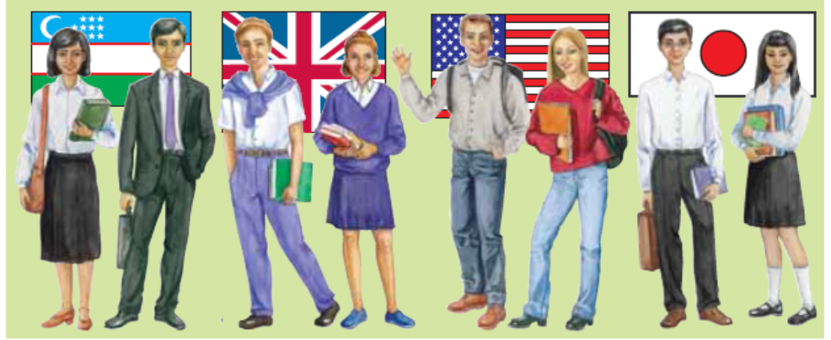
Tapescript
Today’s programme is about uniforms around the world. Let’s speak first to Victoria who is from the UK
Host: Hello, Victoria.
Victoria: Hello.
Host: You wear a uniform in your school, don’t you?
Victoria: Yes, we wear a uniform. I like it because it’s beautiful. Girls wear a white blouse and a dark blue skirt or trousers. Boys wear a white shirt and dark blue trousers.
Host: Thank you. Now it’s Michael’s turn. He lives in the USA. Hello, Michael.
Michael: Hello.
Host: Michael, you don’t wear a uniform in your school, do you?
Michael: No, we don’t. I think it’s OK if we wear what we want. We wear jeans, shorts, trousers, T-shirts and shirts and the girls do too.
Host: Thank you. And what can you tell us about Japanese uniform, Junji. Do you wear a school uniform?
Junji: Yes, we do. All schools have the same uniform. I think that pupils must wear a uniform when they go to school. It’s nice If pupils wear the/same uniform. Boys wear a shirt and trousers. Girls a blouse and a skirt.
Host: What about schools in Uzbekistan, Dilbar?
Dilbar: All schools in Uzbekistan have a school uniform. Boys wear black or dark blue trousers and a white shirt. Girls wear a white blouse, and a brown or black skirt or a light blue dress and an apron.
Activity 2b Copy, listen and complete the table.
Objectives: to practise listening for detail;
to practise note-taking
PP copy the table into their Ex.Bks. Then they listen to the tape again and complete the table.
Country | Boys | Girls
UK e.g. | White shirt and dark blue trousers
Activity 2c Answer the questions.
Objective: to compare school uniform in Uzbekistan with uniforms in other countries
Let PP work in groups of 3-4 to answer the questions. Then check the answers. Start by asking each group about questionl, then question 2, etc.
1 Do you like to wear a school uniform?
2 Which country’s uniform do you like best?
3 Did your parents wear school uniform?
Activity 3a Look and say why the speaker uses a question.
Objective: to introduce question tags to confirm information
PP look at the sentencess from the dialogue and guess the meaning of the questions. Help them to understand the tag questions. Explain that we use these questions when we are almost sure about something. Draw PP attention to the form of the questions: positive statement + negative tag positive + short answer (=yes) negative statement + positive tag negative + short answer (=yes) and draw their attention to the falling intonation.
A: You wear a uniform in your school, don’t you? Yes, we do.
B: Michael, you don’t wear a uniform in your school, do you? No, we don’t.
Activity 3b Listen and repeat.
Objective: to reinforce the new structure and its intonation pattern
Read aloud the sentences from the dialogue with tag questions or play the tape and PP repeat them after you or the tape. Then write the examples on the BB and mark the intonation as in the Grammar References. Tell PP to copy the tag questions and intonation in their Ex.Books.
Remember:
You wear a school uniform in your school, don’t you? Yes, we do.
You don’t wear a school uniform in your school, do you? No, we don’t.
Activity 3c Ask and answer. Use the verbs in the cloud.
Objective: to give practice in using question tags to confirm information Work with the class in open pairs.

Wear speak like (sport/games) play (a musical instrument/games)
get up/go to bed eat

e.g. A: You get up at seven o’clock, don’t you?
B: Yes, I do./No, I don’t.

V. Post-activity
Activity 3d Write five things you think you know about your partner, but you aren’t sure.
Obiective: to give practice in writing question tags
In their Ex.Bks PP write 5 things they think are true about their partner using verbs from the box.

Activity 3e Swap books and answer your partner’s questions.
Obiective: to give practice in answering questions with question tags
PP work in closed pairs. They swap books and write answers to their partner's questions.
Suggestion: If there is time, when PP have finished they could read (in pairs) some of their questions and answers to the class.

Activity 4 Watch the video about 8 smart school uniforms in the world.
Play the video about 8 smart school uniforms in the world. And ask questions which countries school uniforms they like most and why?
VI. Homework Ex 1,2 P. 45
Copy and complete the sentences with the correct tag questions. Use:
do they, don’t you, don’t they, do they, don’t they, don’t you.

VII. Evaluation. Giving marks

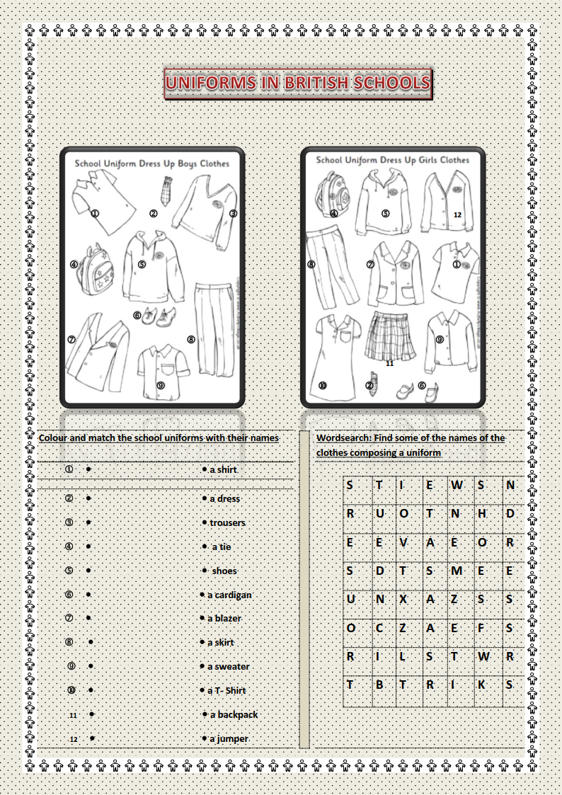
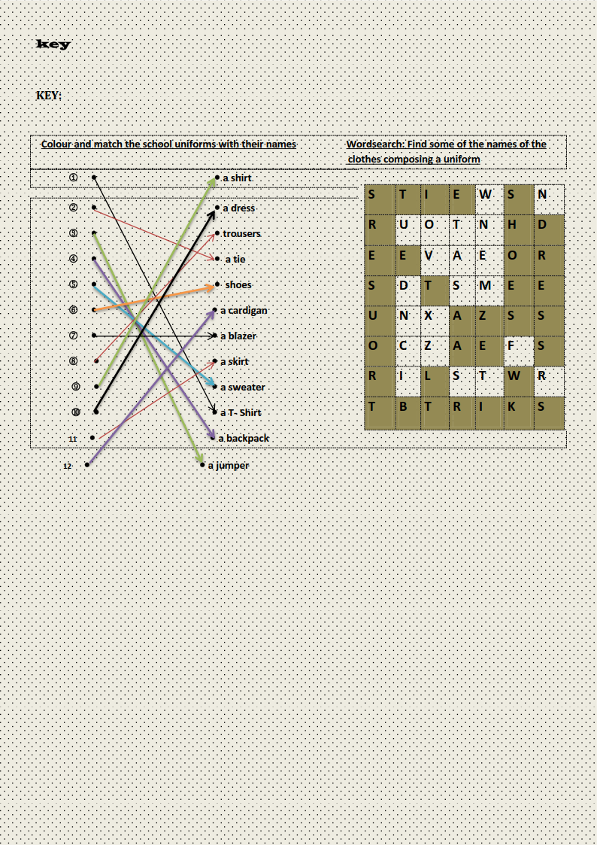
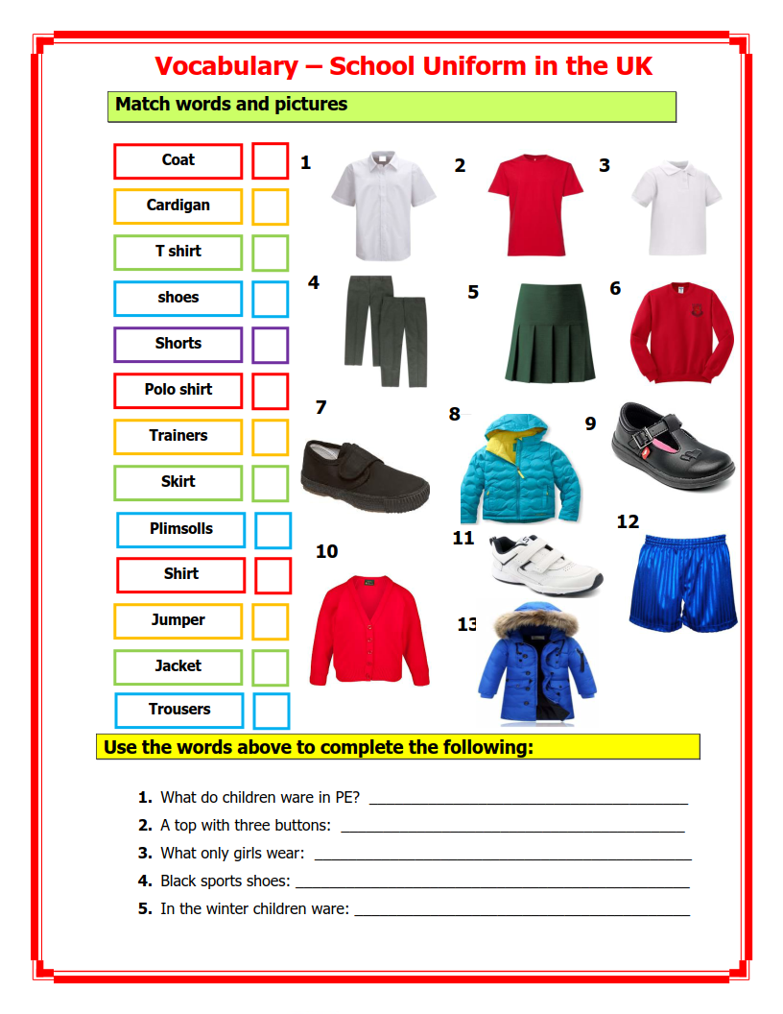
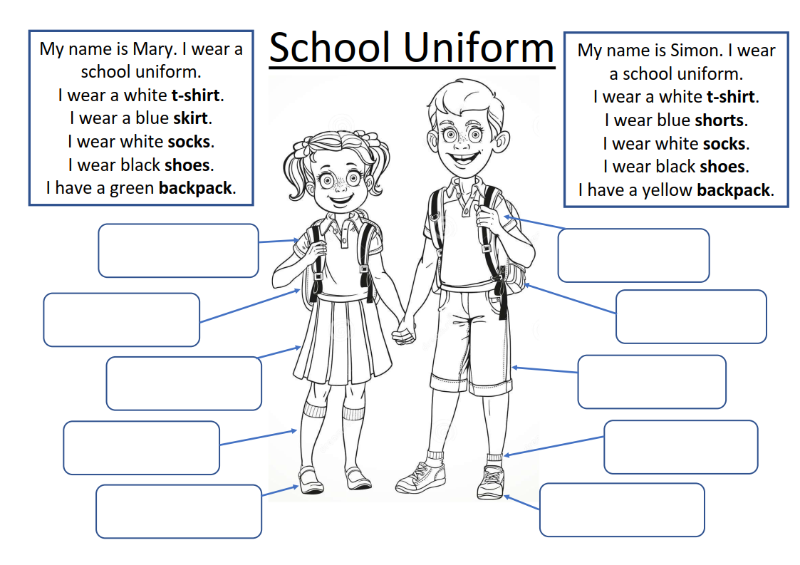

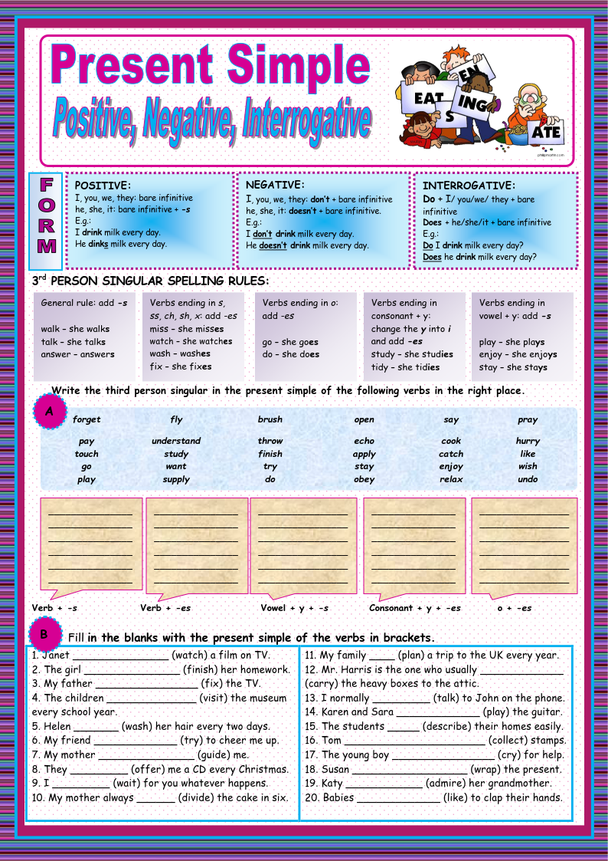
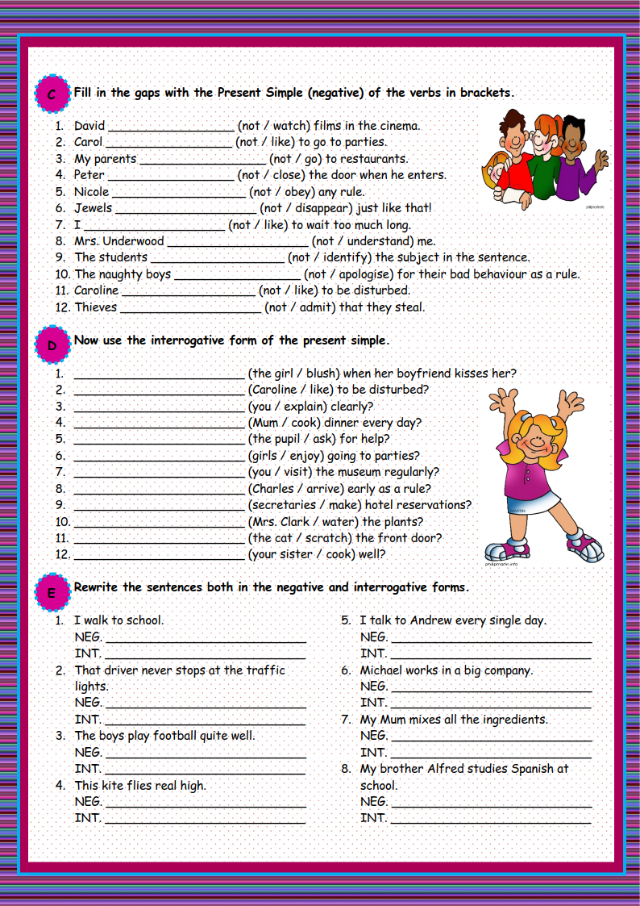
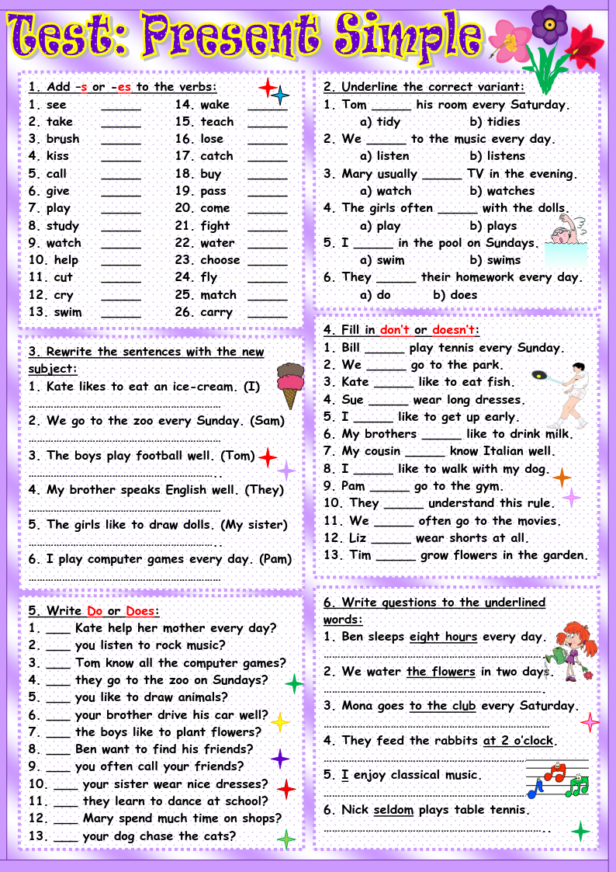
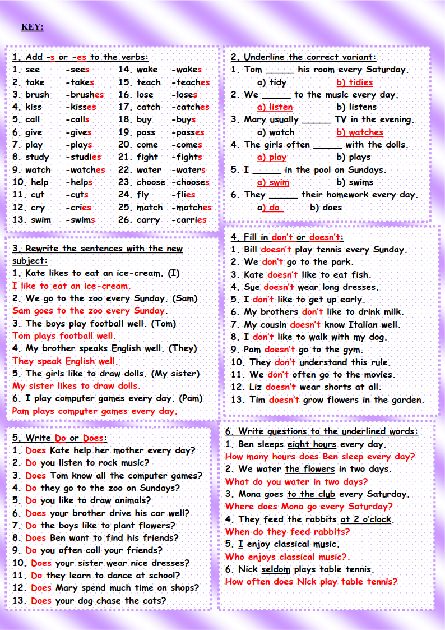
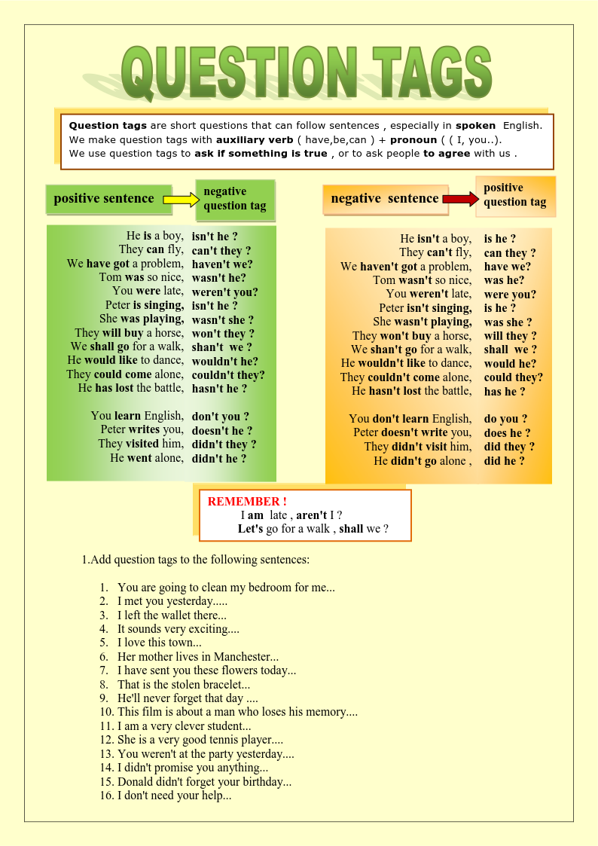
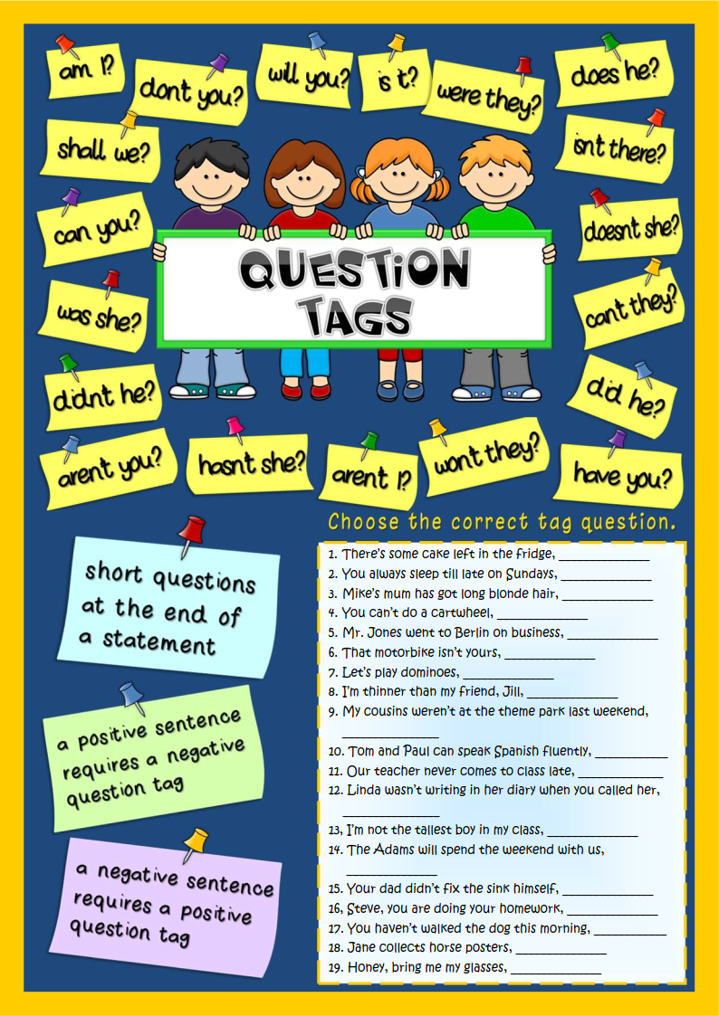
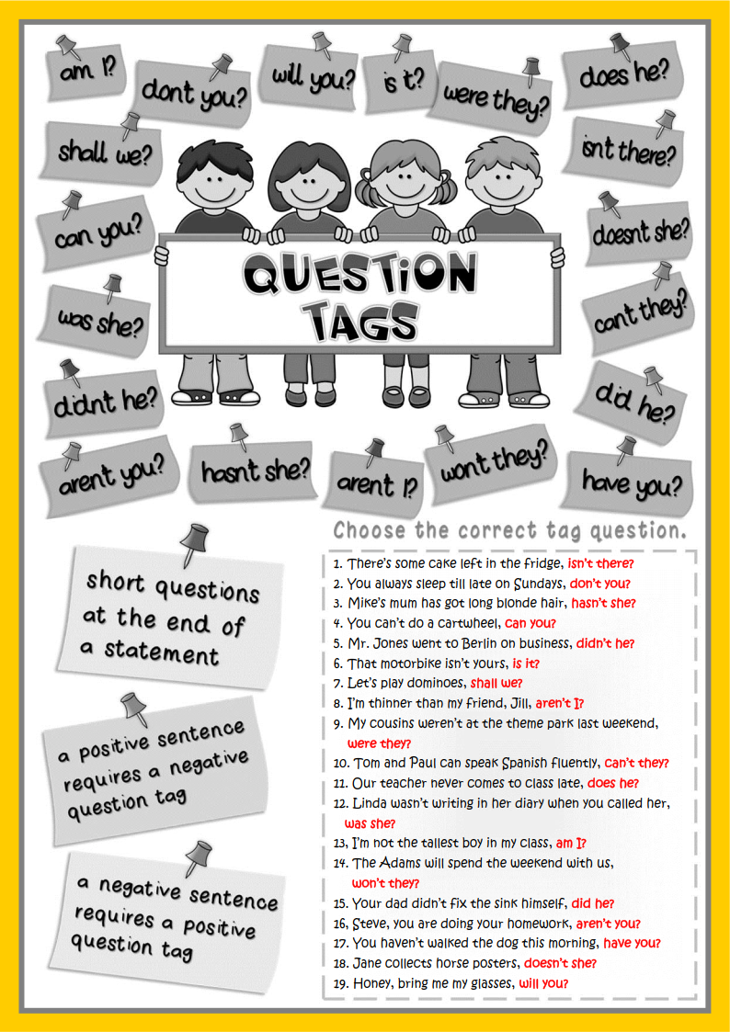
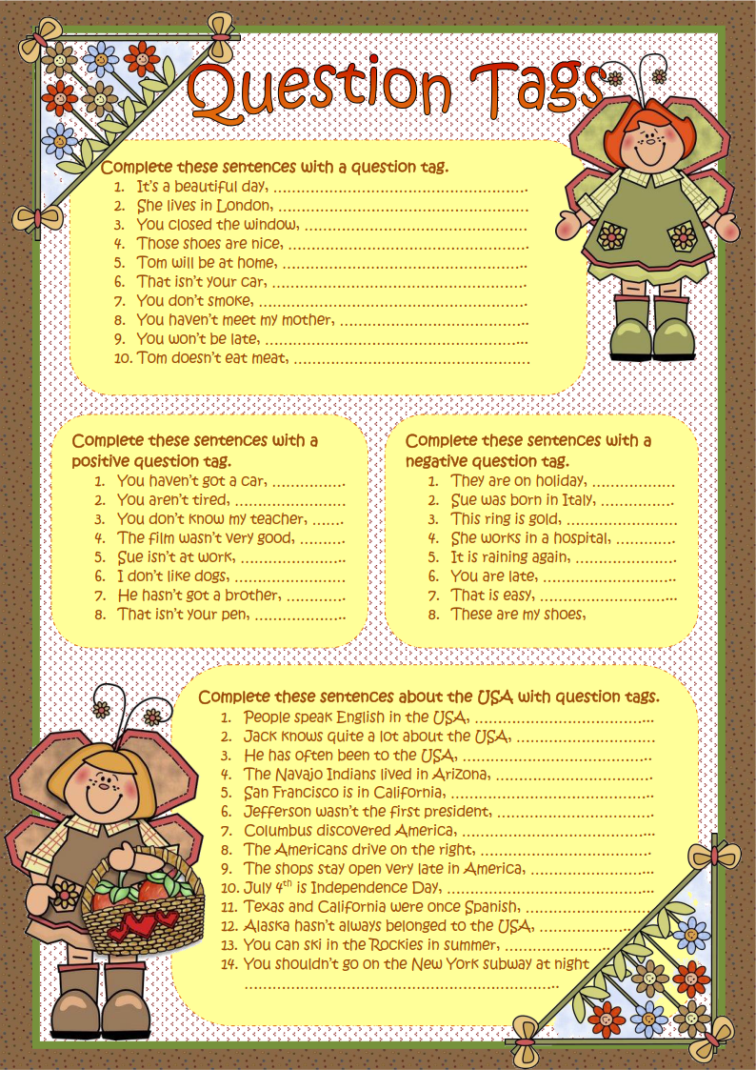

Siz istagan darslik asosidagi mavzu bo’yicha namunaviy dars ishlanmaga buyurtma berishingiz mumkin. Biz bilan bog’lanish +998911800985 telegram raqami, @uzteachers_admin ga xabar yuboring.
Narxi 20 ming so’m (1-9-sinflar uchun)
To’lov payme yoki click orqali
Bog’lanish faqat telegram orqali. Telefon qilinganda yoki sms yozilganda javob bermasligim ehtimoli yuqori

