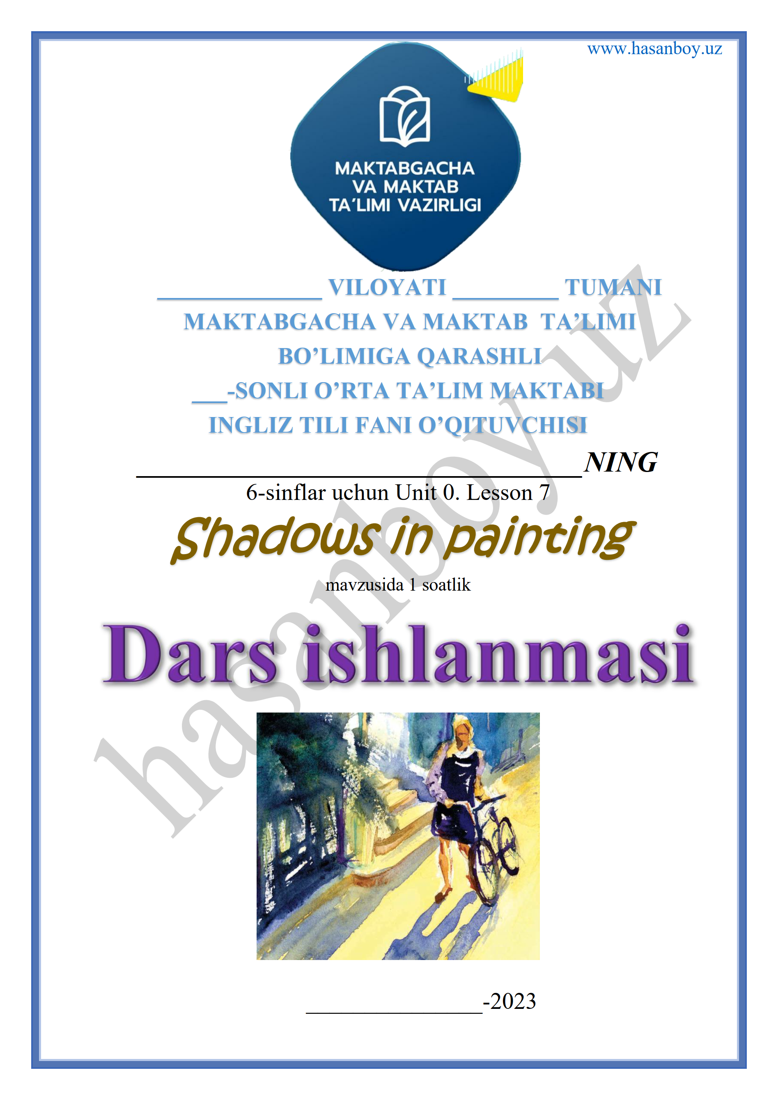

Date_____ Form_____ Subject: English
Theme: Shadows in painting
Aims:
Educational: - students learn how to interpret shadows in paintings.
Developing: - to develop listening, reading, writing, and speaking skills
Socio-cultural: - to raise awareness of different cultures
Up bringing: - to enrich pupils’ knowledge of our tradition and nation
Learning outcomes: At the end of the lesson, pupils will be able to use learnt language in practice, ask and answer questions
Competence: SC1, FLCC, and PC
Type of the lesson: Mixed, group work, pair-work, individual work
Method of the lesson: nontraditional, mixed
Equipment of the lesson: “Guess What 6” SB, WB, pictures, internet, computers, projector

TECHNOLOGICAL MAP OF THE LESSON:

№ | Part of the lesson | Tasks | Time
1 | Organizational  Moment | -to greet pupils.  - to check up the register | 5 min
2 | Repeating last lesson | - to give pupils some questions about last lesson. – to ask words from previous lesson | 5 min
3 | Explaining new theme | - to explain to pupils new vocabulary and theme | 20 min
4 | Consolidating new theme. | - to consolidate new theme and new words of the theme. | 10 min
5 | Marking. | - To mark pupils | 5 min
6 | Homework. | - Giving homework.

Procedure of the lesson:
I. Organizing moment: Motivation, Greeting, checking attendance, season, weather, checking the preparation for the lesson.
- Check for homework given on past lesson.
- Ask pupils all new words learnt on previous lesson.
II. Pre-activity:
• Before the class, position a lamp so that it shines onto the whiteboard/a light-colored wall and practice placing items so that shadows are cast on the wall.
• Make shadows with different objects for students to name.Elicit/present shadow and light. Ask students to guess what will happen if you move the light around. Show them by moving the lamp to the left and right of the item (the shadow moves) and closer/farther away (the shadow gets bigger/smaller).

III. Main part
What do the shadows in a painting tell us?
• Point to the painting and ask What can you see? (A girl/woman in a street with a bike.) Then ask Where are the shadows? What do shadows in a painting tell us? (Students guess.)

Activity 1 Listen and repeat.
• Say Let’s find out more about shadows in paintings. Play the recording, pausing for students to repeat. If necessary, explain the meaning using your lamp.
• Ask questions about the painting on page 12. Say Look at the shadows. Where does the light come from? Does it come from above or from the side? Is it from behind her or in front of her?

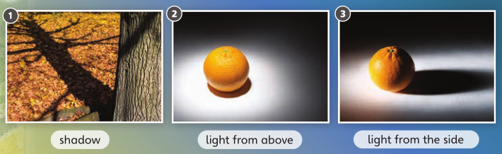

Activity 2 Watch the video.
• Play the video.
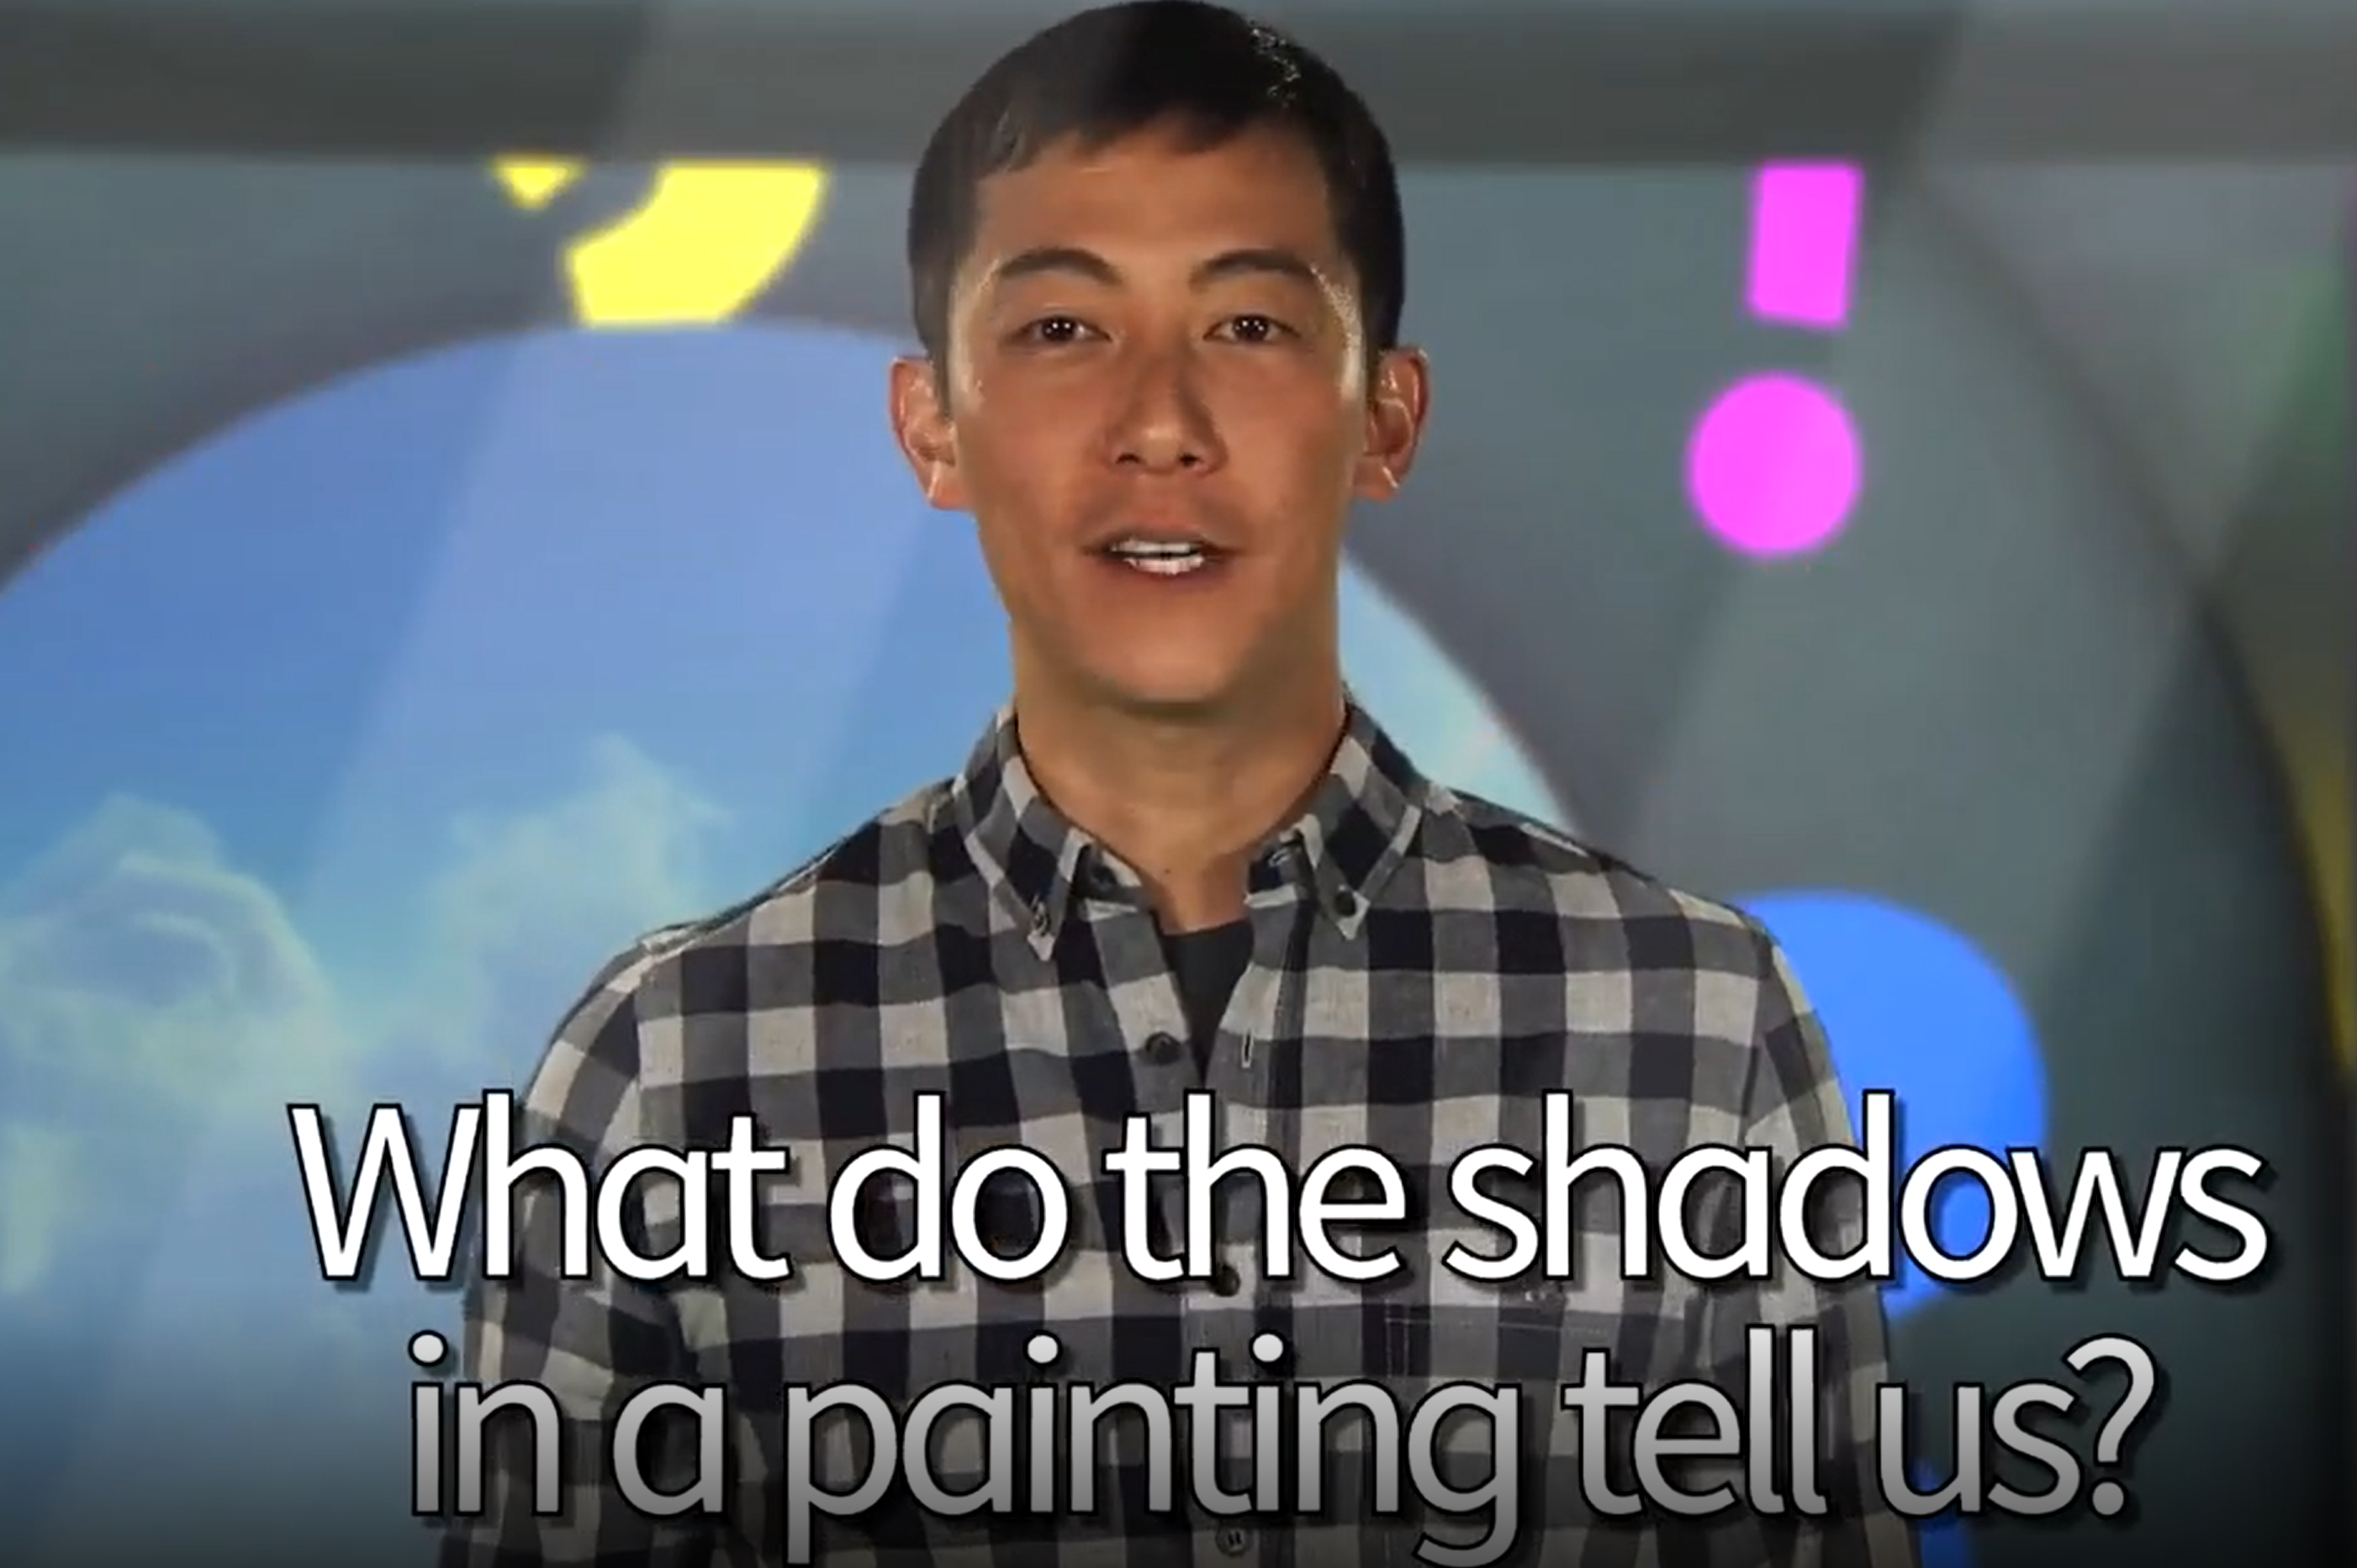
• If you don’t have the video, call a volunteer to the front and ask him/her to put one hand in front of the lamp. Ask the class to guess what will happen if the student moves his/her hand farther away from the light. Will the shadow be bigger or smaller? Let the student try and see what happens (it gets bigger). Repeat with the student moving his/her hand nearer the light source.

Activity 3 Read and listen.
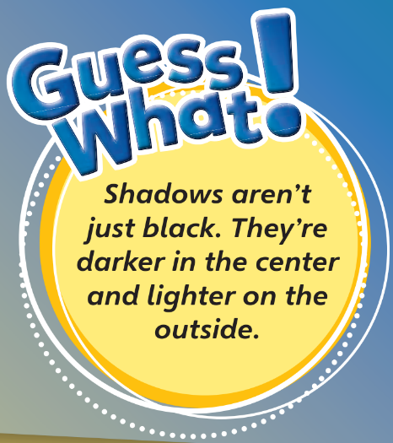
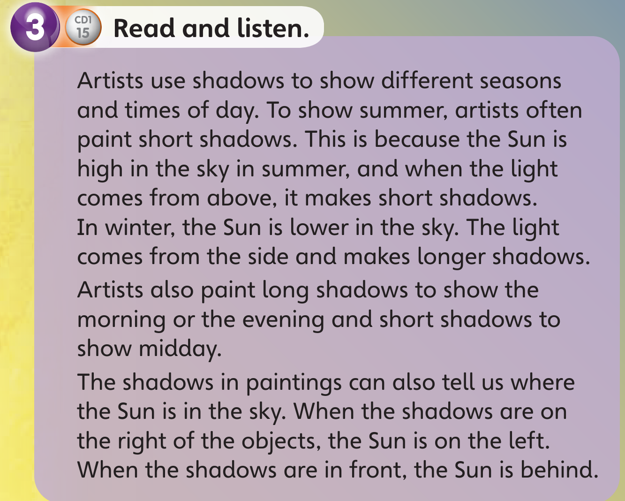
• Play the recording while students read the text. Then play the recording again, pausing to check comprehension.
• Ask some general comprehension questions, e.g., Is the Sun high or low in the sky in the summer? (It’s high.) Where is the Sun if the shadow is on the right? (It’s on the left.)

Activity 4 Answer the questions.
• Students answer the questions and compare in pairs.

1. What’s different about shadows in summer paintings and in winter paintings?
2. Why do we see long shadows in winter paintings?
3. Are shadows shorter in the morning or at midday?
4. Look at the painting on page 12. Where is the Sun?

Key: 1 The shadows in summer paintings are short, in winter paintings they’re long. 2 Because the light comes from the side (the Sun is lower in the sky). 3 They’re shorter at midday. 4 The Sun is behind the woman and the bike.

Activity 5 Which season would you like to paint?
• Students discuss in pairs which season they would like to paint. Encourage them to think about shadows as well as the weather. Find out the most popular season.
• Students can then read the Guess What! for the page. Ask them if they’ve ever noticed this effect with shadows and tell them to watch for it.

IV. Post-activity
Activity 1 Read and match.
• Students read and match the sentence halves.
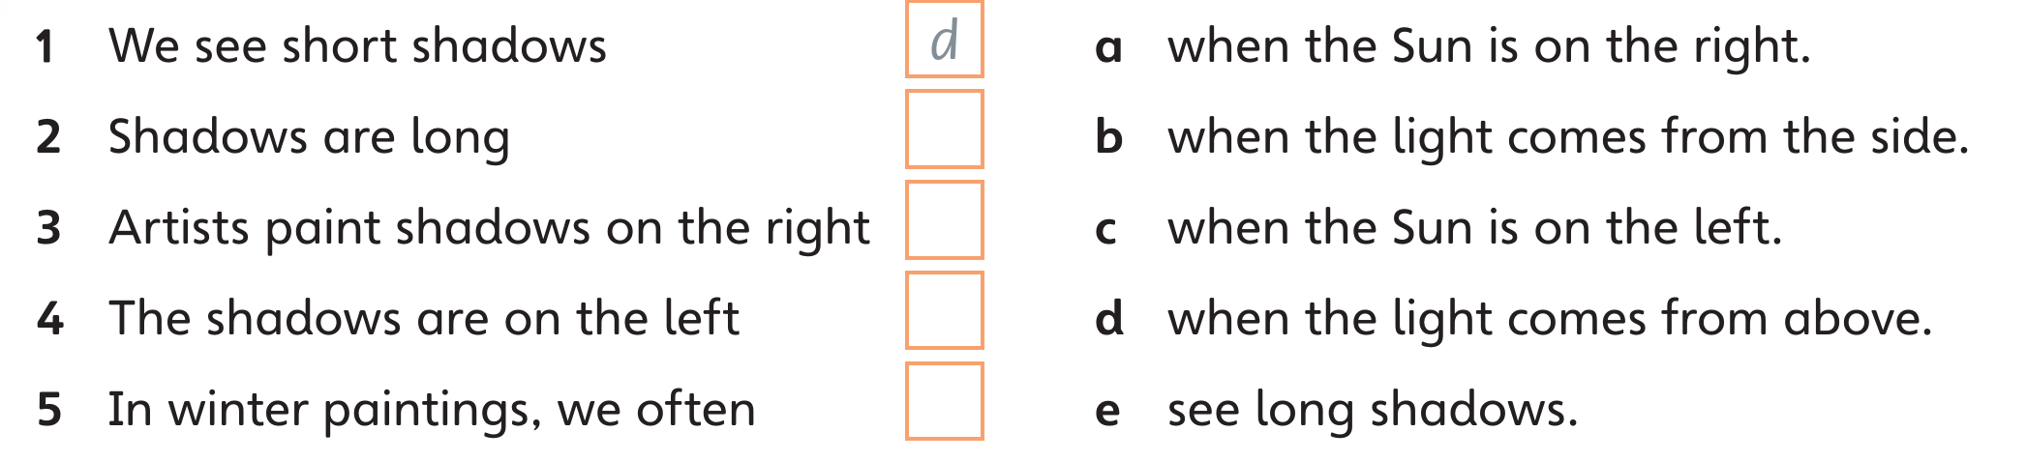

Key: 2 b 3 c 4 a 5 e

Activity 2 Circle the shadow in the two drawings. Then answer the questions.
• Students circle the shadows, then read and answer.
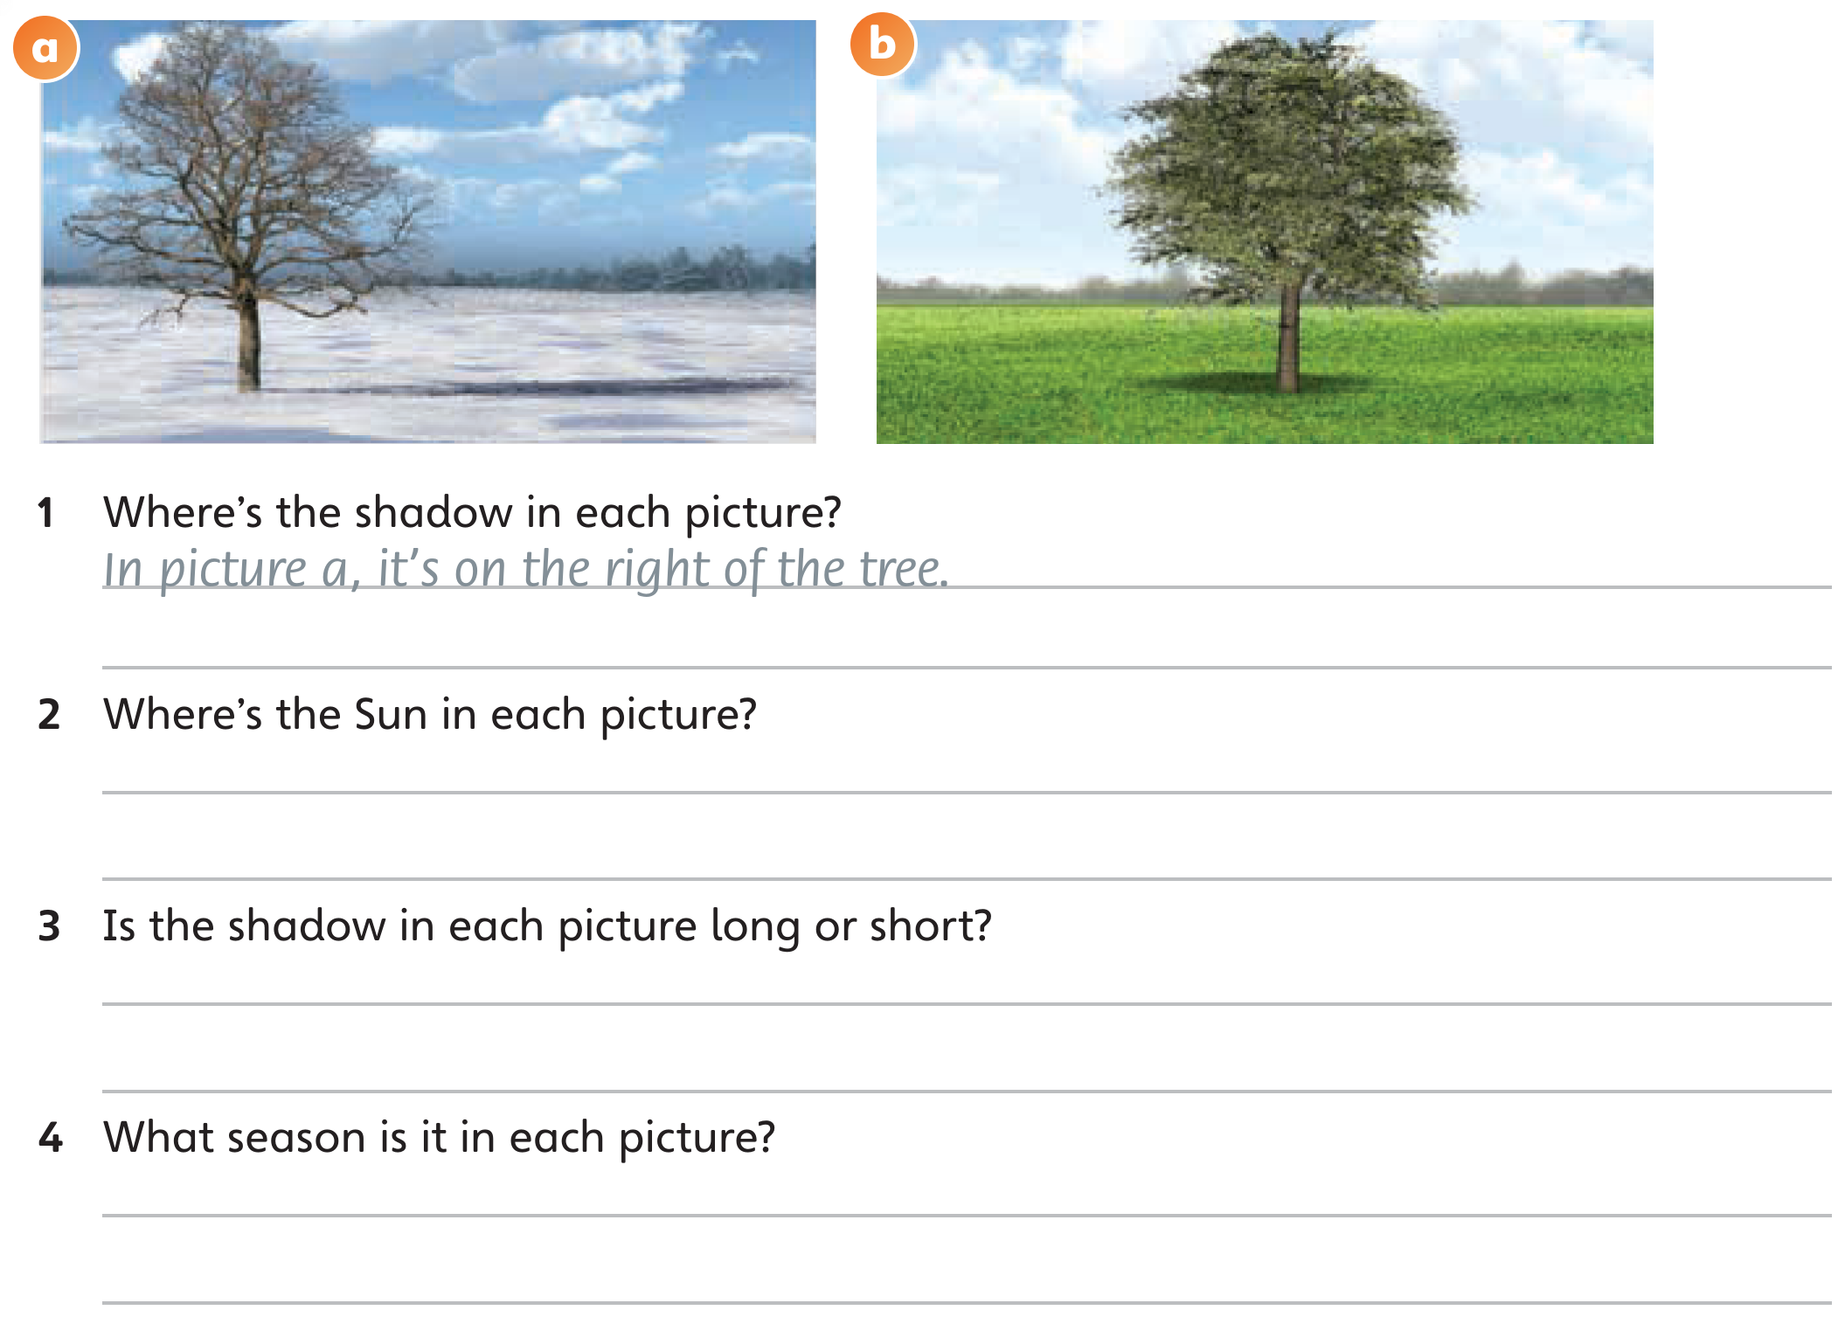

Key: 1 In picture b, it’s on the left of the tree. 2 In picture a, it’s on the left. In picture b, it’s on the right. 3 In picture a, the shadow is long. In picture b, the shadow is short. 4 In picture a, it’s winter. In picture b, it’s summer.

V. Homework
Activity 3 In your notebook, draw and write about the things you can see outside and their shadows.
• Looking out the window for help, students draw a picture showing shadows and write a description.

Ending the lesson
• Play The last word (page xvii) with information from the lesson: In summer paintings, the shadows are … (short). In winter paintings, the shadows are … (long). In the summer, the Sun is … (high) in the sky. In the winter, the Sun is … (low) in the sky.

VI. Evaluation
Giving marks according to pupils’ participation to the lesson

Deputy director on educational affairs: _________ Signature: __________

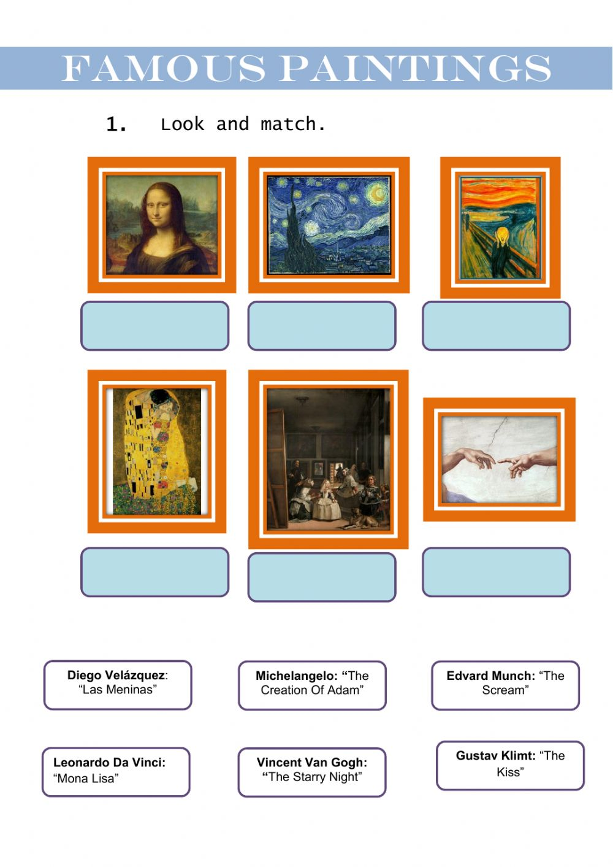

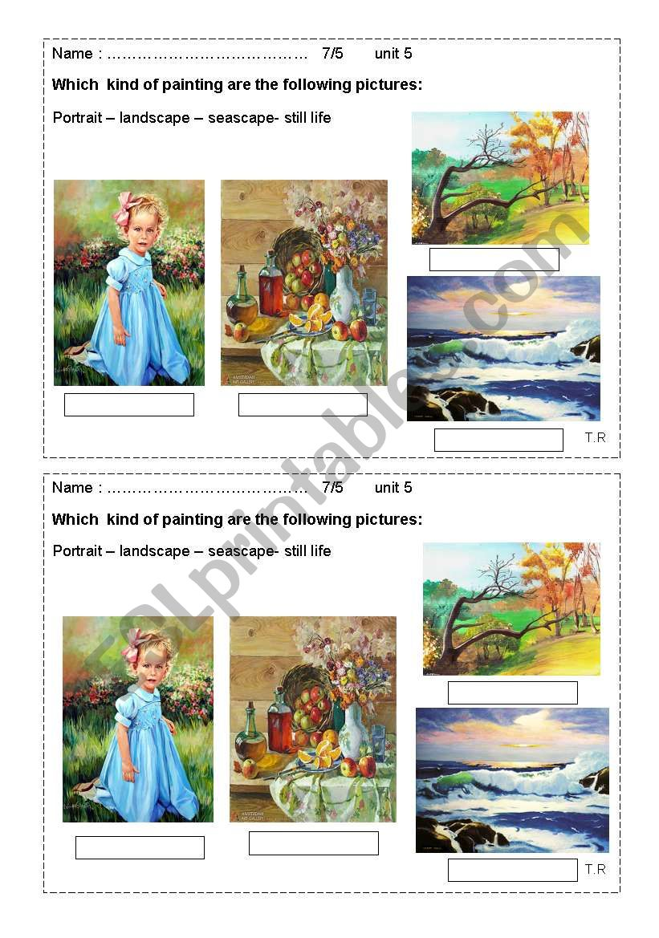
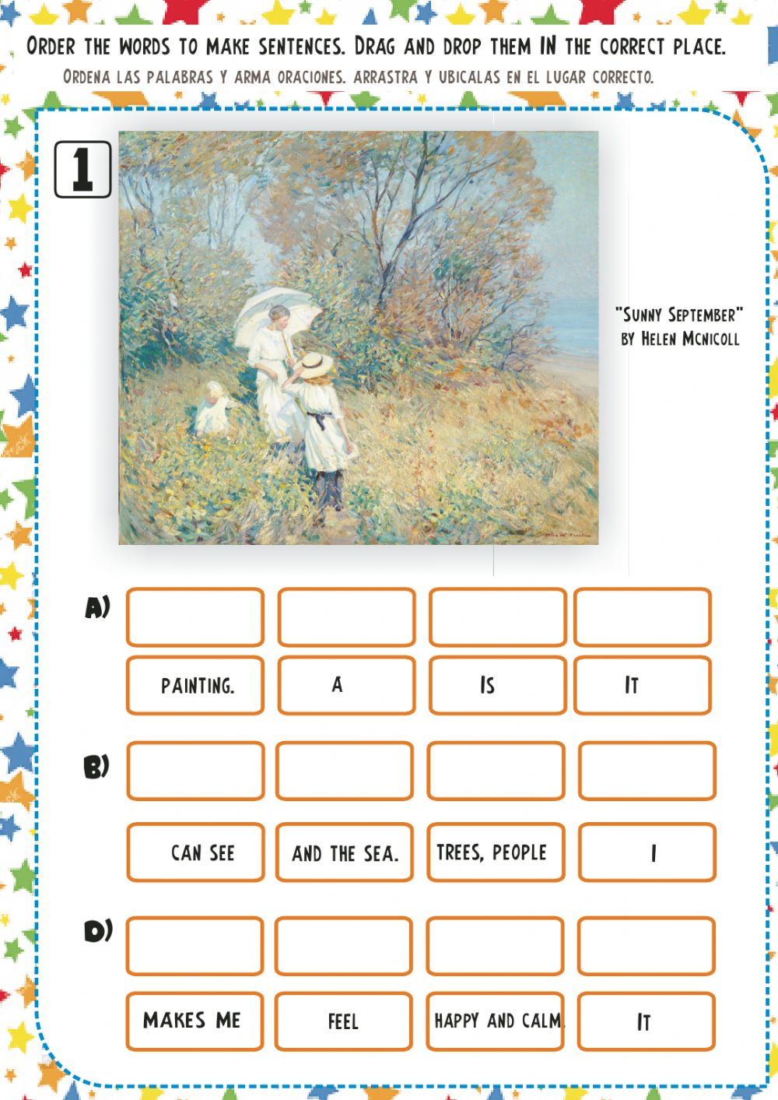

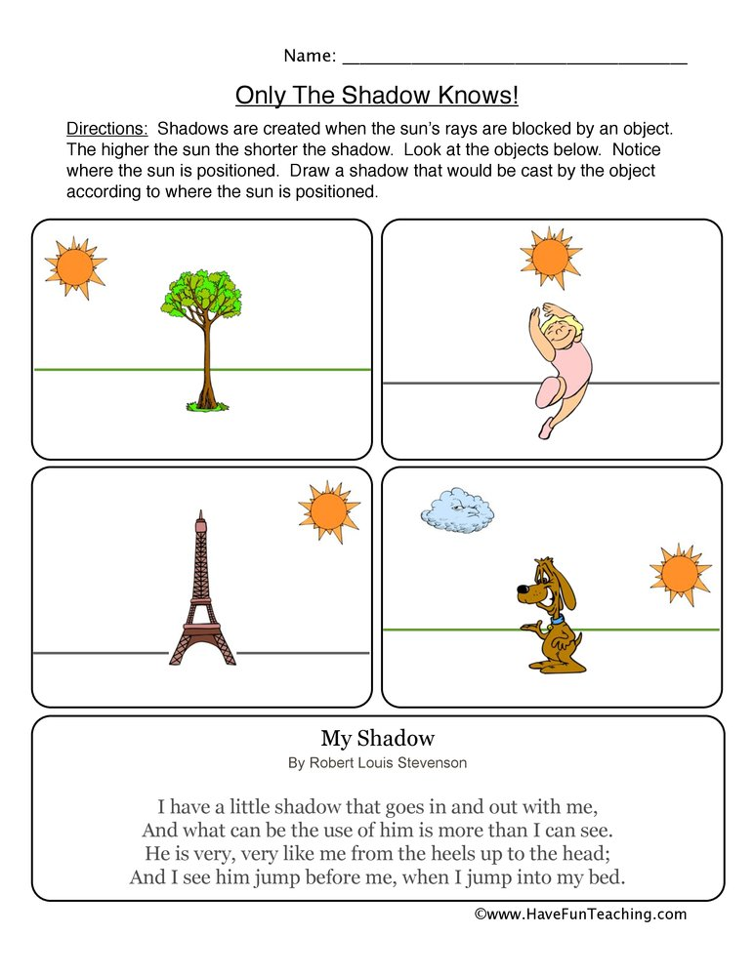

Huddi shunday namunada Guess What va Prepare darsliklaridan istalgan mavzu bo’yicha namunaviy dars ishlanmalar olishingiz mumkin. Biz bilan bog’lanish uchun Telegramdan @uzteachers_admin manzili yoki +998911800985 telegram raqami ga xabar yuboring. Fondagi yozuvlarsiz beriladi. Narxi 1ta mavzu
20 ming so’m
To’lov payme yoki click orqali
BOG’LANISH FAQAT TELEGRAM ORQALI. Telefon qilinganda yoki sms yozilganda javob berilmaydi!

