______________ VILOYATI _________ TUMANI XALQ TA’LIMI BO’LIMIGA QARASHLI
___-SONLI O’RTA TA”LIM MAKTABI
INGLIZ TILI FANI O’QITUVCHISI
_______________________________NING
6-sinflar uchun Unit 6. Lesson 1
What did you do yesterday?
mavzusida 1 soatlik

Dars ishlanmasi

_______________-2020
Date_____ Form_____ Subject: English
Theme: What did you do yesterday?
Aims:
Educational: - to learn how to write and act out dialogues.
Developing: - to enable pupils to talk about different activities;
- to enable pupils to write and act out dialogues;
- to enable pupils to listen for specific information.
Socio-cultural: - to raise awareness of past simple activities.
Up bringing: - to enrich pupils’ knowledge of English.

Learning outcomes: At the end of the lesson pupils will be able to:
- talk about different activities;
- listen for specific information;
- write and act out dialogues.
Competence: SC1, FLCC, and PC
Type of the lesson: Mixed, group work, pair-work, individual work
Method of the lesson: nontraditional, mixed
Equipment of the lesson: Textbook “New Fly High 6”, pictures, internet, computers, projector

TECHNOLOGICAL MAP OF THE LESSON:

№ | Part of the lesson | Tasks | Time
1 | Organizational  Moment | -to greet pupils.  - to check up the register | 5 min
2 | Repeating last lesson | - to give pupils some questions about last lesson. – to ask words from previous lesson | 5 min
3 | Explaining new theme | - to explain to pupils new vocabulary and theme | 20 min
4 | Consolidating new theme. | - to consolidate new theme and new words of the theme. | 10 min
5 | Marking. | - To mark pupils | 5 min
6 | Homework. | - Giving homework.

Procedure of the lesson:
I. Organizing moment: Motivation, Greeting, checking attendance, season, weather, checking the preparation for the lesson.
II. Asking homework:
- Check for homework given on past lesson.
- Ask pupils all new words learnt on previous lesson.

III. Pre-activity:
Activity 1 Listen and repeat. 5 min
Objectives: to introduce the unit topic;
to warm up
STEP 1: Ask the pupils to listen to the song and say what this song is about. Play the DVD.
STEP 2: Play the DVD again and ask them to repeat the song.
DVD script:
Did you visit your grandparents? (Tune of “Mary had a little lamb”)
Did you visit your grandparents,
Your grandfather, your grandmother?
Did you sweep and mop the floor?
Yes, of course I did.
Did you help them in the kitchen,
In the bathroom, in the bedroom?
Did you help them clean the rooms?
Yes, of course I did.
Did you help them in the garden?
Did you water plants and flowers?
Did you help them in the garden?
Yes, of course I did.
IV. Main part
Activity 2 Play “Miming”. 10 min
Objectives: to recycle the previously learnt vocabulary;
to give practice in talking about different activities
STEP 1: Get the pupils to read the activities in the cloud.
STEP 2: Demonstrate the activity before the class as shown in the example.
STEP 3: When everybody understands what to do, you can let the pupils mime and guess.
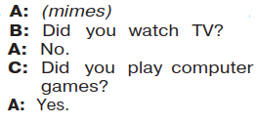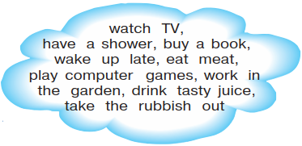
Activity 3 Listen and match the dialogues and pictures. 15 min
Objectives: to listen for specific information;
to practise speaking
STEP 1: Explain that a reporter asks different people the same question.
They answer. The pupils must listen to the answers and find the pictures.
STEP 2: Ask the pupils to look at the pictures carefully and answer your questions. Ask them about the people in the pictures, where they are and what they are doing.
STEP 3: Ask the pupils to listen and match. Play the DVD two times.
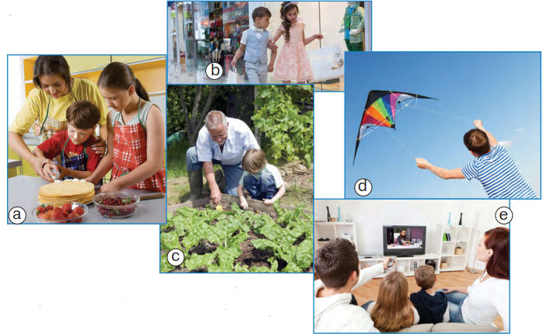
Answer key: 1) e; 2) c; 3) b; 4) a; 5) d
DVD script:
1) A: What did you do yesterday?
B: I stayed at home yesterday. I watched TV with my sister.
A: How was it?
B: It was interesting.
2) A: What did you do yesterday?
B: I visited my grandparents yesterday. I helped them in the garden.
A: How are your grandparents?
B: They’re fine. They were happy to see me.
3) A: What did you do yesterday?
B: I went shopping with my sister yesterday.
A: How was it?
B: It was great.
A: What did you buy?
B: I bought new jeans.
4) A: What did you do yesterday?
B: Uh, let’s see. We cooked a cake with my mum.
A: How was it?
B: It was delicious.
5) A: What did you do yesterday?
B: We went to the park.
A: What did you do there?
B: We flew kites.
A: How was it?
B: It was fun.
Activity 4a Work in pairs. Read and write your dialogue. 7 min
Objective: to practise writing dialogues
STEP 1: Ask the pupils to read the examples and the activities and the adjectives in the clouds individually.
STEP 2: Ask the pupils to work in pairs. Explain that they must discuss and write a dialogue using the words in the clouds.
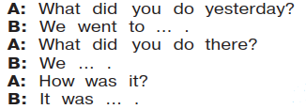
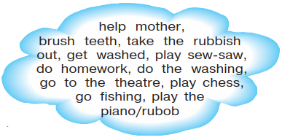
V. Post-activity
Activity 4b Act your dialogue out. 7 min
Objectives: to give practice in acting out dialogues;
to develop speaking skills
STEP 1: Ask the pupils to act out their dialogues in pairs.
STEP 2: You can ask as many pairs as time allows to act out their dialogues for the class.
VI. Homework 1 min
Ask the pupils to look at the homework on Page 100. Check that everybody understands what to do with the task. If necessary, explain how to do the homework.
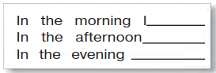
VII. Evaluation. Giving marks

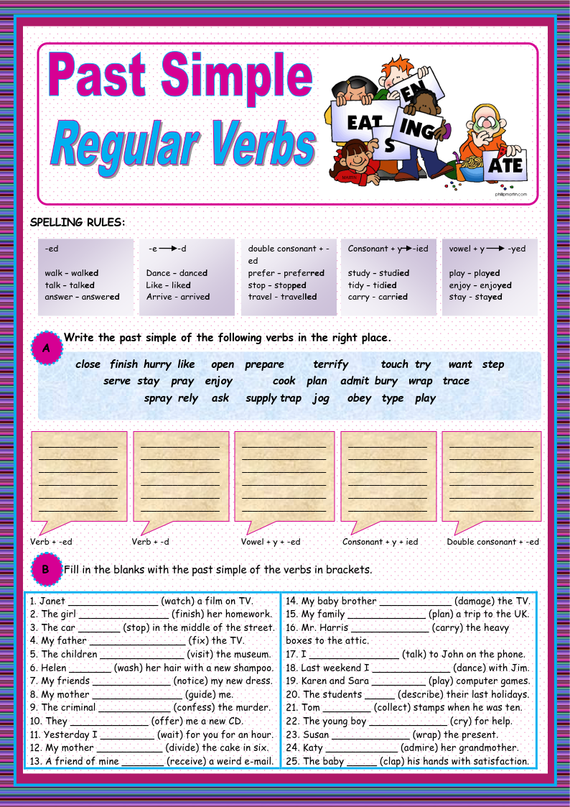
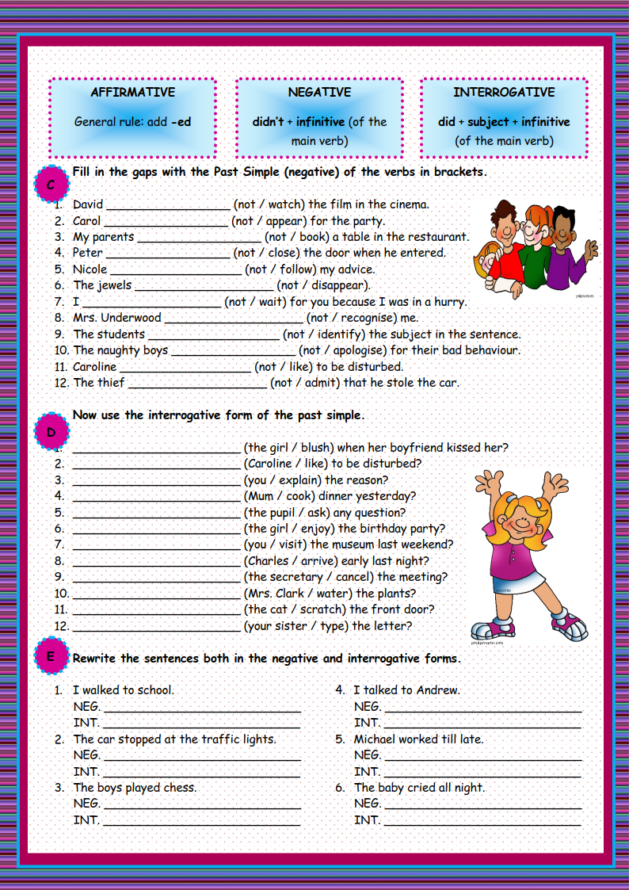
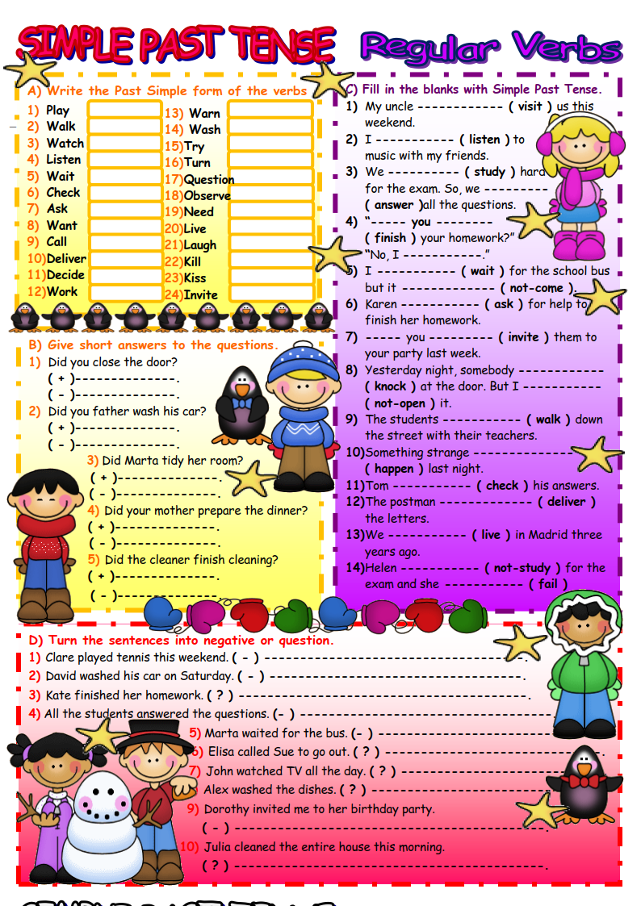
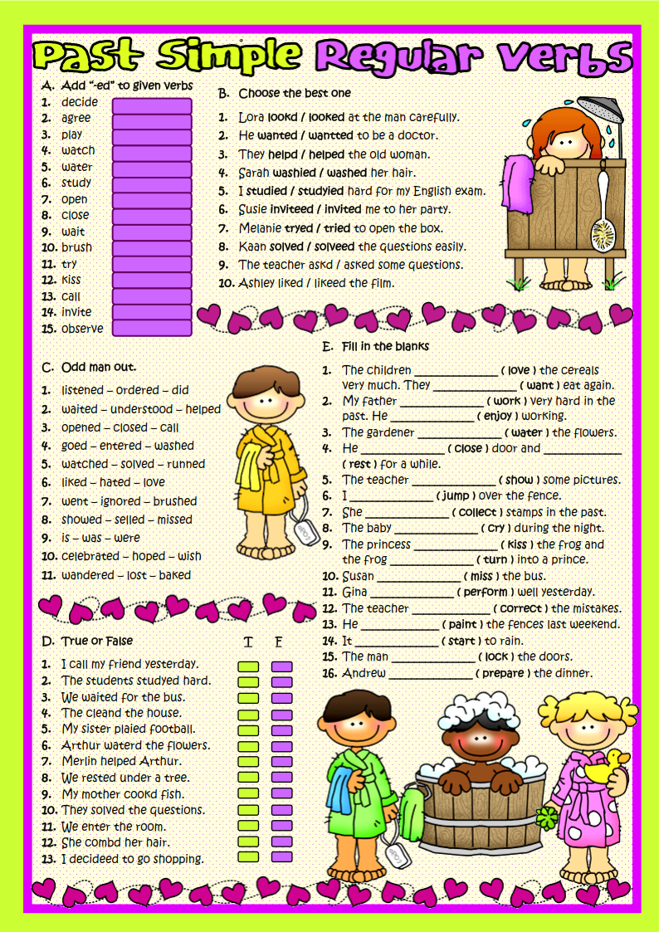
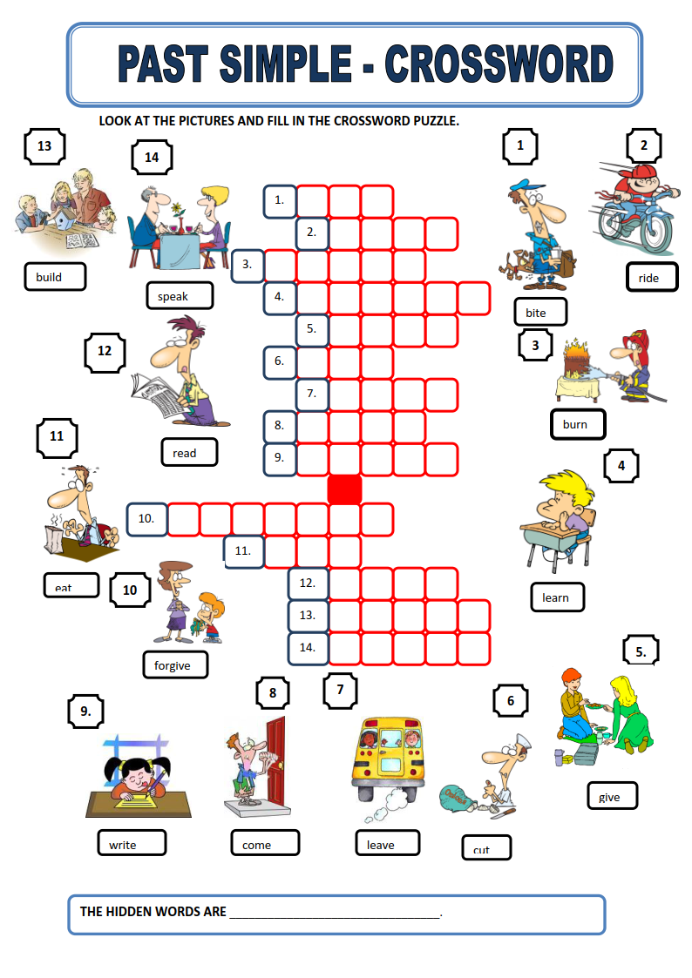

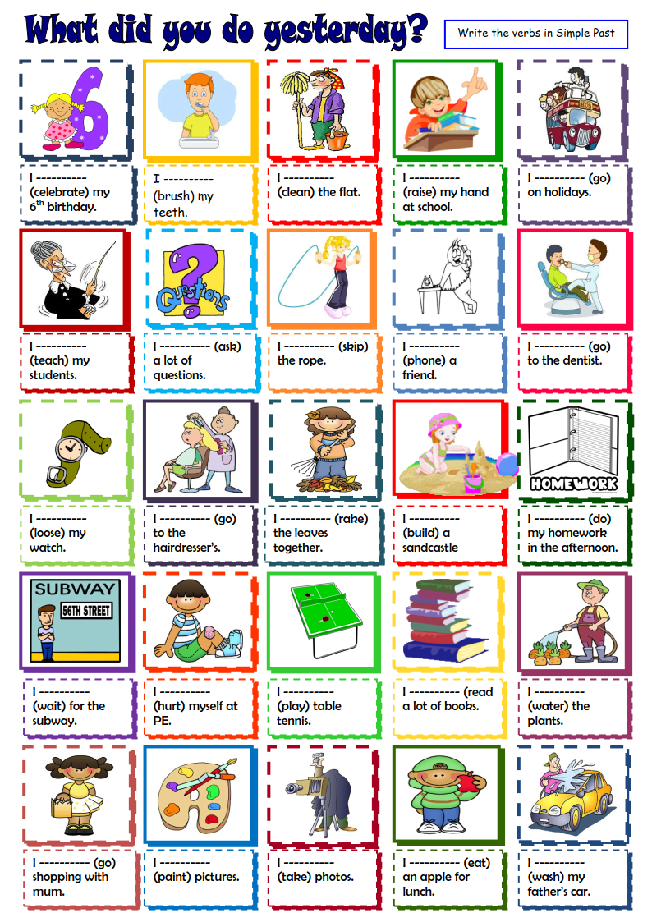
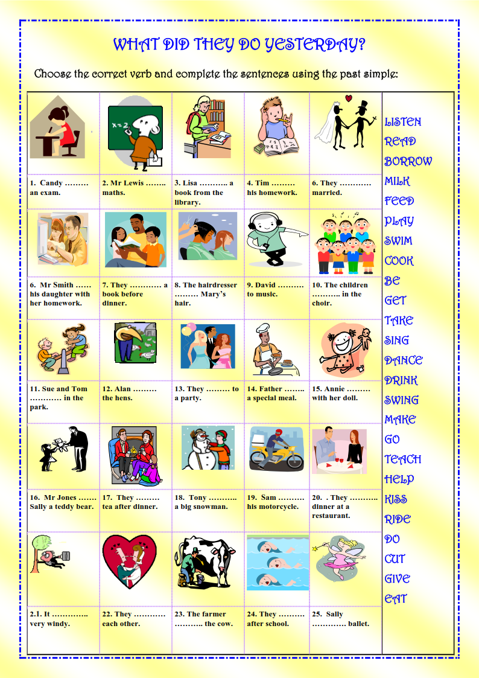
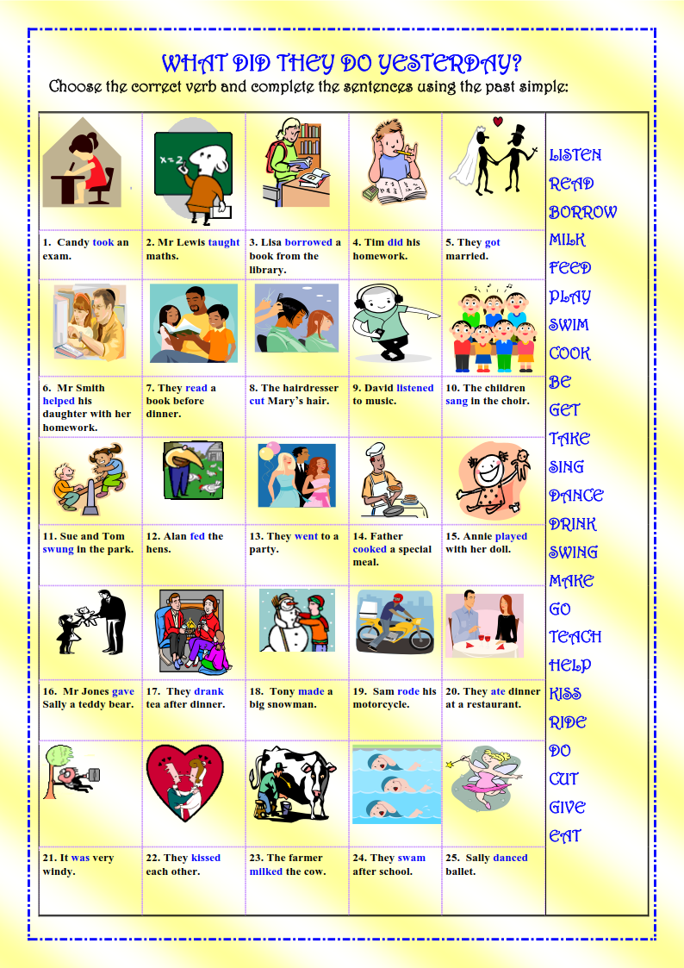
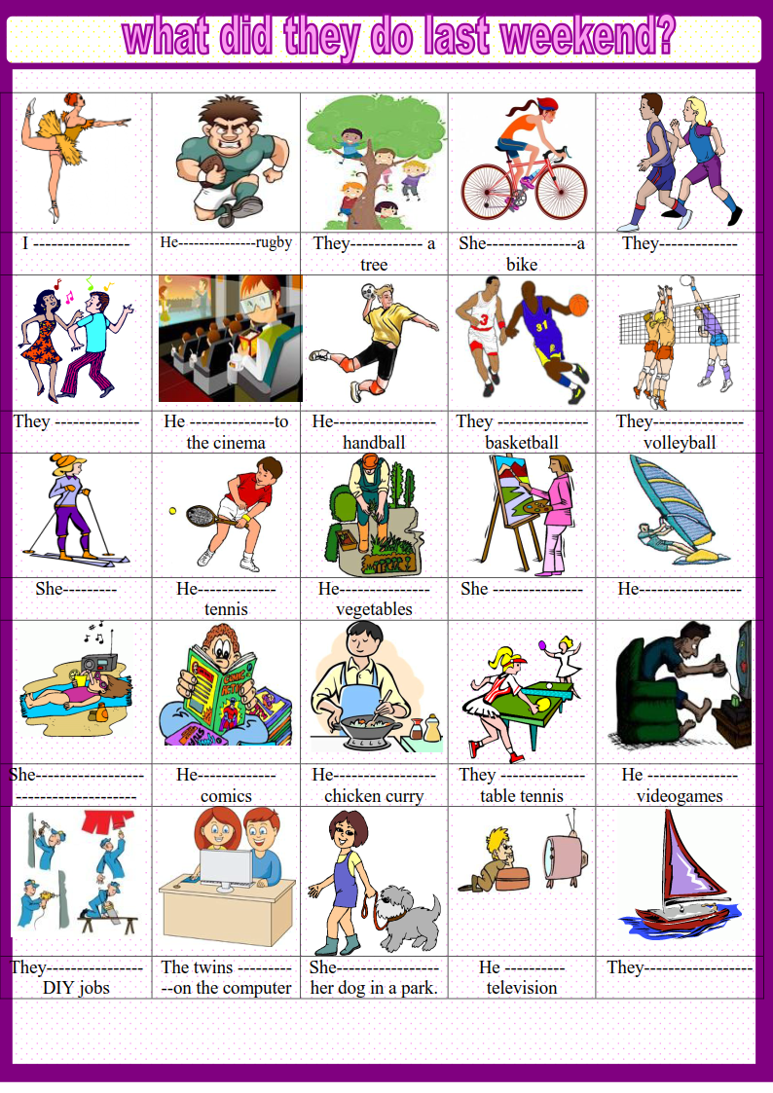
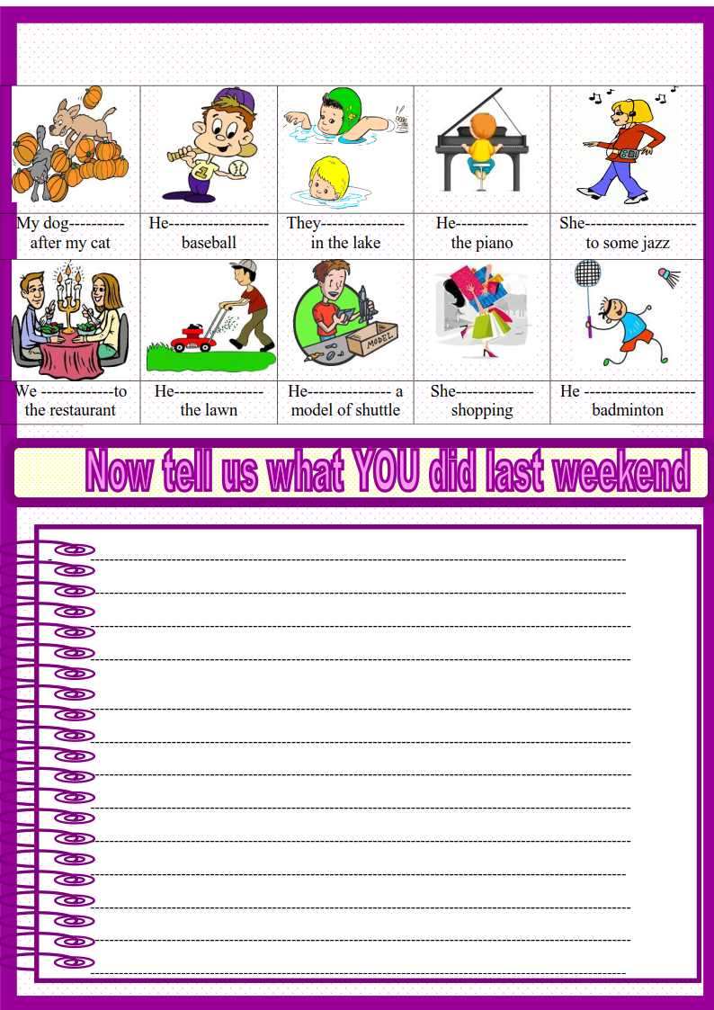

Siz istagan darslik asosidagi mavzu bo’yicha namunaviy dars ishlanmaga buyurtma berishingiz mumkin. Biz bilan bog’lanish +998911800985 telegram raqami, @uzteachers_admin ga xabar yuboring.
Narxi 20 ming so’m (1-9-sinflar uchun)
To’lov payme yoki click orqali
Bog’lanish faqat telegram orqali. Telefon qilinganda yoki sms yozilganda javob bermasligim ehtimoli yuqori

