______________ VILOYATI _________ TUMANI XALQ TA’LIMI BO’LIMIGA QARASHLI
___-SONLI O’RTA TA’LIM MAKTABI
INGLIZ TILI FANI O’QITUVCHISI
_______________________________NING
5-sinflar uchun Unit 8. Lesson 2
Do you have a hobby?
mavzusida 1 soatlik
Dars ishlanmasi

_______________-2019
Date_____ Form_____ Subject: English
Theme: Do you have a hobby?
Aims:
Educational: - to learn about leisure activities.
Developing: - to enable pupils to talk about leisure activities and hobbies;
Socio-cultural: - to raise awareness of English children’s life.
Up bringing: - to enrich pupils’ knowledge of spending their spare time usefully.

Learning outcomes: By the end of the lesson pupils will be able to:
- use the gerund;
- talk about leisure activities.
Competence: SC1, FLCC, and PC
Type of the lesson: Mixed, group work, pair-work, individual work
Method of the lesson: nontraditional, mixed
Equipment of the lesson: Textbook “New Fly High 5”, pictures, internet, computers, projector

TECHNOLOGICAL MAP OF THE LESSON:

№ | Part of the lesson | Tasks | Time
1 | Organizational  Moment | -to greet pupils.  - to check up the register | 5 min
2 | Repeating last lesson | - to give pupils some questions about last lesson. – to ask words from previous lesson | 5 min
3 | Explaining new theme | - to explain to pupils new vocabulary and theme | 20 min
4 | Consolidating new theme. | - to consolidate new theme and new words of the theme. | 10 min
5 | Marking. | - To mark pupils | 5 min
6 | Homework. | - Giving homework.

Procedure of the lesson:
I. Organizing moment: Motivation, Greeting, checking attendance, season, weather, checking the preparation for the lesson.
II. Asking homework:
- Check for homework given on past lesson.
- Ask pupils all new words learnt on previous lesson.

III. Pre-activity:
Activity 1 Listen and repeat. 5 min
Objectives: to introduce the unit topic; to warm up
Play the DVD. Ask the pupils to listen to and repeat the song.
Look at Unit 8 Lesson 1 Activity 1 for the DVD script.
DVD script.
Things I like  (Tune of “Mary had a little lamb”)  Do you like collecting stamps?  Doing puzzles, playing chess?  Do you like sewing, cooking,  Reading, playing chess? | No, I don’t like sewing, cooking.  I like reading, I like singing.  No, I don’t like doing puzzles.  I like playing chess.

IV. Main part
Activity 2 Look, listen and repeat. 5 min
Objective: to present new vocabulary
STEP 1: Ask the pupils to look at the pictures and guess the meaning of the new words. Elicit the answers.
STEP 2: Ask the pupils to listen and repeat the DVD.
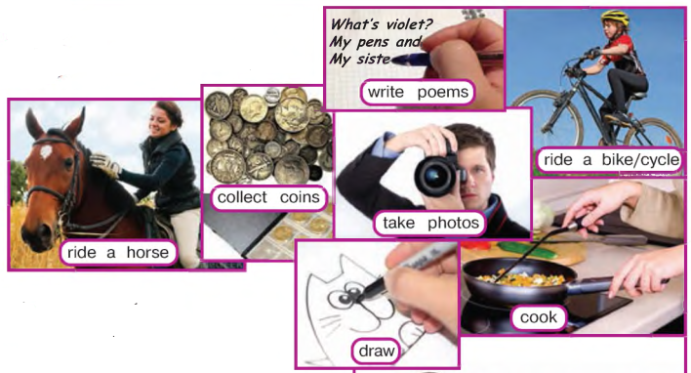
Activity 3 Chain Drill. 5 min
Objective: to practise the new vocabulary
As usual, this is a practice of the new vocabulary. Play the DVD to see how the pupils do the activity.
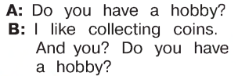
Activity 4a, 4b 15 min
Objective: to consolidate the new vocabulary
STEP 1: Ask the pupils to copy the table on Page 108.
STEP 2: Divide the class into groups of 4 or 5. Demonstrate how to begin this game. P1 asks P2 a question like Do you like playing chess? If P2 answers Yes, I do. The rest of the group should write P2’s name in their tables. Then P2 asks P3 another question. Continue like this until all group members have asked and answered several questions.
STEP 3: Ask some of your pupils to report.
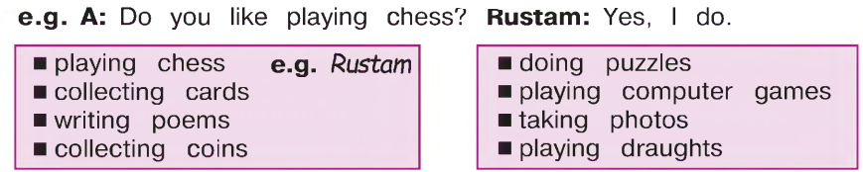
Activity 5a Listen and choose a title. 5 min
Objective: to practise listening for gist
The pupils listen to/read the text and choose the best title.
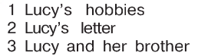
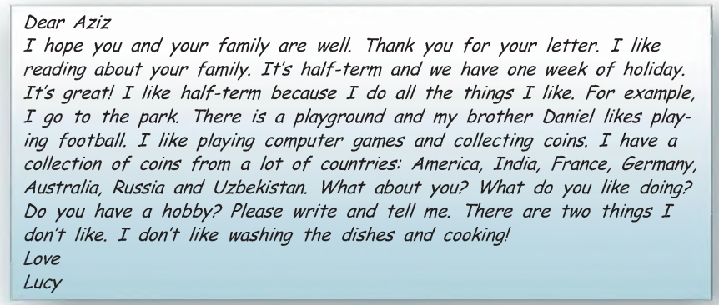

V. Post-activity
Activity 5b Read and write Lucy’s hobbies. 8 min
Objective: to practise writing the new vocabulary
Ask the pupils to read the text and write Lucy’s hobbies.
Dear A ziz
I hope you and your family are well. Thank you for your letter. I like reading about your family. It's half-term and we have one week of holiday. It's great! I like half-term because I do all the things I like. For example, I go to the park. There is a playground and my brother Daniel likes playing football. I like playing computer games and collecting coins. I have a collection of coins from a lot of countries: America, India , France, Germany, Australia, Russia and Uzbekistan. What about you? What do you like doing? Do you have a hobby? Please w rite and tell me. There are two things I don't like. I don't like washing the dishes and cooking!
Love
Lucy

VI. Homework 2 min
Ask the pupils to look at the homework. Check that everybody understands
what to do with the 2 tasks. If necessary, explain how to do the homework.

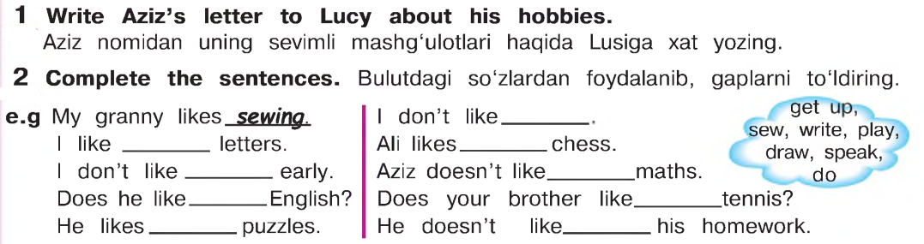

VII. Evaluation. Giving marks

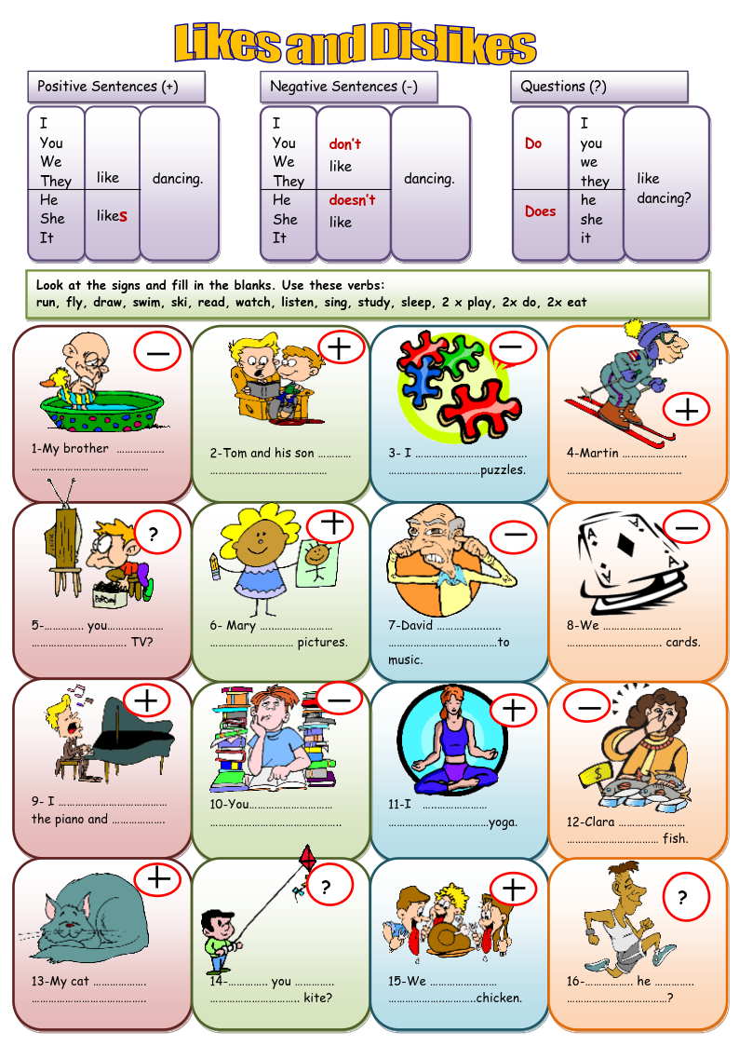
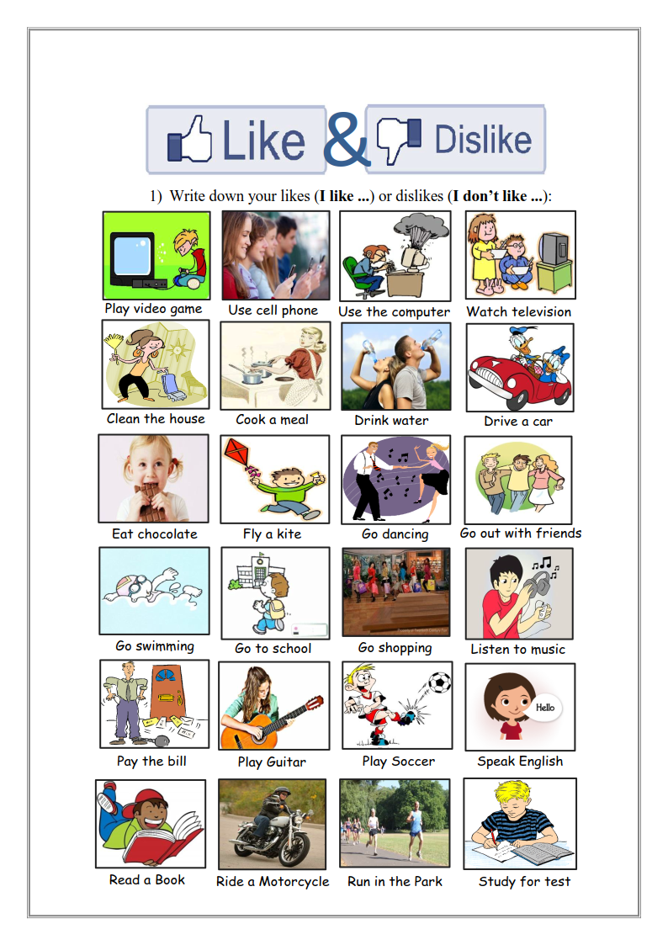
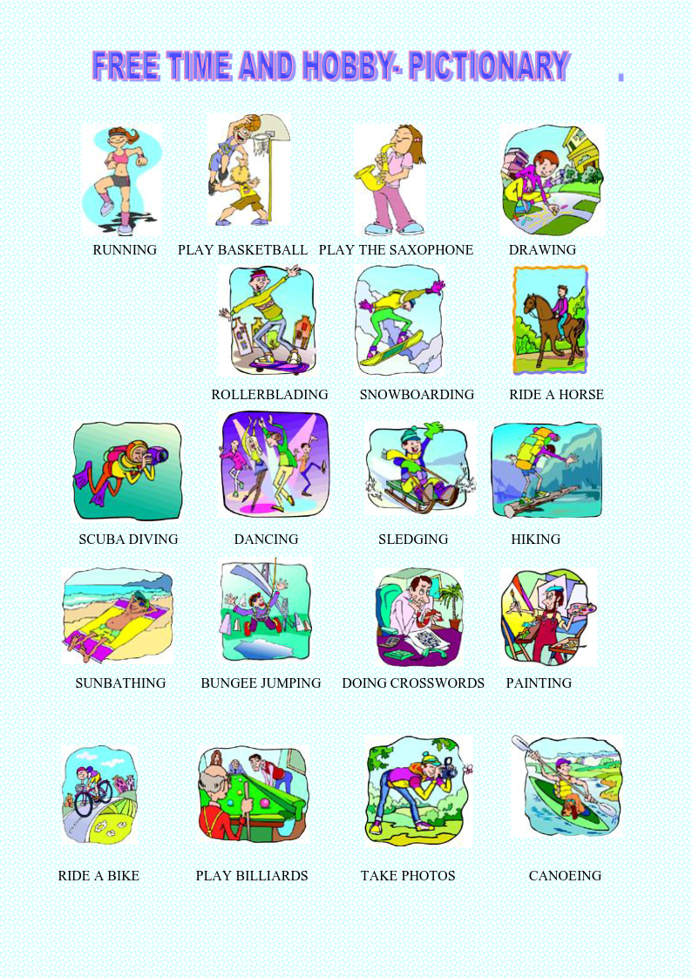
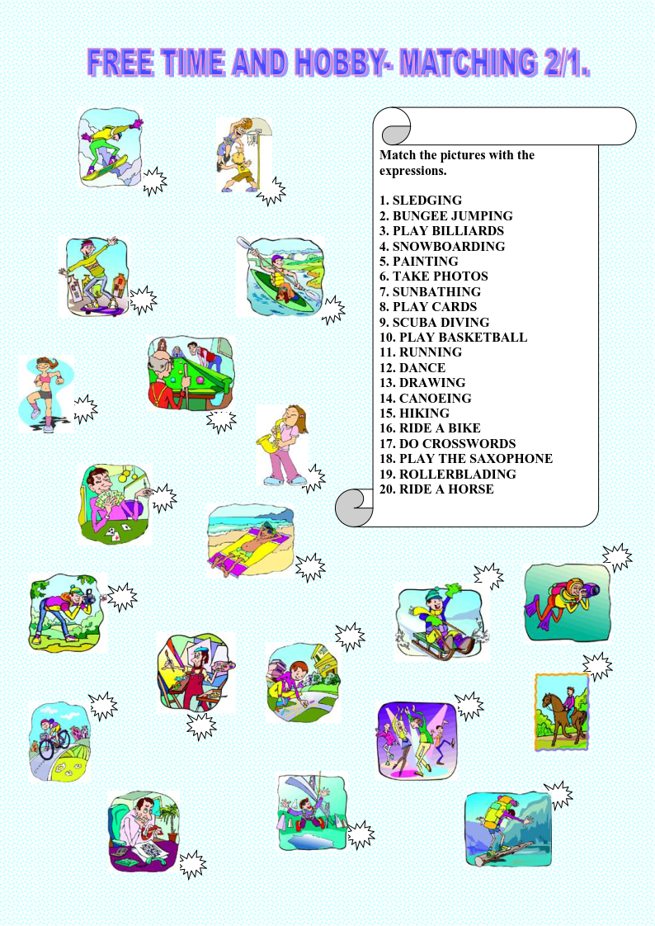
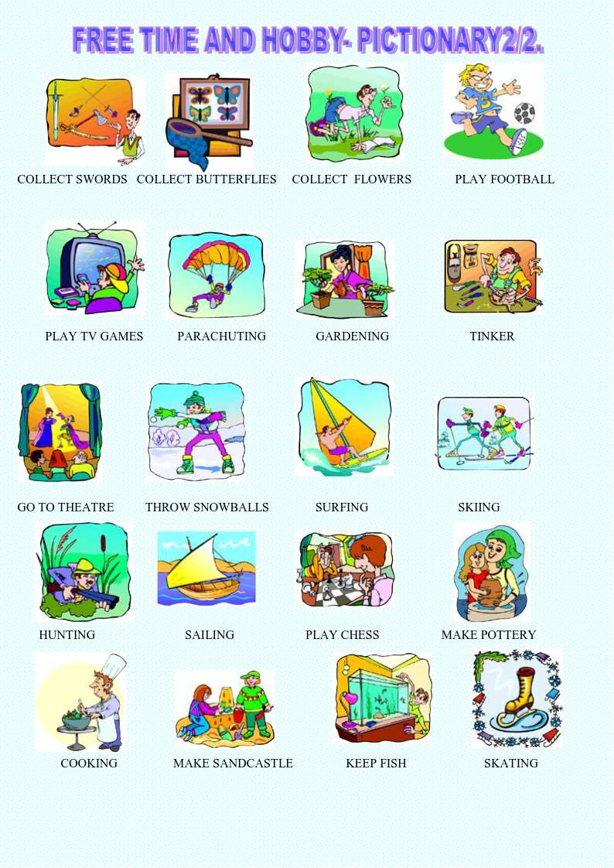
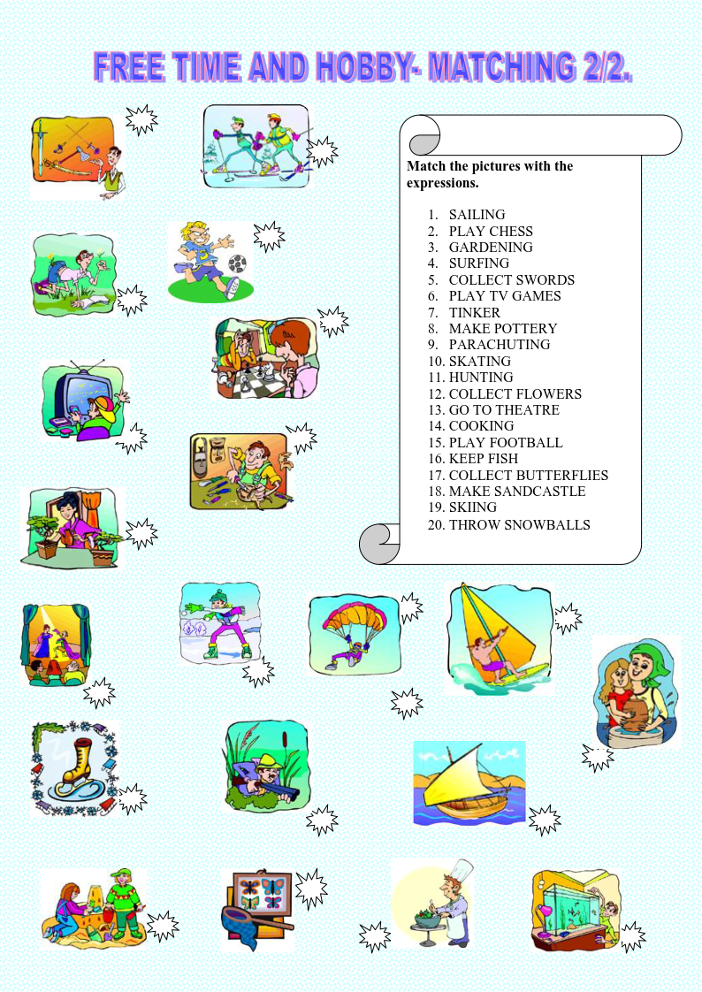
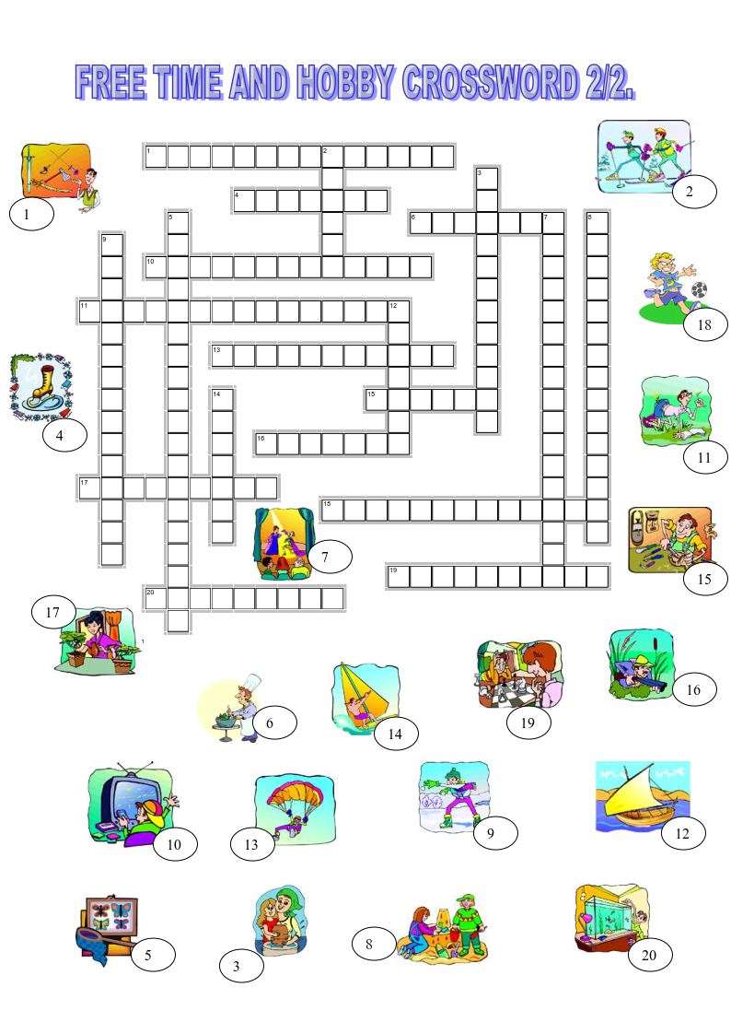
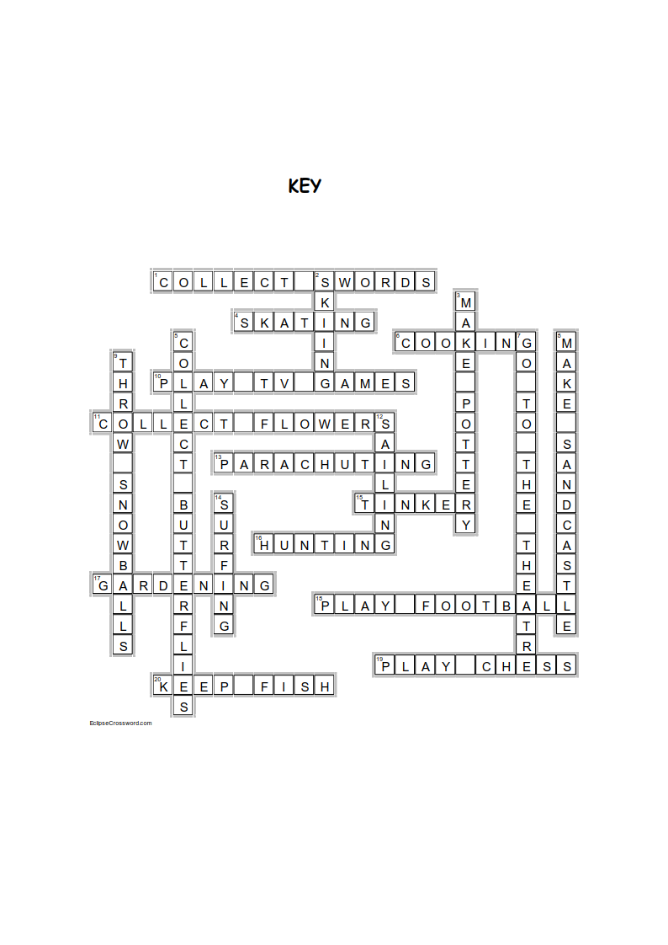

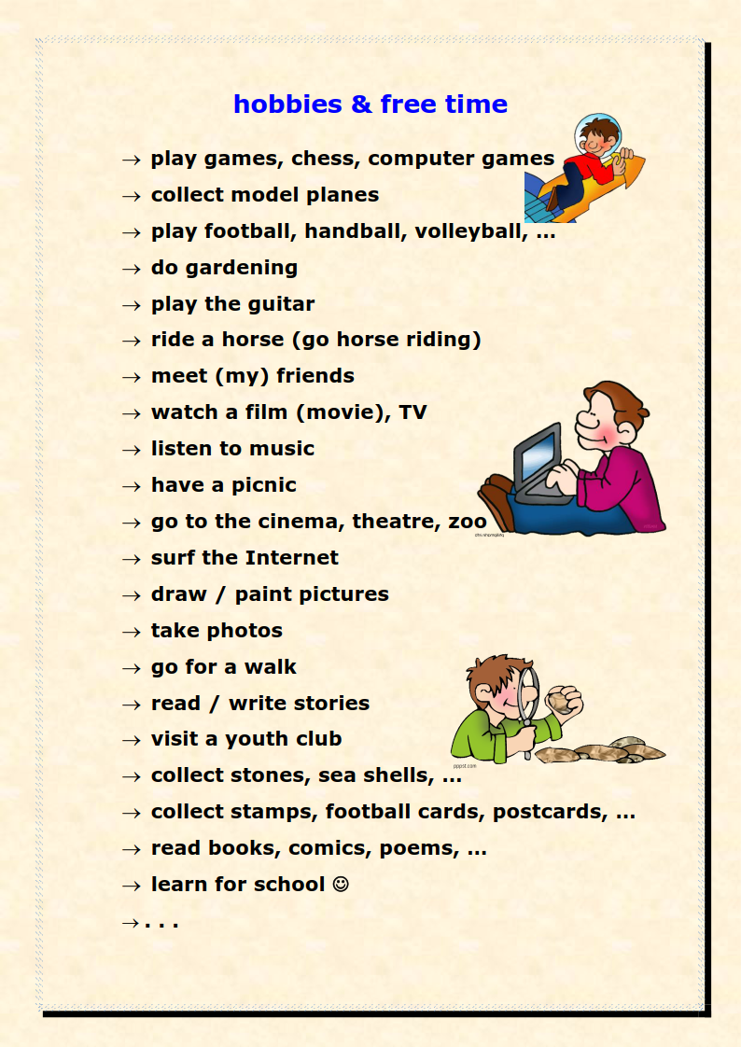
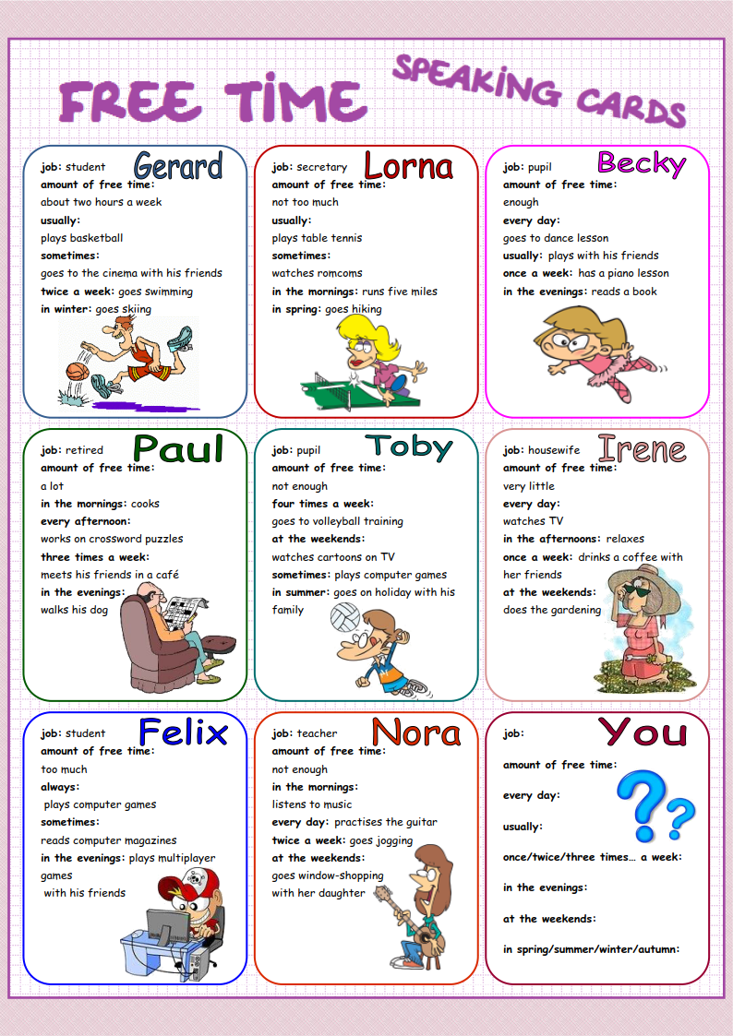
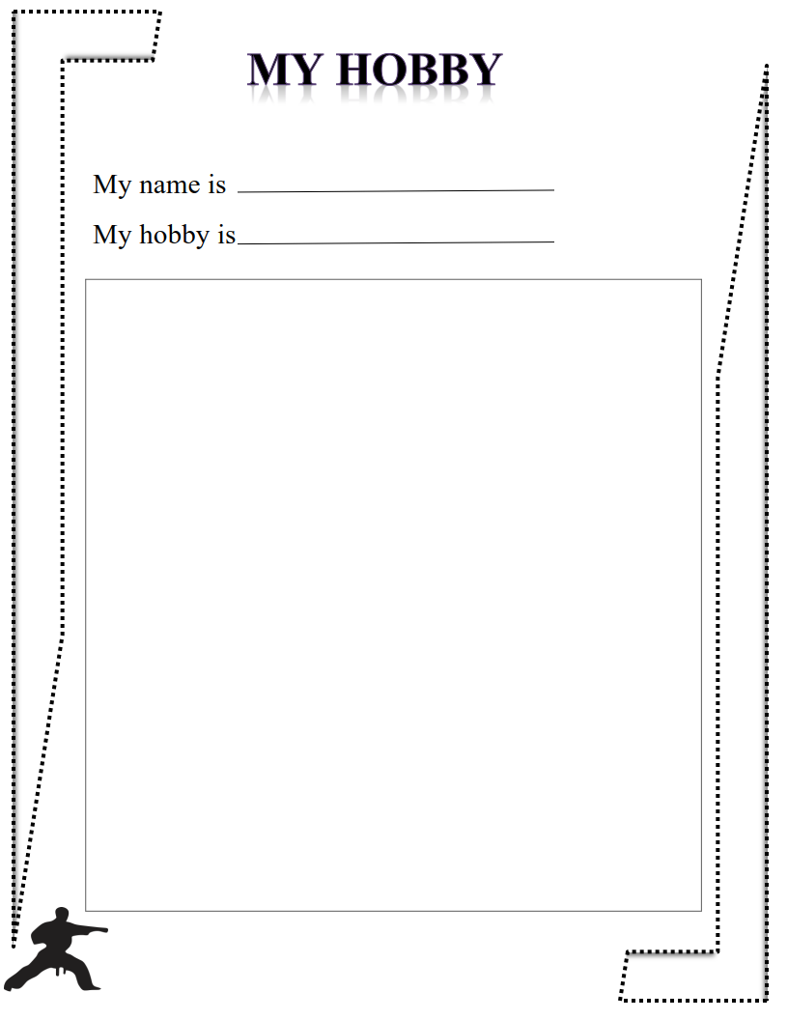

Siz istagan darslik asosidagi mavzu bo’yicha namunaviy dars ishlanmaga buyurtma berishingiz mumkin. Biz bilan bog’lanish +998911800985 telegram raqami, @uzteachers_admin ga xabar yuboring.
Narxi 20 ming so’m (1-9-sinflar uchun)
To’lov payme yoki click orqali
Bog’lanish faqat telegram orqali. Telefon qilinganda yoki sms yozilganda javob bermasligim ehtimoli yuqori

