______________ VILOYATI _________ TUMANI XALQ TA’LIMI BO’LIMIGA QARASHLI
___-SONLI O’RTA TA’LIM MAKTABI
INGLIZ TILI FANI O’QITUVCHISI
_______________________________NING
4-sinflar uchun Unit 8. Lesson 3
Can I help you?
mavzusida 1 soatlik
Dars ishlanmasi
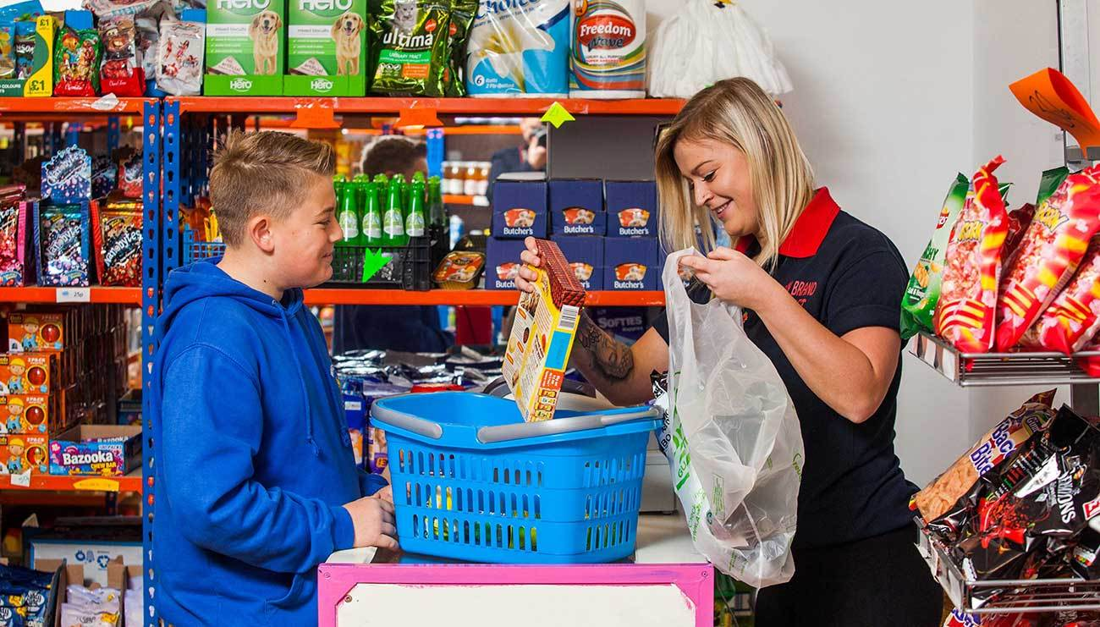
_______________-2019
Date_____ Form_____ Subject: English
Theme: Can I help you?
Aims:
Educational: - to learn how to go shopping;
Developing: - to enable pupils to go shopping
Socio-cultural: - to raise awareness of using phrases at the shop.
Up bringing: - to enrich pupils’ knowledge of English.

Learning outcomes: At the end of the lesson pupils will be able to go shopping
Competence: SC1, FLCC, and PC
Type of the lesson: Mixed, group work, pair-work, individual work
Method of the lesson: nontraditional, mixed
Equipment of the lesson: Textbook “Kids’ English 4 ”, “Workbook 4” pictures, internet, computers, projector

TECHNOLOGICAL MAP OF THE LESSON:

№ | Part of the lesson | Tasks | Time
1 | Organizational  Moment | -to greet pupils.  - to check up the register | 5 min
2 | Repeating last lesson | - to give pupils some questions about last lesson. – to ask words from previous lesson | 5 min
3 | Explaining new theme | - to explain to pupils new vocabulary and theme | 20 min
4 | Consolidating new theme. | - to consolidate new theme and new words of the theme. | 10 min
5 | Marking. | - To mark pupils | 5 min
6 | Homework. | - Giving homework.

Procedure of the lesson:
I. Organizing moment: Motivation, Greeting, checking attendance, season, weather, checking the preparation for the lesson.
II. Asking homework:
- Check for homework given on past lesson.
- Ask pupils all new words learnt on previous lesson.

III. Pre-activity:
Activity 1 Listen and sing. 10 min
Objectives: to warm up; to create a friendly atmosphere
STEP 1: The pupils sing the song together with the DVD.
Look at Unit 8 Lesson 1 Activity 1 for the DVD script.
STEP 2: The pupils work in pairs and read to each other their homework.
DVD script:
One bottle o’POP

One bottle o‟pop, two bottles o‟pop,
Three bottles o‟pop, four bottles o‟pop,
Five bottles o‟pop, six bottles o‟pop,
Seven bottles o‟pop, POP!

Don‟t eat too many pickles with hamburger sandwiches,
Don‟t eat too many pickles, or else you will POP!

Hamburgers and apple pie, apple pie, apple pie,
Hamburgers and apple pie, apple pie and POP!

IV. Main part
Activity 2a Play “Where can I buy …?”. 7 min
Objective: to revise the topic vocabulary
It‟s a usual Chain Drill.
A:Where can I buy apples?
B:At the supermarket. Where can I buy books? etc.

Activity 2b Look, read and match. 8 min
Objective: to develop reading for gist
The pupils read the texts and match them with the pictures.

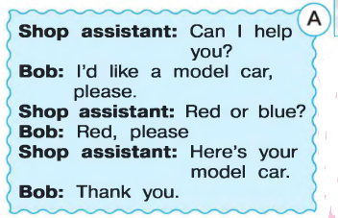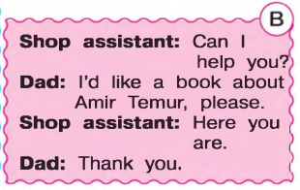

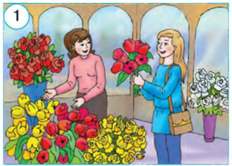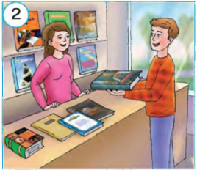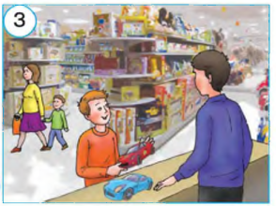
Answer key: 2b, 3a

Activity 2c Complete the dialogue. Help Bob’s mum to buy red tulips. 5 min
Objective: to develop writing skills
The pupils read the text and complete the sentences.
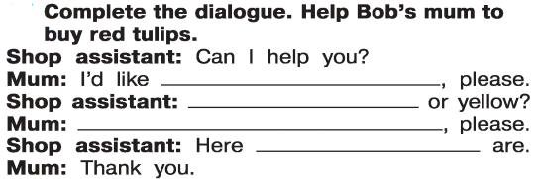
Answer key:
Shop assistant: Can I help you?
Mum: I‟d like tulips, please.
Shop assistant: Red or yellow?
Mum: Red, please.
Shop assistant:Here you are.
Mum: Thank you.

V. Post-activity
Activity 3Work in groups. Play “Shops”.10 min
Objectives: to develop the pupils’ creativity and social skills;
to consolidate the topic vocabulary
STEP 1: The pupils choose a shop they would like to create. They should write a name for their shop and draw the items they can sell in their shop. Say they have 5 minutes for drawing. Say that drawings must be very simple. Also say that they can use real objects like bags, pens, pencils or different toys, etc.
STEP 2: The pupils go and “buy” something from another shop. Say that they should not forget to say: „Good morning, Hello, Good bye, please, thank you‟,etc.

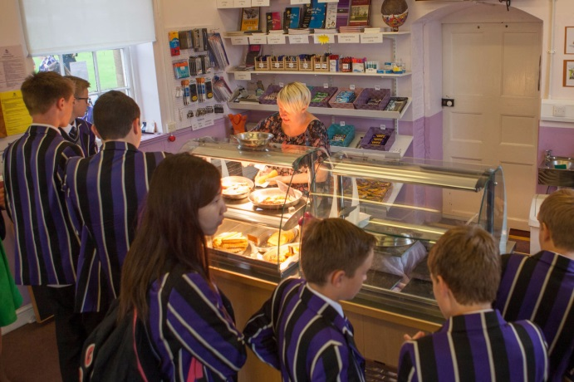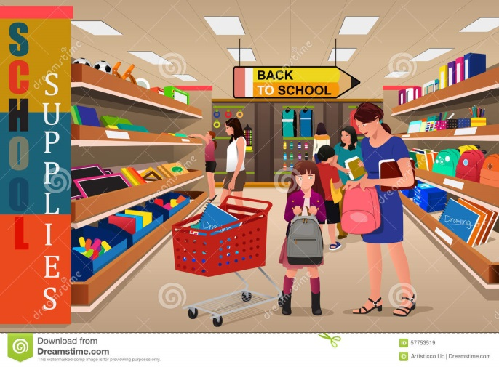

VI. Homework 5 min
Ask the pupils to look at the homework. Check that everybody understands what to do. If necessary, explain that they must read the text on Page 44 and colour the picture on Page 45 according to the sentences. They must write the name of the shop as well.
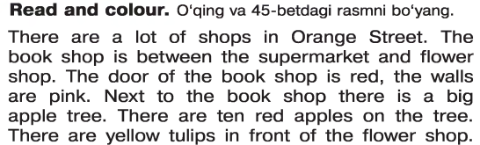
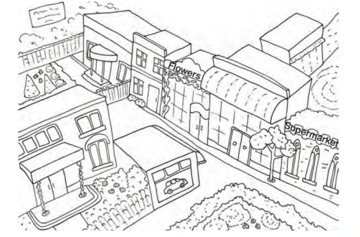
VII. Evaluation. Giving marks

Additional materials
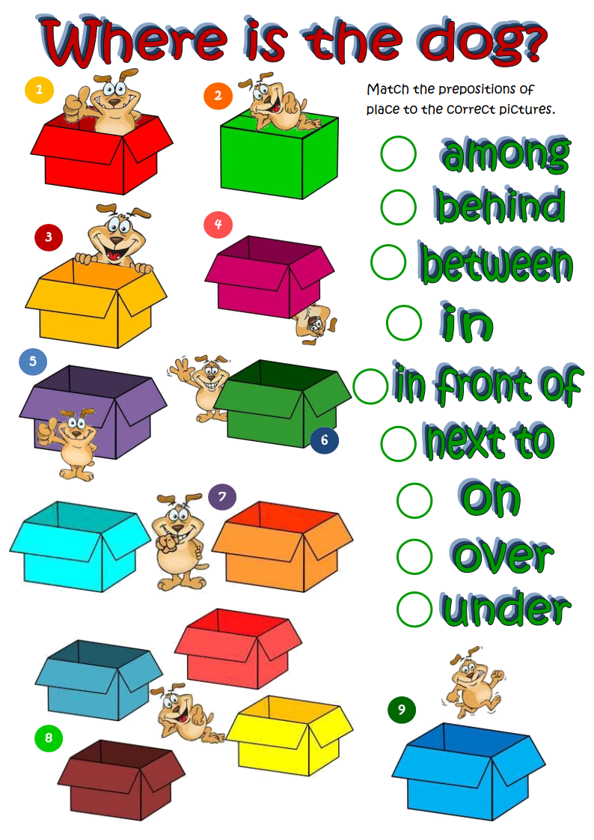
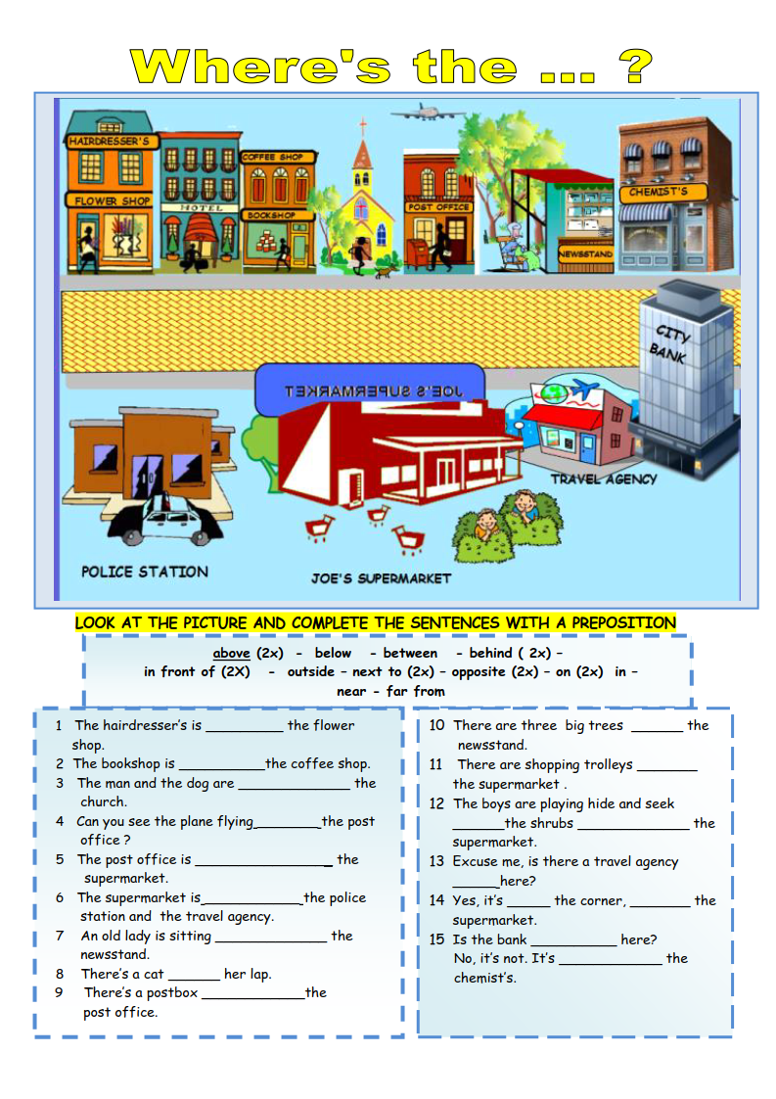
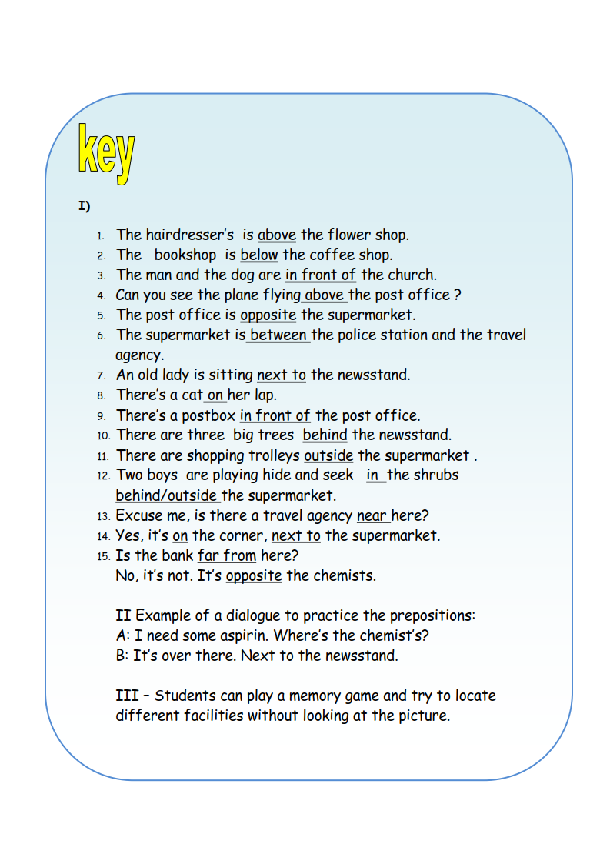
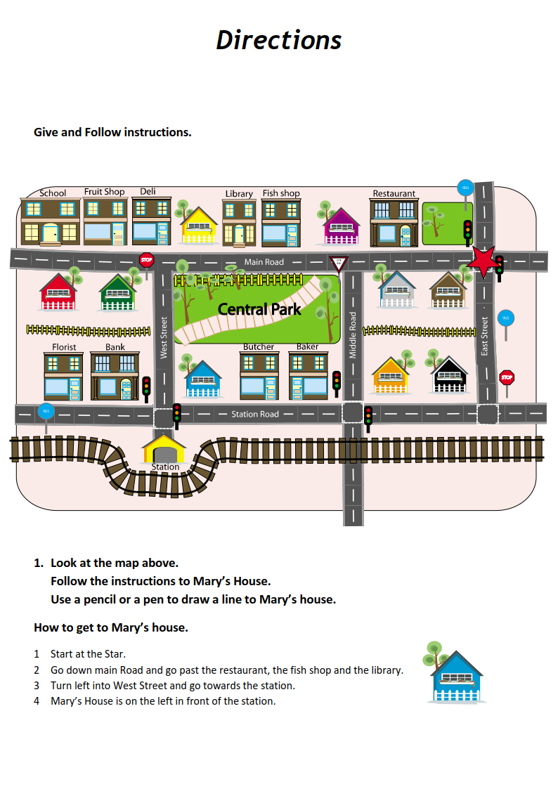
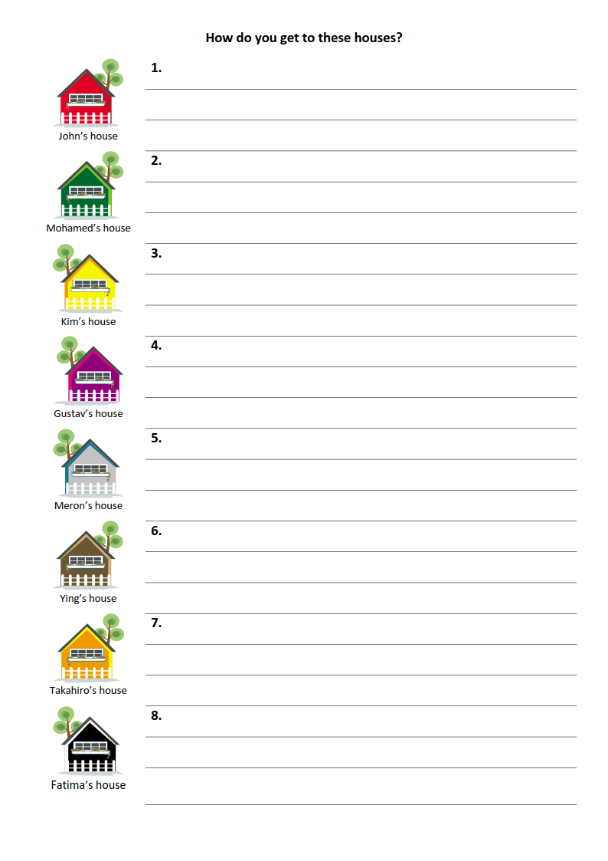

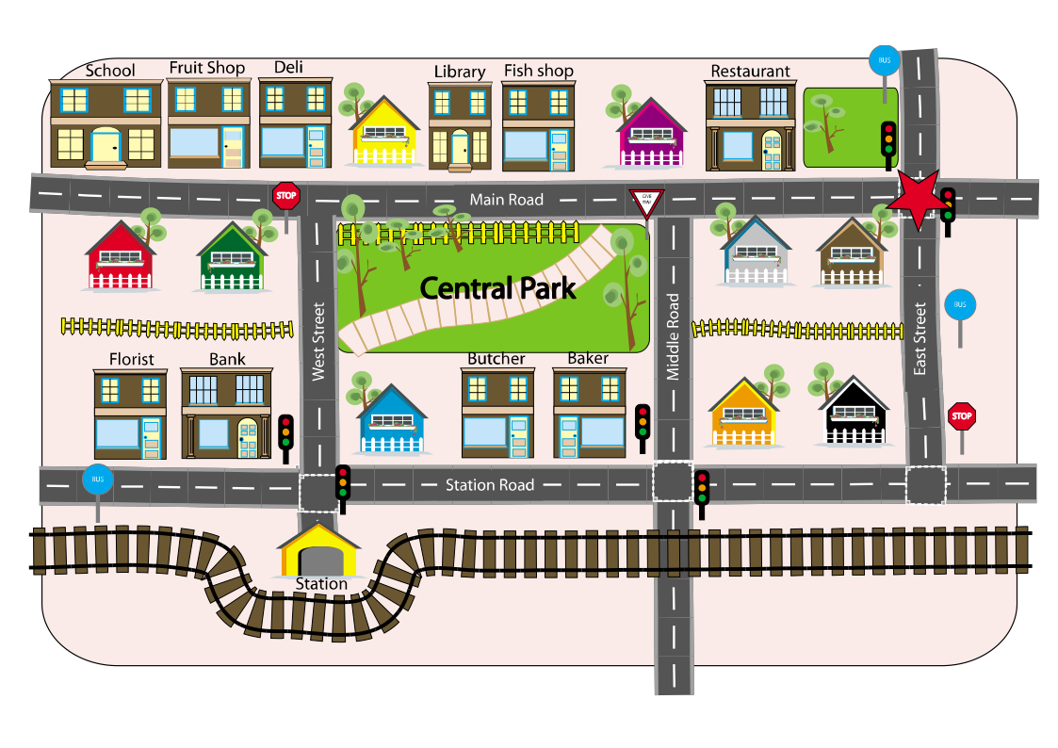

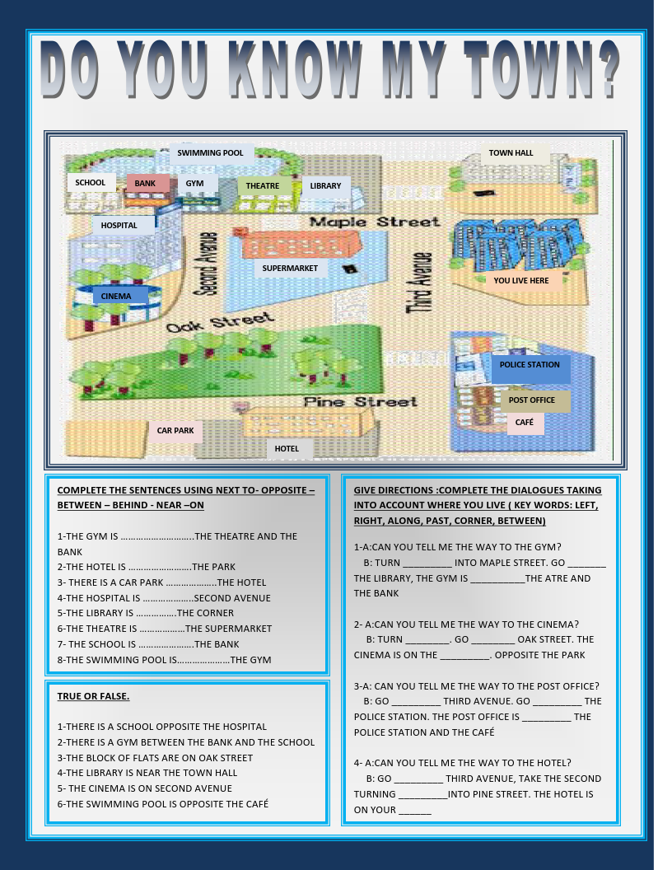
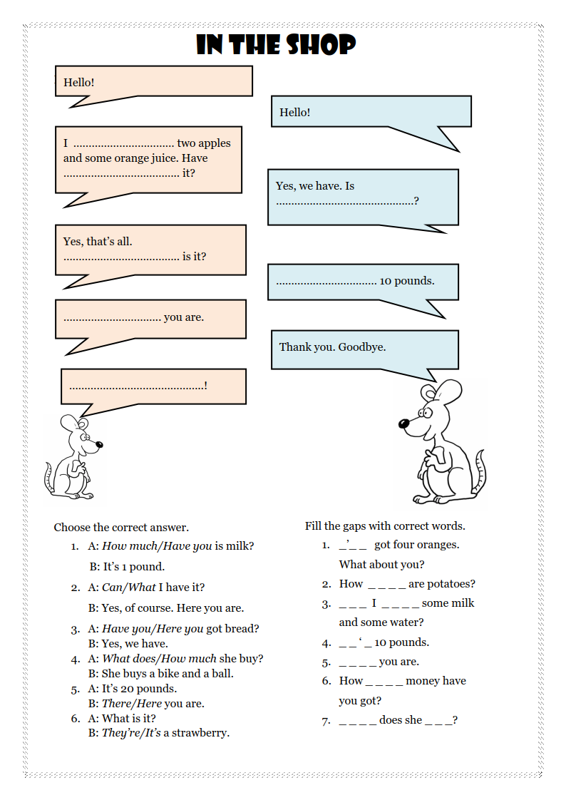
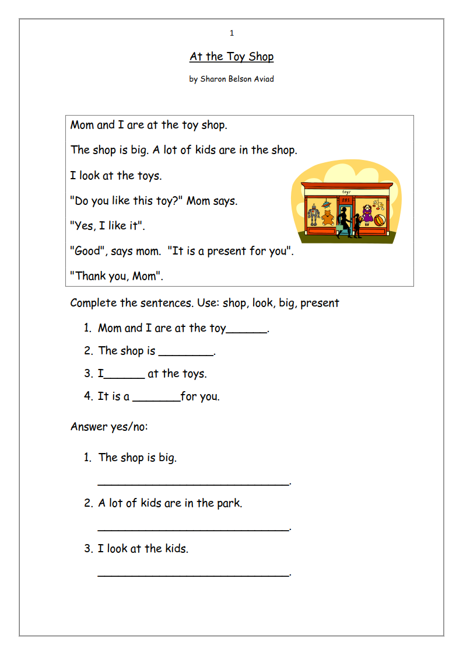
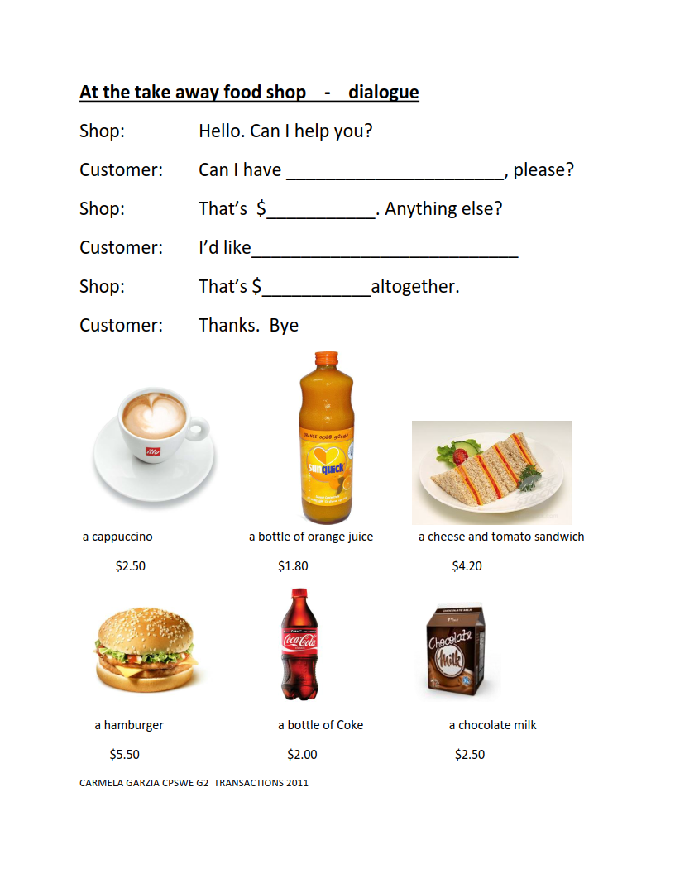
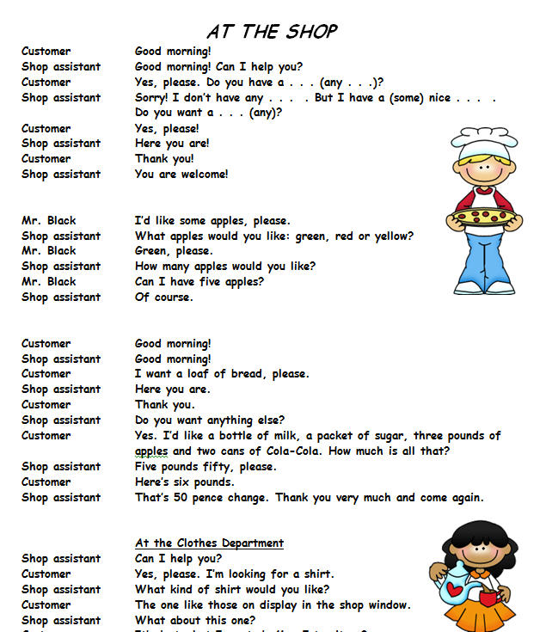
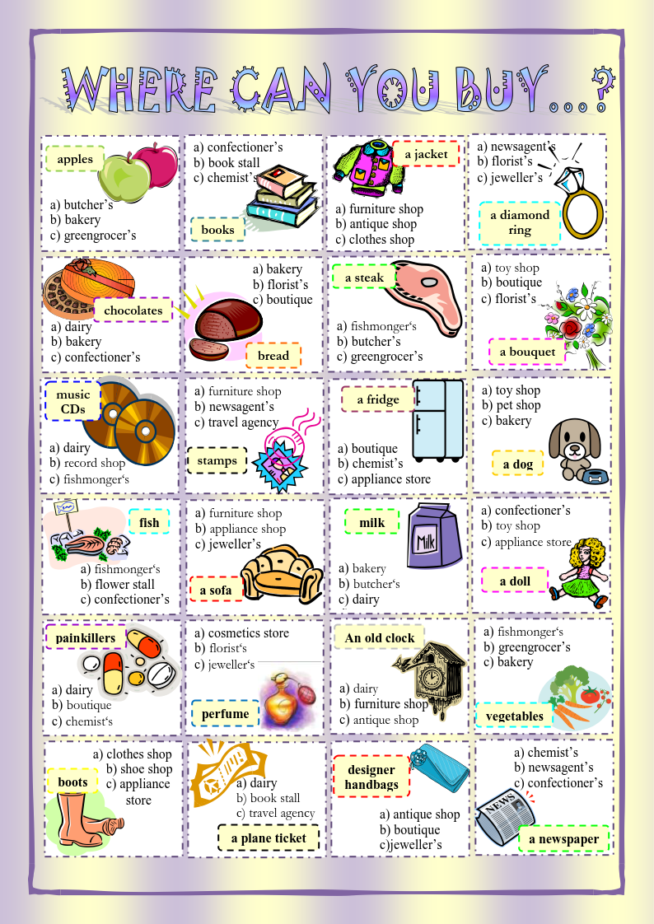

Siz istagan darslik asosidagi mavzu bo’yicha namunaviy dars ishlanmaga buyurtma berishingiz mumkin. Biz bilan bog’lanish +998911800985 telegram raqami, @uzteachers_admin ga xabar yuboring.
Narxi 20 ming so’m (1-9-sinflar uchun)
To’lov payme yoki click orqali
Bog’lanish faqat telegram orqali. Telefon qilinganda yoki sms yozilganda javob bermasligim ehtimoli yuqori

