______________ VILOYATI _________ TUMANI XALQ TA’LIMI BO’LIMIGA QARASHLI
___-SONLI O’RTA TA”LIM MAKTABI
INGLIZ TILI FANI O’QITUVCHISI
_______________________________NING
3-sinflar uchun Unit 6. Lesson 1
Butterfly, fly
mavzusida 1 soatlik
Dars ishlanmasi
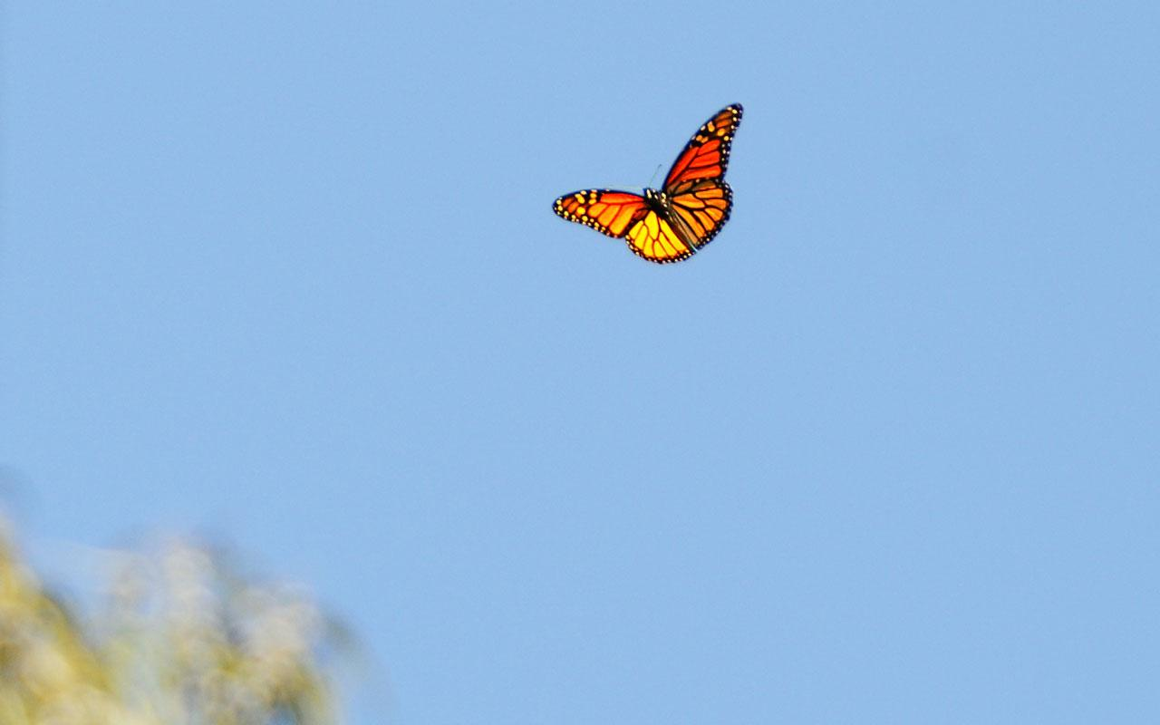
_______________-2020
Date_____ Form_____ Subject: English
Theme: Butterfly, fly
Aims:
Educational: - to learn to say, and write about some insects
Developing: - to enable pupils to say, read and w rite about some insects;
- to enable pupils to write questions and answers about insects
Socio-cultural: - to raise awareness of insects
Up bringing: - to enrich pupils’ knowledge of the name of insects

Learning outcomes: At the end of the lesson pupils will be able to :
- name some of the insects
- sing song about butterfly
Competence: SC1, FLCC, and PC
Type of the lesson: Mixed, group work, pair-work, individual work
Method of the lesson: nontraditional, mixed
Equipment of the lesson: Textbook “Kids’ English 3”, “ Workbook 3“ pictures, internet, computers, projector

TECHNOLOGICAL MAP OF THE LESSON:

№ | Part of the lesson | Tasks | Time
1 | Organizational  Moment | -to greet pupils.  - to check up the register | 5 min
2 | Repeating last lesson | - to give pupils some questions about last lesson. – to ask words from previous lesson | 5 min
3 | Explaining new theme | - to explain to pupils new vocabulary and theme | 20 min
4 | Consolidating new theme. | - to consolidate new theme and new words of the theme. | 10 min
5 | Marking. | - To mark pupils | 5 min
6 | Homework. | - Giving homework.

Procedure of the lesson:
I. Organizing moment: Motivation, Greeting, checking attendance, season, weather, checking the preparation for the lesson.
II. Asking homework:
- Check for homework given on past lesson.
- Ask pupils all new words learnt on previous lesson.

III. Pre-activity:
Activity 1 L isten and repeat. 5 min
Objective: to warm up
Step 1: Play the DVD. A sk the pupils to listen to the song and say what the song is about (answer: A sk what the “ butterfly )” is in mother tongue.
Step 2: Play the DVD again and ask the pupils to sing together with the DVD.
DVD script:
Fly, fly , fly , the butterfly ,
In the meadow is flying high
In the garden is flying low
Fly, fly , fly , the butterfly .
( the couplet above is repeated four times)

IV. Main part
Activity 2 Look and say. 5 min
Objectives: to revise the topic of weather;
to raise awareness of the day’s weather.
Invite all the pupils to the classroom window and ask Yes /No questions about the day’s weather which require negative answers. After a few such questions, ask: “What’s the weather” to which the pupils give the right answer about that day as shown in the example below,
e.g.
You: Is it rainy?
Pupils: No, it isn’t.
You: Is it sunny?
Pupils: No, it isn’t.
You: What’s the weather?
Pupils: I t’s cloudy.

Activity 3a Look, listen and repeat. 5 min
Objective: to in troduce the new voca bulary
Step 1: Ask the pupils to look at the first picture and the word “ ant” . Ask what “ ant” is in mother tongue. Then ask them to look at the second picture and the word “ mosquito” . Elicit what the translation can be in m other tongue. Then do the same with the other two pictures and the word “ insect” .
Step 2: After the pupils get the m eaning, you can ask them to repeat the words after you or the DVD in chorus, rows and individually.
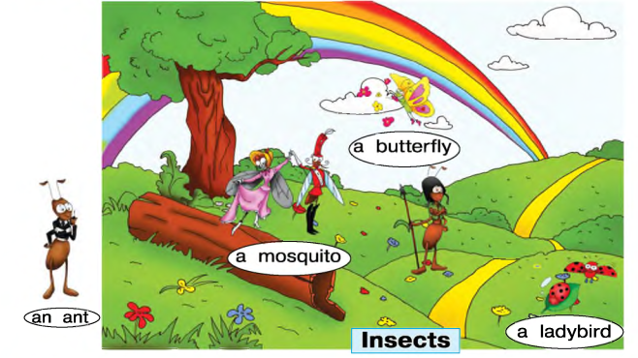
Activity 3b Work in pairs. Point and say. 5 min
Objective: to con solid a te the newly introduced vocabulary
This is a usual “Point and say” activity. Pupil 1 points to, for example, a ladybird. Pupil 2 says: a ladybird Then they change roles.
Activity 4 Play “Fly Swat”. 5 min
Objective: to consolidate the newly introduced vocabulary
You can play the game in two versions:
Version 1: Divide the class into two teams. Stick the flashcards with the insects in 3a on the board. Say a word, the pupils run and slam the card. They repeat what you said to gain a point fo r their team.
Version 2: Get the pupils to sit in a circle. (This is usually possible when the group is sm all.) Show them the flashcards and say the words. Then put the flashcards on the floor or table. When you say a word, the pupils slam the card.
Activity 5a Colour and watch. 10 min
Objectives: to have fun;
to prepare for the next activity.
Step 1: Prepare beforehand two model butterflies (Lucy and Lee) enough for each pupil in the class.
Step 2: Give the model butterflies to the pupils. The pupils colour their butterflies: Lucy in one colou r and the Lee in another. Then they wear the butterfly Lucy on their right fingers and the butterfly Lee on their left fingers. A sk: Where is Lucy? the
pupils show. A sk again: Where is Lee? the pupils show. Then ask the pupils to watch the DVD, listen and repeat the poem /song with gestures.
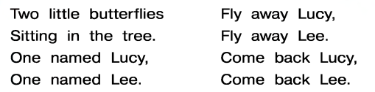

V. Post-activity
Activity 5b Work in pairs. Play “ Two little butterflies ” . 5 min
Objective: to have fun
Ask the pupils to repeat the poem /son g the second /third time togeth er with you without the DVD. Then the pupils do the activity in pairs.
VI. Homework 2 min
Ask the pupils to open their Workbook s at Page 30. Draw their attention to Activity la . Explain that at home they must match the questions and answers as shown in the
example, and find the animal. When they fin d the animal, the must put a tick next to its picture.
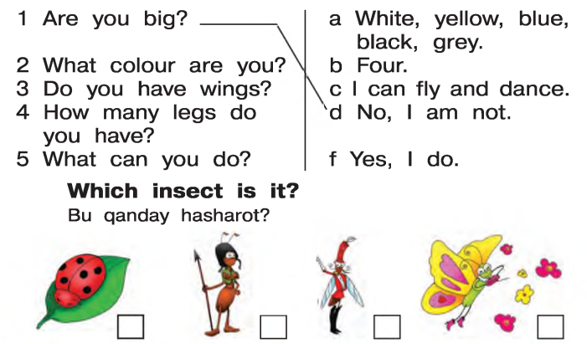
Then draw their attention to the second homework activ ity ( l b ) .
Explain that they must choose any insect they learned and w rite 5 questions and answers about it on Page 34 using the question starters given there. Explain that it will be a puzzle for their friends next lesson.
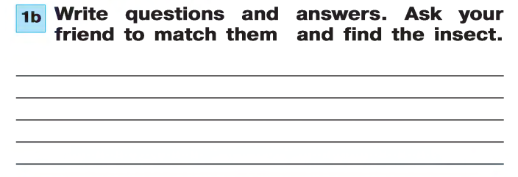VII. Evaluation. Giving marks
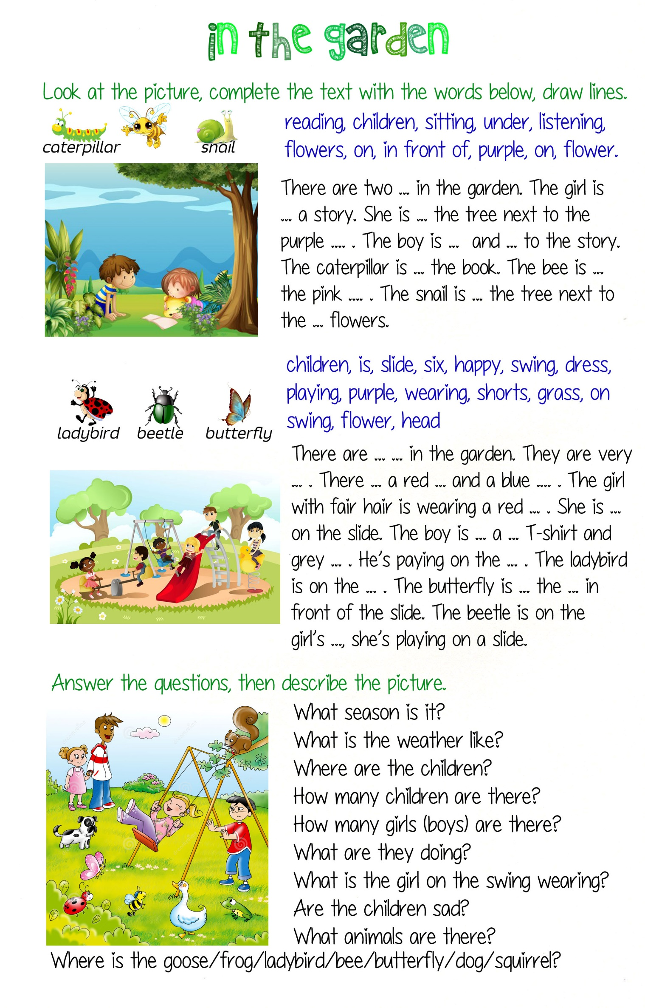

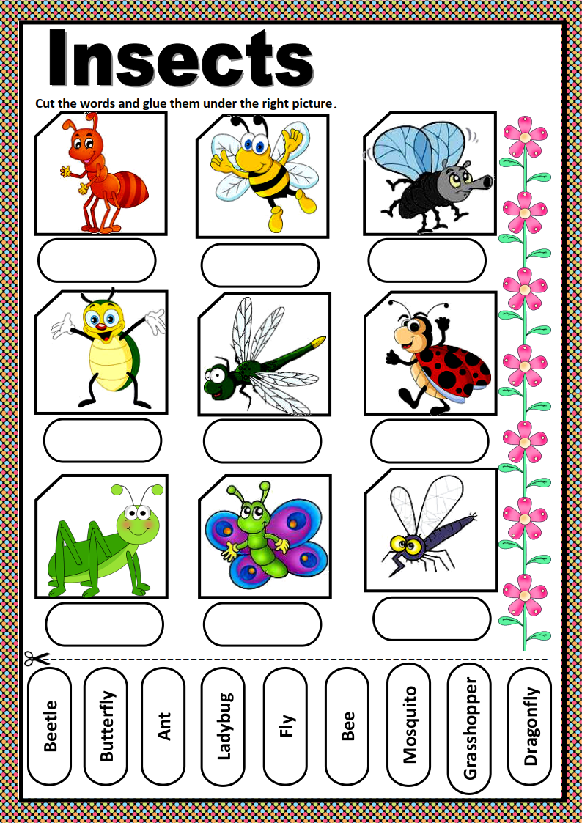
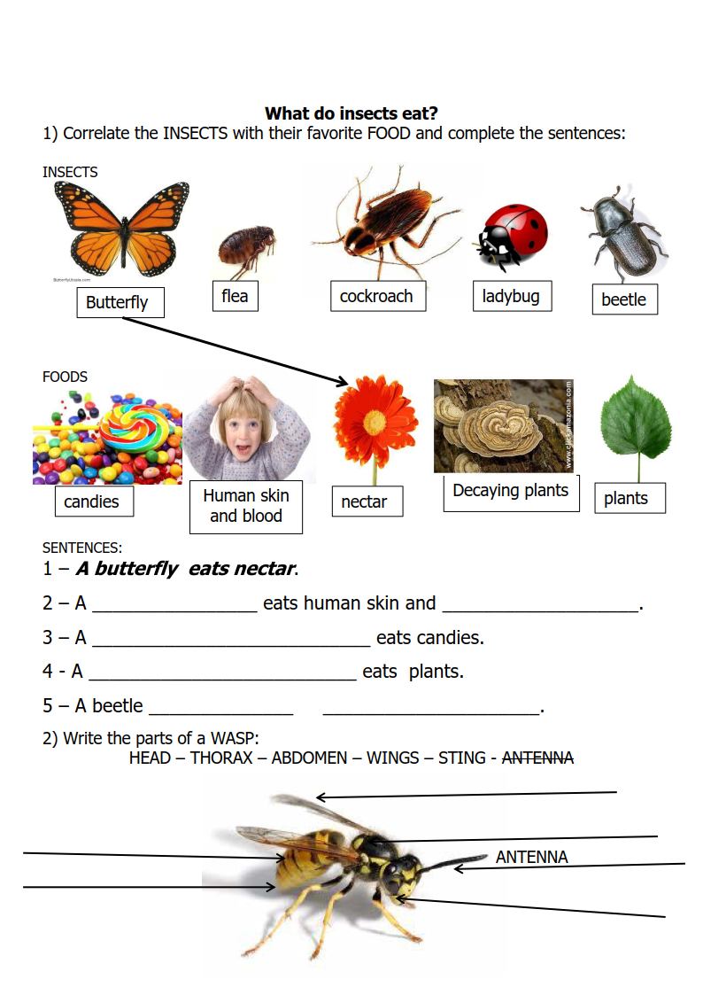
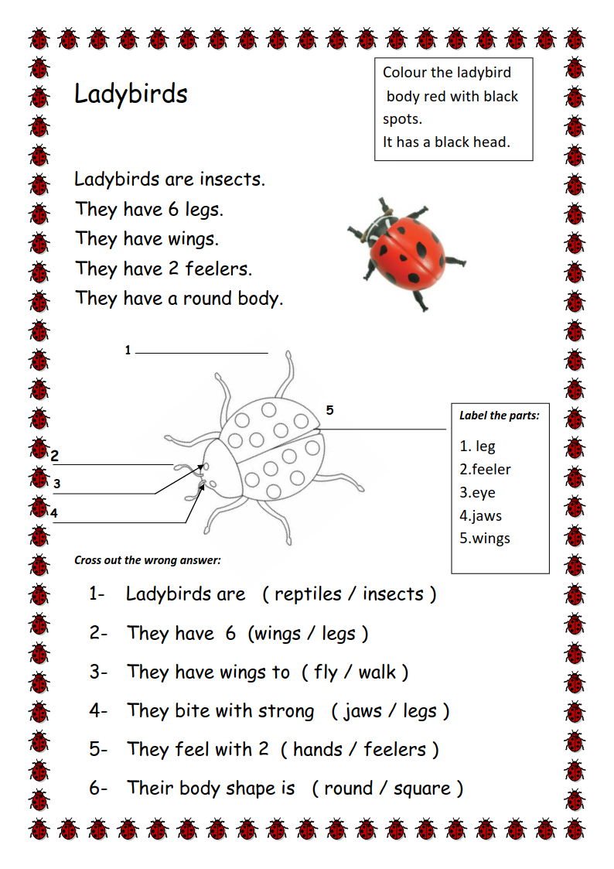
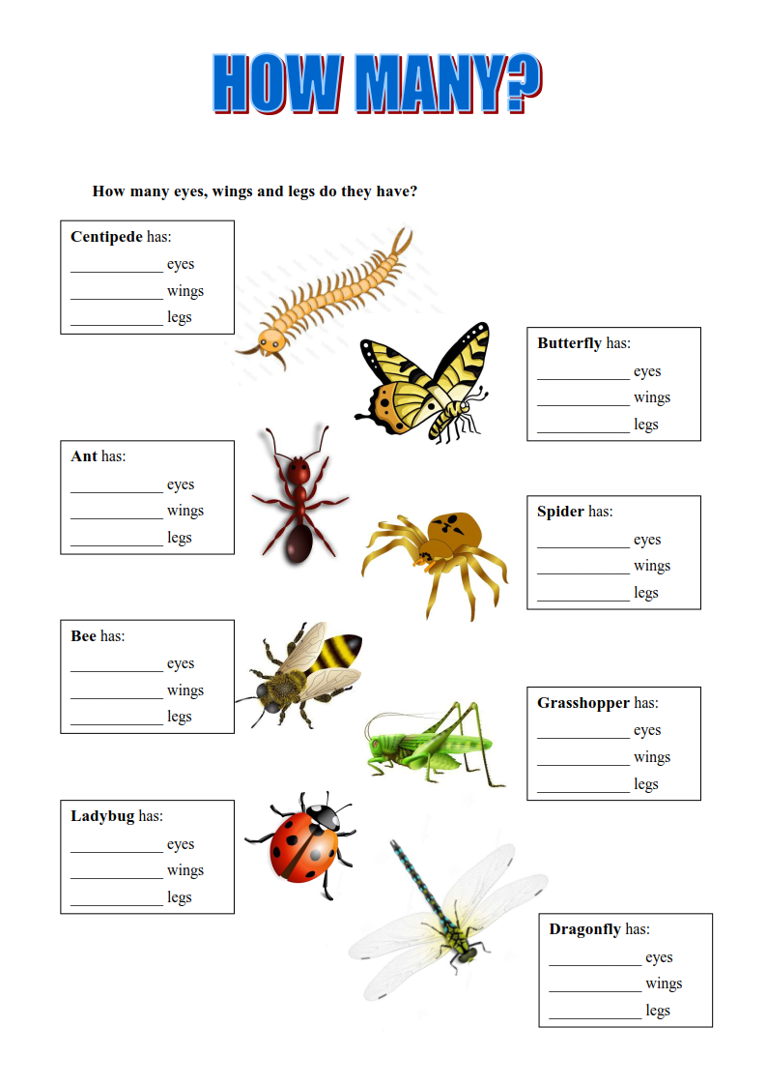

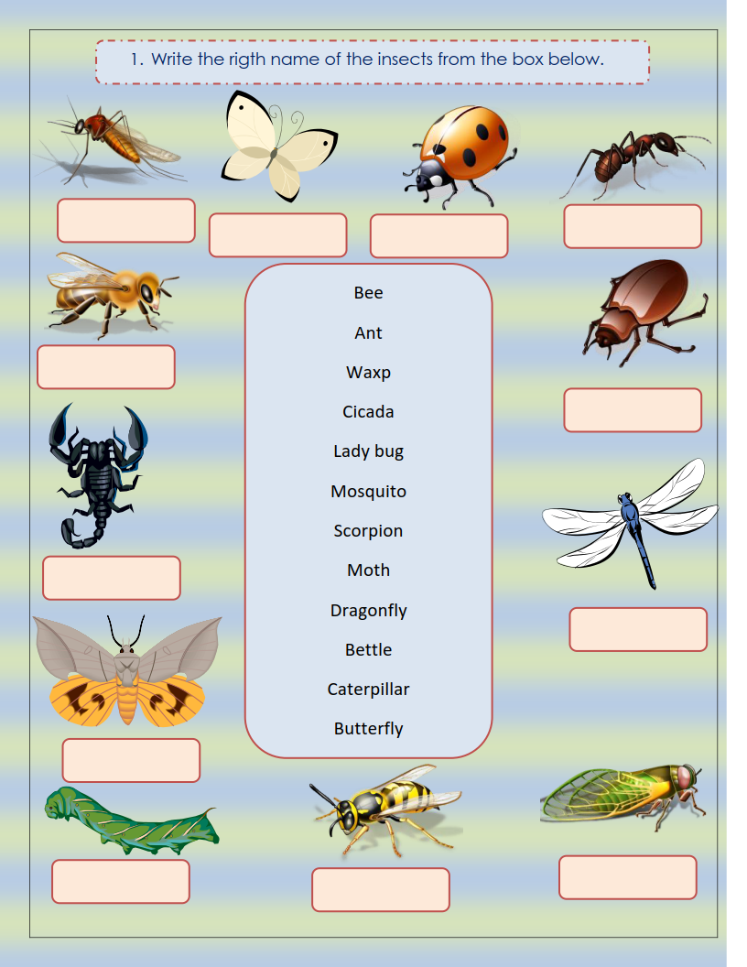

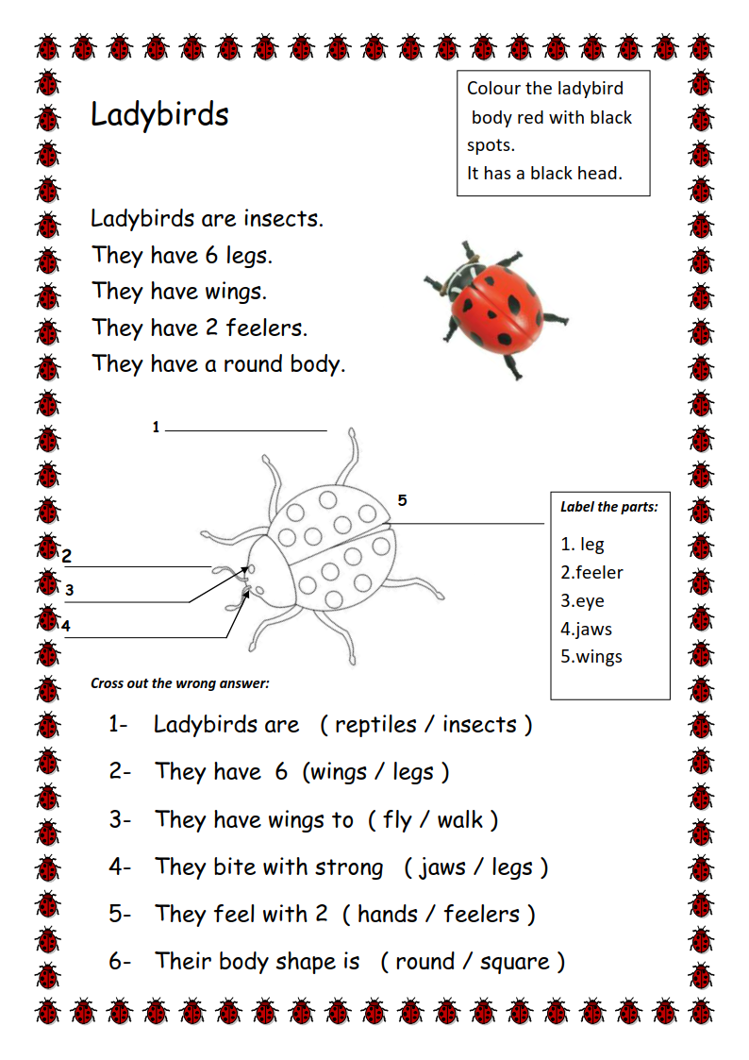
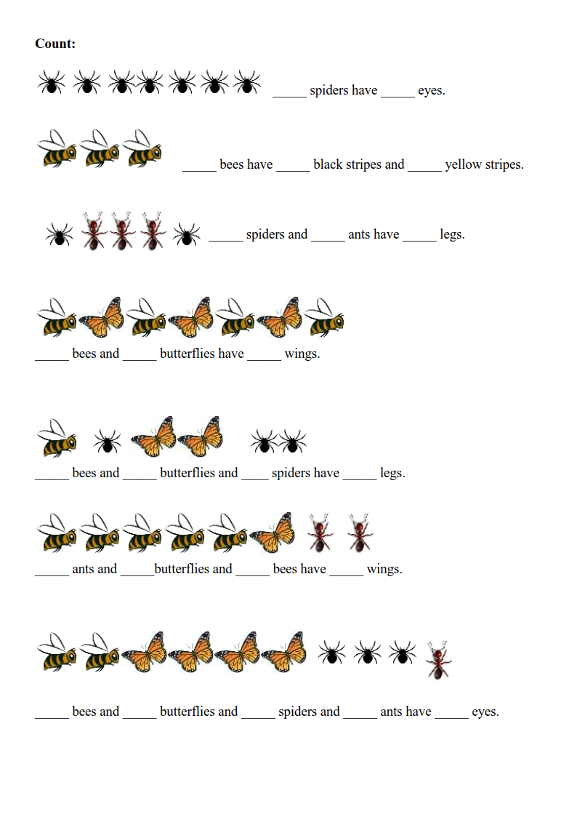

Siz istagan darslik asosidagi mavzu bo’yicha namunaviy dars ishlanmaga buyurtma berishingiz mumkin. Biz bilan bog’lanish +998911800985 telegram raqami, @uzteachers_admin ga xabar yuboring.
Narxi 20 ming so’m (1-9-sinflar uchun)
To’lov payme yoki click orqali
Bog’lanish faqat telegram orqali. Telefon qilinganda yoki sms yozilganda javob bermasligim ehtimoli yuqori

