______________ VILOYATI _________ TUMANI XALQ TA’LIMI BO’LIMIGA QARASHLI
___-SONLI O’RTA TA”LIM MAKTABI
INGLIZ TILI FANI O’QITUVCHISI
_______________________________NING
2-sinflar uchun Unit 1. Lesson 3
This is my friend
mavzusida 1 soatlik

Dars ishlanmasi

_______________-2020
Date_____ Form_____ Subject: English
Theme: This is my friend
Aims:
Educational: - to learn two more letters: Ee and Ff; - to practise Class 1 vocabulary (This is my friend. My name’s... . Her\his name’s...)
Developing: - to enable pupils to identify the difference between “his” and“her”;
- to enable pupils to say about themselves and their friends with target structures.
Socio-cultural: - to raise awareness of the difference between “he”–“she” and “his”– “her”; - to raise awareness of different pronunciation of the letter; “E” and single pronunciation of “F”.
Up bringing: - to enrich pupils’ knowledge of our tradition and nation
Learning outcomes: At the end of the lesson pupils will be able to - recognise, say
and write the letters Ee and Ff; - say about themselves and their friends with structures “My name’s … This is my friend. His/ her name’s ...”; - recognise different pronunciation of the letter “E” sounds and single pronunciation of “F”.;
Competence: SC1, FLCC, and PC
Type of the lesson: Mixed, group work, pair-work, individual work
Method of the lesson: nontraditional, mixed
Equipment of the lesson: Textbook “Kids’ English 2”, pictures, internet, computers, projector
TECHNOLOGICAL MAP OF THE LESSON:

№ | Part of the lesson | Tasks | Time
1 | Organizational  Moment | -to greet pupils.  - to check up the register | 5 min
2 | Repeating last lesson | - to give pupils some questions about last lesson. – to ask words from previous lesson | 5 min
3 | Explaining new theme | - to explain to pupils new vocabulary and theme | 20 min
4 | Consolidating new theme. | - to consolidate new theme and new words of the theme. | 10 min
5 | Marking. | - To mark pupils | 5 min
6 | Homework. | - Giving homework.

Procedure of the lesson:
I. Organizing moment: Motivation, Greeting, checking attendance, season, weather, checking the preparation for the lesson.
II. Asking homework:
- Check for homework given on past lesson.
- Ask pupils all new words learnt on previous lesson.

III. Pre-activity:
Activity 1 Listen and sing. 5 min
Objectives: to warm up;
to create an English speaking atmosphere
Say: ‘Stand up please. Good morning class.’ Use gestures so the pupils stand up.
Say: ‘How are you?’ Get answers from the pupils.
Say: ‘Sit down please.’ Use gestures so the pupils sit down.
Show the pupils the textbook. Say: ‘Take out your books.’ Make sure all the children have their Pupil’s Book.
Say: ‘Open your books on Page 10.’ Point to Activity 1. Use gestures and wait for all children to open their textbooks. Check they have the correct page.
Say: ‘Listen to the song “Rain, rain, go away” and repeat.’
Play the DVD, track ‘Rain, rain, go away’ and ask the pupils to sing.

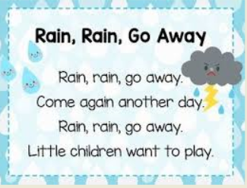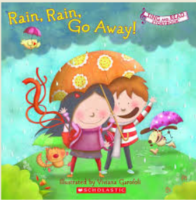

IV. Main part
Activity 2 Play “Snowball”. 10 min
Objectives: to revise the structures: My name’s ...; his name’s ...; her name’s ... ;
to enable pupils to identify the difference between
“he” – “she” and “his” – “her”.
Remind the pupils the difference between he-his and she-her.
Invite one boy and one girl to the board. Point to the boy and say: ‘He is a boy. His name’s ...’ (Say the pupil’s name.) Then point to a girl and say: ‘She is a girl. Her name’s ... (Say the girl’s name.)
Then say: ‘Look and listen.’ Use gestures to attract their attention.
Point to Activity 2 and play the DVD, video with “Snowball” activity.
Demonstrate with one group. Point to the 1st pupil near you and ask: ‘What’s your name?’ Pupil 1 answers: ‘My name’s ...’
Help the next pupil to say: ‘His (her) name’s …. My name’s ….’
Then ask the next pupil to repeat and say his (her) own name, etc.
Then say: ‘Let’s play this game! Stand up and make a line.’
Use the gestures to help the pupils to understand what to do.

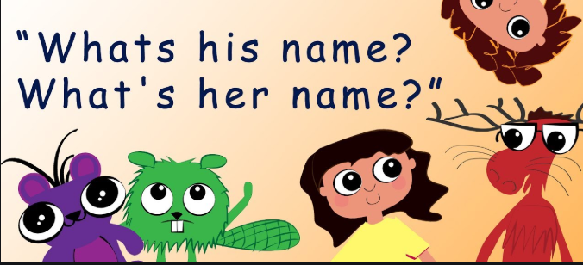

Note: If you have enough time for Optional Activities № 3 and 4, you can do them with your pupils.

Optional Activity 3 Play “This is my friend. His name’s … .”
Objective: to revise the structures: My name’s …, This is my friend, His name’s …, Her name’s … .
Step 1 Say: ‘Let’s play. We are English now.’ Calls some English names for boys and ask them to choose any they like. Start yourself. Say: ‘My name’s Diana.’ (for example).
Say: ‘Boys, listen and choose – Mike, Andrew, Bob, Andy, Harry,’ etc Then say: ‘Girls, listen and choose – Ann, Kate, Mary, Diana.’ etc
Step 2 Say: ‘Let’s play.’ Start yourself first. Shake one pupil’s hand and say: ‘Hello, my name’s Barbara’. Use mime to help the pupil to introduce himself/herself. Then shake another pupil’s hand and repeat the procedure.
Step 3 Ask the pairs to introduce their new friends to each other.
Come with one pupil to one pair and say: ‘Hello, this is my friend. His/her name’s ... .’
Ask the pupils to continue.

Optional Activity 4 Look and do.
Objectives: to do physical exercise and to energize the pupils; to introduce another physical activity.
Point to Activity 4 and say: ‘Look at the pictures.’
Say: ‘Number 1 – hands up. Number 2 – Hands down. Number
3 – Hands on the hips. Number 4 – Sit down. Number
5 – Bend to left. Number 6 – Bend to the right. Number 7 –
Hands to the sides. Number 8 – Hands down.’
Say: ‘Look and listen.’ Play the DVD, video with this activity.
Say: ‘Stand up, please. Look and do.’ Use gestures to attract their attention.
Stand in front of the pupils and do the activity together with the pupils.
Say the commands first slowly then faster and faster.
The order of the commands can vary: ‘Hands up! Hands down!
Hands on the hips! Sit down! Stand up! Hands to the sides!
Bend to the left! Bend to the right!’

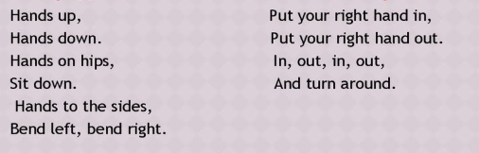

Activity 5 Write the letters. 15 min
Objectives: to learn two more letters of the alphabet – Ee and Ff;
to practise writing the letters; to consolidate the letters.
Say: ‘Look and listen.’ Play the DVD, letters E, F. Let the pupils listen to the pronunciation several times. Show the pictures.
Say: E [i:] for English (click on the picture of the English textbook) and E [e] for Elephant (click on the picture of the elephant).
F [f] for Fish (click on the pictures of the fish) and Frog (click on the picture of the frog).’
The pupils listen to the DVD and repeat.
Stand facing a board and say: ‘Look – letter E’ (show in the air that you write a big letter E). Ask: ‘Repeat after me.’ (use gestures to encourage the pupils to write the letter in the air. Monitor that all pupils repeat after you.
Then say: ‘Look – letter E’ (show that you ‘write the letter C on your hand). When the pupils finish ‘writing’ on their hands, write the letter on the board.
Say: ‘Open your Workbooks on Page 8.’ Use gestures and wait for all the pupils to open the Workbooks and look at
Say: ‘Write letter E.’ Use gestures to show what to do. Go round the class and see how well the pupils write. Help if necessary.
Write on the board Ee and say: ‘Big E, small e’. Repeat the procedure you have done to teach E.
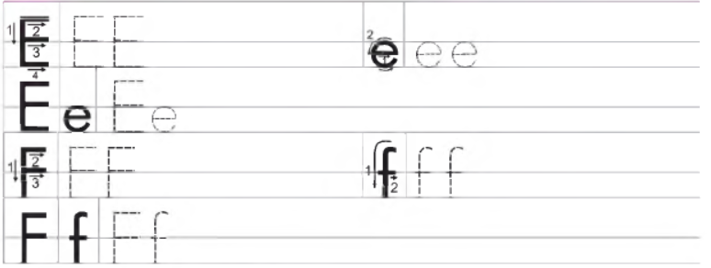

Repeat the procedure to teach Ff.
Optional activity
Say: ‘Now look at this activity.’ Point to the next task.
Draw the pictures from the first line on the board and demonstrate how to do the activity. Say: ‘Circle the odd one.’ And circle a cucumber.
Answer Key: 1 – cucumber; 2 – three; 3 – apple; 4 – ball.

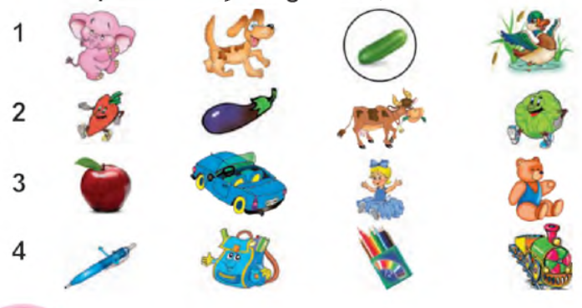

V. Post-activity
Activity 6 Play “Letters”. 10 min
Objective: to consolidate the letters learnt so far
Say: ‘Look and listen.’ Use gestures to attract their attention.
Play the DVD, video with “Letters” activity.
Say: ‘Repeat the letters and words from the video.’ Use the gesture (point to the screen). Elicit all the answers. Ask the pupils to correct if someone is wrong.
Say: ‘Stand up, please!’ Wait for all the pupils to stand up.
Make a circle. Use the gesture to explain what to do. Give a ball to any pupil and say: ‘A.’ Help the pupil to say any word which starts with this letter.
Note: If necessary, revise the letters and words and/or put the cards with letters and words on the board.
VI. Homework
VII. Consolidation

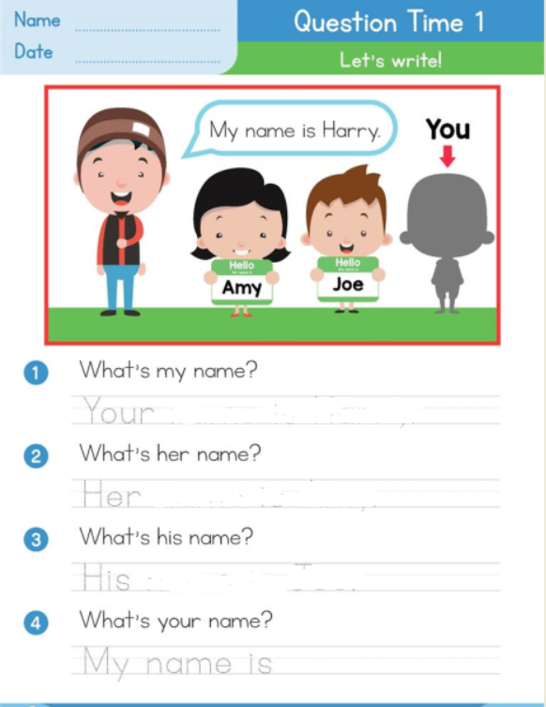

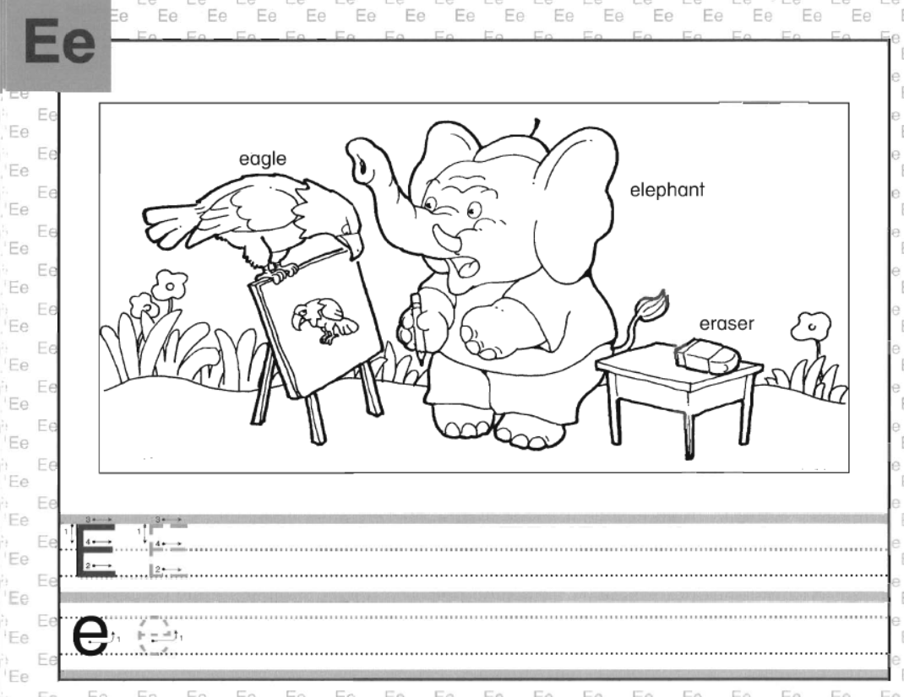

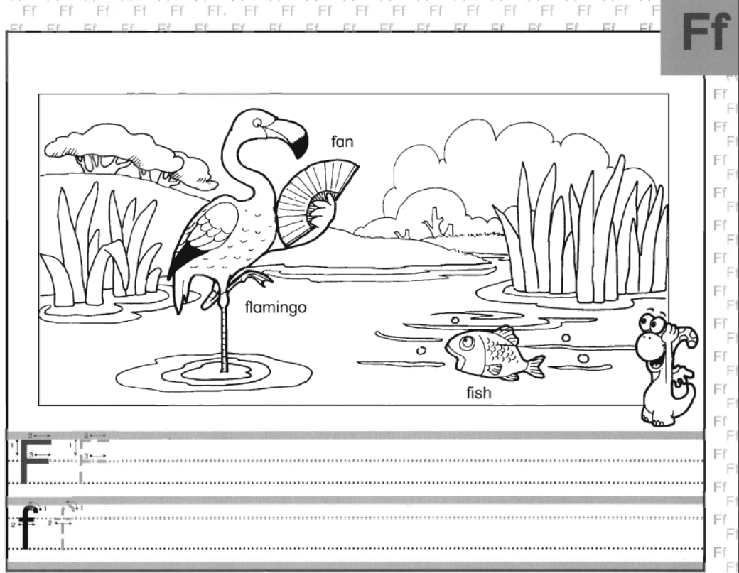

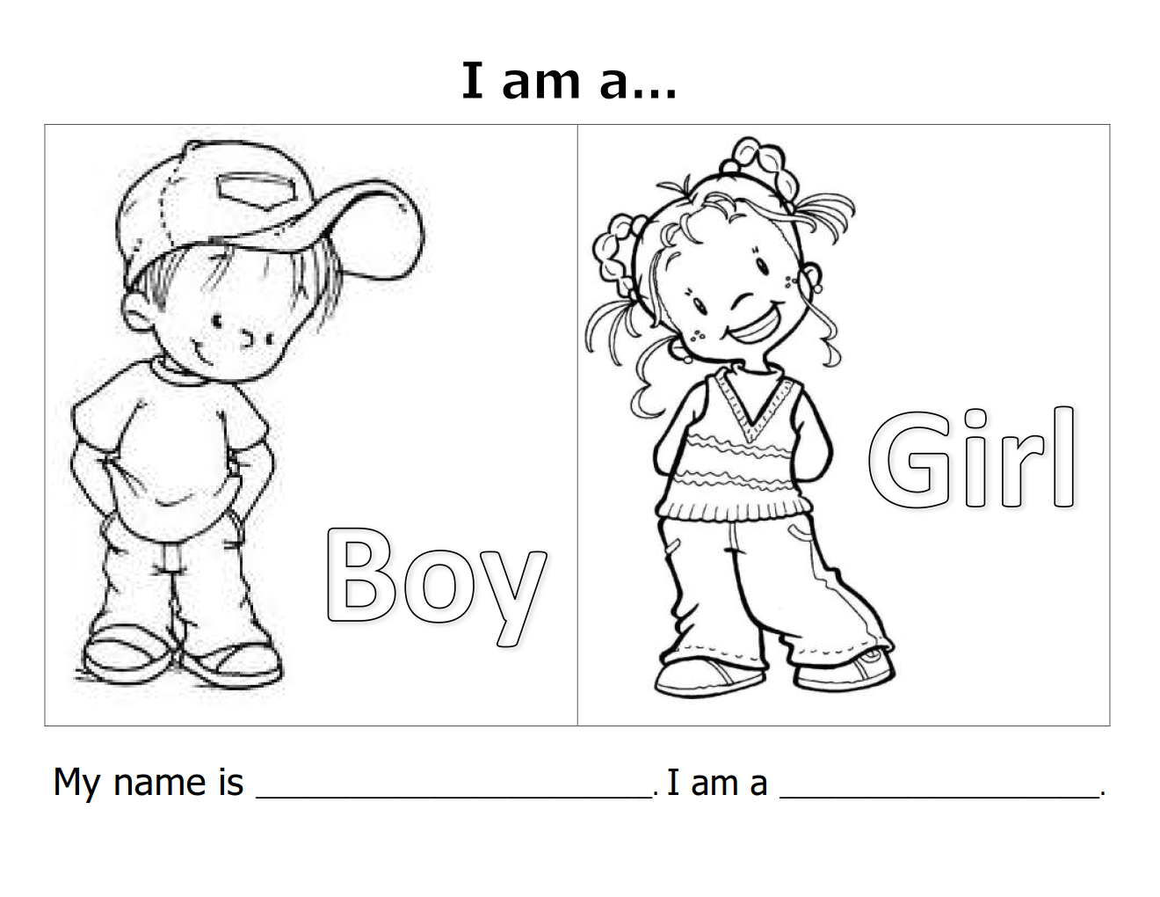

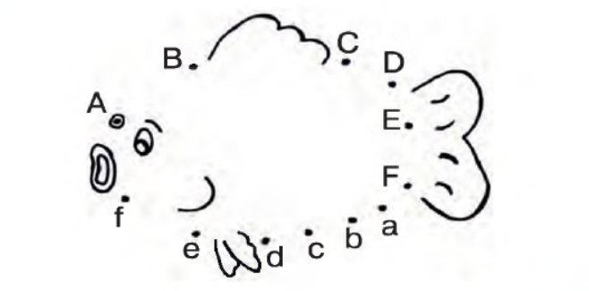

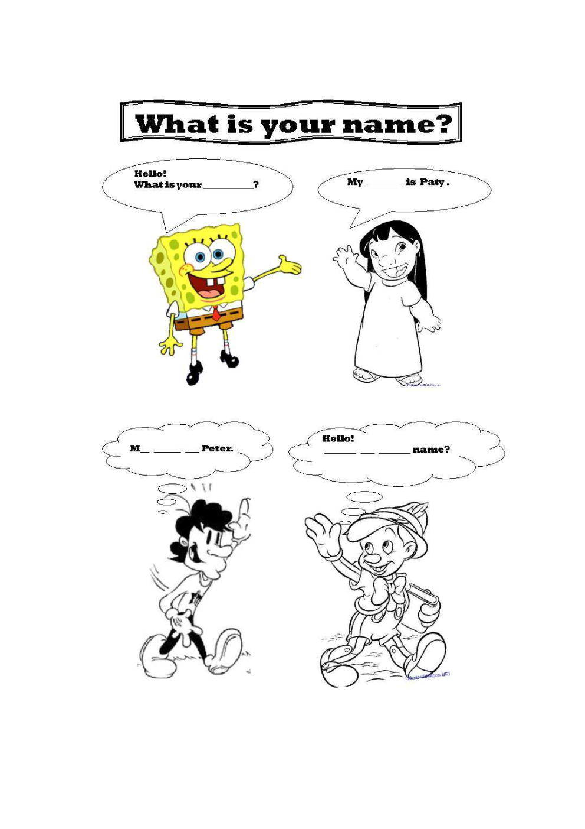

Siz istagan darslik asosidagi mavzu bo’yicha namunaviy dars ishlanmaga buyurtma berishingiz mumkin. Biz bilan bog’lanish +998911800985 telegram raqami, @uzteachers_admin ga xabar yuboring.
Narxi 20 ming so’m (1-9-sinflar uchun)
To’lov payme yoki click orqali
Bog’lanish faqat telegram orqali. Telefon qilinganda yoki sms yozilganda javob bermasligim ehtimoli yuqori

