______________ VILOYATI _________ TUMANI MAKTABGACHA VA MAKTAB TA’LIMI BO’LIMIGA QARASHLI
___-SONLI O’RTA TA’LIM MAKTABI
INGLIZ TILI FANI O’QITUVCHISI
_______________________________NING
11-sinflar uchun Unit 1. Lesson 3
Determiners
mavzusida 1 soatlik
Dars ishlanmasi
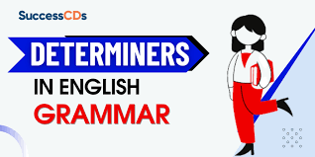
_______________-2023

Date_____ Form_____ Subject: English
Theme: Determiners
Aims:
Educational: - to learn about teenagers’ shopping habits and things they buy.
Developing: - to develop listening, reading, writing, and speaking skills
Socio-cultural: - to raise awareness of different cultures
Up bringing: - to enrich pupils’ knowledge of our tradition and nation
Learning outcomes: At the end of the lesson, pupils will be able to use learnt language in practice, ask and answer questions
Competence: SC1, FLCC, and PC
Type of the lesson: Mixed, group work, pair-work, individual work
Method of the lesson: nontraditional, mixed
Equipment of the lesson: “Prepare11” SB, WB, pictures, internet, computers, projector

TECHNOLOGICAL MAP OF THE LESSON:

№ | Part of the lesson | Tasks | Time
1 | Organizational  Moment | -to greet pupils.  - to check up the register | 5 min
2 | Repeating last lesson | - to give pupils some questions about last lesson. – to ask words from previous lesson | 5 min
3 | Explaining new theme | - to explain to pupils new vocabulary and theme | 20 min
4 | Consolidating new theme. | - to consolidate new theme and new words of the theme. | 10 min
5 | Marking. | - To mark pupils | 5 min
6 | Homework. | - Giving homework.

Procedure of the lesson:
I. Organizing moment: Motivation, Greeting, checking attendance, season, weather, checking the preparation for the lesson.
- Check for homework given on past lesson.
- Ask pupils all new words learnt on previous lesson.
II. Pre-activity:
Dictate the following words: teens, friends, make-up, food, games, hair, websites, discounts, money, shops. Draw two columns entitled ‘countable (C)’ and ‘uncountable (U)’ and ask students, in pairs or small groups, to classify the words. Ask for suggestions and write the words in the appropriate column. (C = teens, friends, games, websites, discounts, shops; U = make-up, food, hair, money).
III. Main Part
Activity 1 Read the examples and look at the nouns after the words. Which are countable and which are uncountable?
Read the instructions and do the first item with the class. Monitor and help as necessary, encouraging stronger students to say when a noun is countable or uncountable. Invite students to write words and phrases in the appropriate columns on the board to check answers.

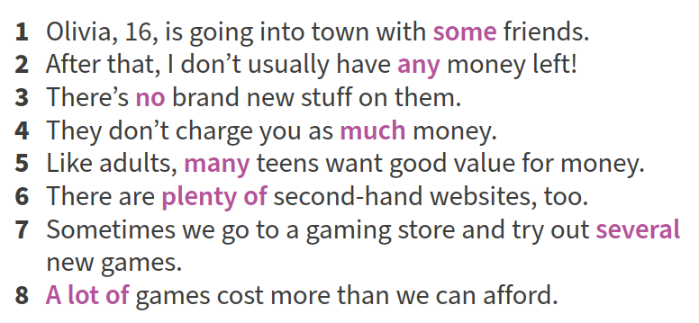

Answers
1 countable 2 uncountable 3 uncountable 4 uncountable 5 countable 6 countable 7 countable 8 countable

Activity 2 Complete the table with the words in the box. Use the examples in Exercise 1 to help you.
Copy the chart onto the board and put students into pairs to complete it. Check answers by asking students to write the answers on the board. Nominate individuals to make different sentences about their town e.g. There are some new shops opening in town.

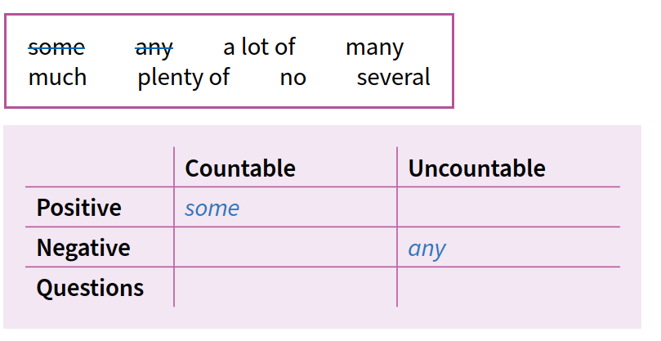

Activity 3 Listen to the short conversations. Add more determiners to the table.
Play the conversations and pause after each one for students to suggest different determiners. See if the class agrees and play the conversation again if necessary. Add the determiners to the chart on the board.

Answers 2 and 3 (Words in italics are from the conversations in Exercise 3)

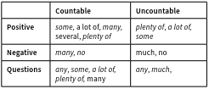

Activity 4 Choose the correct word to complete the sentences.
Direct students to find the noun (discounts) in item 1. Nominate a student to give the answer (some) and see if the class agrees before confirming. Monitor and encourage stronger students to complete the exercise without looking at the chart. Check answers as a class, and point out that we don’t use a double negative in English, for example ‘We don’t eat no special food’, item 6, is wrong.

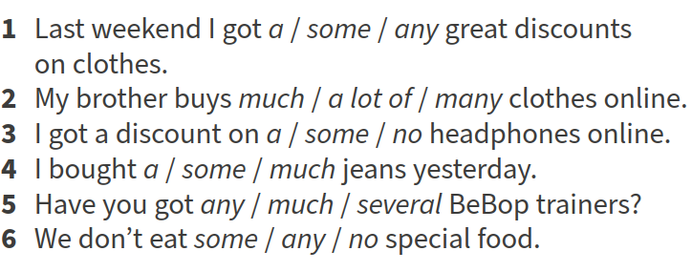
Answers
1 some 2 a lot of 3 some 4 some 5 any 6 any

Activity 5 Complete the conversation with the words in the box.
Ask students to read the conversation quickly, ignoring the gaps, and say whether or not the shopper found trainers in the right size on the website (No). Remind them to look at the information before and after the gap before they continue individually. When you check answers, make sure that students understand the difference in meaning between several (some, but not a lot) and plenty (more than enough, a large amount).
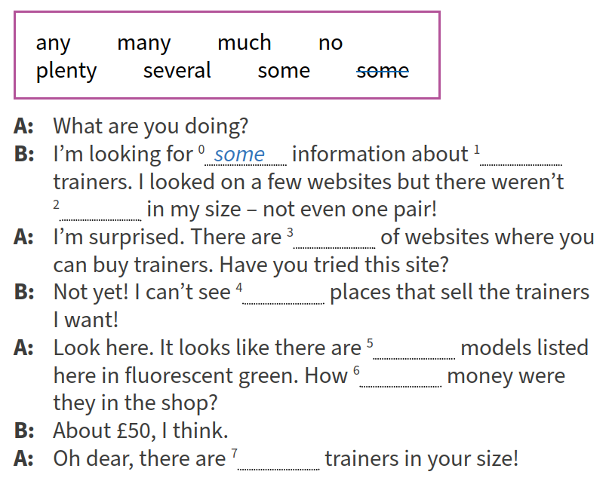

Answers
1 some 2 any 3 plenty 4 any 5 many, several, some 6 much 7 no

Activity 6 Complete the questions with the correct words. Then ask and answer the questions with a partner.
Do the exercise as a class, directing students to the chart in Exercise 2 for support. Check students understand why there are two possible answers for item 4. Nominate two strong students to take turns asking and answering in open class pairs to demonstrate the activity, and give positive feedback for accuracy and/or informative answers.

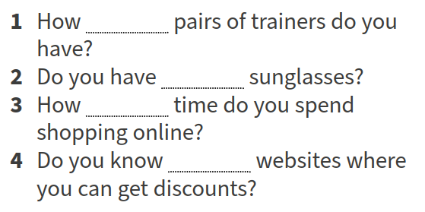

Answers
1 many 2 any 3 much 4 any / many
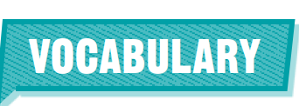
Activity 1 Read the examples. Complete the rules with the words in the box.
Write the word any on the board and ask students to think of words with any. Ask which word is used to talk about a place (anywhere); an item (anything); a person (anyone). Go through the exercise with the class. Read sentences 1–3 and the words in the box.

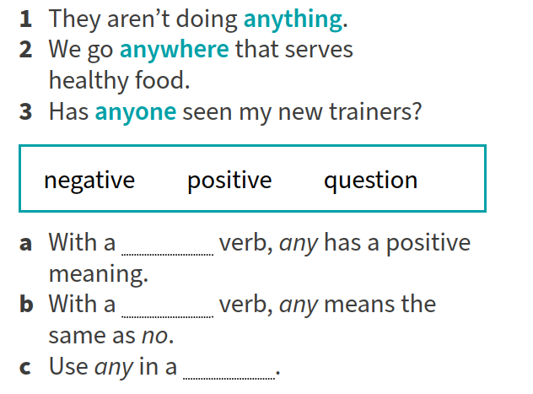

Answers
a positive b negative c question

Activity 2 What other words or phrases do you know with any?
Read the question and ask students for suggestions, without looking at their books. Write answers on the board.

Possible answers
any more, any longer, any better, any good

Activity 3 Complete the sentences with the words and phrases in the box.
Go through these phrases from the box and elicit or explain meaning. Use simple sentences to help students understand: any better = Today’s school dinner isn’t any better (the structure ‘isn’t any’ + an adjective strengthens the negative, so that it means something like not at all. This applies to the following phrases in the box: any good and any longer). Monitor as students continue individually and nominate individuals to give answers.

Answers
1 any longer / any more 2 anything 3 any good 4 anyone 5 any better 6 anywhere 7 any more

Activity 4 Work in pairs. Turn to page 120.
Direct students to page 120. Ask students to read the first question and nominate stronger students to ask and answer as open pairs for the class. Give feedback after each turn, encouraging students to continue with informative and interesting answers. Put them into same ability pairs to continue.
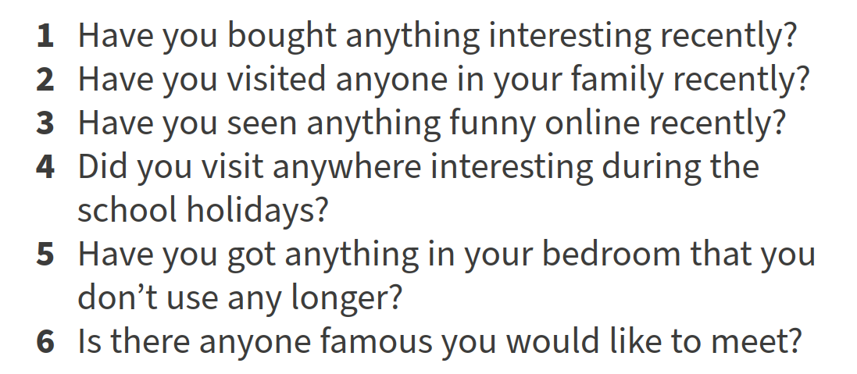

Answers
Students’ own answers
IV. Post-activity
WB Activity 1 Choose the correct word.
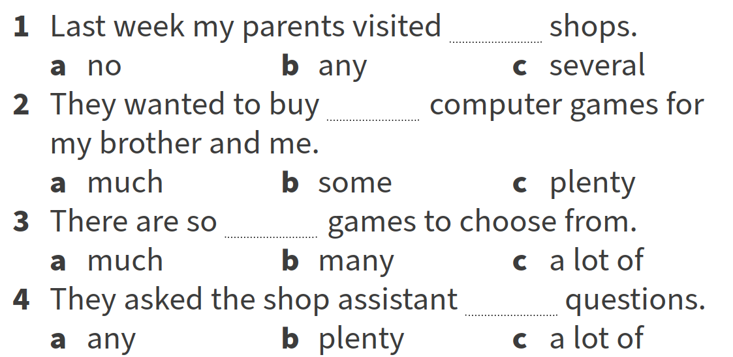
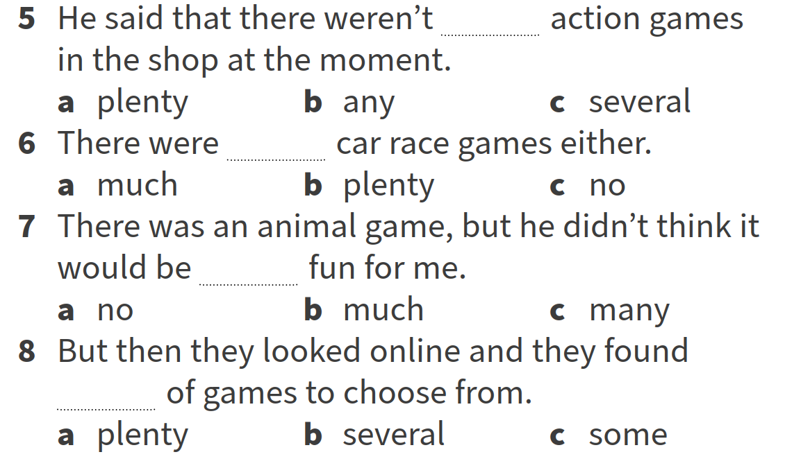

WB Activity 2 Complete the conversation with the words from the box. Use each word once only.

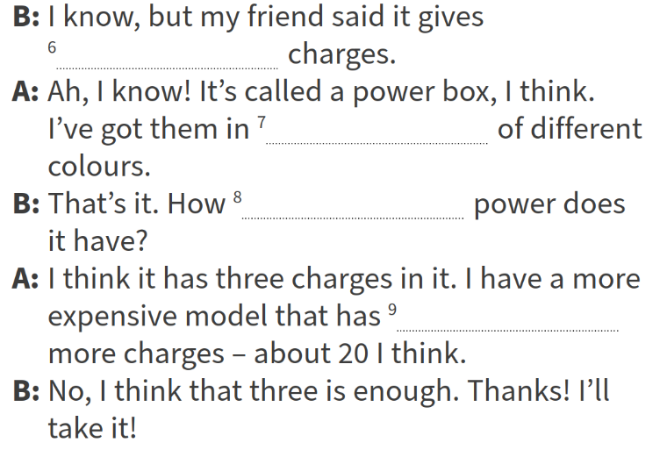
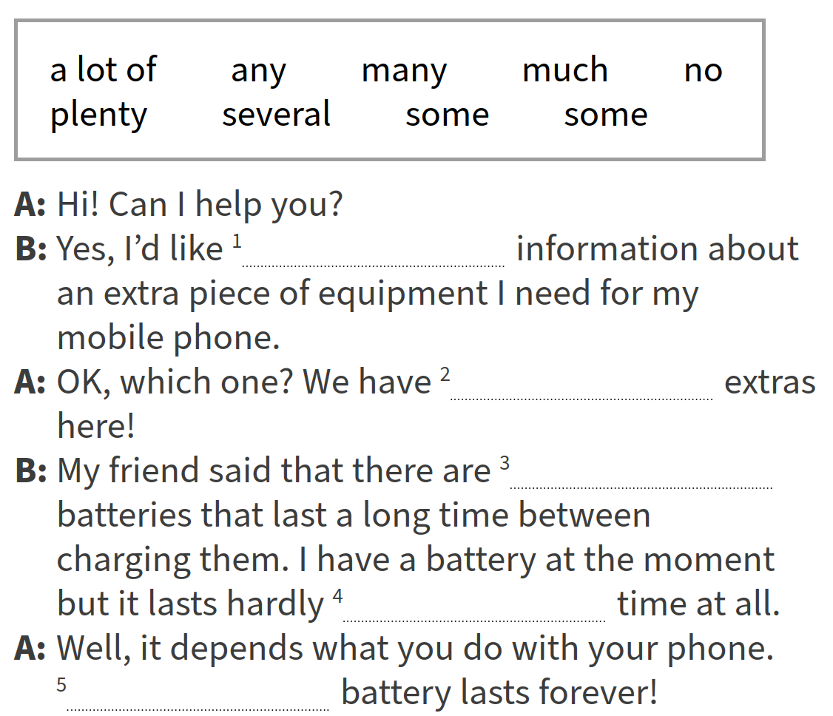

V. Homework
WB Activity 3 Choose the correct sentence in each pair.

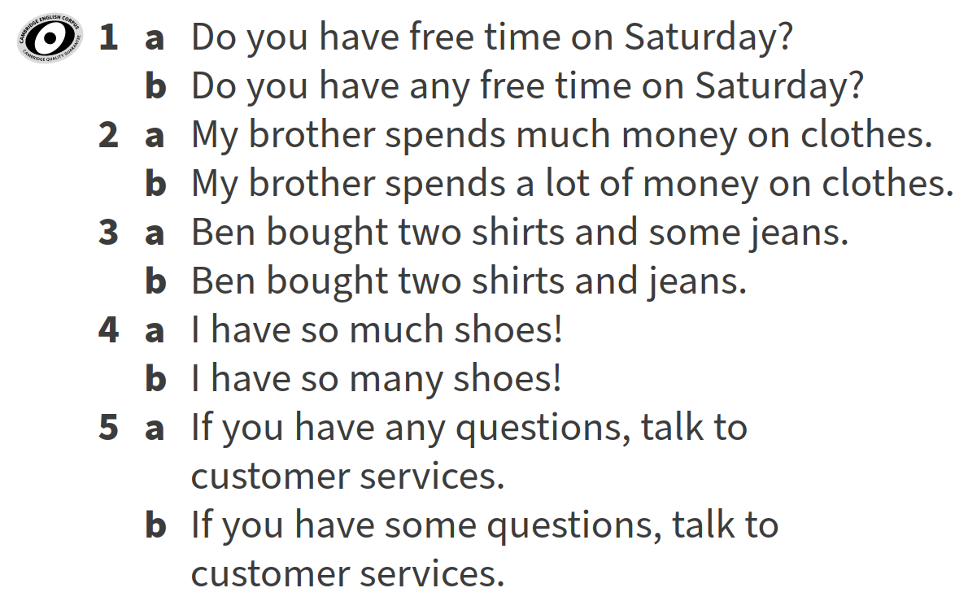

VI. Evaluation
Giving marks according to pupils’ participation to the lesson

Deputy director on educational affairs: _________ Signature: __________

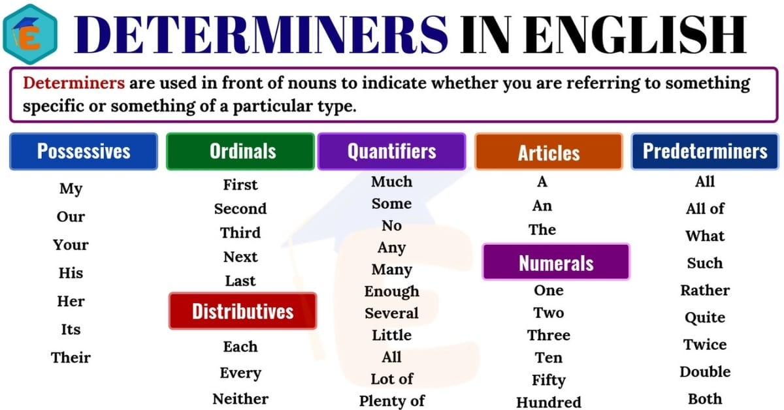

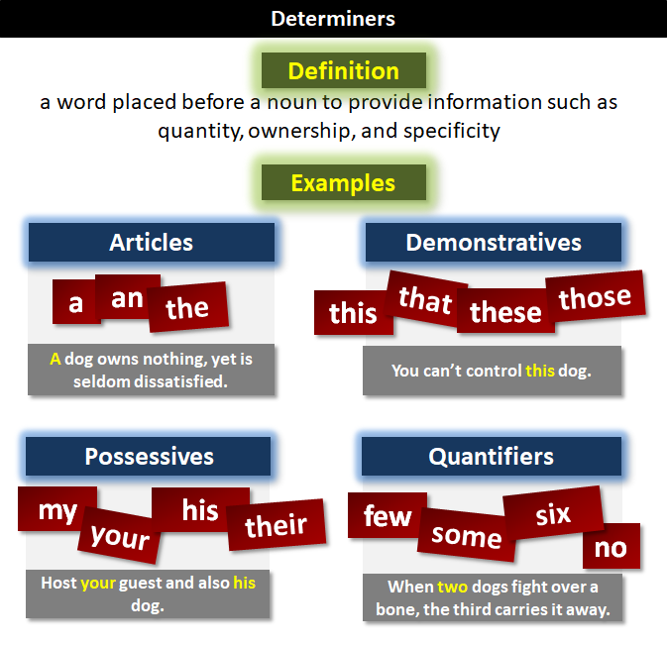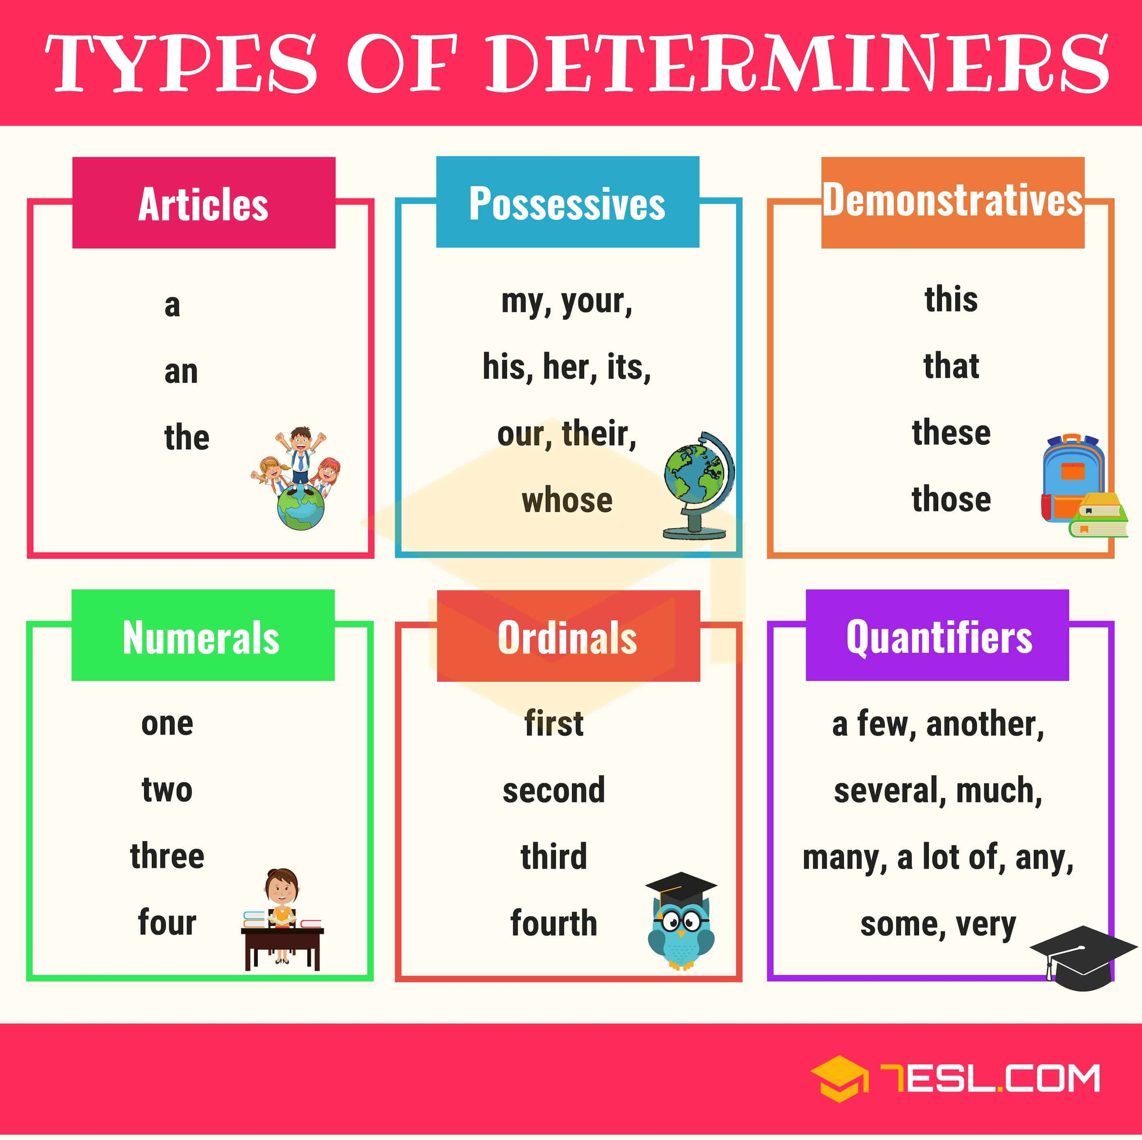
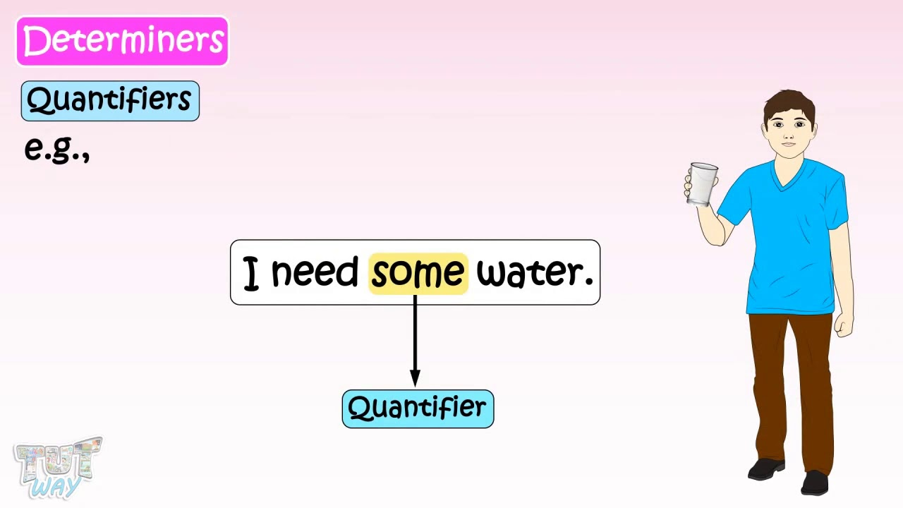
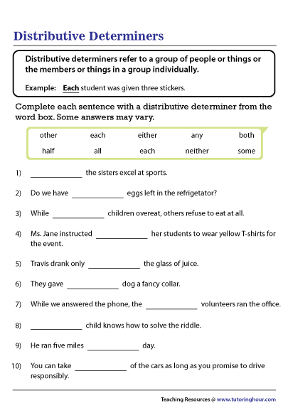
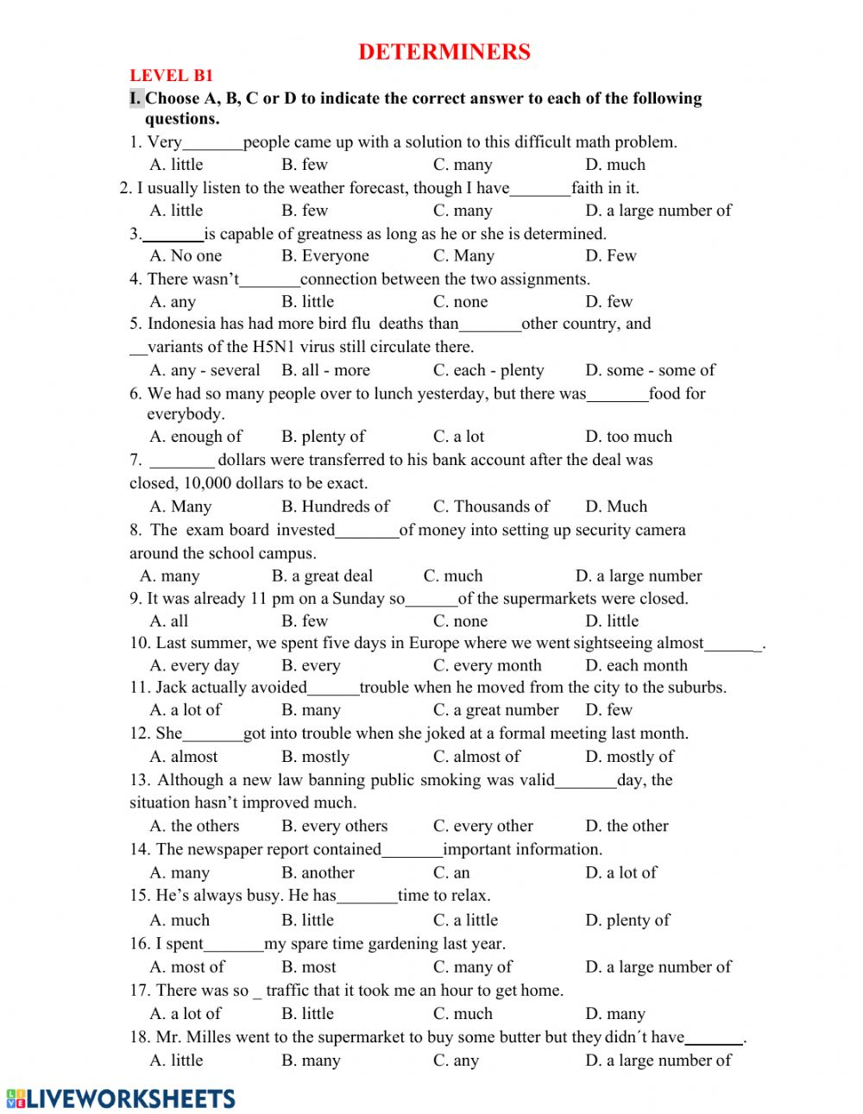

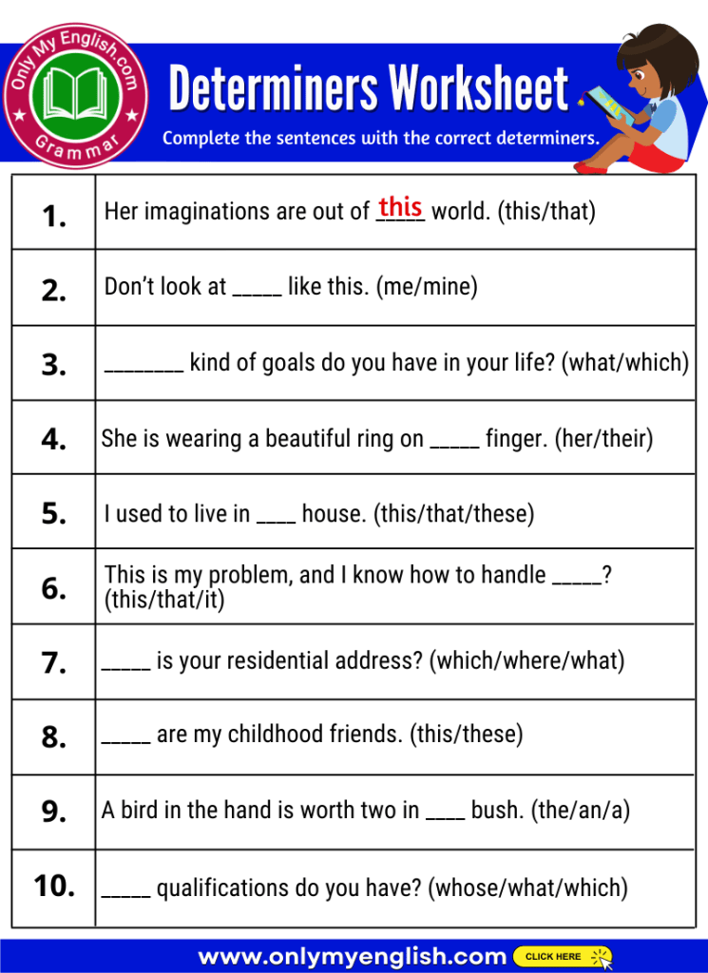

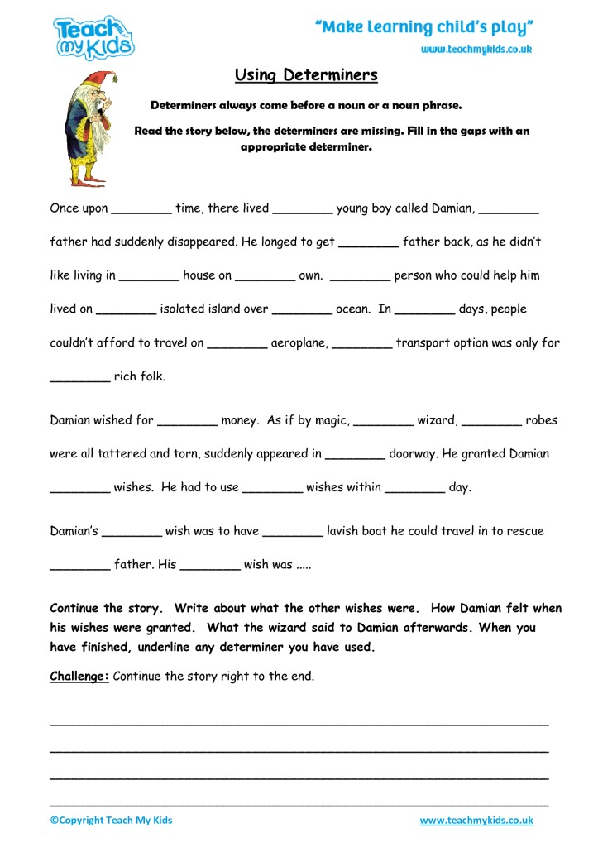

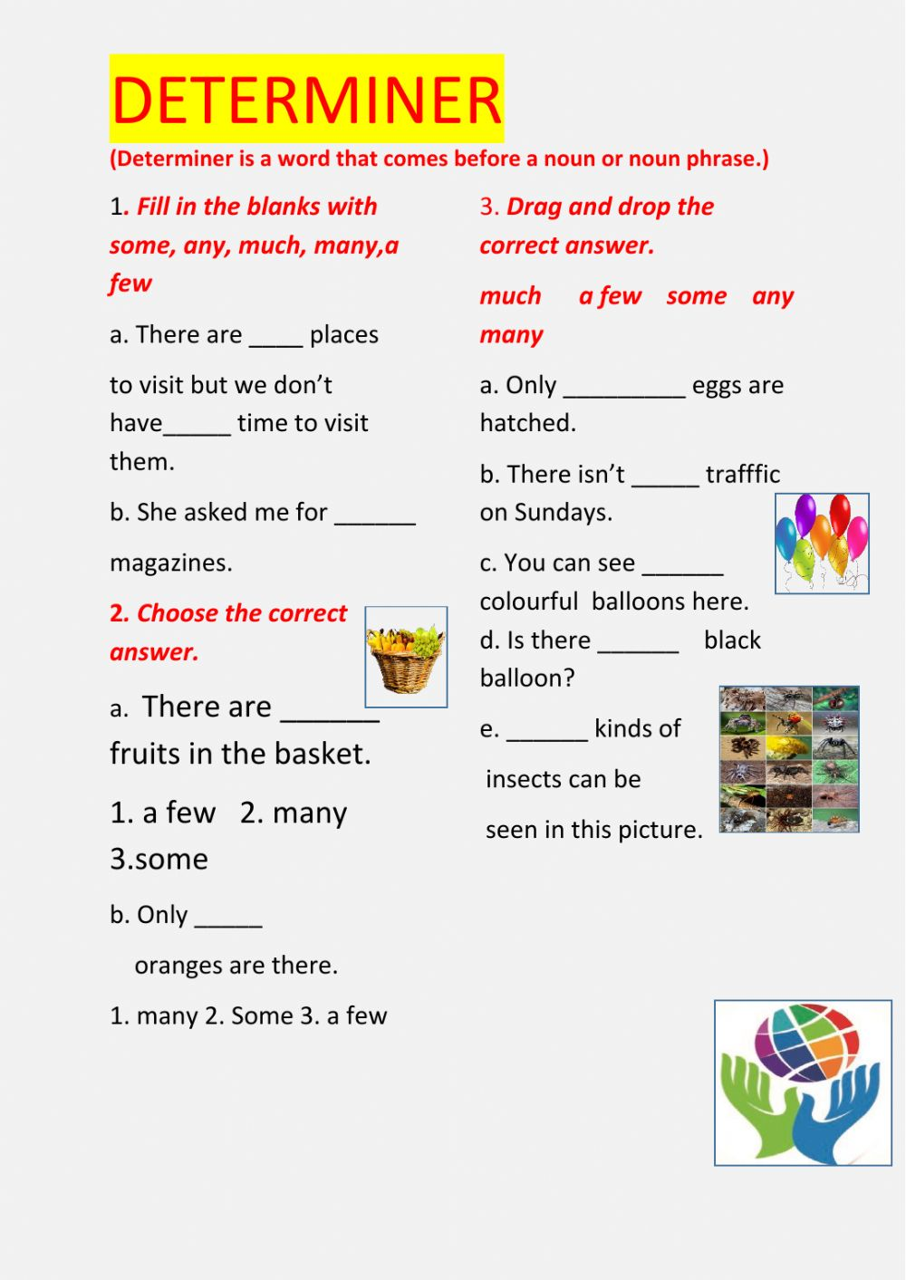

Huddi shunday namunada Guess What va Prepare darsliklaridan istalgan mavzu bo’yicha namunaviy dars ishlanmalar olishingiz mumkin. Biz bilan bog’lanish uchun Telegramdan @uzteachers_admin manzili yoki +998911800985 telegram raqami ga xabar yuboring. Narxi 1ta mavzu
20 ming so’m
To’lov payme yoki click orqali
BOG’LANISH FAQAT TELEGRAM ORQALI. Telefon qilinganda yoki sms yozilganda javob berilmaydi!

