______________ VILOYATI _________ TUMANI XALQ TA’LIMI BO’LIMIGA QARASHLI
___-SONLI O’RTA TA”LIM MAKTABI
INGLIZ TILI FANI O’QITUVCHISI
_______________________________NING
11-sinflar uchun Unit 2. Lesson 1A
Environmental problems
mavzusida 1 soatlik
Dars ishlanmasi
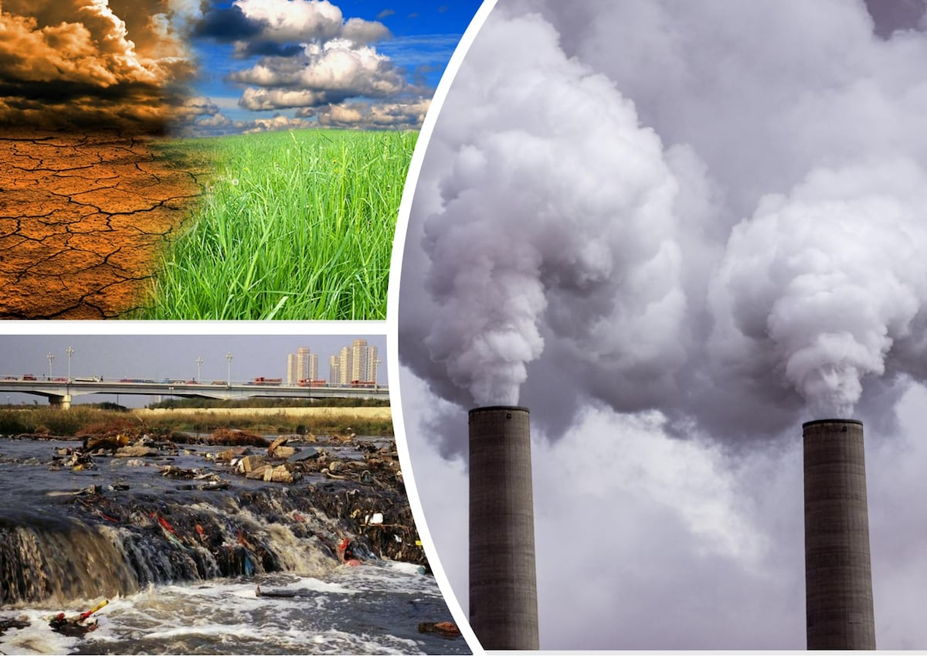

_______________-2019
Date_____ Form_____ Subject: English
Theme: Environmental problems
Aims:
Educational: - to talk about environmental problems and propose solutions for them; raise awareness of problem of Aral Sea
Developing: - to practise listening for the main ideas and for specific information.
- to practise speaking and reading skills
Socio-cultural: - to raise awareness of different cultures
Up bringing: - to enrich pupils’ knowledge of our tradition and nation
Learning outcomes: At the end of the lesson pupils will be able to talk about environmental problems and propose solutions for them; raise awareness of problem of Aral Sea
Competence: SC1, FLCC, and PC
Type of the lesson: Mixed, group work, pair-work, individual work
Method of the lesson: nontraditional, mixed
Equipment of the lesson: Textbook “English 11”, pictures, internet, computers, projector

TECHNOLOGICAL MAP OF THE LESSON:

№ | Part of the lesson | Tasks | Time
1 | Organizational  Moment | -to greet pupils.  - to check up the register | 5 min
2 | Repeating last lesson | - to give pupils some questions about last lesson. – to ask words from previous lesson | 5 min
3 | Explaining new theme | - to explain to pupils new vocabulary and theme | 20 min
4 | Consolidating new theme. | - to consolidate new theme and new words of the theme. | 10 min
5 | Marking. | - To mark pupils | 5 min
6 | Homework. | - Giving homework.

Procedure of the lesson:
I. Organizing moment: Motivation, Greeting, checking attendance, season, weather, checking the preparation for the lesson.
II. Asking homework:
- Check for homework given on past lesson.
- Ask pupils all new words learnt on previous lesson.
III. Pre-activity:
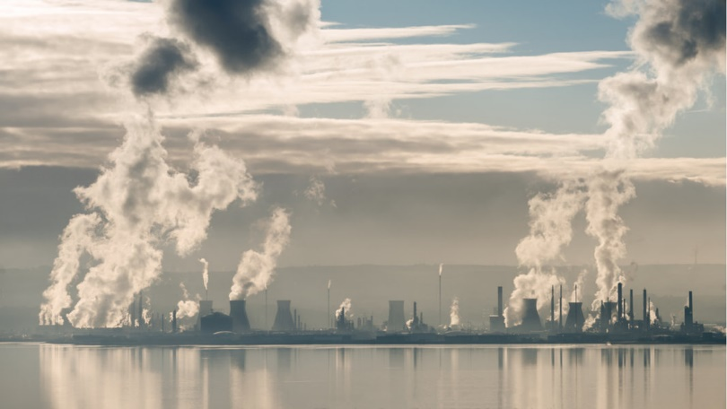
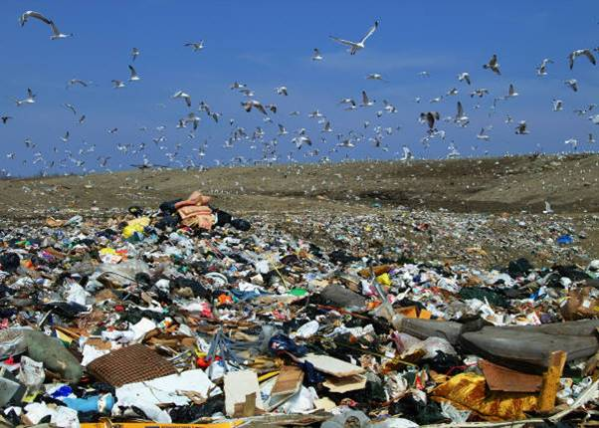

What can you see in the pictures? What is the main cause for this?

Activity 1. Label the pictures with the expressions from the box.
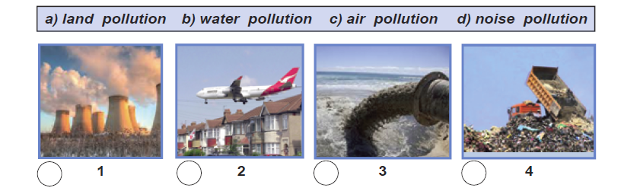
Answer key: 1.c 2.d 3.b 4.a

IV. Main part
Activity 2. Match the words and phrases with their definitions.
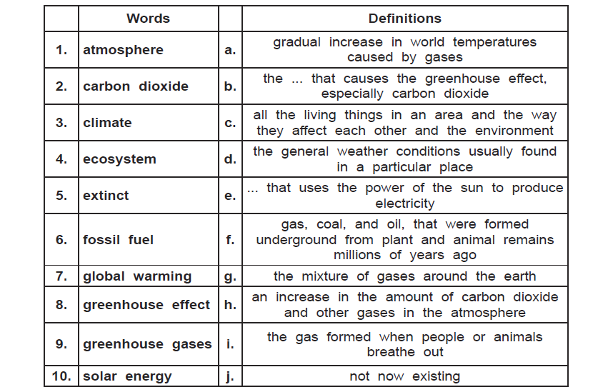
Answer key:
1-g 2.i 3.d 4.с 6.f 7.a 8.h 9.b 10.e

Activity 3. T.3. Listen to the tape and choose the best answer for each question.
Answer key: 1.c 2.b 3.c 4.с 5.d 6.b
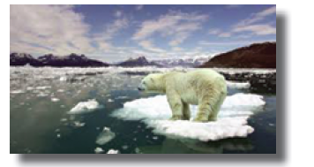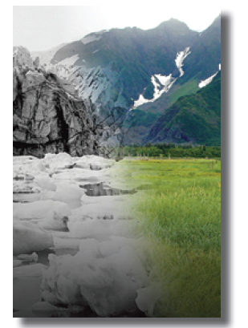

Activity 4. Discuss the following questions with your partner.
1. What causes climate to change?
2. Why is a climate change a problem?
3. What can we do to prevent it?

Activity 5. Read the passage and match the words in italics with their definitions below.
The Story of the Aral Sea
(a news item about it from the National Geographic news page)
In 2009 a group of fi shermen met on a Sunday afternoon. They were on the beach of the North Aral Sea. They ate food. They did some sports. Afterwards, they told stories and sang songs about the Aral Sea and fishing. It was a good party.
The fishermen were happy because there were fi sh in the water. For many years, there weren’t many fish. At one time, the Aral Sea in Central Asia was the fourth largest lake in the world. It had an area of 67,300 square kilometres. Two of the biggest rivers in Central Asia, the Amu Darya and the Syr Darya, went into the Aral Sea. But the water almost disappeared.
The Aral Sea was a busy place. Almost 20 percent of the Soviet Union’s fish came from here. 40,000 people lived and worked near the lake. Then people used the water in the two rivers for agriculture, so the water didn’t arrive at the Aral Sea. Also, it didn’t rain for many years.
Then, in 2005, the Kazakh government and the World Bank built a dam. The dam separated the north and south parts of the sea. Then the north part of the Aral Sea started to fi ll with water again.
Philip Micklin is a scientist. He studies the Aral Sea. In 2010, he said ‘Nature can come back.’ But in 2014, he saw satellite pictures of the east part of the Aral Sea. It was completely dry.
In June 2015 a scientist from Uzbekistan, Yusuf Kamalov, and a National Geographic reporter visited the Aral Sea. They found a huge desert. They stood on the sand. Once it was the edge of the water. Now the water is 80 kilometres away. They drove to the water. On the way, they passed oil
and natural gas rigs. Kamalov said that every year there are more oil rigs. They arrived at the edge of the Aral Sea. The water was very salty. There were no fi sh. Kamalov said, ‘This is what the end of the world looks like’.

Answer key:
1. fishermen (n) men whose job is to catch fish
2. dam (n) a wall to stop water flowing
3. rig (n) a structure for getting oil or gas out of the ground
4. beach (n) land with sand or stones that is next to the sea
5. desert (n) a large area of land where there is little rain and not many plants grow
6. east (n) the direction from which the sun rises in the morning; opposite to west.
7. lake (n) a large area of water with land all around it
8. north (n) the direction on the left when you look at the sunrise; opposite to south
9. rain (v) when water falls from the sky in drops
10. river (n) water that travels along a natural channel across the land to the sea
11. sand (n) the substance usually found on beaches and in deserts that is made of very small pieces of rock
12. sea (n) the salty water that covers about three-quarters of the Earth's surface
13. south (n) the direction on the right when you look at the sunrise; opposite the north.

Activity 6. Work in pairs. Read the article again and decide if the statements below are True or False.
Answer key: 1.F, 2. T, 3. T, 4. T, 5. F, 6. T, 7. T, 8. F, 9. F, 10.T

V. Post-activity
Activity 7. Discuss the following questions with your partner using your background knowledge.
Answer key:
1. Kazakhstan and Uzbekistan
2. arid
3. amu darya and syr darya
4. in the mountains of Kyrgyzistan and Tajikistan
5. plant less thirsty crops
6. health problems, economic problems
7. fishing industry

VI. Homework
1. Make a list of vocabulary which you have learned today.
2. Make a report about one of the current ecological problems.
• Try to give reliable data and show the resource.

VII. Consolidation

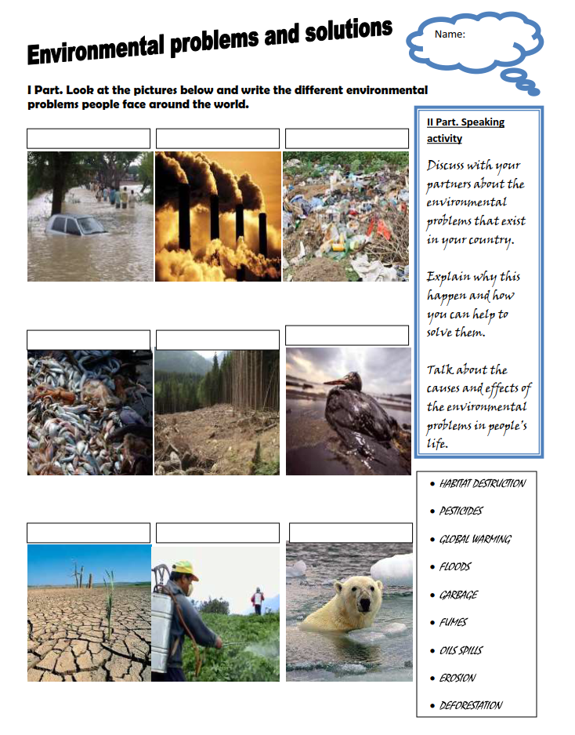

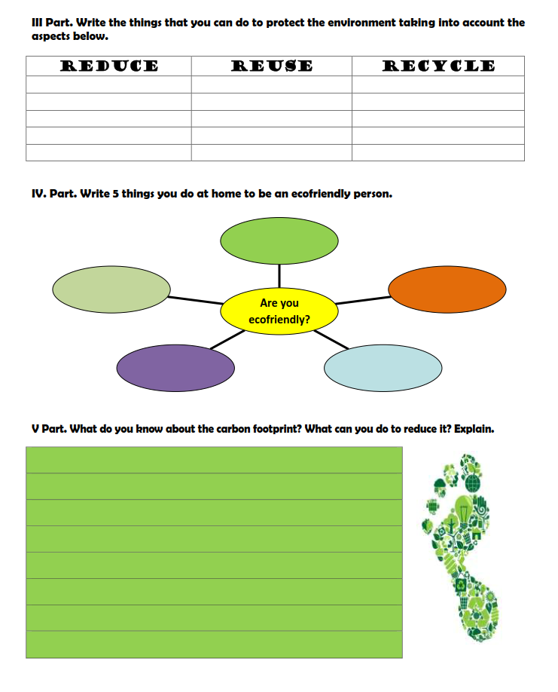
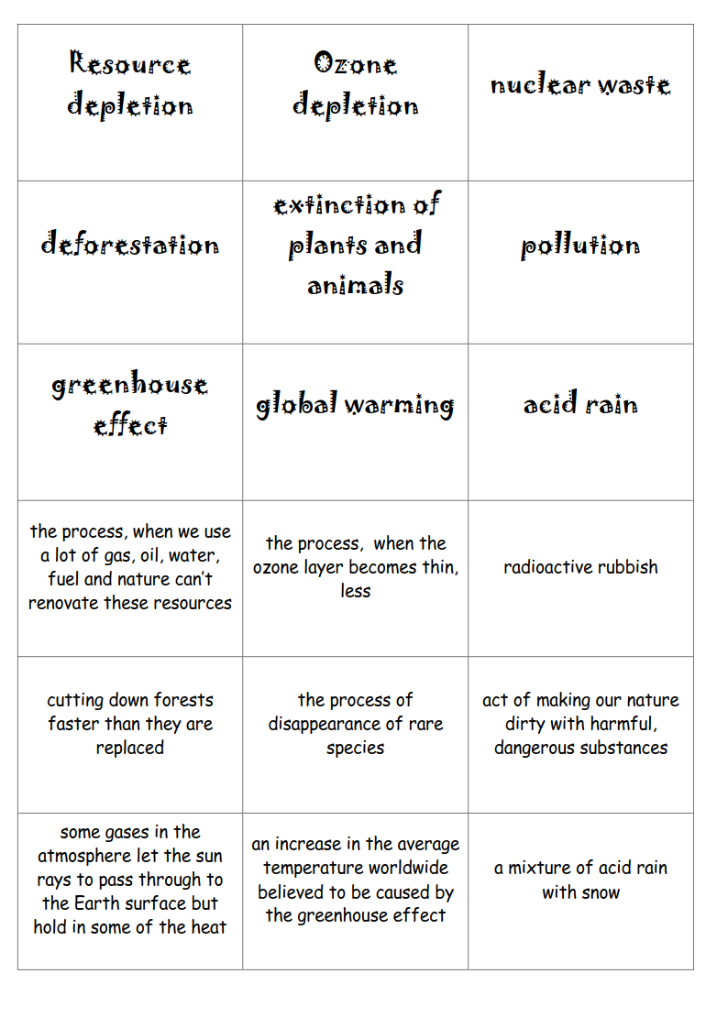

PICTURE-BASED DISCUSSION

Describe and compare the following pictures. Use the words in the word bank to help you.
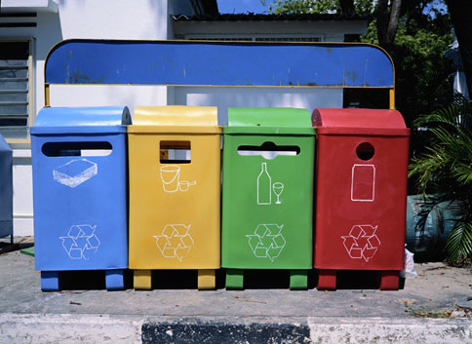
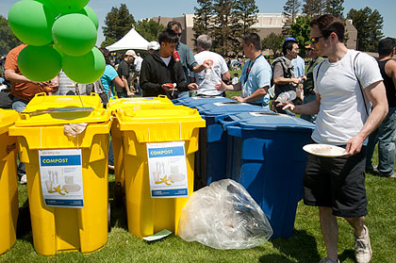

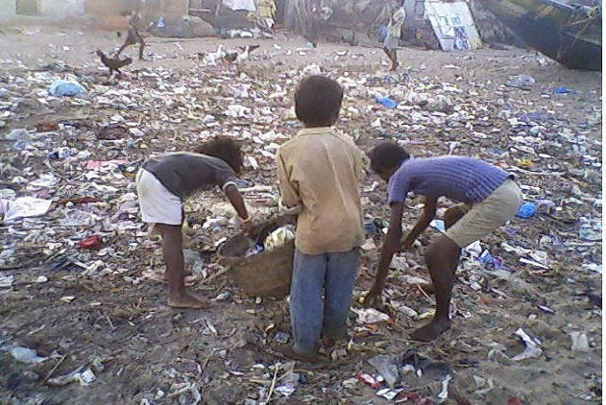
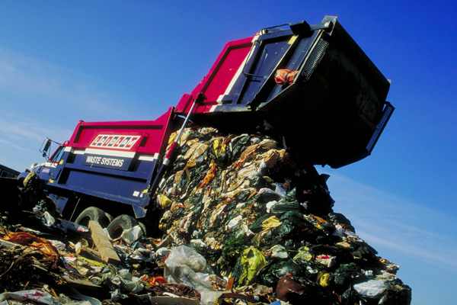

Word bank
environment environmental problems recycle community
recycling bins bottle bank paper bank
recycling bin for containers and cans the three R’s
to dump rubbish garbage/refuse truck dumping site
to pick up (rubbish) to survive global warming pollution
(non-)renewable resources sustainable development

Discuss these questions with the rest of your classmates.
- What do you think are the main environmental problems nowadays?
- What things do you do at home/every day to help the environment?
- Do you think that people are aware enough of the environmental problems?
- What will happen if we don’t stop global warming?
- Do you think that people buy too many products and gadgets or don’t reuse them enough? (e.g. bags, household appliances, computers, mobile phones, etc.)
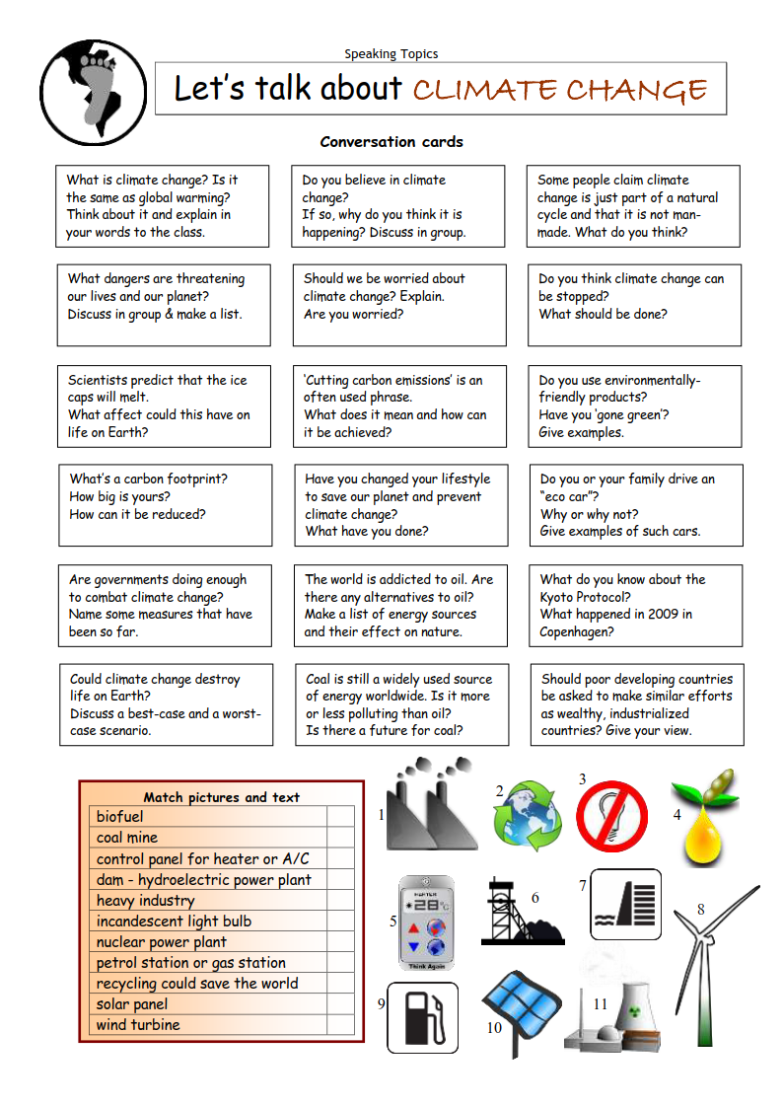
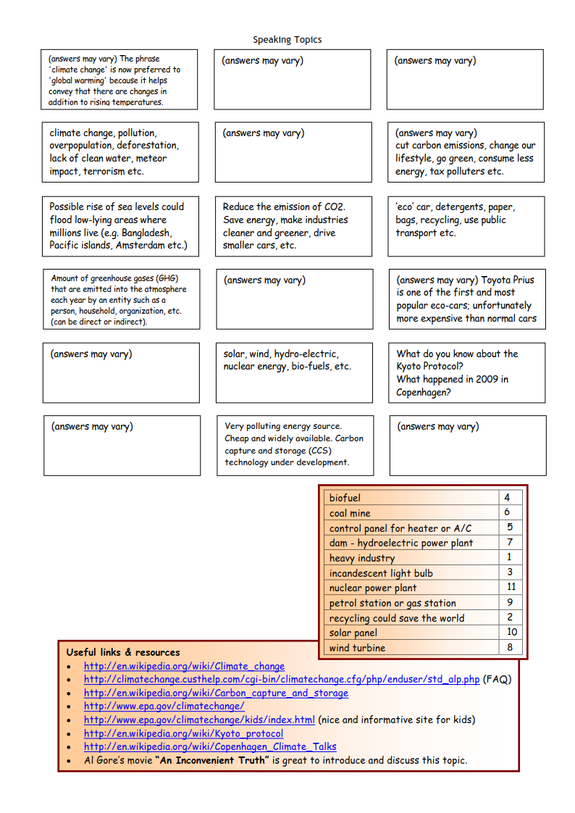
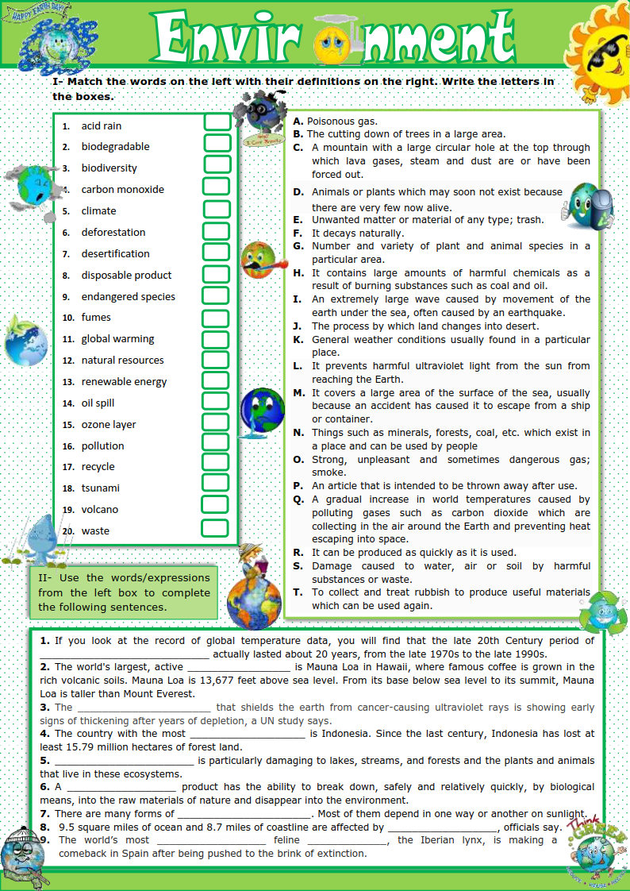
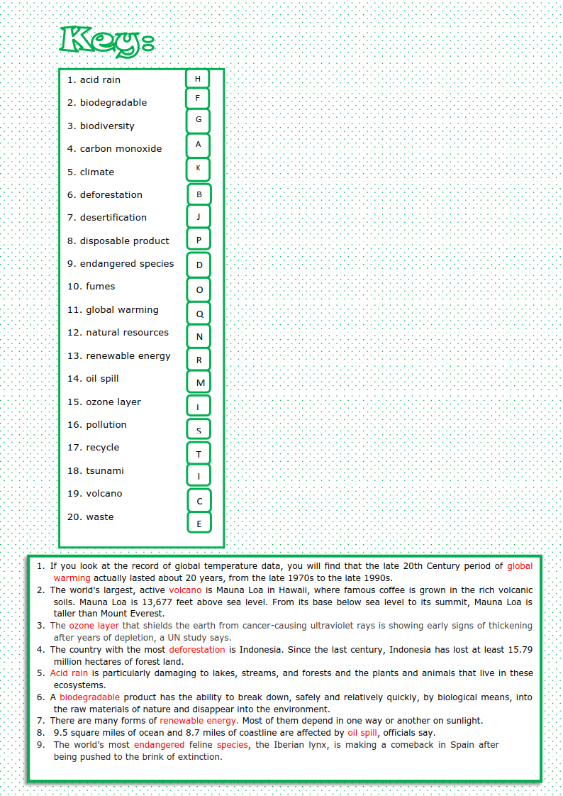

Siz istagan darslik asosidagi mavzu bo’yicha namunaviy dars ishlanmaga buyurtma berishingiz mumkin. Biz bilan bog’lanish +998911800985 telegram raqami, @uzteachers_admin ga xabar yuboring.
Narxi 20 ming so’m (1-9-sinflar uchun)
To’lov payme yoki click orqali
Bog’lanish faqat telegram orqali. Telefon qilinganda yoki sms yozilganda javob bermasligim ehtimoli yuqori

