______________ VILOYATI _________ TUMANI MAKTABGACHA VA MAKTAB TA’LIMI BO’LIMIGA QARASHLI
___-SONLI O’RTA TA’LIM MAKTABI
INGLIZ TILI FANI O’QITUVCHISI
_______________________________NING
10-sinflar uchun Unit 1. Lesson 2
All about me
mavzusida 1 soatlik
Dars ishlanmasi
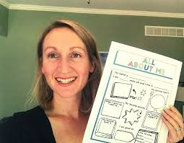
_______________-2023

Date_____ Form_____ Subject: English
Theme: All about me
Aims:
Educational: - to learn about personal profiles
Developing: - to develop listening, reading, writing, and speaking skills
Socio-cultural: - to raise awareness of different cultures
Up bringing: - to enrich pupils’ knowledge of our tradition and nation
Learning outcomes: At the end of the lesson, pupils will be able to use learnt language in practice, ask and answer questions
Competence: SC1, FLCC, and PC
Type of the lesson: Mixed, group work, pair-work, individual work
Method of the lesson: nontraditional, mixed
Equipment of the lesson: “Prepare 10” SB, WB, pictures, internet, computers, projector

TECHNOLOGICAL MAP OF THE LESSON:

№ | Part of the lesson | Tasks | Time
1 | Organizational  Moment | -to greet pupils.  - to check up the register | 5 min
2 | Repeating last lesson | - to give pupils some questions about last lesson. – to ask words from previous lesson | 5 min
3 | Explaining new theme | - to explain to pupils new vocabulary and theme | 20 min
4 | Consolidating new theme. | - to consolidate new theme and new words of the theme. | 10 min
5 | Marking. | - To mark pupils | 5 min
6 | Homework. | - Giving homework.

Procedure of the lesson:
I. Organizing moment: Motivation, Greeting, checking attendance, season, weather, checking the preparation for the lesson.
- Check for homework given on past lesson.
- Ask pupils all new words learnt on previous lesson.
II. Pre-activity:

BACKGROUND INFORMATION
According to statistics from Statista.com and the UK Office for National Statistics, young people aged 8–15 spend 68 minutes a day on outdoor activities, sports and active travel (walking or cycling). Boys spend an average of 15 more minutes a day than girls. 75% of 12–15-year-olds use social media: 82% of young people have a Facebook account while 56% use Instagram. Internet users in the UK spend an average 114 minutes a day on social media.

III. Main part
Activity 1 Read the information about part of a school website. Discuss the questions.
Ask students to read the information and help them with any new vocabulary. They discuss the questions in pairs. Ask for feedback and then hold a short class discussion about question 2.
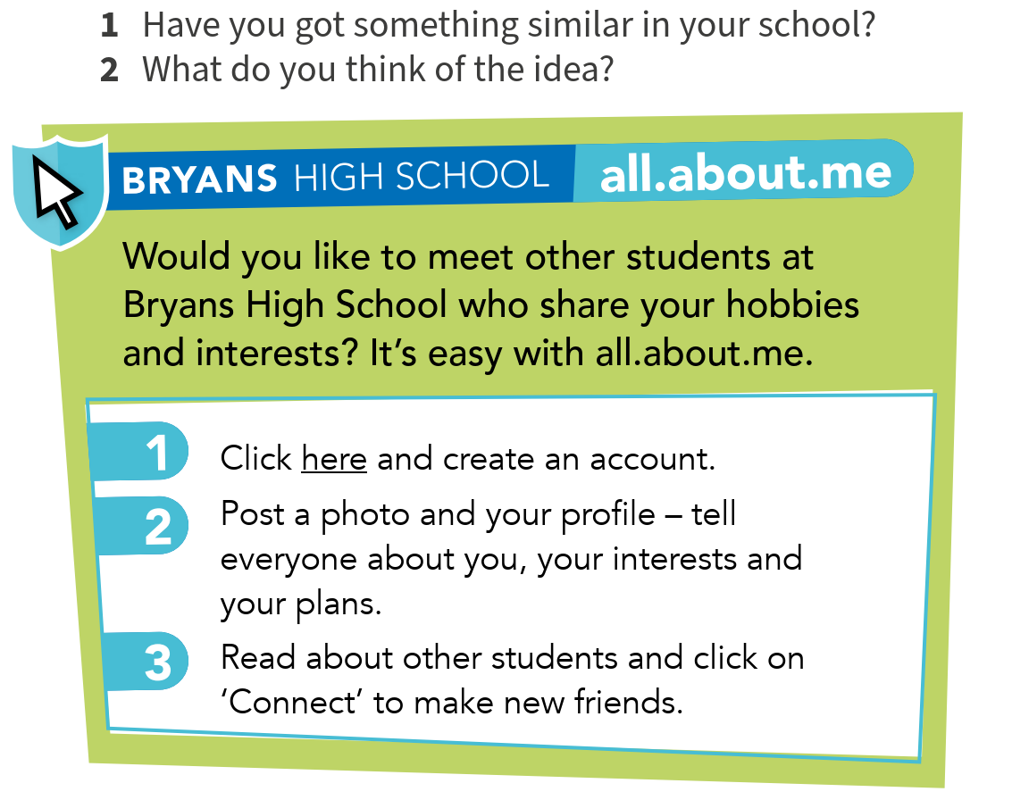
Answers
Students’ own answers

Activity2. Three students have posted information on all.about.me. Read the profiles below and ignore any gaps. Match each person to one interest.

Divide the students into three groups (A, B and C) and give them each a different profile to read. Tell group C not to worry about the missing words in their text about Alfie. Ask each group to match their profile to one of the activities in the box. Then put students into groups of three, with one student from each group A, B and C. Each student tells their group about the person whose profile they read. Students then read all three profiles and check that the people and activities are correctly matched. Check answers.

Answers
Lucas – technology
Grace – fitness
Alfie – going to the cinema
The Reading text is recorded for students to listen, read and check their answers.

Activity 3 Now read Alfie’s profile again. Write ONE word for each gap.

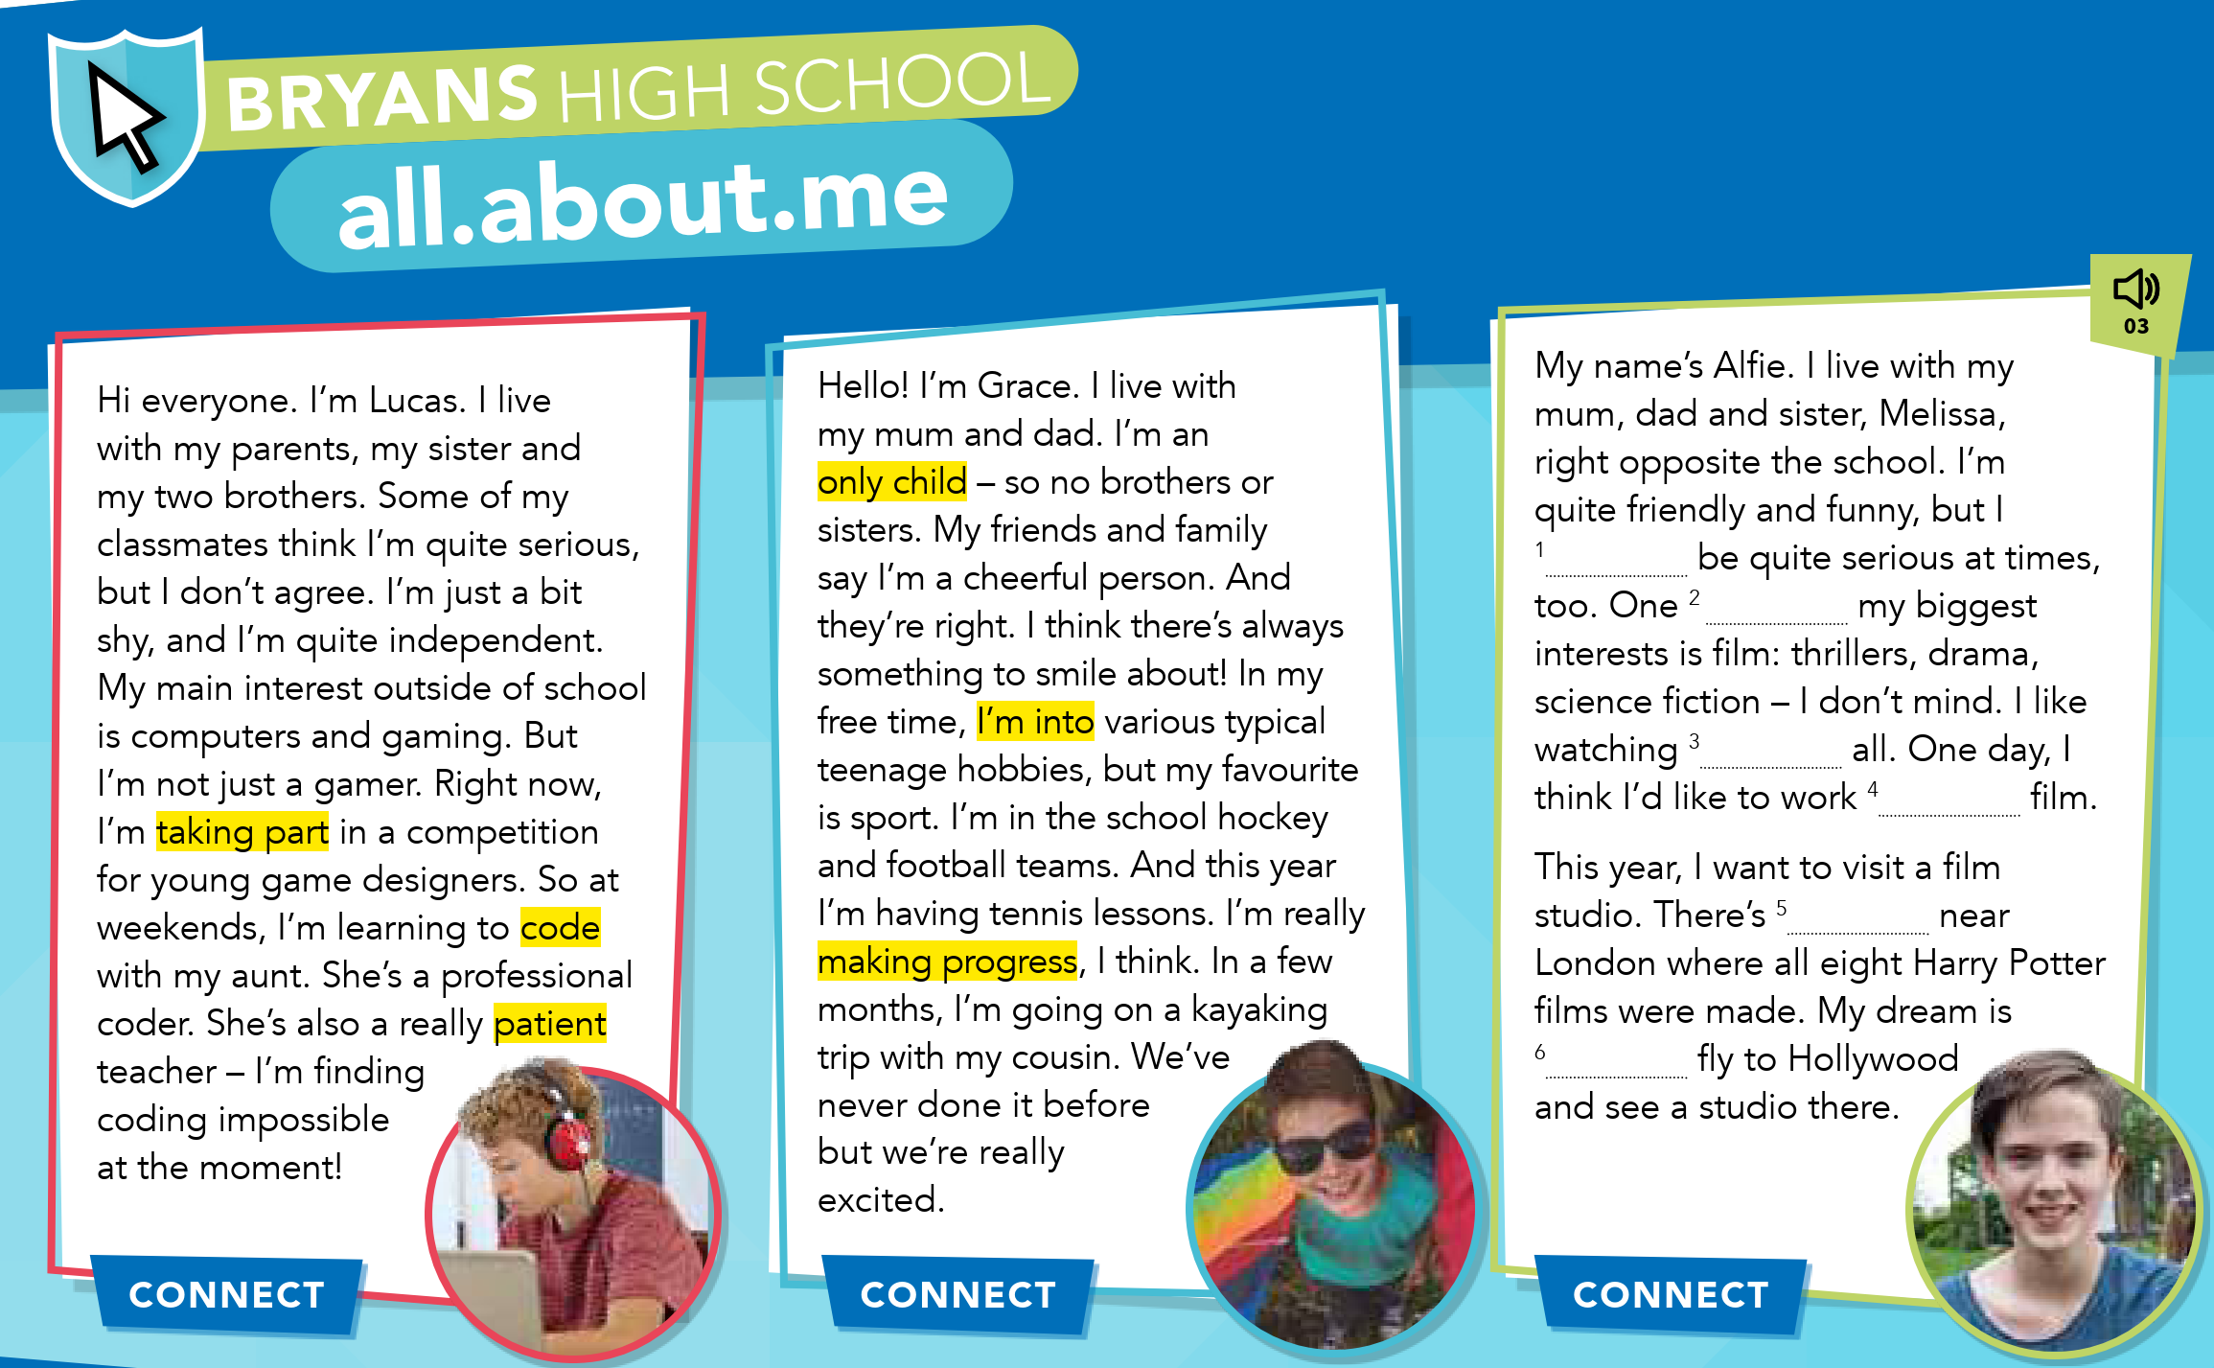

Explain to students that they have to complete each gap in Alfie’s profile with one word. They should look at the words before and after the gap and think of one word which fits the gap. Look at the first gap together and ask students what sort of word goes after a subject and before a base form (an auxiliary or a modal verb). Ask them to complete the exercise and compare their answers with a partner before checking answers with the class. With the students, name the parts of speech used. Explain that these parts of speech are very typical of the words used in this kind of exercise.

MIXED ABILITY
For weaker students, monitor and help them to identify the correct part of speech for each gap. For example, we do not use the auxiliary do with the verb to be so they need a modal verb to fill the gap. Ask them to think about whether it will be positive or negative.
Answers

1 can (modal verb) 2 of (preposition) 3 them (pronoun)
4 in (preposition) 5 one (pronoun) 6 to (part of the infinitive)

Activity 4 Read the three profiles again. Write the correct name.
Set a short time limit for students to read the profiles again and answer the questions. They compare their answers with a partner before checking answers as a class. Check understanding of any new words in the text. Encourage students to work out the meaning with a partner before confirming their ideas. New words may include properly (correctly) and keen on (very interested in or enthusiastic about).
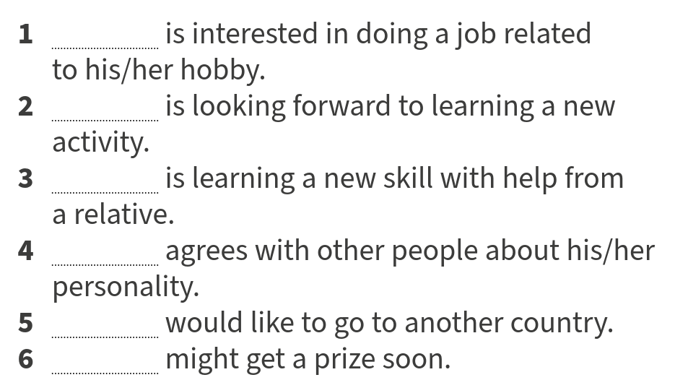

Answers
1 Alfie 2 Grace 3 Lucas 4 Grace 5 Alfie 6 Lucas

Activity 5 Match the highlighted words and phrases in Lucas's and Grace’s profiles with the meanings.
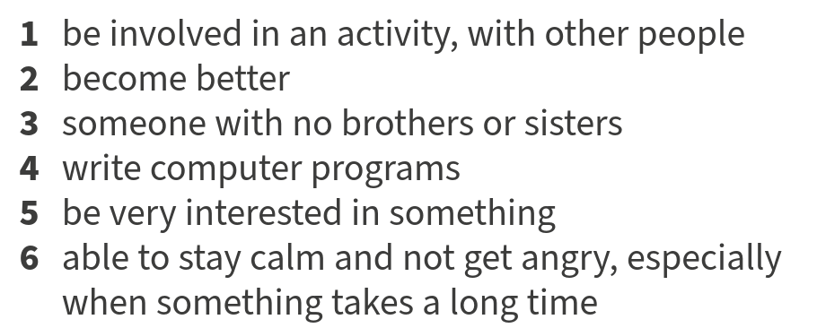

Answers

1 take part (taking part in the text)
2 make progress (making progress in the text)
3 only child
4 code
5 be into (something) (I’m into in the text)
6 patien

IV. Post-activity
TALKING POINTS
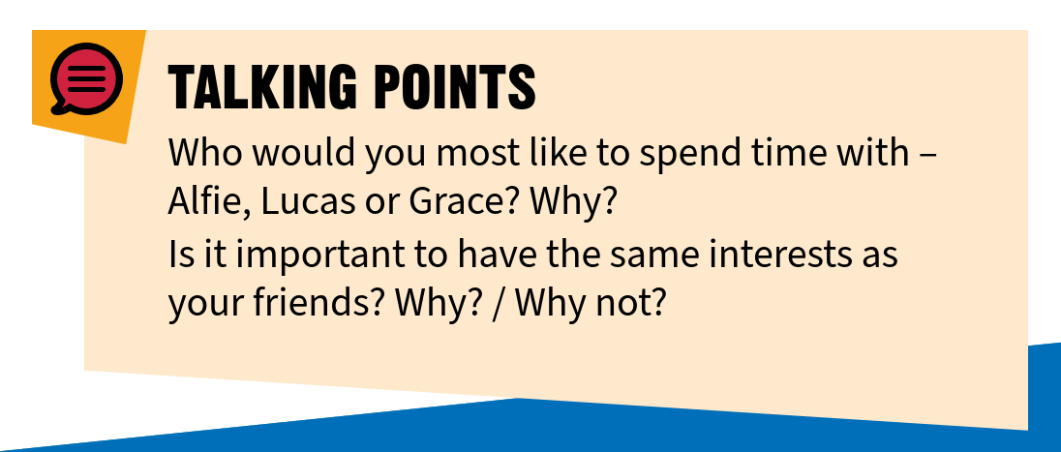
For the first question, take a class vote to find out who the class would most like to spend time with. Invite different students to explain why. Students discuss the second question in small groups. Monitor the discussions, giving positive feedback for interesting ideas.
COOLER
Ask students to find three sentences using right in the profiles:
• Right now, I’m taking part in a competition for young game designers.
• My friends and family say I’m a cheerful person. And they’re right.
• I live … right opposite the school.
Ask students to work in pairs and discuss the meaning of right in each sentence. Listen to feedback as a class (right now means at the present moment; they’re right means they are correct; right opposite means directly opposite). In small groups, students write another sentence for each of the meanings. Invite them to read their sentences out.

V. Homework
Ask pupils open their WB page on 4and do the tasks 1,2 and 3
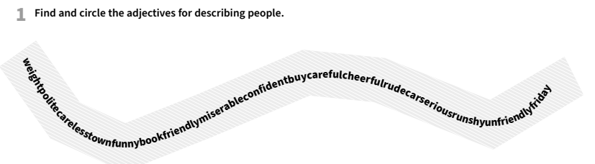

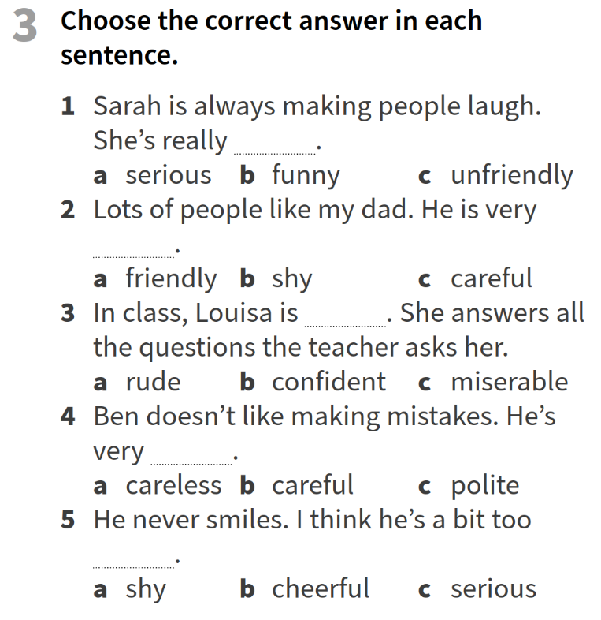
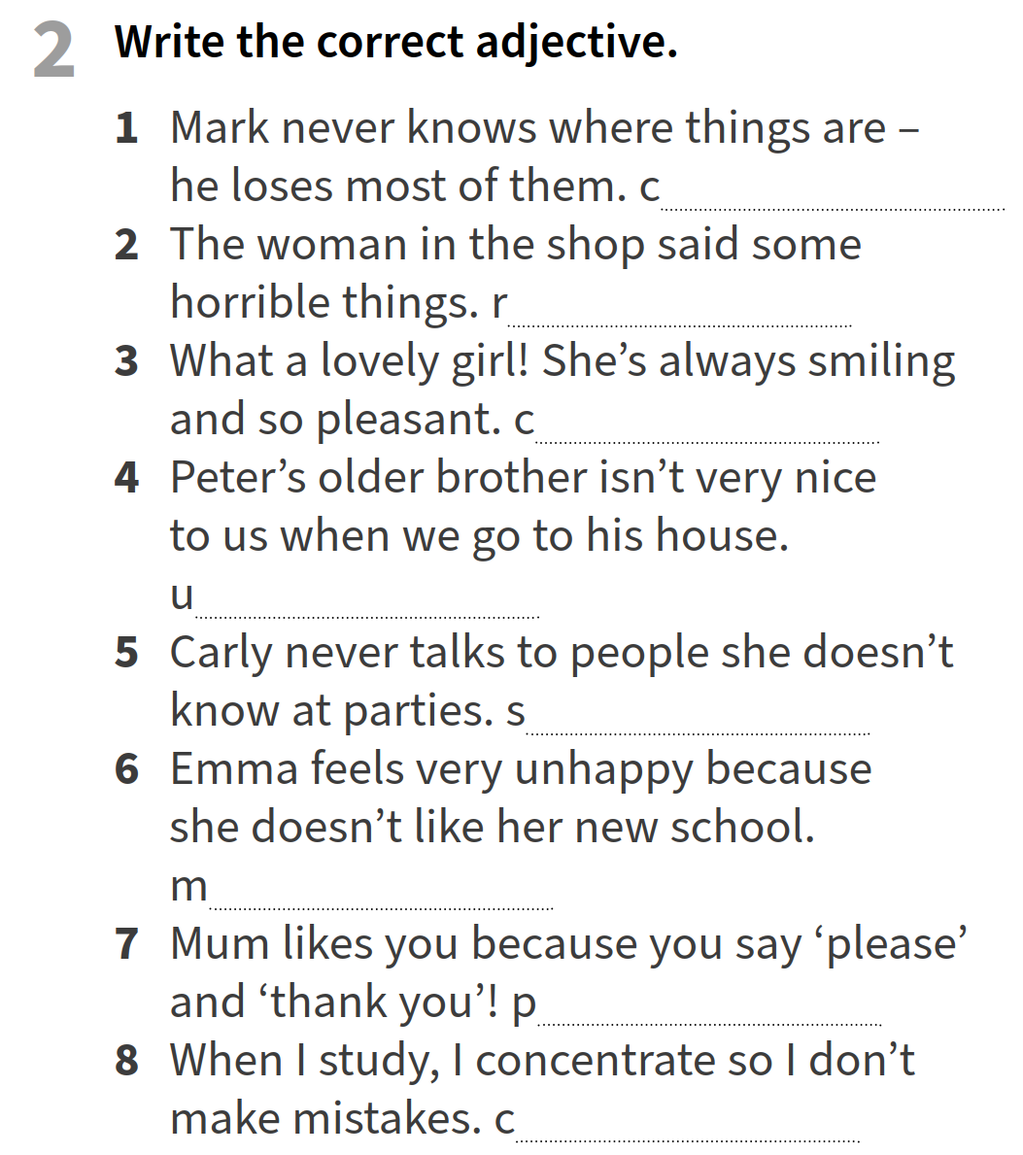
VI. Evaluation
Giving marks according to pupils’ participation to the lesson

Deputy director on educational affairs: _________ Signature: __________
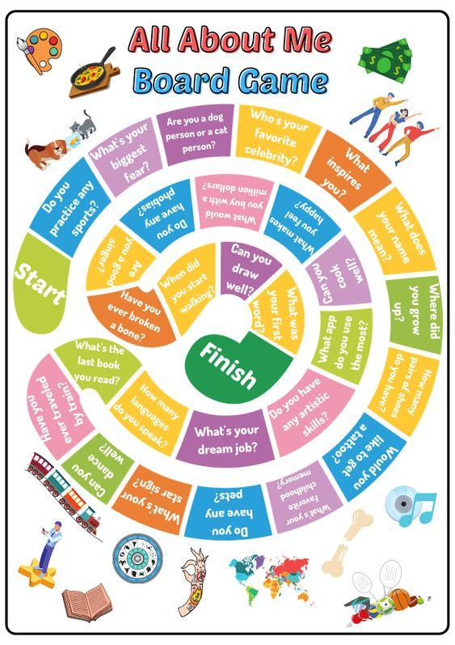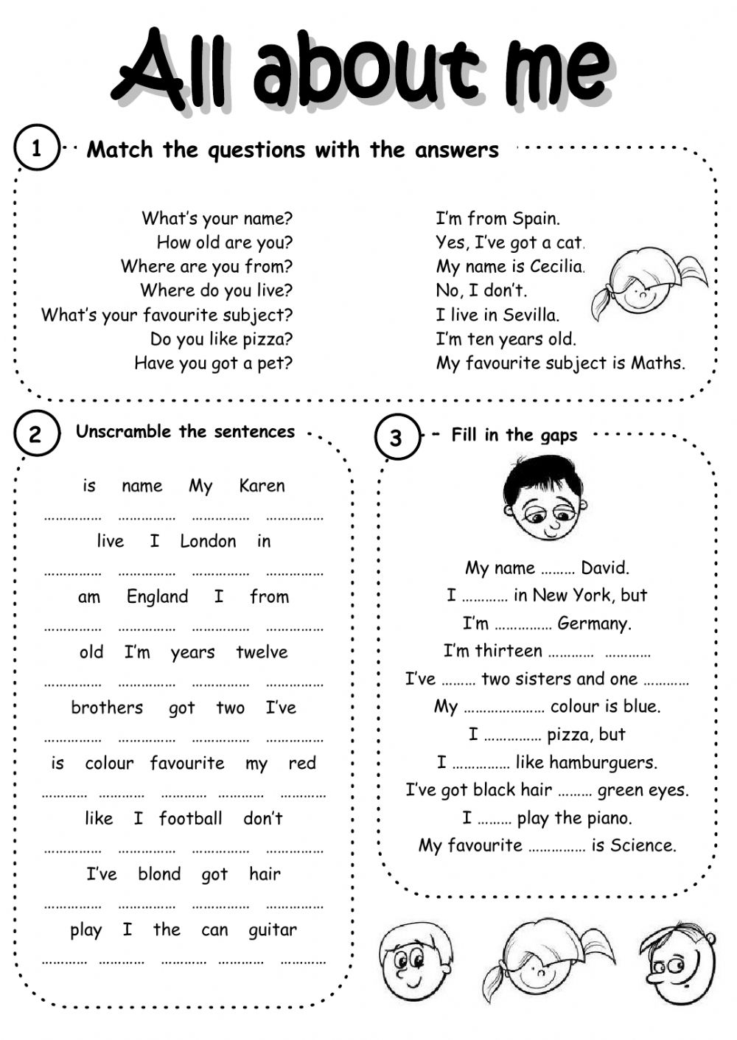
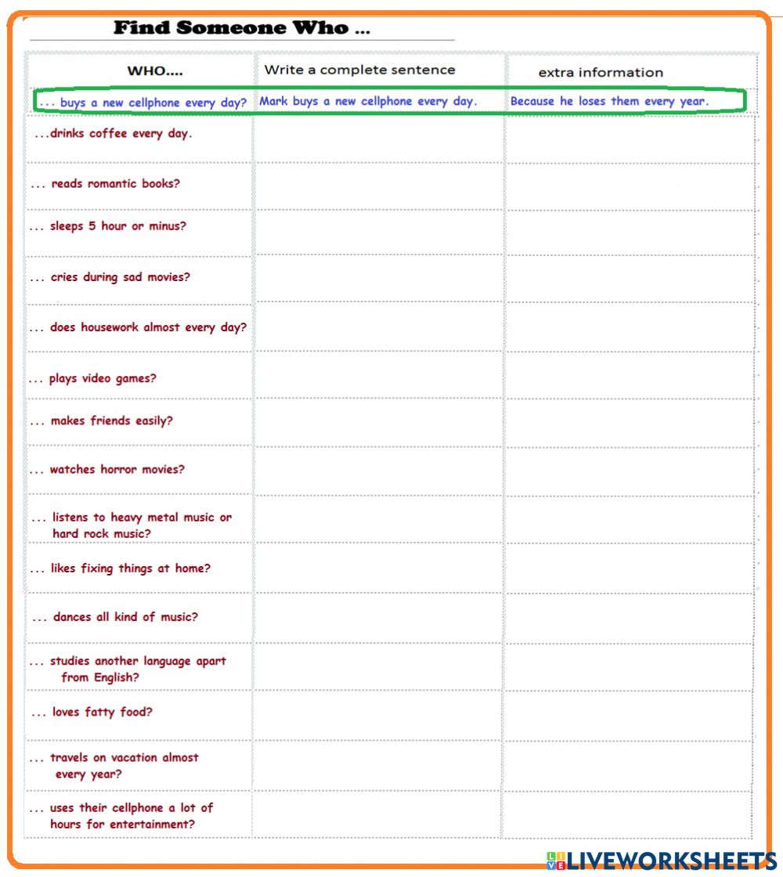

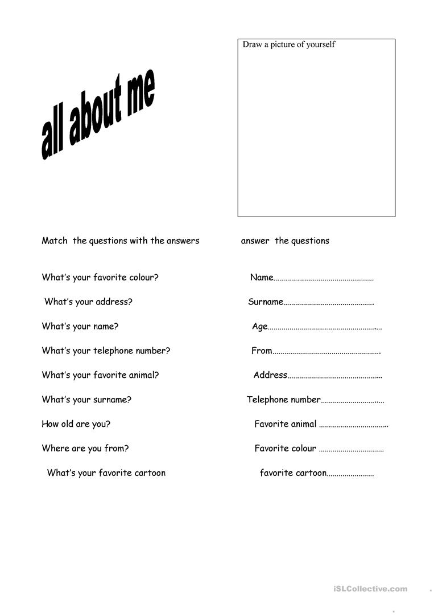
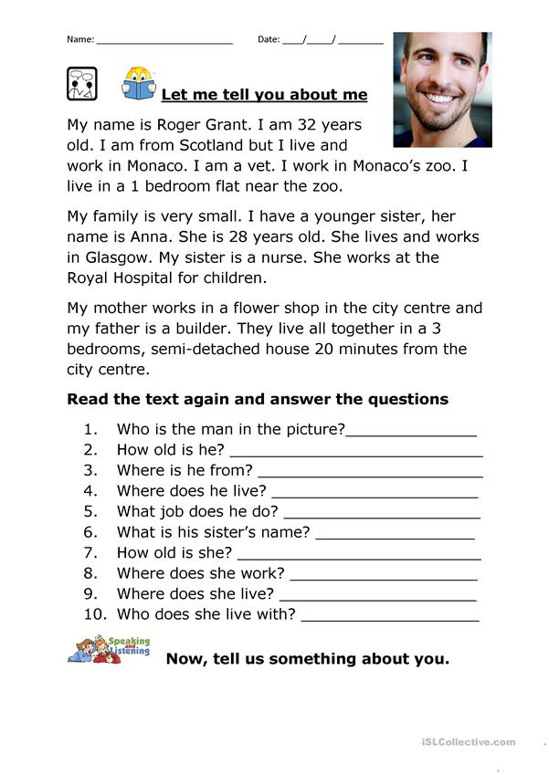
Huddi shunday namunada Guess What va Prepare darsliklaridan istalgan mavzu bo’yicha namunaviy dars ishlanmalar olishingiz mumkin. Biz bilan bog’lanish uchun Telegramdan @uzteachers_admin manzili yoki +998911800985 telegram raqami ga xabar yuboring. Narxi 1ta mavzu
20 ming so’m
To’lov payme yoki click orqali
BOG’LANISH FAQAT TELEGRAM ORQALI. Telefon qilinganda yoki sms yozilganda javob berilmaydi!

