 **______________ VILOYATI _________ TUMANI XALQ TA’LIMI BO’LIMIGA QARASHLI**

**___-SONLI O’RTA TA”LIM MAKTABI**

**INGLIZ TILI FANI O’QITUVCHISI**

***_______________________________NING***10-sinflar uchun Unit 8. Lesson 2A  
***How smart are you?***

mavzusida 1 soatlik

**Dars ishlanmasi**



_______________-2019

**Date_____ Form_____ Subject: English**

**Theme: How smart are you?**

**Aims:**

***Educational****:* - to raise awareness of types of language learning; effective ways of learning

***Developing:*** - to practise reading and listening for main ideas

***Socio-cultural:*** - to raise awareness of different cultures

***Up bringing****:* - to enrich pupils’ knowledge of our tradition and nation

***Learning outcomes:*** At the end of the lesson pupils will be able to talk about labguage learning; effective ways of learning

***Competence:*** SC1, FLCC, and PC

***Type of the lesson:*** Mixed, group work, pair-work, individual work

***Method of the lesson:*** nontraditional, mixed

***Equipment of the lesson:*** Textbook “English 10”, pictures, internet, computers, projector

**TECHNOLOGICAL MAP OF THE LESSON:**

|  |  |  |  |
| --- | --- | --- | --- |
| **№** | **Part of the lesson** | **Tasks** | **Time** |
| 1 | Organizational  Moment | -to greet pupils.  - to check up the register | 5 min |
| 2 | Repeating last lesson | - to give pupils some questions about last lesson. – to ask words from previous lesson | 5 min |
| 3 | Explaining new theme | - to explain to pupils new vocabulary and theme | 20 min |
| 4 | Consolidating new theme. | - to consolidate new theme and new words of the theme. | 10 min |
| 5 | Marking. | - To mark pupils | 5 min |
| 6 | Homework. | - Giving homework. |

**Procedure of the lesson:**

***I. Organizing moment:*** Motivation,Greeting, checking attendance, season, weather, checking the preparation for the lesson.

***II. Asking homework:***

- Check for homework given on past lesson.

- Ask pupils all new words learnt on previous lesson.

***III. Pre-activity:***

**Activity 1** Answer the questions of the quiz: “What kind of student are you?”

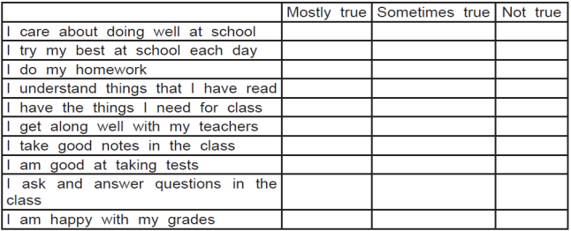

Good Study Habits mean Good Grades.

Good Grades lead to Good Career Options.

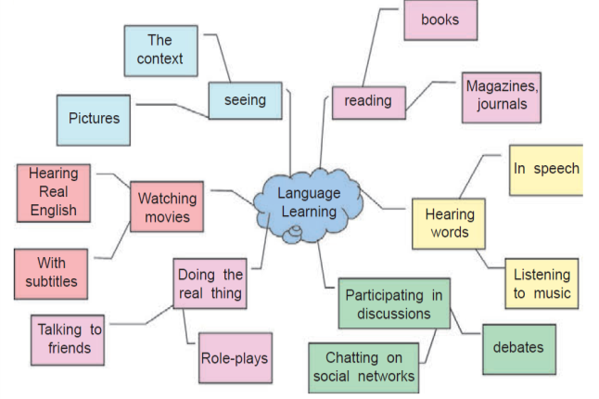Good Career Options mean Good Life.

***IV. Main part***

**Activity 2** Look at the following words and Ask your pupils to match their synonyms.

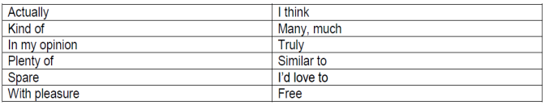*Answer key:*

**Activity 3** Listen to the dialogue and complete the sentences.

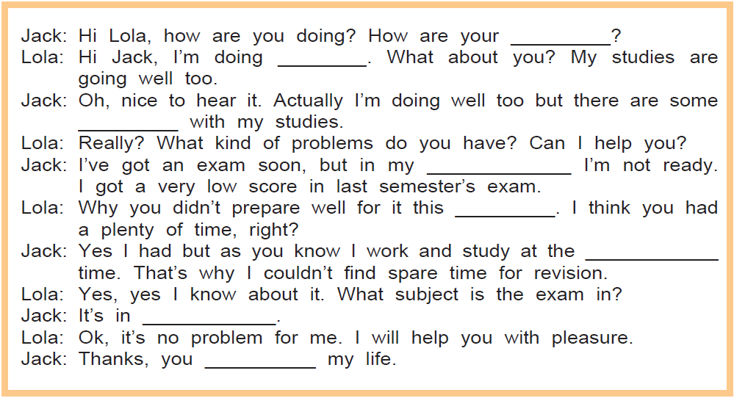

|  |  |
| --- | --- |
| 1. studies  2. great  3. problems  4. opinion | 5. semester  6. same time  7. German  8. saved |

*Answer key:*

**Activity 4** List eight effective ways of learning English

***Possible answers:***

*1. Listen podcasts*

*2. Read English newspapers and magazines*

*3. Learn by hear new words*

*4. Watch English music*

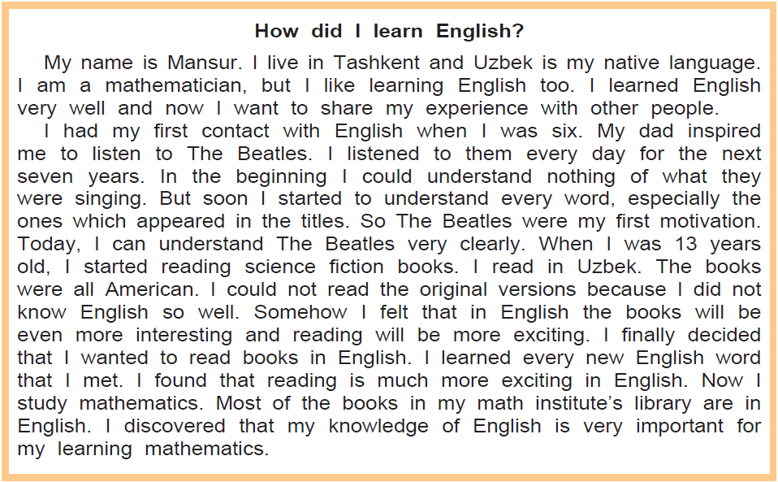**Activity 5** Ask your pupils to read the text and mark the statements with True or False.

1. Mansur is an architect. ______________

2. He began learning English when he was six. ______________

3. He began learning by reading books. ______________

4. The fi rst English songs he heard were by The Beatles. ______________

5. He began reading English books when he was 13. ______________

6. He wanted to read books in the original language. ______________

7. He discovered that his English is useful for mathematics too. ______________

***Answer key:***

1. False. 2. False. 3. False. 4. True. 5. True. 6. True. 7. False.

***V. Post-activity***

**Activity 6** Ask your pupils to match the words with the suitable definitions. Find out their antonyms.

**New words Definitions Antonym**

1. Native A) motivate ___________________

2. Contact B) start to be seen ___________________

3. inspire C) desire ___________________

4. Appear D) connected with the place

where you were born ___________________

5. Motivation E) copy ___________________

6. Version F) to be sure for doing something ___________________

7. decide G) relationship ___________________

8. discover H) fi nd something new ___________________

***Answer key:***

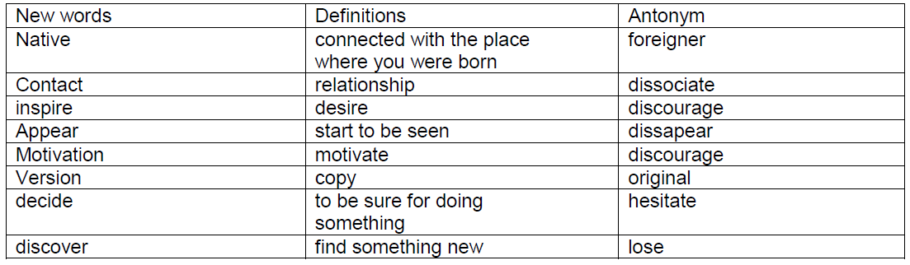

***VI. Homework***

1. Make a list of vocabulary which you have learned today.

2. Make a report on the importance of learning English. Word limit is 80 – 100.

3. Share your report with your peers.

***VII. Evaluation.*** Giving marks

***Deputy director on educational affairs: ____________________ Signature _________***

**Extra activities**

**Activity** Put the verbs in brackets into the correct future form:

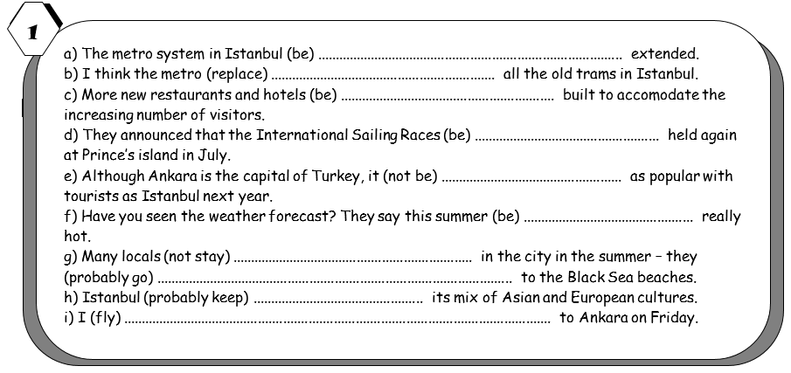

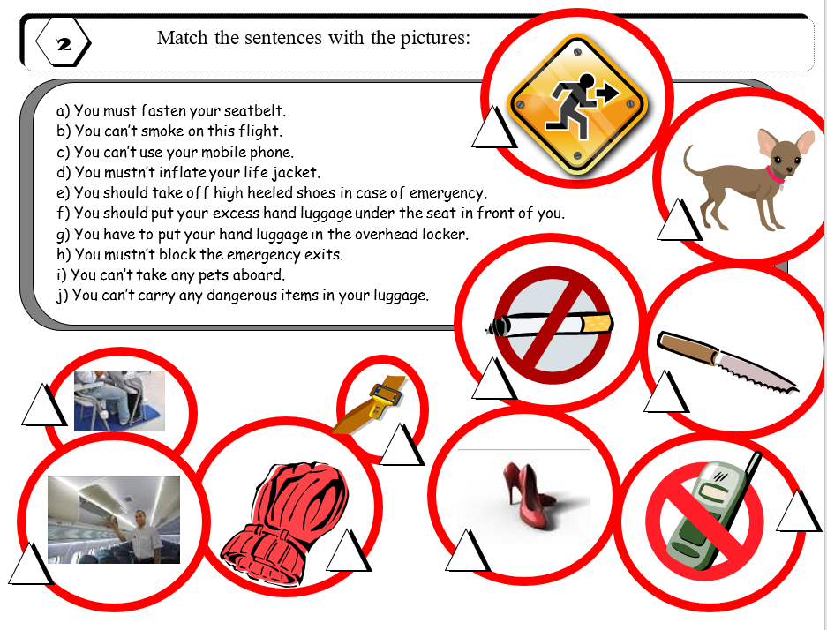

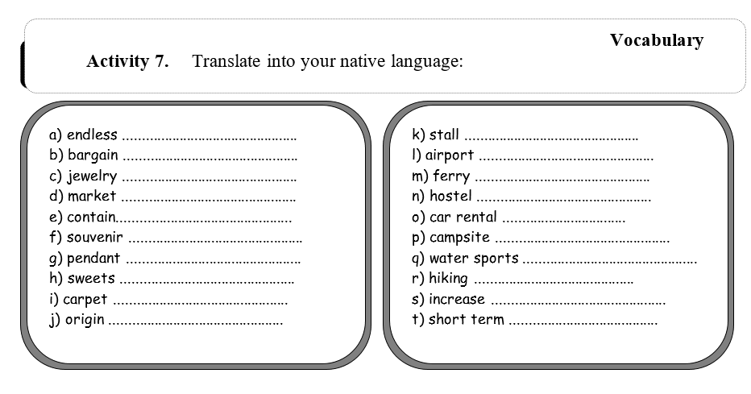

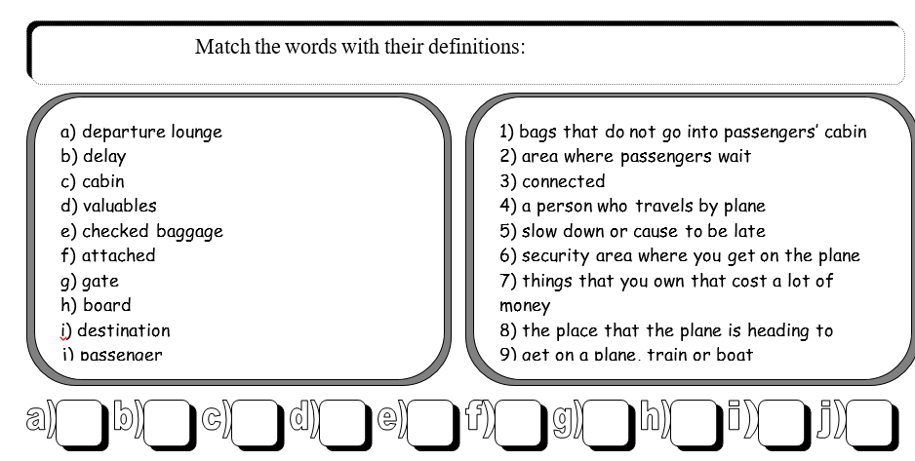

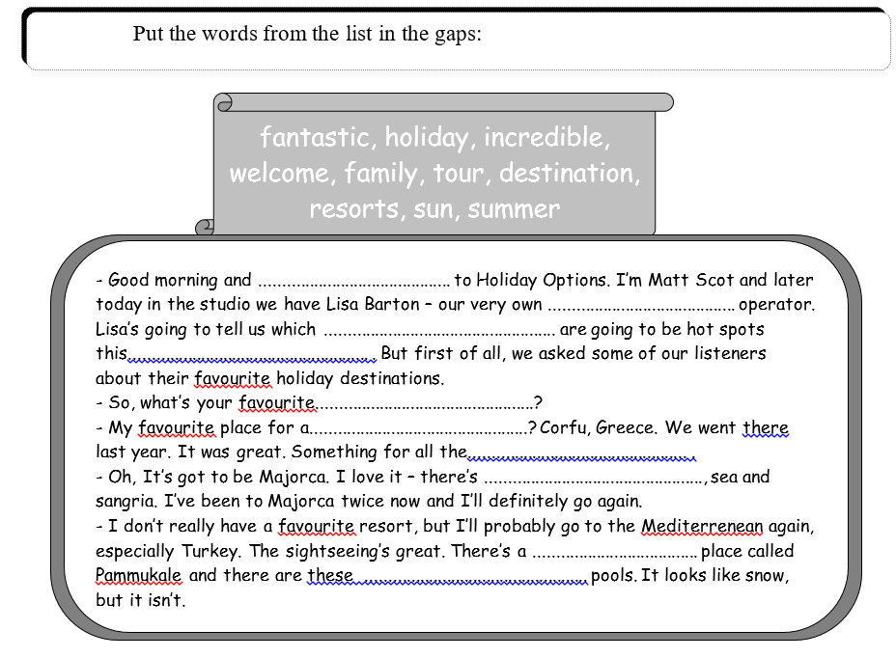

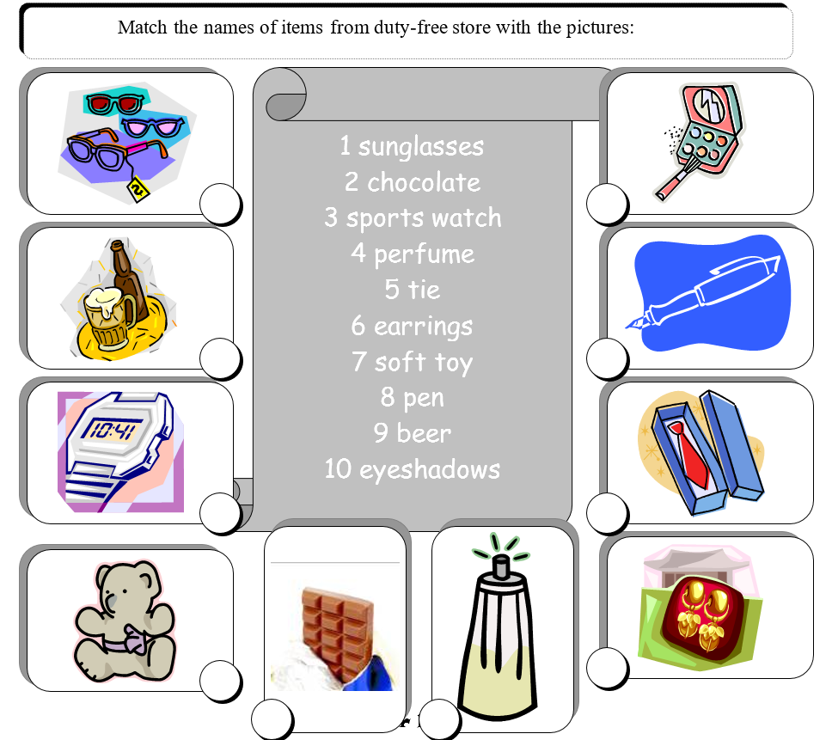

Answer key:

**Grammar**

1. a) is going to be

b) will replace

c) will be built

d) are going to be

e) won’t be

f) will be

g) are not going to stay/ will probably go

h) will probably keep

i) am flying

2. the correct order of pictures is as follows:



**Vocabulary:**

1 translate into your own language

2.

a) 2

b) 5

c) 10

d) 7

e) 1

f) 3

g) 6

h) 9

i) 8

j) 4

3.

- Good morning and welcome to Holiday Options. I’m Matt Scot and later today in the studio we have Lisa Barton – our very own tour operator. Lisa’s going to tell us which resorts are going to be hot spots this summer . But first of all, we asked some of our listeners about their favourite holiday destinations.

- So, what’s your favourite destination?

- My favourite place for a holiday? Corfu, Greece. We went there last year. It was great. Something for all the family .

- Oh, It’s got to be Majorca. I love it – there’s sun, sea and sangria. I’ve been to Majorca twice now and I’ll definitely go again.

- I don’t really have a favourite resort, but I’ll probably go to the Mediterrenean again, especially Turkey. The sightseeing’s great. There’s a fantastic place called Pammukale and there are these incredible pools. It looks like snow, but it isn’t.

4. the correct order of pictures is as follows:



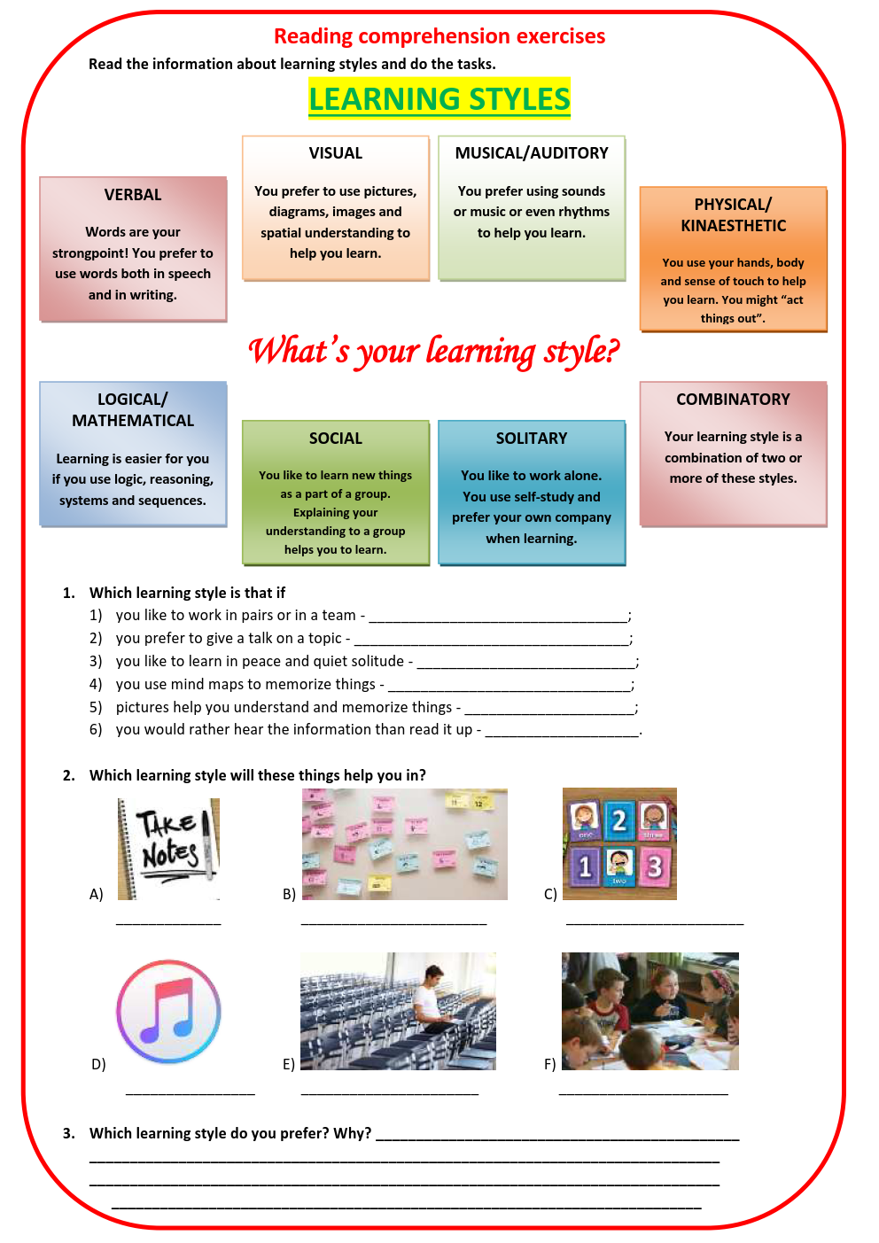

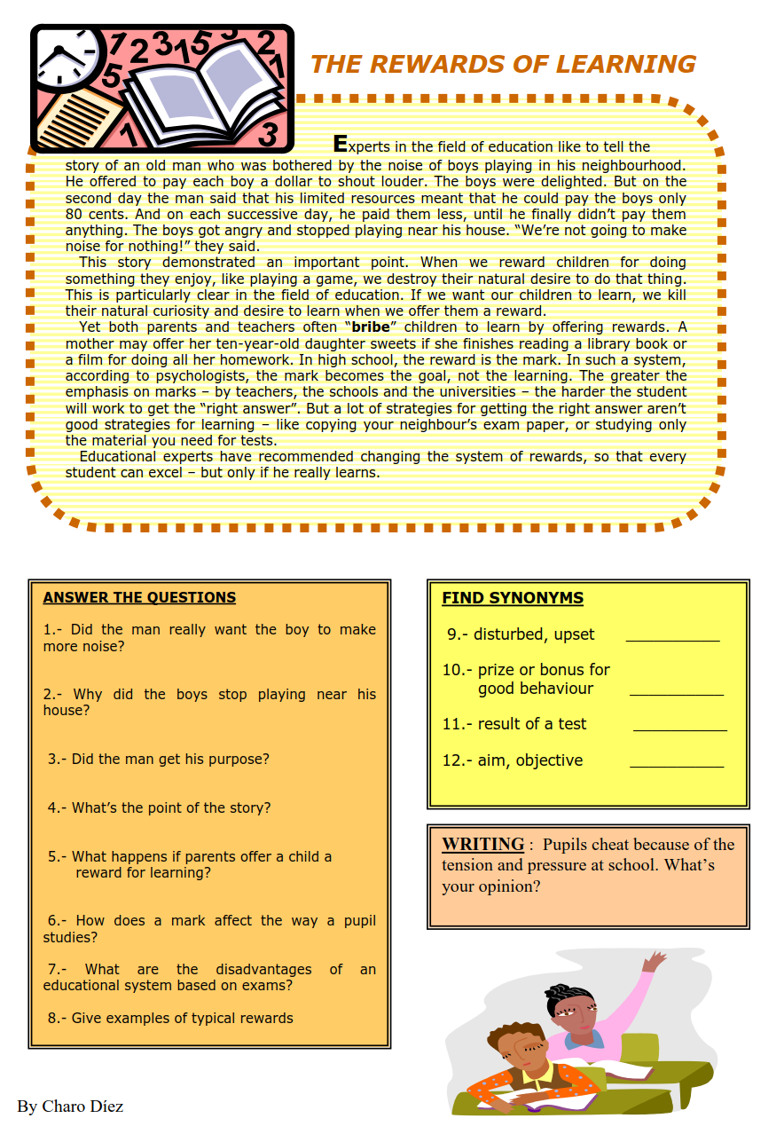

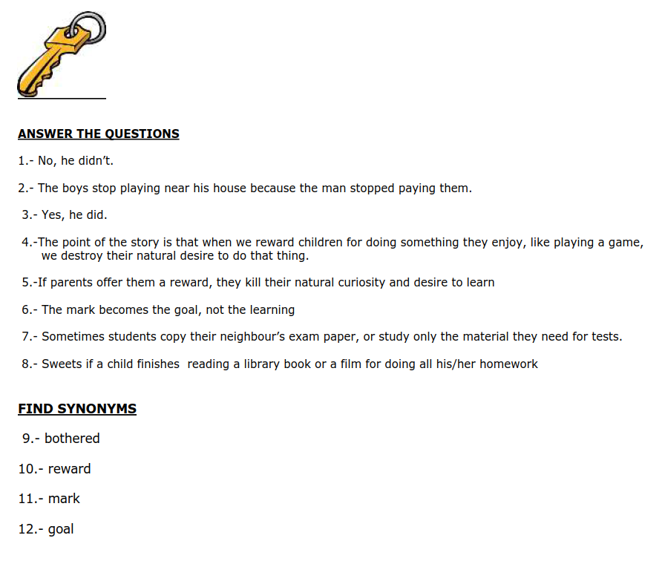

Siz istagan darslik asosidagi mavzu bo’yicha namunaviy dars ishlanmaga buyurtma berishingiz mumkin. Biz bilan bog’lanish **+998911800985 telegram raqami,** **@uzteachers_admin** ga xabar yuboring.

**Narxi 20 ming so’m** (1-9-sinflar uchun)

To’lov payme yoki click orqali

**Bog’lanish faqat telegram orqali. Telefon qilinganda yoki sms yozilganda javob bermasligim ehtimoli yuqori**