______________ VILOYATI _________ TUMANI XALQ TA’LIMI BO’LIMIGA QARASHLI
___-SONLI O’RTA TA”LIM MAKTABI
INGLIZ TILI FANI O’QITUVCHISI
_______________________________NING
1-sinflar uchun Unit 10. Lesson 4
How are you?
mavzusida 1 soatlik
Dars ishlanmasi

_______________-2019
Date_____ Form_____ Subject: English
Theme: How are you?
Aims:
Educational: - to learn basic greetings
– to ask and say how one feels.
Developing: - to enable pupils to greet, ask and say how they feel;
Socio-cultural: - to raise awareness of ways of greetings, asking and saying how
one feels;
– to raise awareness of the pronunciation of the sounds [w] and [h]
Up bringing: - to enrich pupils’ knowledge of our tradition and nation
Learning outcomes: At the end of the lesson pupils will be able to – understand the greetings, use a question for asking how somebody is and say how they feel;
– to pronounce the sounds [w] and [h].;
Competence: SC1, FLCC, and PC
Type of the lesson: Mixed, group work, pair-work, individual work
Method of the lesson: nontraditional, mixed
Equipment of the lesson: Textbook “Kid’s English 1”, pictures, internet, computers, projector

TECHNOLOGICAL MAP OF THE LESSON:

№ | Part of the lesson | Tasks | Time
1 | Organizational  Moment | -to greet pupils.  - to check up the register | 5 min
2 | Repeating last lesson | - to give pupils some questions about last lesson. – to ask words from previous lesson | 5 min
3 | Explaining new theme | - to explain to pupils new vocabulary and theme | 20 min
4 | Consolidating new theme. | - to consolidate new theme and new words of the theme. | 10 min
5 | Homework | - Giving homework. | 5 min
6 | Evaluation | - To mark pupils

Procedure of the lesson:
I. Organizing moment: Motivation, Greeting, checking attendance, season, weather, checking the preparation for the lesson.
- Check for homework given on past lesson.
- Ask pupils all new words learnt on previous lesson.
II. Pre-activity:
Activity 1 Listen and sing.
Objective: to sing the song “Good morning”
Look at the instructions in Lesson 1. This time practise singing the song with your pupils.
OPTION:
Besides you can play the game “Good morning. Good bye”. Say that now they will play a good game, but first they must learn how to say one little word “Goodbye”. Explain that it is very important to learn it because polite people should not only
greet but also say goodbye properly. Then work with your pupils on the pronunciation of “Goodbye”.
The rules of the game are as follows:
1) Select a pupil. He or she will stand by the door and will not look at the others.
2) One of the pupils chosen by you says loudly “Good morning”
(here he/she can change his\her voice).
3) The pupil standing by the door should guess who has greeted and answer “Good morning, Malik”.
4) If he/she has guessed right, Malik tells him/her “Good morning”. If he/she has made a mistake and couldn’t guess who said “Good morning”, Malik answers “Good bye”.

III. Main part
Activity 3 Play “Ask and answer”.
Objective: to practise the new language material “What’s your name?”
You should praise all the pupils, but say that two or three pupils were the best to put out the candle and then call their names.
Therefore, offer to sing the song “What’s your name?” with their names. Also say that they will sing the song with the names of the other pupils of the class in the next lessons.
Now, the pupils are more likely to say the question, so they can ask and answer the question “What’s your name?” in chains.
See the instructions in the Introduction (the section 6) for how to organise the chain drill activities.
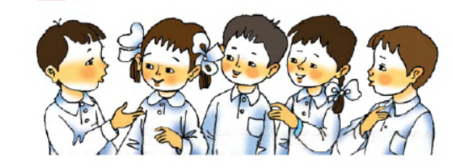

Activity 4 Watch and do.
Objective: to do physical exercise and energise the pupils
First year pupils also have to learn to sit at their desks in the classroom during a number of lessons. As they are not used to this, it will be difficult for them to sit unmoved. For this reason you need to make a little pause and do some energising exercise.
This is usually done by small rhyming songs. Since the purpose of the energising exercise is to give pupils the opportunity to relax, to get up from their seats and move around a bit, it is not much important to choose rhymes for energising exercises. Because the educational process at school does not allow much time for pure
entertainment, in this task there is another purpose. Specifically, using this opportunity, the authors propose to perform a physical exercise with numbers from 1 to 10 as in the DVD. The purpose of this activity is not to teach pupils the numbers but familiarize
them with the pronunciation of numbers as entertainment.
So the kids take it as a game, but in the future it will help them learn the numbers faster.
Play the DVD. Ask the pupils to watch and repeat.
Activity 5 Listen and repeat.
Objective: to practise and pronounce the sound [h]
The purpose of this activity is to teach pupils how to pronounce the English sound [h].
Remind the pupils about Mr. Tongue and his room. His room has a lot of furniture and a large mirror. When the mirror is dirty, it does not reflect much. Therefore, it needs wiping with a cloth. So, explain and show the pupils that first they need to blow
to it in a special way to make it misted.

Activity 6 Watch and do.
Objective: to practise the question “How are you?” and an appropriate
answer to it
STEP 1: Explain that when Zumrad and Jasur meet, they greet and ask each other how they are. So ask the pupils to repeat together with them the question “How are you?” At first train the pupils to pronounce the sound to help Zumrad and then repeat the question “How are you?”
STEP 2: Play the DVD and ask the pupils to watch the video. Further explain that there are many variations to answer the question. Ask them to guess the meaning of the following answers:
Good; I’m OK; Great; So-so. Help them guess the answers with your gestures. It is very important for the pupils to use the language of gestures as often as possible as it helps them remember the information faster. It is also important to give the pupils freedom to choose an answer to the question so that they could approach creatively later.
Ask them to look at Zumrad and repeat the answers together with her.
STEP 3: Practise the language as follows:
You: How are you?
Pupil 1: I’m OK. / Pupil 2: Good. / Pupil 3: Great.
Pupil 4: So-so.

IV. Post-activity
Optional Activity 7 Play “Ask and answer”.
Objective: to practise the question “How are you?” and an appropriate
answer to it
Now you can do the chain drill activity with the target question
“How are you?” and answers “Good”/ “I’m OK ”/ “Great”/ “So-so”.
See the instructions in the Introduction (the section 6) for how to organise the chain drill activities

V. Homework
Homework:
Explain to the pupils that they should colour the picture on the right hand page at home and remember how people greet each other and ask and answer how they feel.
VI. Evaluation. Marking pupils according to their attendance

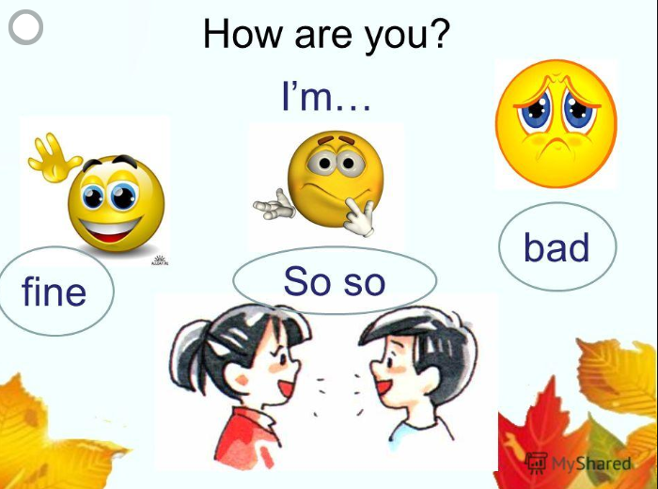

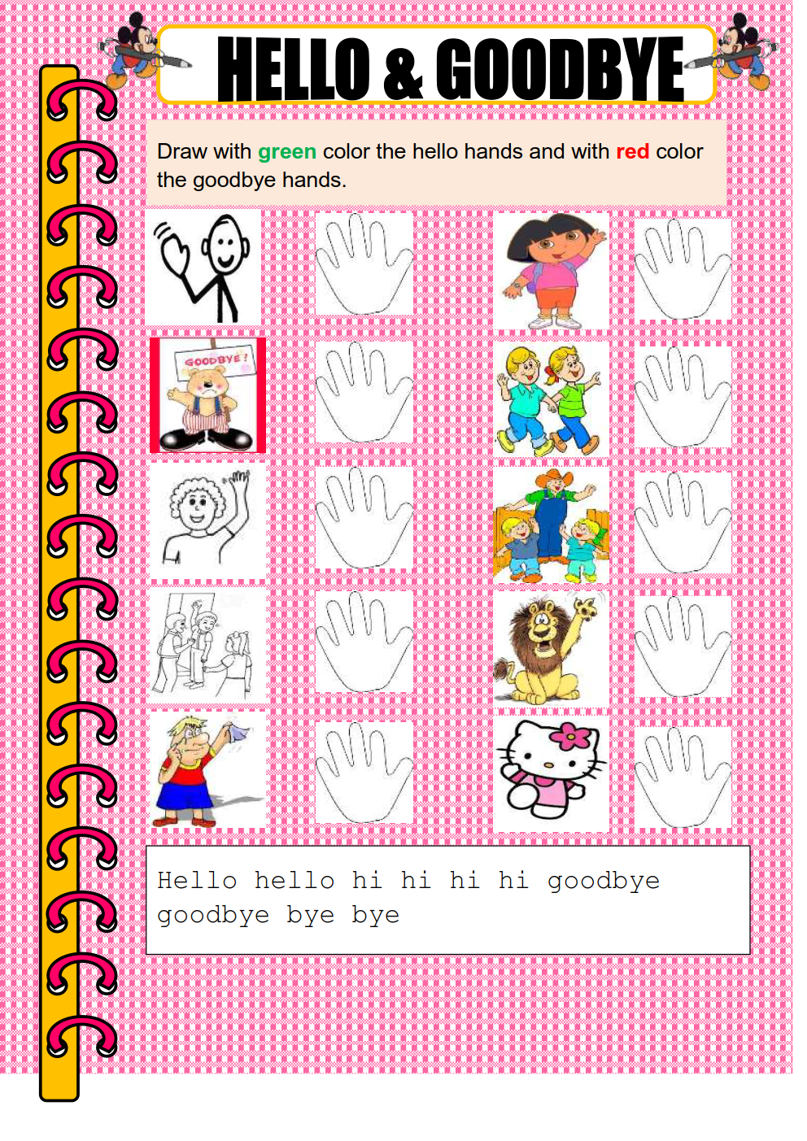

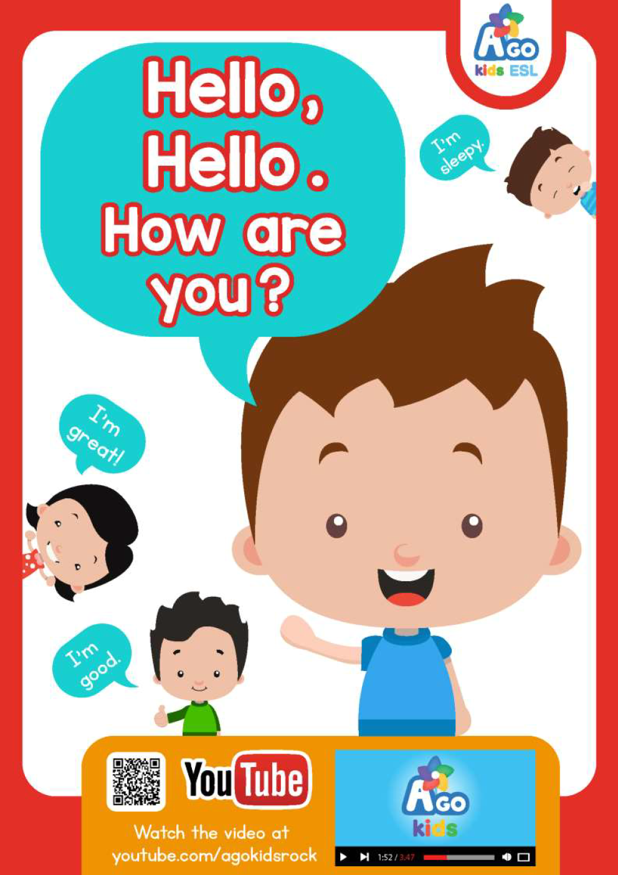
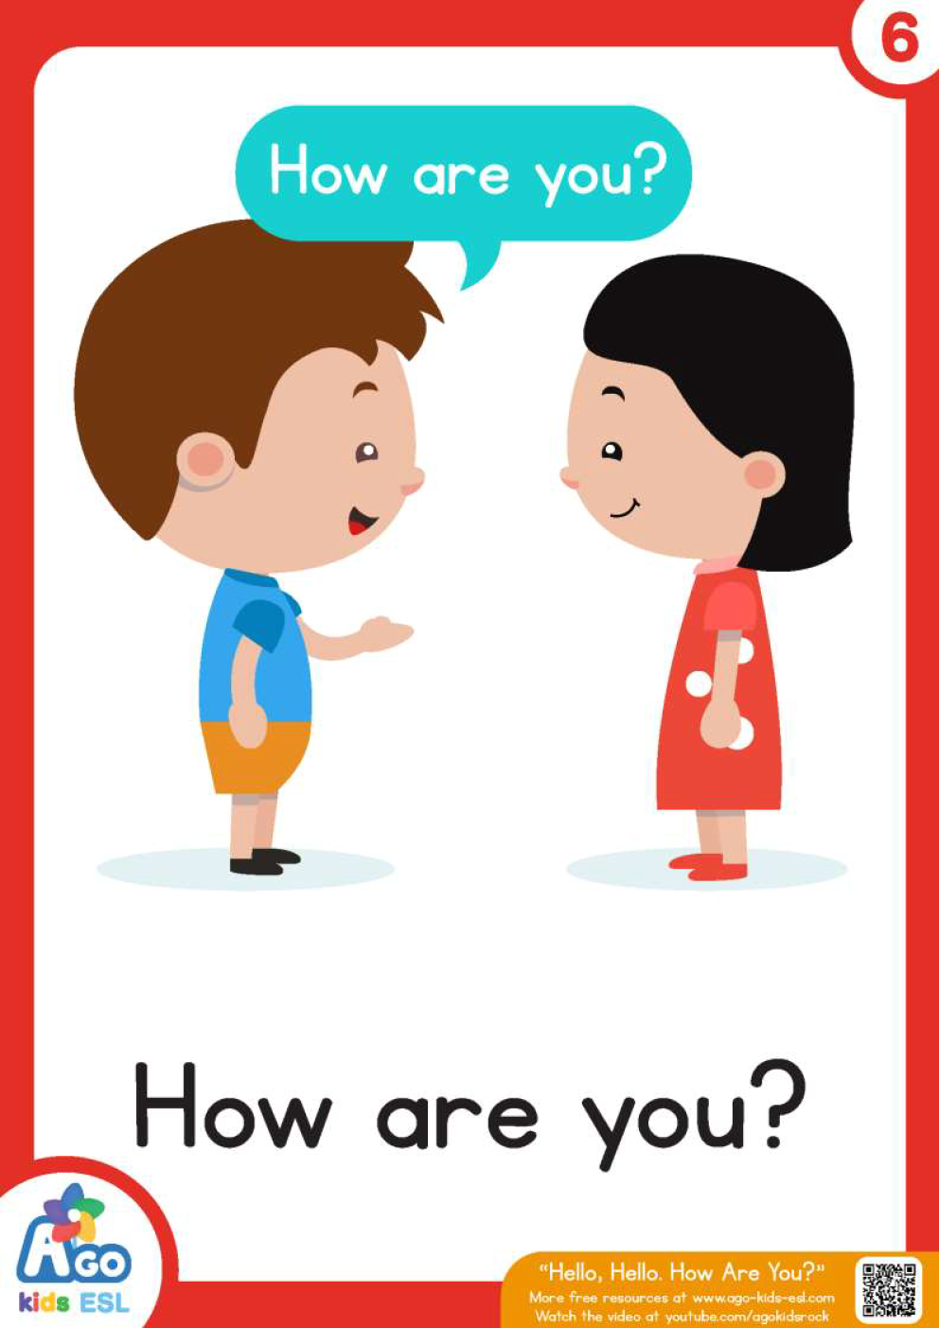

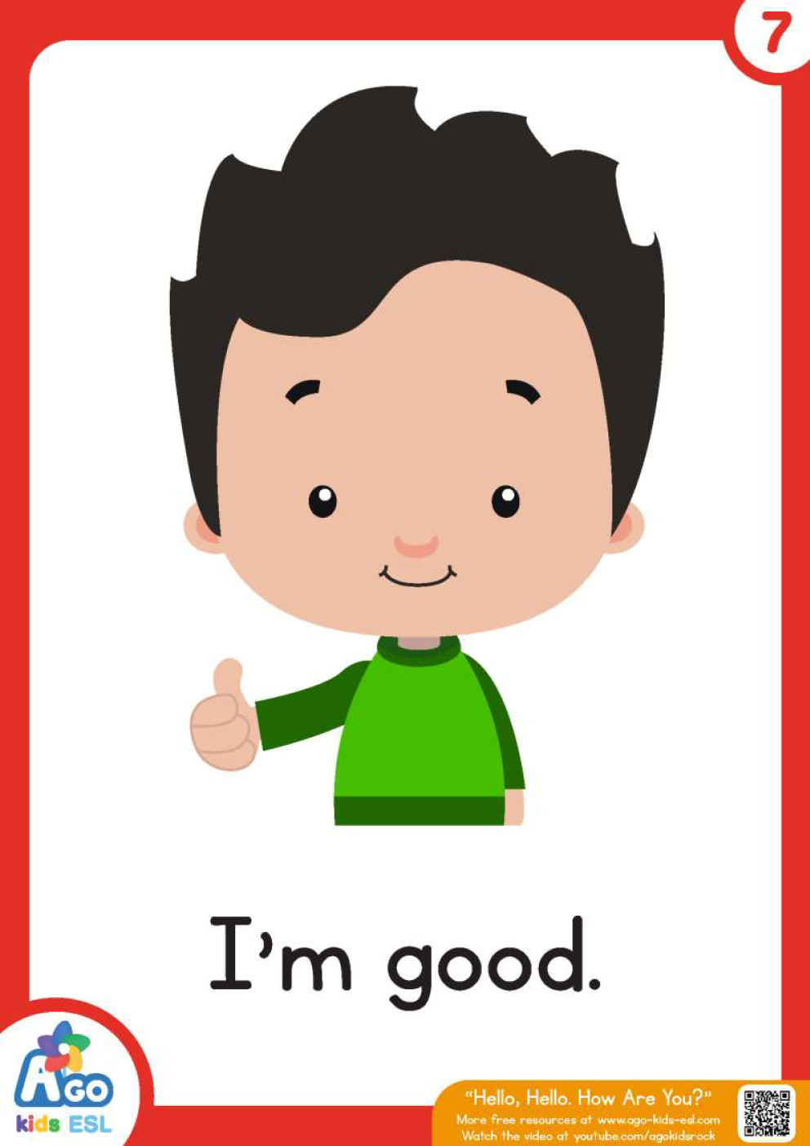
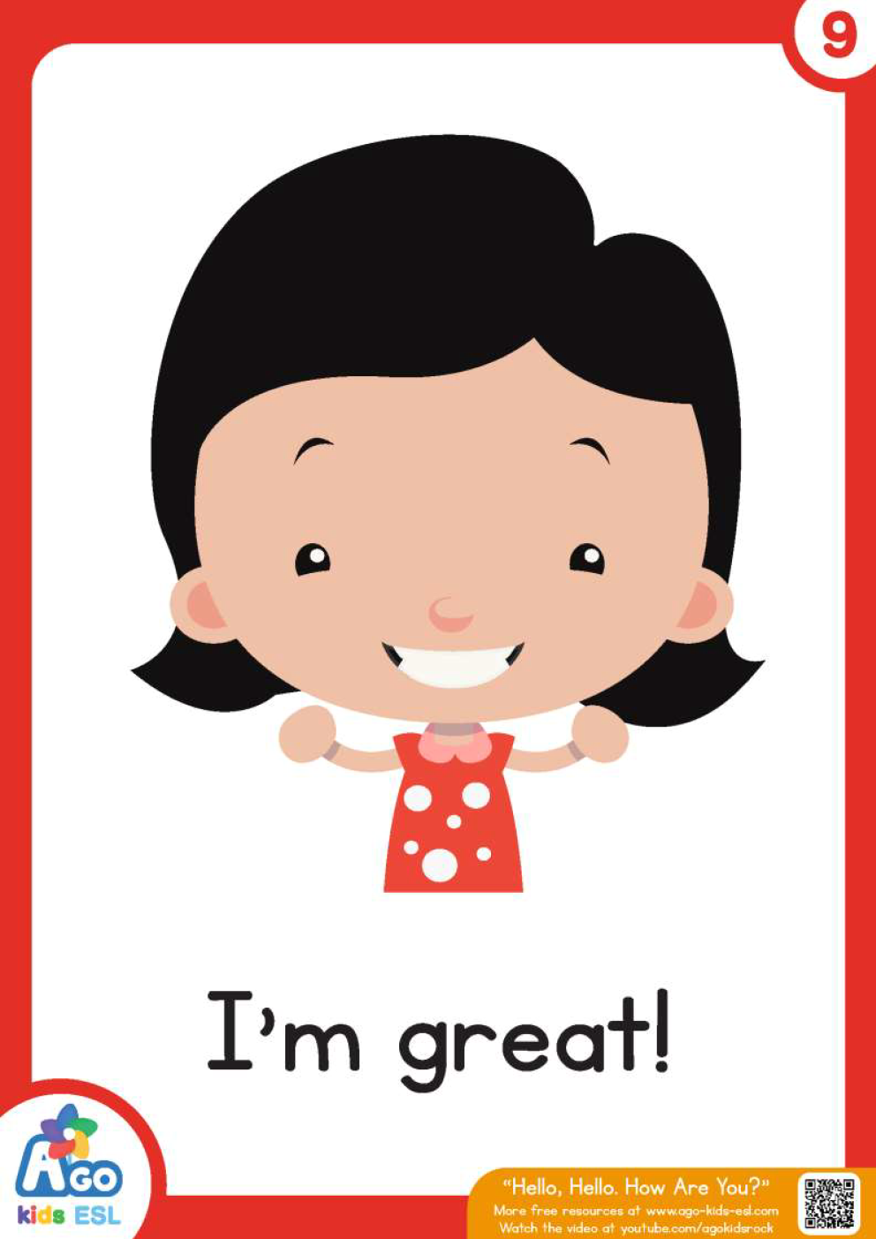
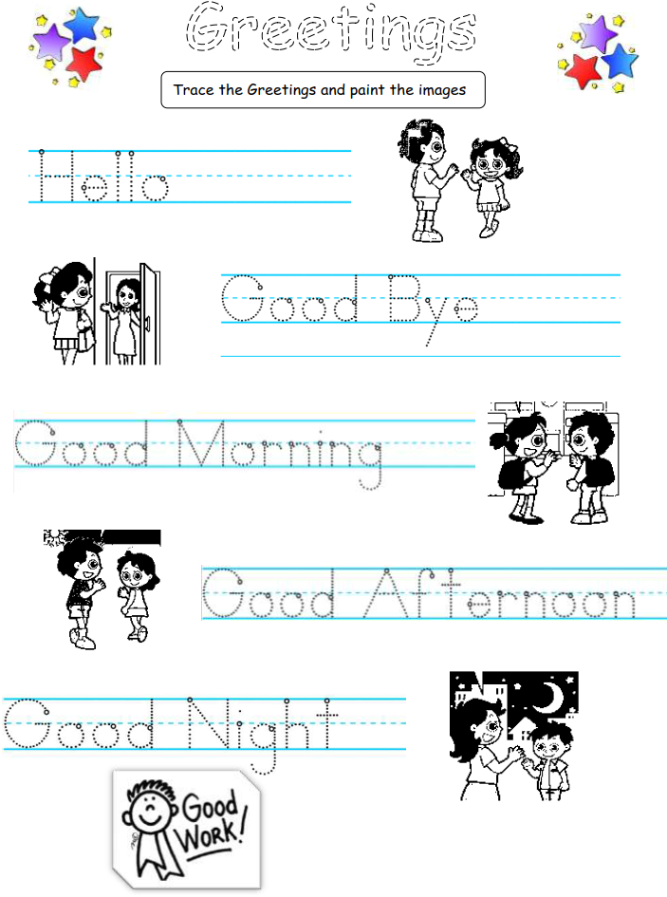

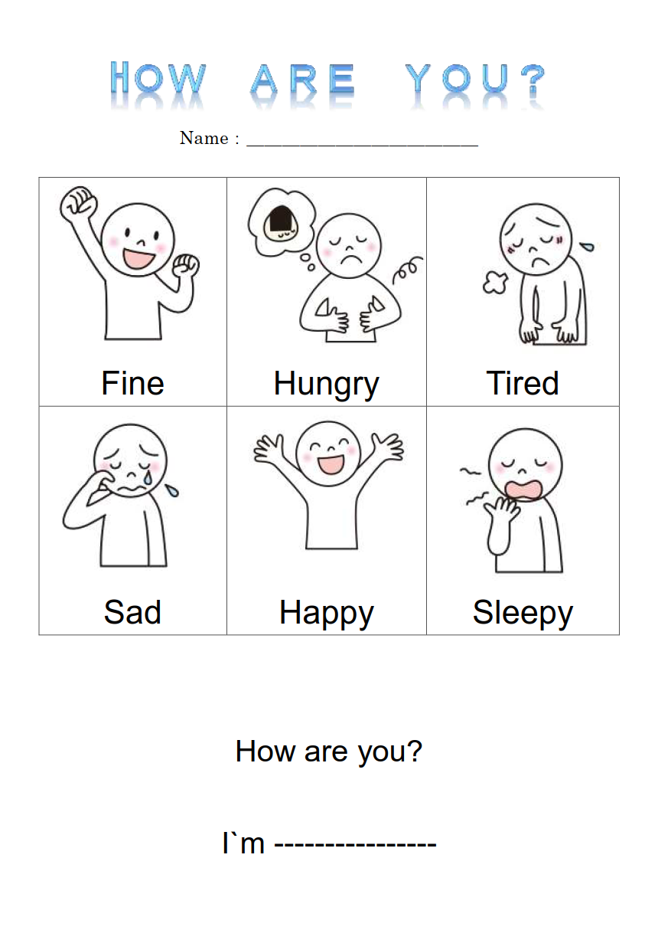

Siz istagan darslik asosidagi mavzu bo’yicha namunaviy dars ishlanmaga buyurtma berishingiz mumkin. Biz bilan bog’lanish +998911800985 telegram raqami, @uzteachers_admin ga xabar yuboring.
Narxi 20 ming so’m (1-9-sinflar uchun)
To’lov payme yoki click orqali
Bog’lanish faqat telegram orqali. Telefon qilinganda yoki sms yozilganda javob bermasligim ehtimoli yuqori

