______________ VILOYATI _________ TUMANI XALQ TA’LIMI BO’LIMIGA QARASHLI
___-SONLI O’RTA TA’LIM MAKTABI
INGLIZ TILI FANI O’QITUVCHISI
_______________________________NING
5-sinflar uchun Unit 0. Lesson 1
Countries around the world
mavzusida 1 soatlik
Dars ishlanmasi
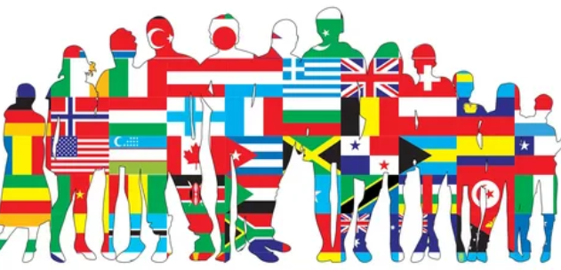

_______________-2022
Date_____ Form_____ Subject: English
Theme: Countries around the world
Aims:
Educational: - students will review talking about themselves and learn about countries around the world.
Developing: - learning names of countries and their flags
- saying where and when they and other people are from
- finding out about festivals around the world
- they will also learn what mosaics are made of.
Socio-cultural: - to raise awareness of different cultures
Up bringing: - to enrich pupils’ knowledge of our tradition and nation
Learning outcomes: At the end of the lesson pupils learn the names of and talk
about countries around the world;
Competence: SC1, FLCC, and PC
Type of the lesson: Mixed, group work, pair-work, individual work
Method of the lesson: nontraditional, mixed
Equipment of the lesson: “Guess What 5” SB, WB, pictures, internet, computers, projector

TECHNOLOGICAL MAP OF THE LESSON:

№ | Part of the lesson | Tasks | Time
1 | Organizational  Moment | -to greet pupils.  - to check up the register | 5 min
2 | Repeating last lesson | - to give pupils some questions about last lesson. – to ask words from previous lesson | 5 min
3 | Explaining new theme | - to explain to pupils new vocabulary and theme | 20 min
4 | Consolidating new theme. | - to consolidate new theme and new words of the theme. | 10 min
5 | Marking. | - To mark pupils | 5 min
6 | Homework. | - Giving homework.

Procedure of the lesson:
I. Organizing moment: Motivation, Greeting, checking attendance, season, weather, checking the preparation for the lesson.
- Check for homework given on past lesson.
- Ask pupils all new words learnt on previous lesson.
Warmer
• Use a world map to preteach the countries of the lesson and also the students’ own country.
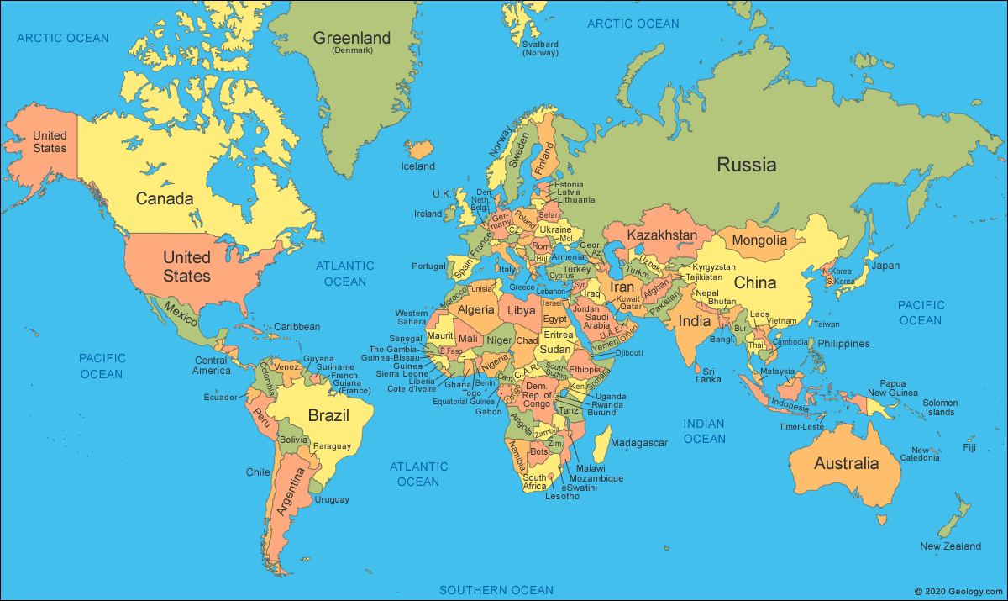

II. Pre-activity:
Activity 1 Listen and look.
• Use the flags to introduce the countries, asking What country is this? (Russia.) Students repeat the words.
• Write the names Emma, Pedro, Alex, and Carla on the board. Ask Do these children like traveling? Listen and look. Play the recording. Students point to the flags of
the countries in the order they hear them.
• Play the recording again, pausing to ask more questions

CD1:02

Pedro: Do you like traveling, Emma?
Emma: I love it!
Pedro: Which of these countries would you like to visit? Would you like to visit the United Kingdom?
Emma: Yes, I would. And Mexico. I’d love to visit Mexico. My aunt lives there. Would you like to go to Mexico, Pedro?
Pedro: I would. Or what about Colombia? It’s beautiful. What about you, Carla?
Carla: I’d love to visit Brazil.
Emma: So would I. What about you, Alex?
Alex: I’d like to go to the United States. My cousins live there.
Carla: Cool. My cousins live in France. We go and visit them sometimes.
Pedro: I sometimes go to Italy on vacation.
Emma: So do I. And Spain.
Alex: Is it nice?
Emma: Yes, it’s great.
Pedro: I’d love to go to Russia, too.
Carla: Me, too. Or China. What about you, Alex? Would you like to go to China?
Alex: Yes, of course.
Pedro: Someday.
Emma: Come on! We’re late for school.
III. Main part
Activity 2 Listen and repeat. Then match.
• Play the recording. Students repeat and point to the flags.
• Play the recording again. Students match the words.
• Point out capital letters are used for countries.

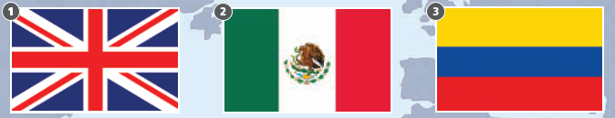
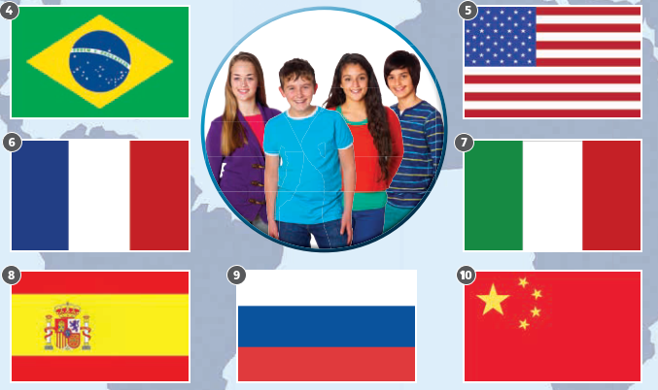

Key: 1 i 2 f 3 c 4 a 5 j 6 d 7 e 8 h g 10 b

CD1:03

1 the United Kingdom 2 Mexico 3 Colombia 4 Brazil 5 the United States 6 France
7 Italy 8 Spain Russia 10 China

Activity 3 Listen and answer the questions. Then practice with a friend.
• Say Listen and answer the questions. Play the recording, pausing for students to answer.
• Students then ask and answer in pairs, using the example speech bubbles to help.
e.g. Which country has a yellow, blue, and red flag? Colombia!

CD1:04

1 Which country has a yellow, blue, and red flag?
2 Which country has a red flag with yellow stars?
3 Which other country has a red and yellow flag?
4 Which country has a green and yellow flag with a blue circle?
5 Which two countries have a green, white, and red flag?
6 Which country has a flag with an eagle and a snake on it?
7 Which four countries have a red, white, and blue flag?
8 Which country has a flag with 50 stars on it?

Key: 2 China 3 Spain 4 Brazil 5 Mexico and Italy 6 Mexico 7 the United Kingdom, the United States, France, Russia 8 the United States

Activity 4 Which countries do you want to visit? Ask and answer.
• Students ask each other in pairs or groups. This could be done as a Class survey (see pages xiv–xv).

Class survey
Class surveys can be used to compare a range of students’ experiences, e.g., in Around the world finding out which countries most students want to visit. Divide the students
into groups of five. Students draw a chart with six columns and five rows on a piece of paper. They write the names of the other students in their group along the top of the chart and the countries down the side of the chart. Students then ask and answer in their groups, e.g., Do you want to visit (China)? They record each person’s answers with
checks or ✗s. Students then look at the completed chart to see which country has the most checks and therefore is the most popular choice. They then compare this country with the most popular choice in the other groups in order to find the most popular choice in the class.

IV. Post-activity

Workbook activity 1 Look and write the words on the map.
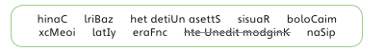
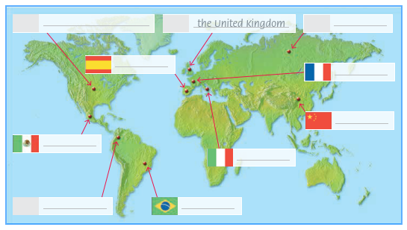

Key: China, Brazil, the United States, Russia, Colombia, Mexico, Italy, France, Spain

V. Homework
WB Activity 2. Look at activity 1. Answer the questions.
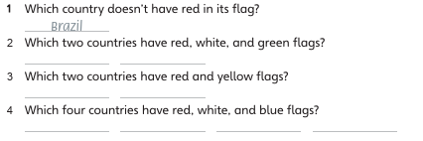
Key: 1 Brazil 2 Italy and Mexico 3 Spain and China 4 Russia, France, the United States, the United Kingdom

VI. Evaluation
Giving marks according to pupils’ participation to the lesson

Deputy director on educational affairs: _________ Signature: __________

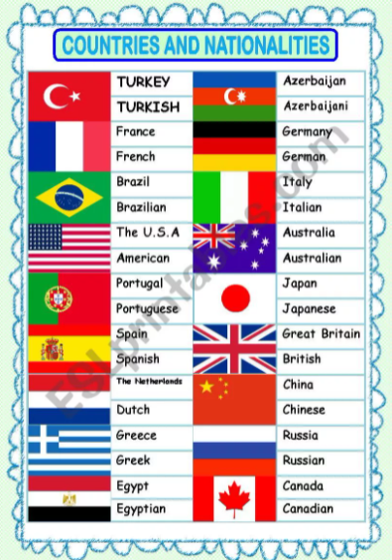
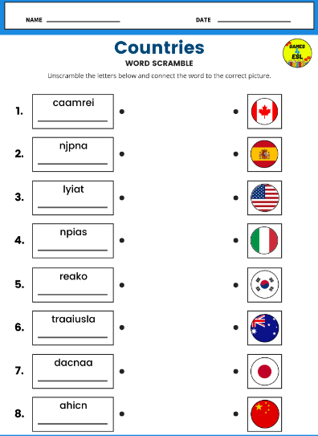

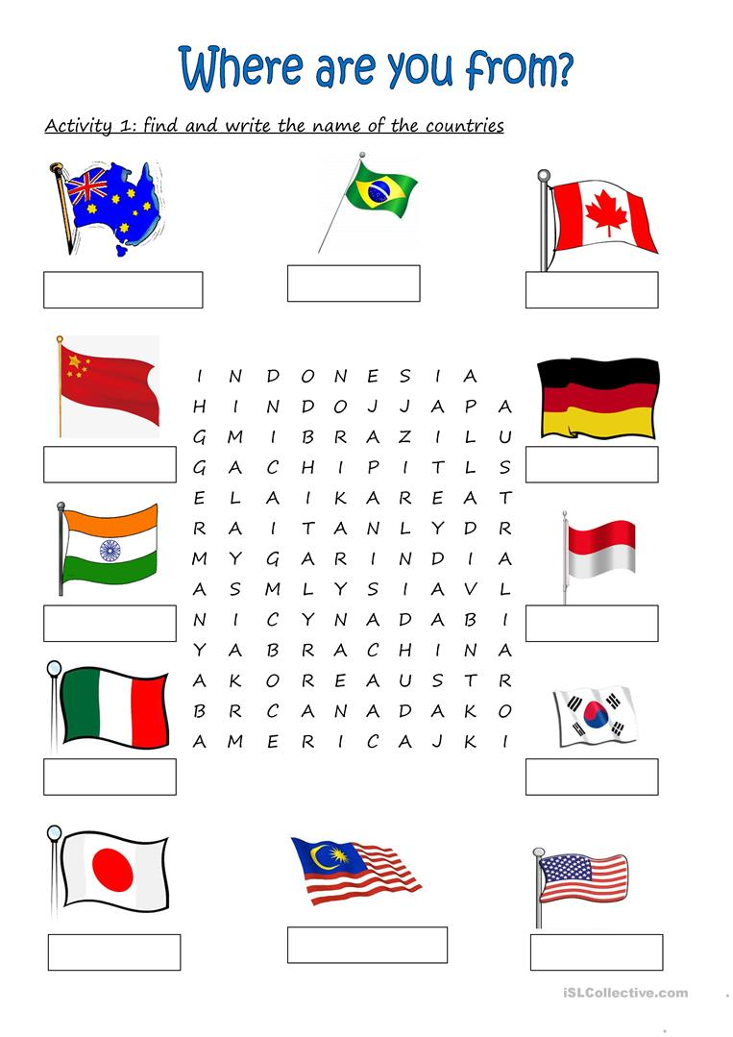

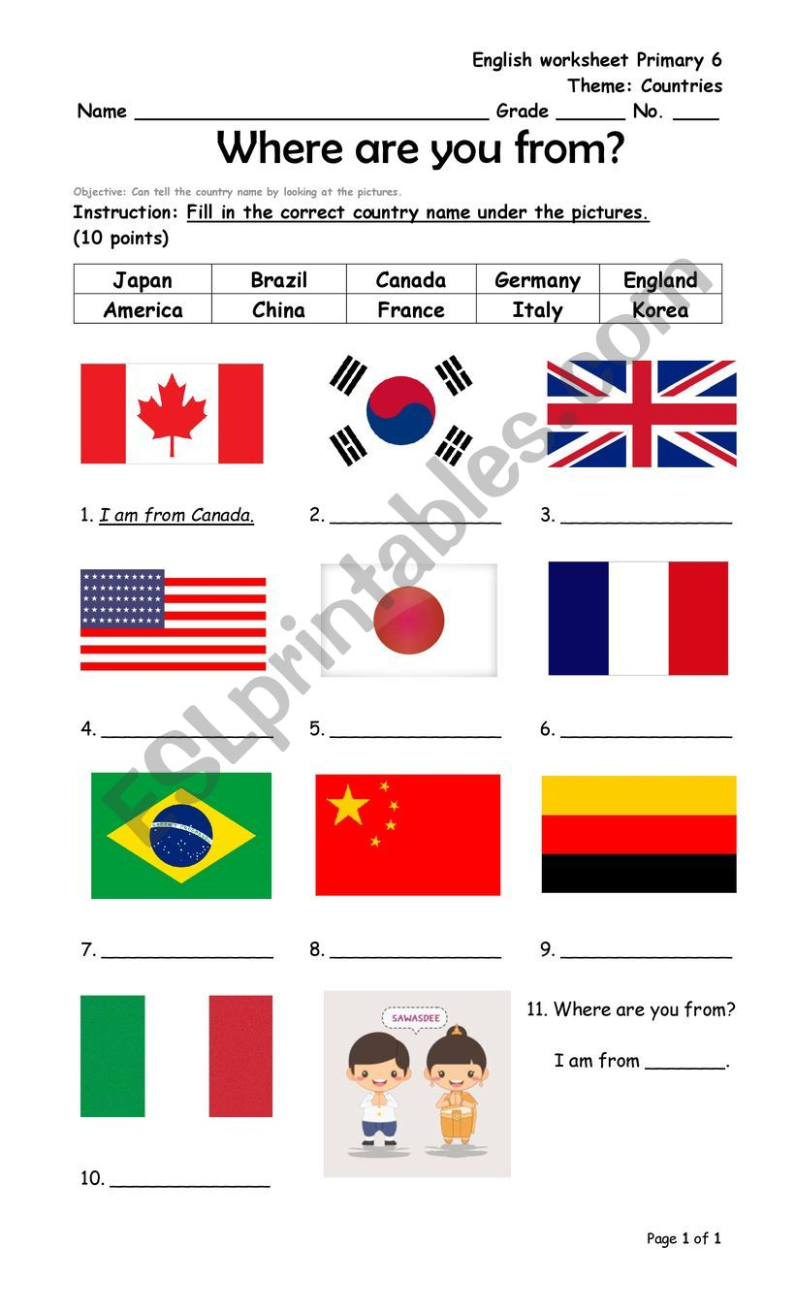
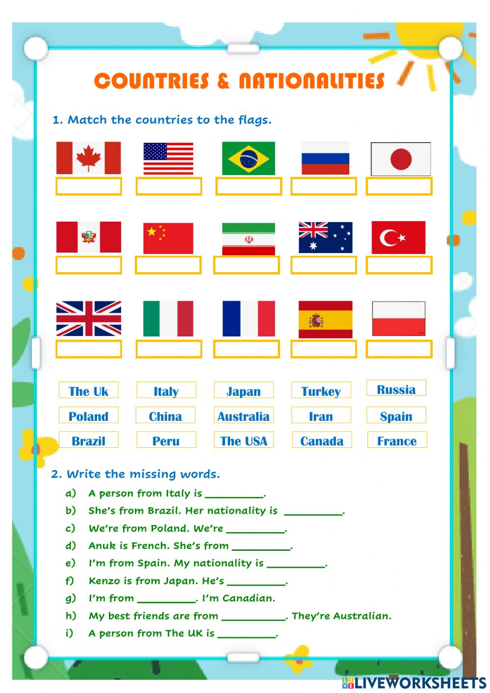

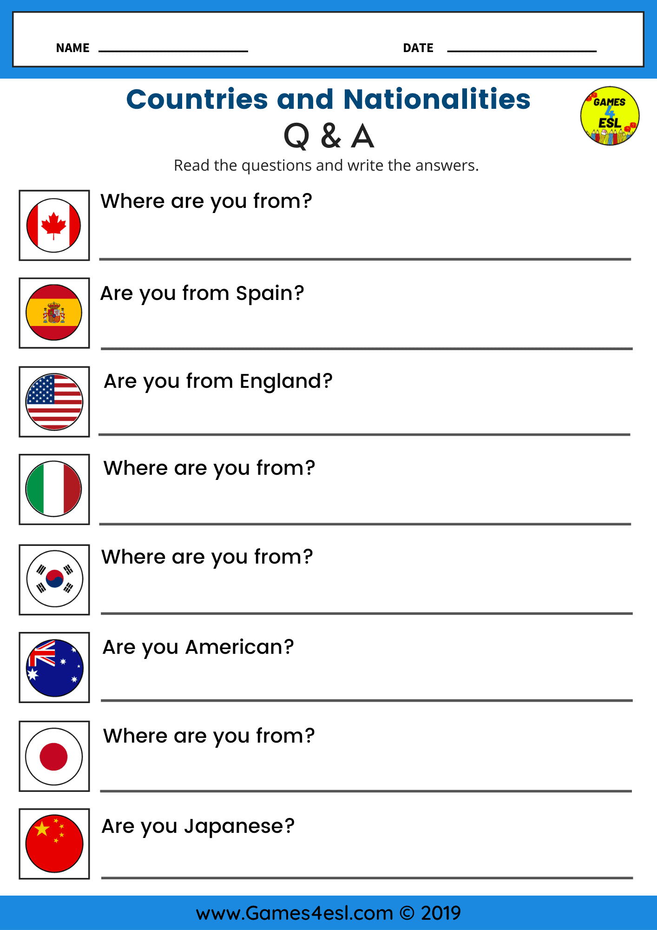

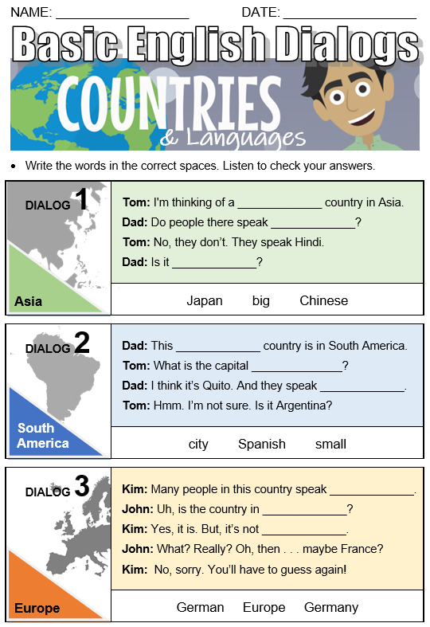

Huddi shunday namunada Guess What va Prepare darsliklaridan istalgan mavzu bo’yicha namunaviy dars ishlanmalar olishingiz mumkin. Biz bilan bog’lanish uchun Telegramdan @hasanboy_uz manzili yoki +998911800985 telegram raqami ga xabar yuboring. Narxi 1ta mavzu
20 ming so’m
To’lov payme yoki click orqali
Bog’lanish faqat telegram orqali. Telefon qilinganda yoki sms yozilganda javob berilmaydi!

