
4 – sinf uchun olimpiada topshiriqlari.
Sana: ____________
Sinf: ____
Ismi : _________________
Familiyasi: _______________
- Choose the answer.
I’m good at …..
- playing tennis b) playing football c) playing piano
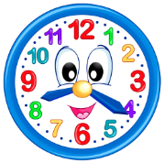
- Look, read and match.
- It’s eight o’clock
- It’s seven thirty
- It’s eight twenty
- Translate the words. kechki ovqatni yemoq, maktabda qolmoq, hech qachon
- have dinner, go to bed, never
- have dinner, stay at school, never
- have dinner, stay at school, usually
- Find names of countries.
- England , Uzbekistan , German, Russia, France
- England , Uzbekistan , Germany, Russia, France
- England , Uzbekistan , German, Russian, France
- Translate the words. Sweep the floor, wash the dishes, go shopping
- Polni supurmoq, idishlarni yuvmoq, bozorlik qilmoq
- Polni artmoq, idishlarni yuvmoq, dasturxon tuzamoq
- Polni artmoq, idishlarni yuvmoq, dasturxon yozmoq
- Translate . Kecha men gullarga suv quydim.
- I watered the flowers today.
- I planted flowers yesterday.
- I planted the flowers yesterday.
- Find true answer . Ocok, itlpo, sneur
- Cook, potil, nurse b) cook, pilot, nures c) cook ,pilot , nurse
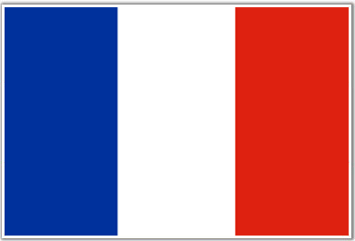
- Find true answer. Which country’s flag is it ?
- Germany b)French c)France

- Put in order. work/ doctors/at the hospital
- At the hospital doctors work.
- Work doctors at the hospital.
- Doctors work at the hospital.
- Choose the answer. Mening buvim ingliz tili o’qituvchisi bo’lgan.
- My granny was an English teacher. b) My granny were an English teacher.
c) My granny was a English teacher.
- Find true answer. My mother …. to Tashkent yesterday.
a) goes b)went c)go
- Translate. Dushanba kuni biz Samarqandga ketdik.
- On Monday we went to Samarkand. b) On Monday we go to Samarkand .
c)On Monday we goes to Samarkand.
13. Translate. Bir finjon qora choy, bir kosa sho’rva, bir stakan suv.
a) a cup of tea, a bowl of soup, a glass of juice b) a glass of water, a bowl of salad, a cup of tea
c)a cup of black tea, a bowl of soup, a glass of water
14. Translate . Bir stakan shaftoli sharbati hohlayman.
a) I’d like a cup of juice. b) I’d like a glass of water c) I’d like a glass of peach juice
15. There …. two books, three copybooks , a bag and a ruler on the round table .
a) is b)are c)has
16. When’s Teachers’ Day ? It’s …. October.
a) on b) in c)at
17. Oyim hozir ovqat pishiryaptilar .
a) My mum is cook no. b) My mum is cooking now. c) My mum cooking now.
18. Translate. Sovg’alar bermoq, sov’g’alar olmoq, nishonlamoq
a) give presents, get presents, celebrate b) give presents, get presents, celebration
c) give presents ,get presents, plant tree
19. cooked/my/a birthday cake/mum
a)My mum cooked a birthday cake. B) Mum my cooked a birthday cake. c) My mum a birthday cake cooked.
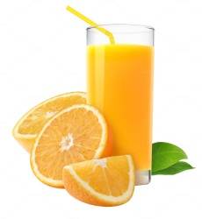
20. Would you like ….. …… juice ?
a) a glass of orange
b)a cup of orange
c)a bowl of
21. Translate.
Men ingliz tilida qo’shiqlar ayta olaman. ________________________________________
22.Put in order.
favourite / my / holiday/ is/ mother’s/ New Year __________________________________________________________

23.Find and write two sentences.
MyfavouritesubjectsareUzbekandEnglishIwanttobeateacher
_________________________________________________________________________

24.Read and write True or False.
1)Teachers work at the hospital _____
2)Nurses work at the canteen ______

25. Translate. Men O’zbekiston ob – havosi haqida gapira olaman.

_____________________________________________________________________________

Savollar | 1 | 2 | 3 | 4 | 5 | 6 | 7 | 8 | 9 | 10 | 11 | 12 | 13 | 14 | 15 | 16 | 17 | 18 | 19 | 20 | 21 | 22 | 23 | 24 | 25
Javoblar
To’g’riligi
Ball
Baho

O’qituvchi:__________________________________

