Hozircha ushbu fayl bo’sh!

Tez orada ushbu linkda e’lon qilinadi - <https://t.me/uz_teachers/225>

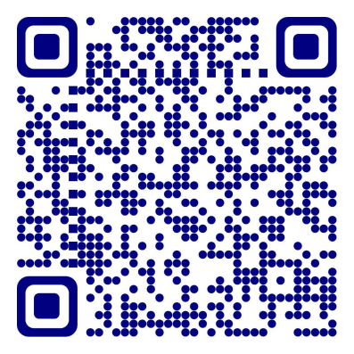Web-sayt: [www.hasanboy.uz](http://www.hasanboy.uz)



**@uz_teachers**